St. Mark’s Worship Sunday May 29, 2022
Seventh Sunday of Easter
Welcome to worship!
Stationed at the tables at the entrance our greeters have hand sanitizer and masks if you need them.
We will be serving coffee after the service, all are welcome.
St. Mark’s offers this worship service live on zoom at 9 AM or recorded on Facebook or our website at 11 AM. The zoom link is published in the St. Mark's email newsletter. Let the office know if you would like to receive it. If you are worshiping at home, you may want to prepare some bread, wine, or juice to receive Holy Communion. You may commune yourself or those around you with these words:
“The body of Christ given for you; the blood of Christ shed for you.”

Prelude
Welcome
Mission
Celebrating God’s love and forgiveness, we serve others
Opening Hymn – My Hope Is Built on Nothing Less ELW #597
¹ My hope is built on nothing less
than Jesus' blood and righteousness;
no merit of my own I claim,
but wholly lean on Jesus' name.

Refrain
On Christ, the solid rock, I stand;
all other ground is sinking sand.

² When darkness veils his lovely face,
I rest on his unchanging grace;
in ev'ry high and stormy gale
my anchor holds within the veil.
[Refrain]

³ His oath, his covenant, his blood
sustain me in the raging flood;
when all supports are washed away,
he then is all my hope and stay.
[Refrain]

⁴ When he shall come with trumpet sound,
oh, may I then in him be found,
clothed in his righteousness alone,
redeemed to stand before the throne
[Refrain]

Lic #A-735988

Thanksgiving for Baptism
Alleluia! Christ is risen.
Christ is risen indeed. Alleluia!
In the waters of baptism,
we have passed over from death to life with Jesus Christ,
and we are a new creation.
For this saving mystery, and for this water, let us bless God,
who was, who is, and who is to come.
Water may be poured into the font as Pastor Karla gives thanks.
We thank you, God, for your river of life,
flowing freely from your throne:
through the earth,
through the city,
through every living thing.
You rescued Noah and his family from the flood;
You opened wide the sea for the Israelites.
Now in these waters you flood us with mercy,
and our sin is drowned forever.
You open the gate of righteousness
and we pass safely through.
In Jesus Christ, you calm and trouble the waters.
You nourish us and enclose us in safety.
You call us forth and send us out.
In lush and barren places, you are with us.
You have become our salvation.
Now breathe upon this water
and awaken your church once more.
Claim us again as your beloved and holy people.
Quench our thirst; cleanse our hearts; wipe away every tear.
To you, our Beginning and our End,
our Shepherd and Lamb,
be honor, glory, praise, and thanksgiving,
now and forever.
Amen.

Prayer of the Day
O God, form the minds of your faithful people into your one will. Make us love what you command and desire what you promise, that, amid all the changes of this world, our hearts may be fixed where true joy is found, your Son, Jesus Christ our Lord, who lives and reigns with you and the Holy Spirit, one God, now and forever.
Amen.
Children’s message
Psalm: Psalm 97
¹The Lord reigns; let the earth rejoice;
let the multitude of the isles be glad.
²Clouds and darkness surround the Lord,
righteousness and justice are the foundations of God’s throne.
³Fire goes before the Lord,
burning up enemies on every side.
⁴Lightnings light up the world;
the earth sees and trembles.
⁵The mountains melt like wax
before the Lord of all the earth.
⁶The heavens declare your righteousness, O Lord,
and all the peoples see your glory.
⁷Confounded be all who worship carved images and delight in false gods!
Bow down before the Lord, all you gods.
⁸Zion hears and is glad, and the cities of Judah rejoice,
because of your judgments, O Lord.
⁹For you are the Lord, most high over all the earth;
you are exalted far above all gods.
¹⁰You who love the Lord, hate evil!
God guards the lives of the saints and rescues them from the hand of the wicked.
¹¹Light dawns for the righteous,
and joy for the honest of heart.
¹²Rejoice in the Lord, you righteous,
and give thanks to God’s holy name.
Reading: Acts 16:16-34
¹⁶One day, as we were going to the place of prayer, we met a slave-girl who had a spirit of divination and brought her owners a great deal of money by fortune-telling. ¹⁷While she followed Paul and us, she would cry out, “These men are slaves of the Most High God, who proclaim to you a way of salvation.” ¹⁸She kept doing this for many days. But Paul, very much annoyed, turned and said to the spirit, “I order you in the name of Jesus Christ to come out of her.” And it came out that very hour.
¹⁹But when her owners saw that their hope of making money was gone, they seized Paul and Silas and dragged them into the marketplace before the authorities. ²⁰When they had brought them before the magistrates, they said, “These men are disturbing our city; they are Jews ²¹and are advocating customs that are not lawful for us as Romans to adopt or observe.” ²²The crowd joined in attacking them, and the magistrates had them stripped of their clothing and ordered them to be beaten with rods. ²³After they had given them a severe flogging, they threw them into prison and ordered the jailer to keep them securely. ²⁴Following these instructions, he put them in the innermost cell and fastened their feet in the stocks.
²⁵About midnight Paul and Silas were praying and singing hymns to God, and the prisoners were listening to them. ²⁶Suddenly there was an earthquake, so violent that the foundations of the prison were shaken; and immediately all the doors were opened and everyone’s chains were unfastened. ²⁷When the jailer woke up and saw the prison doors wide open, he drew his sword and was about to kill himself, since he supposed that the prisoners had escaped. ²⁸But Paul shouted in a loud voice, “Do not harm yourself, for we are all here.” ²⁹The jailer called for lights, and rushing in, he fell down trembling before Paul and Silas. ³⁰Then he brought them outside and said, “Sirs, what must I do to be saved?” ³¹They answered, “Believe on the Lord Jesus, and you will be saved, you and your household.” ³²They spoke the word of the Lord to him and to all who were in his house. ³³At the same hour of the night he took them and washed their wounds; then he and his entire family were baptized without delay. ³⁴He brought them up into the house and set food before them; and he and his entire household rejoiced that he had become a believer in God.
Gospel Acclamation (Please Stand as you are able)
Alleluia! Lord to whom shall we go? You have the words of eternal life! Alleluia!
The Holy Gospel according to John.
Glory to you, O Lord.

Gospel: John 17:20-26
[Jesus prayed:] ²⁰“I ask not only on behalf of these, but also on behalf of those who will believe in me through their word, ²¹that they may all be one. As you, Father, are in me and I am in you, may they also be in us, so that the world may believe that you have sent me. ²²The glory that you have given me I have given them, so that they may be one, as we are one, ²³I in them and you in me, that they may become completely one, so that the world may know that you have sent me and have loved them even as you have loved me. ²⁴Father, I desire that those also, whom you have given me, may be with me where I am, to see my glory, which you have given me because you loved me before the foundation of the world.
²⁵“Righteous Father, the world does not know you, but I know you; and these know that you have sent me. ²⁶I made your name known to them, and I will make it known, so that the love with which you have loved me may be in them, and I in them.”
The Gospel of our Lord.
Praise to you, O Christ
Sermon Pastor Karla Halvorson
Hymn of the Day – You Are Mine (Verses 1,2,4) ELW #597

¹ I will come to you in the silence
I will lift you from all your fear
You will hear My voice
I claim you as My choice
Be still, and know I am near

² I am hope for all who are hopeless
I am eyes for all who long to see
In the shadows of the night,
I will be your light
Come and rest in Me

Refrain
Do not be afraid, I am with you
I have called you each by name
Come and follow Me
I will bring you home
I love you and you are mine

⁴ I am strength for all the despairing
Healing for the ones who dwell in shame
All the blind will see, the lame will all run free
And all will know My name
[Refrain]

Lic #A-735988
Prayers of Intercession

Leader: God, in your mercy
Congregation: Hear our prayer.
Song - I love You, Lord
I love You, Lord, and I lift my voice,
To worship You--
O my soul, rejoice!
Take joy, my King,
In what You hear;
May it be a sweet, sweet sound
In Your ear.
Blessing of prayer quilts
Song - I love You, Lord
I love You, Lord, and I lift my voice,
To worship You--
O my soul, rejoice!
Take joy, my King,
In what You hear;
May it be a sweet, sweet sound
In Your ear.
The Peace
The peace of Christ be with you always.
And also, with you.
(you may share the peace of Christ with anyone who is with you, share the peace in the comments, text an offering of peace to someone, or simply send a prayer of blessing and peace to someone.)
Thanksgiving Moment
Offering
Offering information
St. Mark’s Church, 580 Hilltop Dr. Chula Vista, CA 91910
Venmo: @stmarks-churchchulavista
Each of you should give what you have decided in your heart to give, not reluctantly or under compulsion, for God loves a cheerful giver. 2 Corinthians 9:7
Offering Song
Thank you for giving to the Lord
I am a life that was changed
Thank you for giving to the Lord
I am so glad you gave
Offering Prayer
Living God,
you gather the wolf and the lamb to feed together
in your peaceable reign,
and you welcome us all at your table.
Reach out to us through this meal,
and show us your wounded and risen body,
that we may be nourished and believe
in Jesus Christ, our Savior and Lord.
Amen.

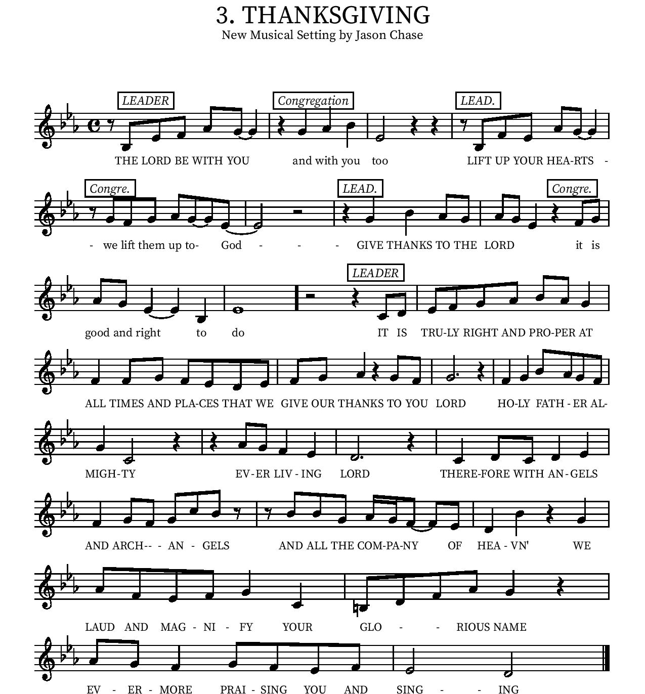
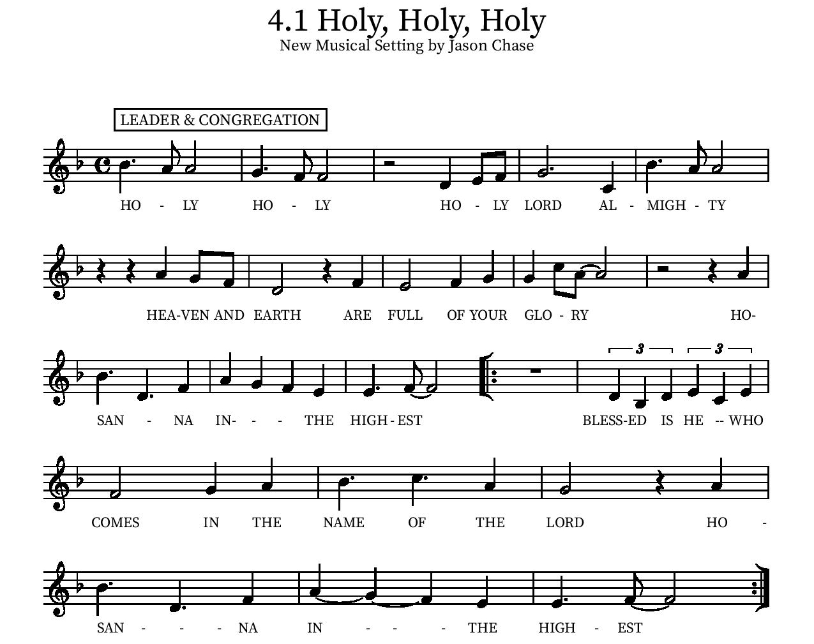

Eucharistic Prayer
P: In the night, in which he was betrayed…. Do this for the remembrance of me.
The Lord’s Prayer
Our Father in heaven, hallowed be your name, your kingdom come, your will be done, on earth as in heaven. Give us today our daily bread. Forgive us our sins as we forgive those who sin against us. Save us from the time of trial and deliver us from evil. For the kingdom, the power, and the glory are yours, now and forever.
Amen.
Invitation to the Table
We invite you to come forward at the usher’s direction. The cups contain red wine or white grape juice. Gluten free wafers are available upon request.

Communion Hymn
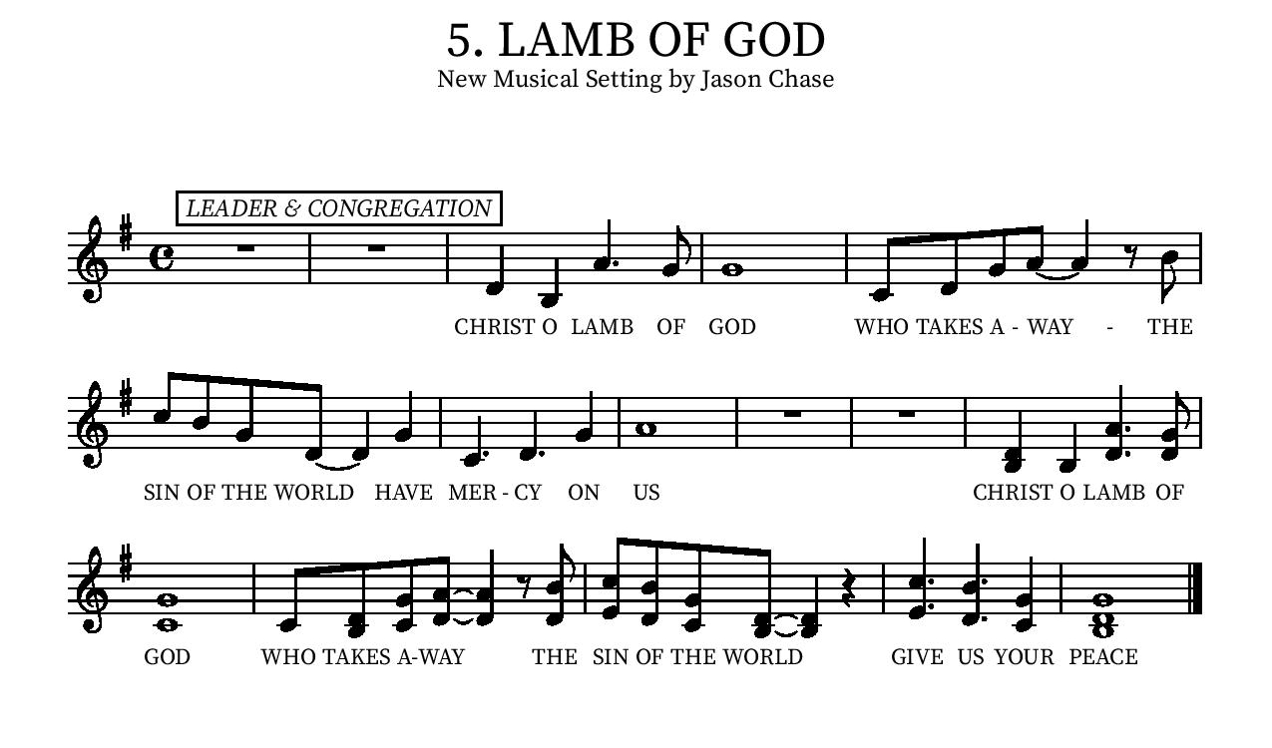
Communion Hymn - One Bread, One Body ELW #496

Refrain
One bread, one body, one Lord of all;
one cup of blessing which we bless,
and we, though many throughout the earth,
we are one body in this one Lord.

¹ Gentile or Jew, servant or free,
woman or man, no more.
[Refrain]

² Many the gifts, many the works,
one in the Lord of all.
[Refrain]

³ Grain for the fields, scattered and grown,
gathered to one for all.
[ Refrain]

Lic #A-735988
Table Blessing
May the grace of our Lord Jesus Christ and the gifts of his body and blood strengthen, keep and unite us, now and forever.
Amen.

Post-Communion Prayer
We give you thanks, generous God,
for in this bread and cup
we have tasted the new heaven and earth
where hunger and thirst are no more.
Send us from this table as witnesses to the resurrection,
that through our lives, all may know life in Jesus’ name.
Amen.

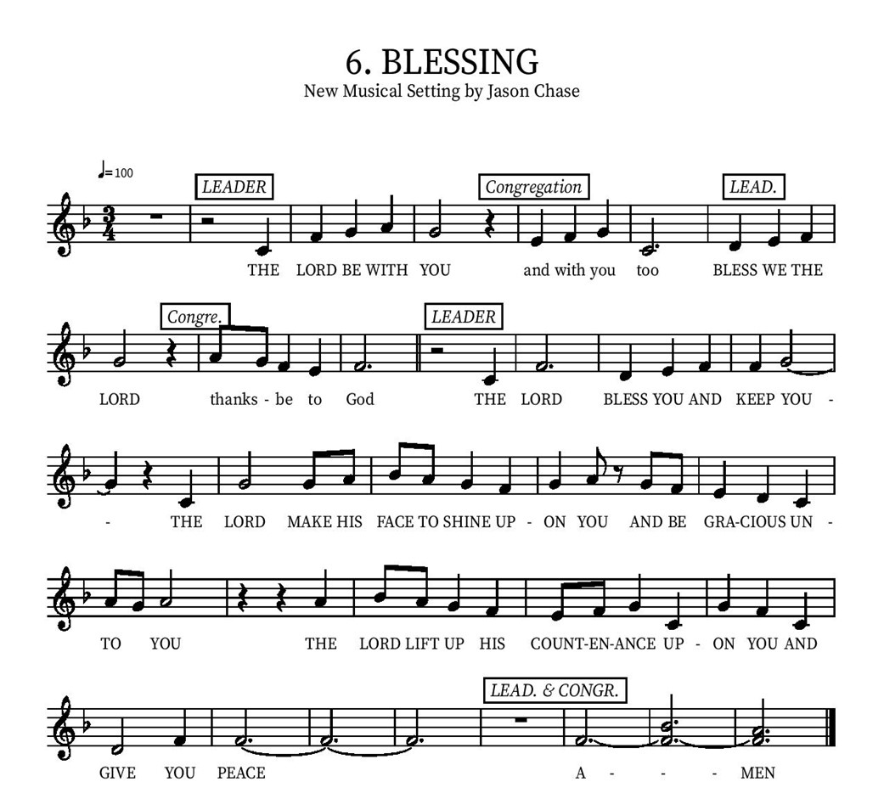

Community Time
Sending Song - I'm So Glad Jesus Lifted Me (Verses 1,3) ELW #860

¹I'm so glad Jesus lifted me.
I'm so glad Jesus lifted me.
I'm so glad Jesus lifted me,
singing glory, hallelujah! Jesus lifted me.

³When I was in trouble, Jesus lifted me.
When I was in trouble, Jesus lifted me.
When I was in trouble, Jesus lifted me,
singing glory, hallelujah! Jesus lifted me.

¹I'm so glad Jesus lifted me.
I'm so glad Jesus lifted me.
I'm so glad Jesus lifted me,
singing glory, hallelujah! Jesus lifted me.

Lic #A-735988

Sending
Alleluia! Christ is risen.
Christ is risen indeed. Alleluia!
Go in peace. Tell what God has done.
Thanks be to God.

*See last page for Upcoming Events
Upcoming Events

Today at 10:20am - Stories of our Lives (Bennie Valeu) and Spanish Ministry of St. Mark’s Luncheon in Jacobson Hall from 12:15 – 4:15pm.

Monday, May 30, Memorial Day- Church office will be closed in observance.

Tuesday, 3 pm - Bible Study on zoom every Tuesday Look for link in email or contact Pastor Karla

Wednesday afternoons, 3-6 pm, June 1 & 15 - VBS Prep Party in Jacobson Hall!

Saturday, June 4, 8:00 – 10:00am- Landscaping Work Party! VBS Planning Prep Day 10 – 2.

Sunday, June 5, 10:00 – 11:00am - One BILINGUAL Service for Pentecost. Children and youth invited to assist with worship. Help needed for “birthday party for the church” on patio 11 am. Bill & Shirley Cox Anniversary Celebration in Jacobson Hall 1:00 – 3:30pm.

Tuesday, June 7, 10:00 – 11:00am - Altar Committee Meeting (Upper Conference Room)

Thursday, June 9 – Sunday, June 12- Pastor Karla gone during this time.

Saturday, June 11, 9:00 – 11:00am - Men's Breakfast, Galley at the Marina 550 Marina Pkwy, Chula Vista, CA 91910

Saturday, June 11, 9:00 – 11:00 am - Women's Breakfast, Sheri Barker’s home, 946 Redbud Rd, Chula Vista. Please RSVP to Sheri at 619 208-2507 and bring a dish to share! Everyone is welcome!

Sunday, June 12, 10:20 - Community forum on property sale around the church in JH.

Saturday, June 18, 9:00am – 5:00pm – VBS Planning Prep Day (Sanctuary and all patio buildings).

Sunday, June 19 - Father's Day! Enjoy fellowship time and all the fathers in your life!
Legacy gives temple talk.

June 20-24 - Vacation Bible School!!!

Sunday, June 25, 10 am - ONE Bilingual service to celebrate VBS! All children and families are welcome to enjoy the music and themes of the Full Armor of God (Ephesians 6). Enjoy a light lunch sponsored by the Church Council following the service. Come welcome our neighbors and enjoy!

Monday, June 27, 6:30 – 7:30pm – Council Meeting.

July 10-15 (Sunday- Friday) - Confirmation Camp (at Luther Glen) for ALL kids in our Confirmation program.
Please contact our office if you have any questions or concerns: (619) 427-5515 or email Office.stmarkscv@gmail.com

