St. Mark’s Worship Sunday May 8, 2022
Mother’s Day!

Welcome to worship!
Stationed at the tables at the entrance our greeters have hand sanitizer and masks if you need them.
We will be serving coffee after the service, all are welcome.
St. Mark’s offers this worship service live on zoom at 9 AM or recorded on Facebook or our website at 11 AM. The zoom link is published in the St. Mark's email newsletter. Let the office know if you would like to receive it. If you are worshiping at home, you may want to prepare some bread, wine, or juice to receive Holy Communion. You may commune yourself or those around you with these words:
“The body of Christ given for you; the blood of Christ shed for you.”

Prelude
Welcome
Mission
Celebrating God’s love and forgiveness, we serve others
Opening Hymn – Faith of Our Fathers (Verse 1,2,4) ELW #813

¹ Faith of our fathers, living still
in spite of dungeon, fire, and sword.
Oh, how our hearts beat high with joy
whene'er we hear that glorious word.
Faith of our fathers, holy faith,
we will be true to you till death.

² Faith of our mothers, daring faith,
your work for Christ is love revealed,
spreading God's word from pole to pole,
making love known and freedom real.
Faith of our mothers, holy faith,
we will be true to you till death.

⁴ Faith born of God, oh, call us yet,
bind us with all who follow you,
sharing the struggle of your cross
until the world is made anew.
Faith born of God, O living faith,
we will be true to you till death.

Lic #A-735988
Mother’s Day Liturgy
All who gather here are sons or daughters.
We praise God for the women who gave us life.
For mother’s brave, strong, compassionate, full of wisdom and grace,
We give God thanks and praise.
For mothers vulnerable, worried, frustrated, and hurried,
We pray for peace.
For relationships that are strained and no longer a source of joy,
We pray for healing.
For mothers who have died, that live no longer with us, but whose light shines on in our hearts and memories,
We pray for those that mourn and give God thanks for life eternal.
For mothers who grieve, who have lost children born or unborn,
We weep with those with broken hearts.
For those who are struggling to raise children, who are tired and weary,
We pray that we may be their village, offering real help in hard times.
For those who are preparing emptier nests,
We both celebrate and mourn with you, and hope their wings are as strong as their roots are deep.
For stepmothers, navigating the pitfalls and joys of creating a new family,
We pray for wisdom and patience.
For Grandmothers who are doing the hard work of raising children again,
We pray the caregivers have those who care for them.
For those who are waiting and sometimes struggling with the biological process to bring new life, and for those who are waiting for adoptive process to be fulfilled.
We wait eagerly with you and offer you our hand to hold in the trial.
For women who do not have children, but instead teach, lead, care for, and guide the children of others,
We give God thanks and praise.
For the mothers, sisters, daughters in our midst and around the world. For the women who, created in the image of God, give not just life, but abundant life. For women fighting, struggling, and sweating for the sake of others.
For women caring, compassionate, and crying with the heart of Christ. For the caregivers, teachers, leaders, shepherds, healers. For Moms, in their wide variety and many forms,
We give God thanks and praise.
Prayer of the Day
O God of our mothers and fathers, you brought again from the dead our Lord Jesus Christ. You renew us daily and grant us the gifts of forgiveness, service, and community. Make us complete in everything that we may do your will, and work among us all that is well-pleasing in your sight, through Jesus Christ, our Savior and Lord, who lives and reigns with you and the Holy Spirit, one God, now and forever.
Amen.
Children’s message
Psalm: Psalm 23
¹The Lord is my shepherd;
I shall not be in want.
²The Lord makes me lie down in green pastures
and leads me beside still waters.
³You restore my soul, O Lord,
and guide me along right pathways for your name’s sake.
⁴Though I walk through the valley of the shadow of death, I shall fear no evil;
for you are with me; your rod and your staff, they comfort me.
⁵You prepare a table before me in the presence of my enemies;
you anoint my head with oil, and my cup is running over.
⁶Surely goodness and mercy shall follow me all the days of my life,
and I will dwell in the house of the Lord forever.
Reading: Acts 9:36-43
³⁶Now in Joppa there was a disciple whose name was Tabitha, which in Greek is Dorcas. She was devoted to good works and acts of charity. ³⁷At that time she became ill and died. When they had washed her, they laid her in a room upstairs. ³⁸Since Lydda was near Joppa, the disciples, who heard that Peter was there, sent two men to him with the request, “Please come to us without delay.” ³⁹So Peter got up and went with them; and when he arrived, they took him to the room upstairs. All the widows stood beside him, weeping and showing tunics and other clothing that Dorcas had made while she was with them. ⁴⁰Peter put all of them outside, and then he knelt down and prayed. He turned to the body and said, “Tabitha, get up.” Then she opened her eyes, and seeing Peter, she sat up. ⁴¹He gave her his hand and helped her up. Then calling the saints and widows, he showed her to be alive. ⁴²This became known throughout Joppa, and many believed in the Lord. ⁴³Meanwhile he stayed in Joppa for some time with a certain Simon, a tanner.

Gospel Acclamation
Alleluia! Lord to whom shall we go? You have the words of eternal life! Alleluia!
The Holy Gospel according to John.
Glory to you, O Lord.

Gospel: John 10:22-30
²²At that time the festival of the Dedication took place in Jerusalem. It was winter, ²³and Jesus was walking in the temple, in the portico of Solomon. ²⁴So the Jews gathered around him and said to him, “How long will you keep us in suspense? If you are the Messiah, tell us plainly.” ²⁵Jesus answered, “I have told you, and you do not believe. The works that I do in my Father’s name testify to me; ²⁶but you do not believe, because you do not belong to my sheep. ²⁷My sheep hear my voice. I know them, and they follow me. ²⁸I give them eternal life, and they will never perish. No one will snatch them out of my hand. ²⁹What my Father has given me is greater than all else, and no one can snatch it out of the Father’s hand. ³⁰The Father and I are one.”
The Gospel of our Lord.
Praise to you, O Christ
Sermon Pastor Karla Halvorson
Hymn of the Day – For All the Faithful Women Verses (1,10,2, Last) ELW #419

For all the faithful women
who served in days of old,
to you shall thanks be given;
to all, their story told.
They served with strength and gladness
in tasks your wisdom gave.
To you their lives bore witness,
proclaimed your pow'r to save.

Lord, hear our praise of Dorcas,
who served the sick and poor.
Her hands were cups of kindness,
her heart an open door.
Send us, O Christ, your Body,
where people cry in pain,
and touch them with compassion
to make them whole again.

O God, for saints and servants,
those named and those unknown,
in whom through all the ages
your light of glory shone,
we offer glad thanksgiving
and fervent prayer we raise
that, faithful in your service,
our lives may sing your praise.

All praise to God the Father!
All praise to Christ the Son!
All praise to God the Spirit,
who binds the church as one!
With saints who went before us,
with saints who witness still,
we sing glad alleluias
and strive to do your will.
Lic #A-735988
Prayers of Intercession

Leader: God, in your mercy
Congregation: Receive our prayer.
Song - I love You, Lord
I love You, Lord, and I lift my voice,
To worship You--
O my soul, rejoice!
Take joy, my King,
In what You hear;
May it be a sweet, sweet sound
In Your ear.
Blessing of prayer quilts
Song - I love You, Lord
I love You, Lord, and I lift my voice,
To worship You--
O my soul, rejoice!
Take joy, my King,
In what You hear;
May it be a sweet, sweet sound
In Your ear.
The Peace
The peace of Christ be with you always.
And also, with you.
(you may share the peace of Christ with anyone who is with you, share the peace in the comments, text an offering of peace to someone, or simply send a prayer of blessing and peace to someone.)
Offering
Thanksgiving Moment
Offering information
St. Mark’s Church, 580 Hilltop Dr. Chula Vista, CA 91910
Venmo: @stmarks-churchchulavista

Offering Song
Thank you for giving to the Lord
I am a life that was changed
Thank you for giving to the Lord
I am so glad you gave
Offering Prayer
Living God,
you gather the wolf and the lamb to feed together
in your peaceable reign,
and you welcome us all at your table.
Reach out to us through this meal,
and show us your wounded and risen body,
that we may be nourished and believe
in Jesus Christ, our Savior and Lord. Amen.
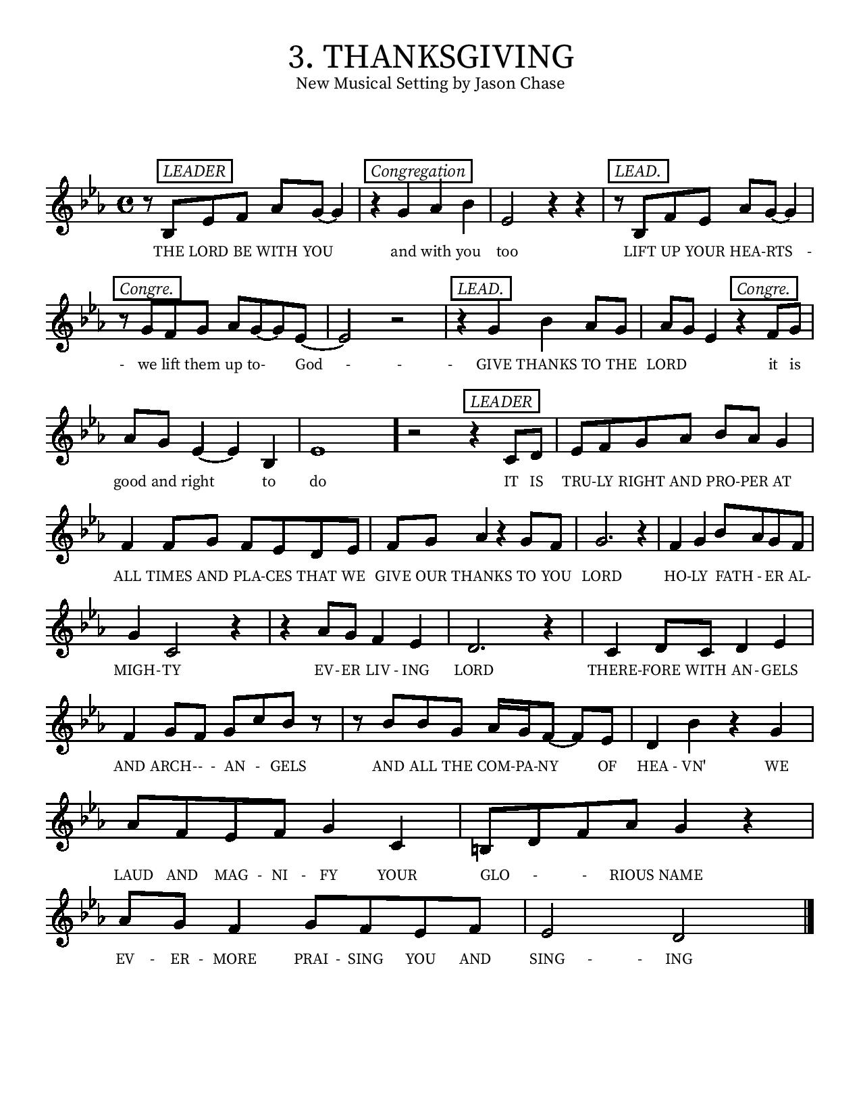
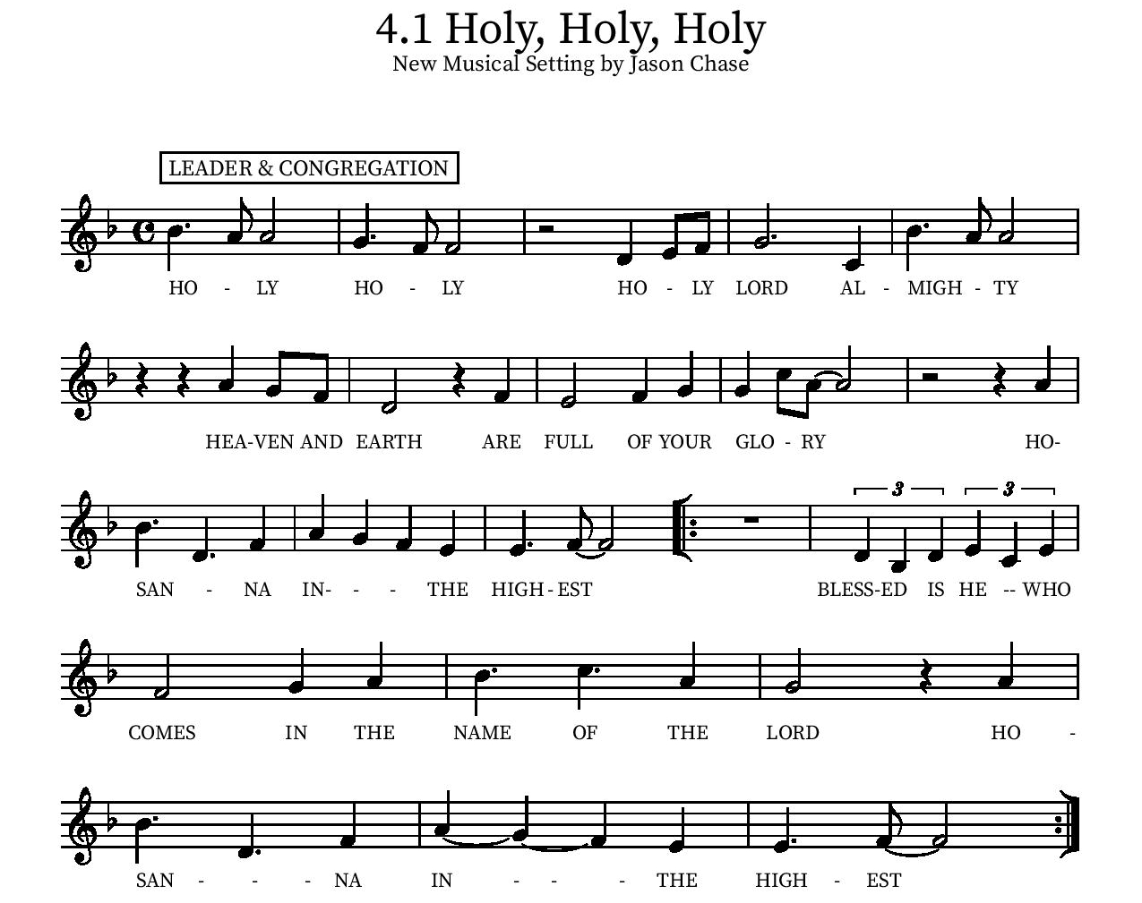

Eucharistic Prayer
P: In the night, in which he was betrayed…. Do this for the remembrance of me.
The Lord’s Prayer
Our Father in heaven, hallowed be your name, your kingdom come, your will be done, on earth as in heaven. Give us today our daily bread. Forgive us our sins as we forgive those who sin against us. Save us from the time of trial and deliver us from evil. For the kingdom, the power, and the glory are yours, now and forever.
Amen.
Invitation to the Table
We invite you to come forward at the usher’s direction. The cups contain red wine or white grape juice. Gluten free wafers are available upon request.

Communion Hymn
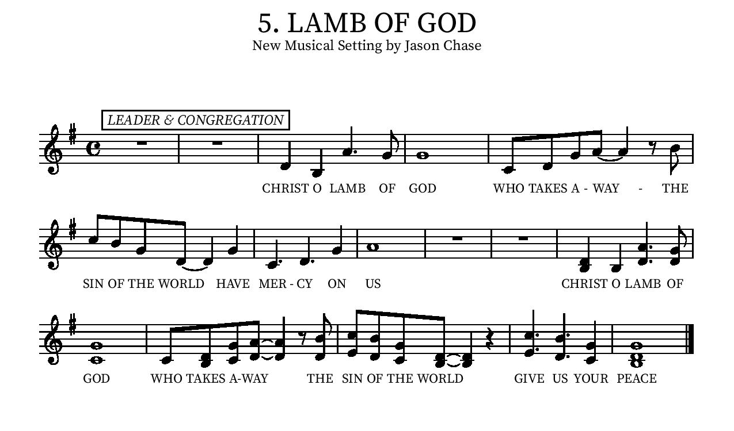
Communion Hymn - Let Us Break Bread Together ELW #471

¹Let us break bread together on our knees;
let us break bread together on our knees.

Refrain
When I fall on my knees,
with my face to the rising sun,
O Lord, have mercy on me.
²Let us drink wine together on our knees;
let us drink wine together on our knees.
[Refrain]

³Let us praise God together on our knees;
let us praise God together on our knees.
[Refrain]

Lic #A-735988

Table Blessing
May the grace of our Lord Jesus Christ and the gifts of his body and blood strengthen, keep and unite us, now and forever.
Amen.
Post-Communion Prayer
We give you thanks, generous God,
for in this bread and cup
we have tasted the new heaven and earth
where hunger and thirst are no more.
Send us from this table as witnesses to the resurrection,
that through our lives, all may know life in Jesus’ name.
Amen.
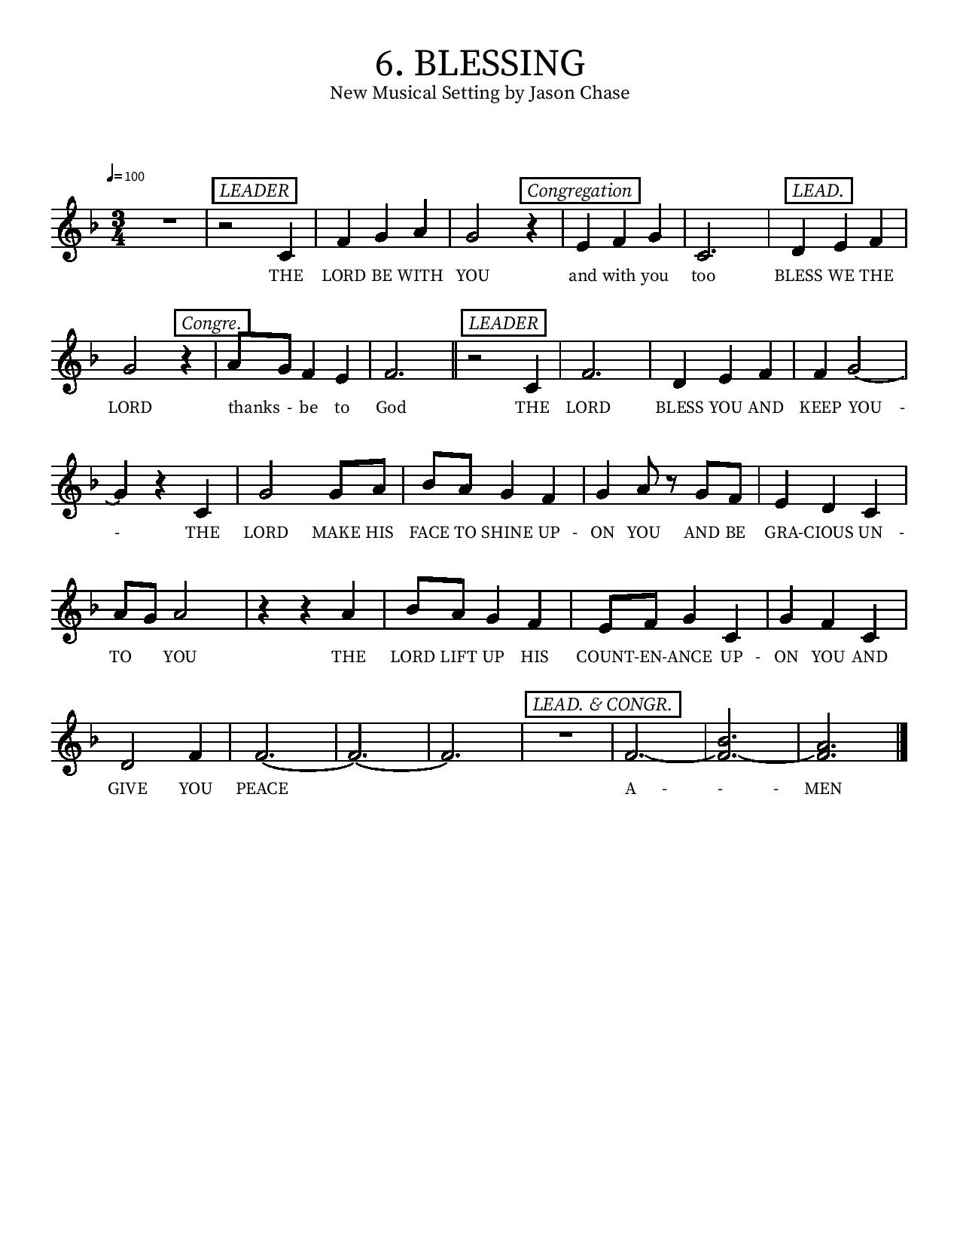

Community Time
Sending Song - I'm So Glad Jesus Lifted Me (Verses 1,3) ELW #860

¹I'm so glad Jesus lifted me.
I'm so glad Jesus lifted me.
I'm so glad Jesus lifted me,
singing glory, hallelujah! Jesus lifted me.

³When I was in trouble, Jesus lifted me.
When I was in trouble, Jesus lifted me.
When I was in trouble, Jesus lifted me,
singing glory, hallelujah! Jesus lifted me.

¹I'm so glad Jesus lifted me.
I'm so glad Jesus lifted me.
I'm so glad Jesus lifted me,
singing glory, hallelujah! Jesus lifted me.

Lic #A-735988

Sending
Alleluia! Christ is risen.
Christ is risen indeed. Alleluia!
Go in peace. Tell what God has done.
Thanks be to God.

*See last page for Upcoming Events
Upcoming Events
Tuesday, 3 pm - Bible Study will be on zoom every Tuesday Look for link in your email or contact Pastor Karla.

Saturday, May 14, 9:00 – 11:00am - Men's Breakfast at Galley at the Marina, 550 Marina Pkwy, Chula Vista, CA 91910.

Saturday, May 14, 9:00 AM – 11:00 am - Women's Breakfast will be held at the home of Jean Lewis 2766 Degen Dr, Bonita. Please come and bring a dish to share. RSVP: 619-475-4799

Sunday, May 15 at 10:20am - Gabby Bernal from LSS Upward Bound presentation with Mari Lizagarra and Danny Alkana.

Tuesday, May 17 at 10 am - Lutheran Immigration and Refugee Services representative will speak in Jacobson Hall. Please join us and invite your friends.

Wednesday, May 18 – 21 – Pacifica Synod Assembly. Pastor Karla, Dick and Caye Bolin attending.

Sunday May 22, 10 am - VBS planning/Child Safety Training in Jacobson Hall.

Sunday, May 29 at 10:20am - Memorial Day weekend and Stories of our Lives (Who? It will be announced soon!)

Saturday, June 4⋅8:00 – 10:00am- Landscaping Work Party!

Sunday, June 5⋅10:00 – 11:00am - One BILINGUAL Service for Pentecost. Legacy Committee meeting at 12:30pm.

June 9 – June 12- Pastor Karla gone during this time.

Sunday, June 12⋅10:20 – 11:20am - Community forum on property sale around the church
in Jacobson Hall.

June 20-24 - Vacation Bible School!!!

July 10-15 (Sunday- Friday) - Confirmation camp (at Luther Glen) for ALL kids in our Confirmation program.
Please contact our office if you have any questions or concerns: (619) 427-5515 or email Office.stmarkscv@gmail.com
Please take this page home

