St. Mark’s Worship Sunday April 24, 2022
Second Sunday of Easter

Welcome to worship!
Stationed at the tables at the entrance our greeters have hand sanitizer and masks if you need them.
We will be serving coffee after the service, all are welcome.
St. Mark’s offers this worship service live on zoom at 9 AM or recorded on Facebook or our website at 11 AM. The zoom link is published in the St. Mark's email newsletter. Let the office know if you would like to receive it. If you are worshiping at home, you may want to prepare some bread, wine, or juice to receive Holy Communion. You may commune yourself or those around you with these words:
“The body of Christ given for you; the blood of Christ shed for you.”

Prelude
Welcome
Mission
Celebrating God’s love and forgiveness, we serve others
Opening Hymn – The Day of Resurrection! (Verse 1,3,4) ELW #361

¹The day of resurrection!
Earth, tell it out abroad,
the Passover of gladness,
the Passover of God.
From death to life eternal,
from sin's dominion free,
our Christ has brought us over
with hymns of victory.

³Now let the heav'ns be joyful,
let earth its song begin,
the round world keep high triumph
and all that is therein.
Let all things, seen and unseen,
their notes of gladness blend;
for Christ the Lord has risen,
our joy that has no end!

⁴All praise to God the Father,
all praise to Christ the Son,
all praise to God the Spirit,
eternal Three in One!

Let all the ransomed number
fall down before the throne,
and honor, pow'r, and glory
ascribe to God alone!

Lic #A-735988

Thanksgiving for Baptism
Alleluia! Christ is risen.
Christ is risen indeed. Alleluia!
In the waters of baptism,
we have passed over from death to life with Jesus Christ,
and we are a new creation.
For this saving mystery, and for this water, let us bless God,
who was, who is, and who is to come.
Water may be poured into the font as Pastor Karla gives thanks.
We thank you, God, for your river of life,
flowing freely from your throne:
through the earth,
through the city,
through every living thing.
You rescued Noah and his family from the flood;
You opened wide the sea for the Israelites.
Now in these waters you flood us with mercy,
and our sin is drowned forever.
You open the gate of righteousness
and we pass safely through.
In Jesus Christ, you calm and trouble the waters.
You nourish us and enclose us in safety.
You call us forth and send us out.
In lush and barren places, you are with us.
You have become our salvation.
Now breathe upon this water
and awaken your church once more.
Claim us again as your beloved and holy people.
Quench our thirst; cleanse our hearts; wipe away every tear.
To you, our Beginning and our End,
our Shepherd and Lamb,
be honor, glory, praise, and thanksgiving,
now and forever.
Amen.

Prayer of the Day
O God of life, you reach out to us amid our fears with the wounded hands of your risen Son. By your Spirit’s breath revive our faith in your mercy, and strengthen us to be the body of your Son, Jesus Christ, our Savior and Lord, who lives and reigns with you and the Holy Spirit, one God, now and forever.
Amen.
Children’s message
Psalm: Psalm 118:14-29
¹⁴The Lord is my strength and my song,
and has become my salvation.
¹⁵Shouts of rejoicing and salvation echo in the tents of the righteous:
“The right hand of the Lord acts valiantly!
¹⁶The right hand of the Lord is exalted!
The right hand of the Lord acts valiantly!”
¹⁷I shall not die, but live,
and declare the works of the Lord.
¹⁸The Lord indeed punished me sorely,
but did not hand me over to death.
¹⁹Open for me the gates of righteousness;
I will enter them and give thanks to the Lord.
²⁰“This is the gate of the Lord;
here the righteous may enter.”
²¹I give thanks to you, for you have answered me
and you have become my salvation.
²²The stone that the builders rejected
has become the chief cornerstone.
²³By the Lord has this been done;
it is marvelous in our eyes.
²⁴This is the day that the Lord has made;
let us rejoice and be glad in it.
²⁵Hosanna! O Lord, save us!
We pray to you, Lord, prosper our days!
²⁶Blessed is the one who comes in the name of the Lord;
we bless you from the house of the Lord.
²⁷The Lord is God and has given us light.
Form a procession with branches up to the corners of the altar.
²⁸You are my God, and I will thank you;
you are my God, and I will exalt you.
²⁹Give thanks to the Lord, for the Lord is good;
God’s mercy endures forever.
Reading: Revelation 1:4-8
⁴John to the seven churches that are in Asia:
Grace to you and peace from him who is and who was and who is to come, and from the seven spirits who are before his throne, ⁵and from Jesus Christ, the faithful witness, the firstborn of the dead, and the ruler of the kings of the earth.
To him who loves us and freed us from our sins by his blood, ⁶and made us to be a kingdom, priests serving his God and Father, to him be glory and dominion forever and ever. Amen. ⁷Look! He is coming with the clouds; every eye will see him, even those who pierced him; and on his account all the tribes of the earth will wail. So it is to be. Amen.
⁸“I am the Alpha and the Omega,” says the Lord God, who is and who was and who is to come, the Almighty.
Gospel Acclamation
Allelulia! Lord to whom shall we go? You have the words of eternal life! Allelulia!
The Holy Gospel according to John.
Glory to you, O Lord.

Gospel: John 20:19-31
¹⁹When it was evening on that day, the first day of the week, and the doors of the house where the disciples had met were locked for fear of the Jews, Jesus came and stood among them and said, “Peace be with you.” ²⁰After he said this, he showed them his hands and his side. Then the disciples rejoiced when they saw the Lord. ²¹Jesus said to them again, “Peace be with you. As the Father has sent me, so I send you.” ²²When he had said this, he breathed on them and said to them, “Receive the Holy Spirit. ²³If you forgive the sins of any, they are forgiven them; if you retain the sins of any, they are retained.”
²⁴But Thomas (who was called the Twin), one of the twelve, was not with them when Jesus came. ²⁵So the other disciples told him, “We have seen the Lord.” But he said to them, “Unless I see the mark of the nails in his hands, and put my finger in the mark of the nails and my hand in his side, I will not believe.”
²⁶A week later his disciples were again in the house, and Thomas was with them. Although the doors were shut, Jesus came and stood among them and said, “Peace be with you.” ²⁷Then he said to Thomas, “Put your finger here and see my hands. Reach out your hand and put it in my side. Do not doubt but believe.” ²⁸Thomas answered him, “My Lord and my God!” ²⁹Jesus said to him, “Have you believed because you have seen me? Blessed are those who have not seen and yet have come to believe.”
³⁰Now Jesus did many other signs in the presence of his disciples, which are not written in this book. ³¹But these are written so that you may come to believe that Jesus is the Messiah, the Son of God, and that through believing you may have life in his name.
The Gospel of our Lord.
Praise to you, O Christ

Sermon Pastor Terry Tuvey Allen, Pacifica Synod Assistant to the Bishop.
Silence for reflection follows the sermon.
Hymn of the Day – Christ Is Risen! Alleluia! (Verses 1,3,4) ELW #382

¹Christ is risen! Alleluia!
Risen our victorious head!
Sing his praises! Alleluia!
Christ is risen from the dead!
Gratefully our hearts adore him
as his light once more appears,
bowing down in joy before him,
rising up from griefs and tears.

Refrain:
Christ is risen! Alleluia!
Risen our victorious head!
Sing his praises! Alleluia!
Christ is risen from the dead!

³Christ is risen! All the sorrow
that last evening round him lay
now hath found a glorious morrow
in the rising of today.
See the grave its first-fruits giving,
springing up from holy ground;
Christ was dead, but now is living;
he was lost, but he is found.
[Refrain]

⁴Christ is risen! Henceforth never
death or hell shall us enthrall.
We are Christ’s, in him forever
we have triumphed over all.
All the doubting and dejection
of our trembling hearts have ceased;
hail the day of resurrection!
Let us rise and keep the feast.
[Refrain]

Lic #A-735988
Prayers of Intercession

Leader: God, in your mercy
Congregation: Receive our prayer.
Song - I love You, Lord
I love You, Lord, and I lift my voice,
To worship You--
O my soul, rejoice!
Take joy, my King,
In what You hear;
May it be a sweet, sweet sound
In Your ear.
Blessing of prayer quilts
Song - I love You, Lord
I love You, Lord, and I lift my voice,
To worship You--
O my soul, rejoice!
Take joy, my King,
In what You hear;
May it be a sweet, sweet sound
In Your ear.
The Peace
The peace of Christ be with you always.
And also, with you.
(you may share the peace of Christ with anyone who is with you, share the peace in the comments, text an offering of peace to someone, or simply send a prayer of blessing and peace to someone.)
Offering
Thanksgiving Moment
Offering information
St. Mark’s Church, 580 Hilltop Dr. Chula Vista, CA 91910
Venmo: @stmarks-churchchulavista

Offering Song
Thank you for giving to the Lord
I am a life that was changed
Thank you for giving to the Lord
I am so glad you gave
Offering Prayer
Living God,
you gather the wolf and the lamb to feed together
in your peaceable reign,
and you welcome us all at your table.
Reach out to us through this meal,
and show us your wounded and risen body,
that we may be nourished and believe
in Jesus Christ, our Savior and Lord. Amen.
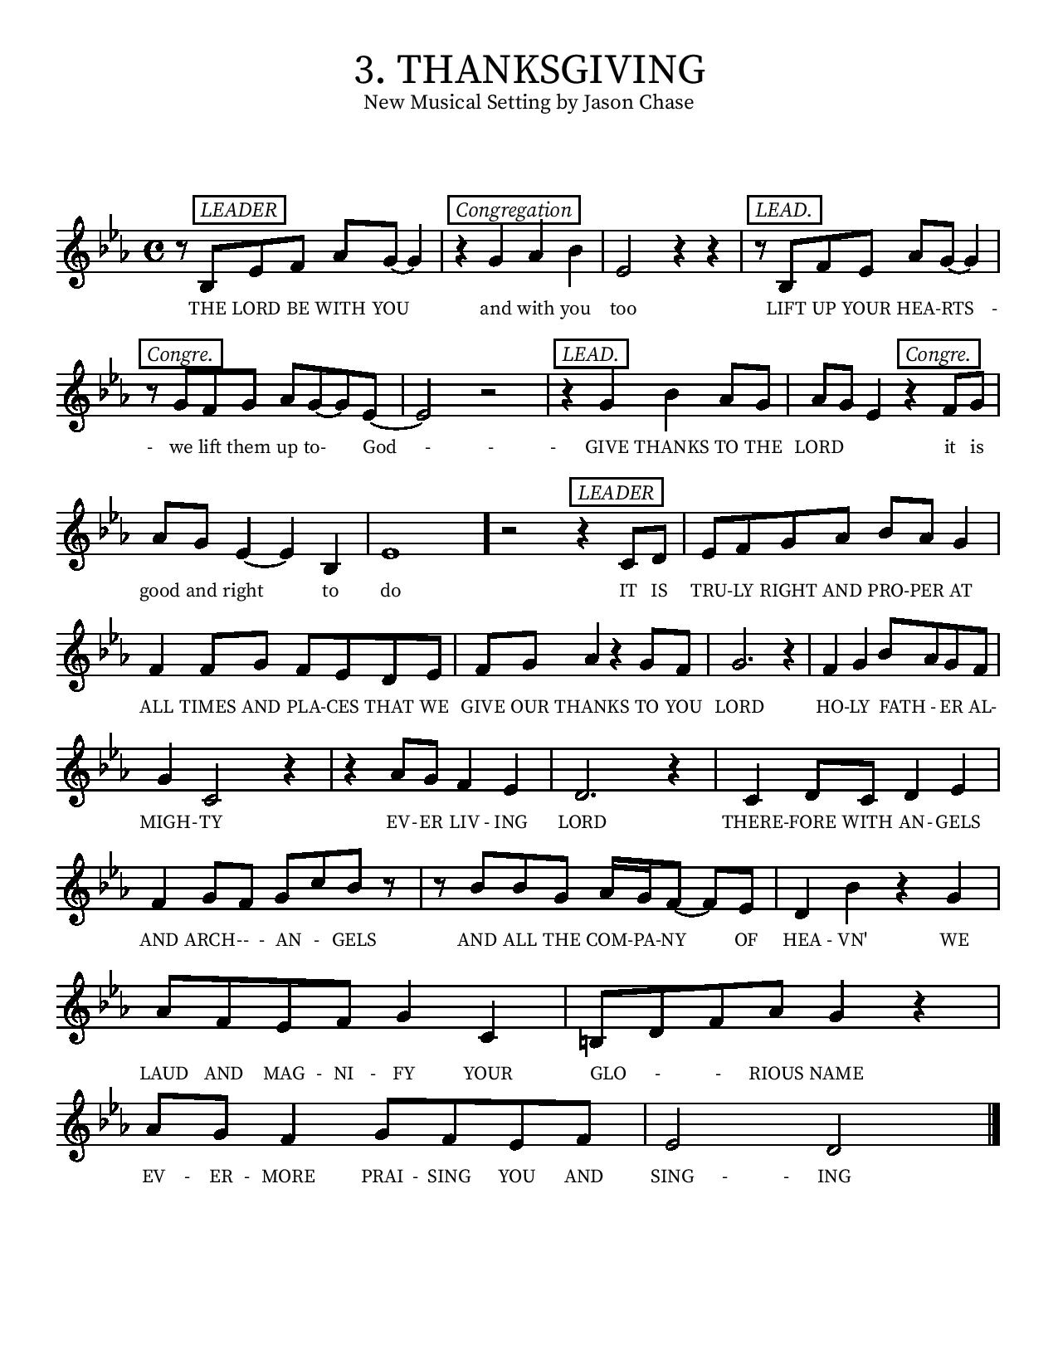
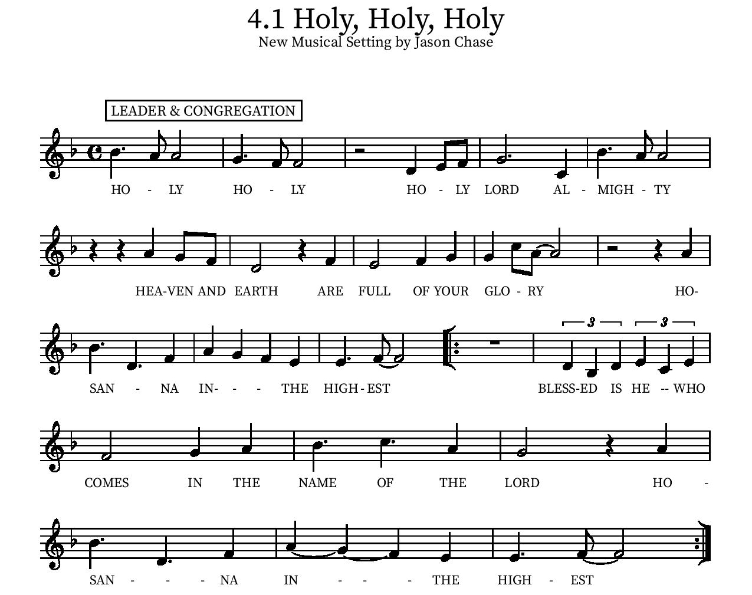

Eucharistic Prayer
P: In the night, in which he was betrayed…. Do this for the remembrance of me.
The Lord’s Prayer
Our Father in heaven, hallowed be your name, your kingdom come, your will be done, on earth as in heaven. Give us today our daily bread. Forgive us our sins as we forgive those who sin against us. Save us from the time of trial and deliver us from evil. For the kingdom, the power, and the glory are yours, now and forever.
Amen.
Invitation to the Table
We invite you to come forward at the usher’s direction. The cups contain red wine or white grape juice. Gluten free wafers are available upon request.

Communion Hymn
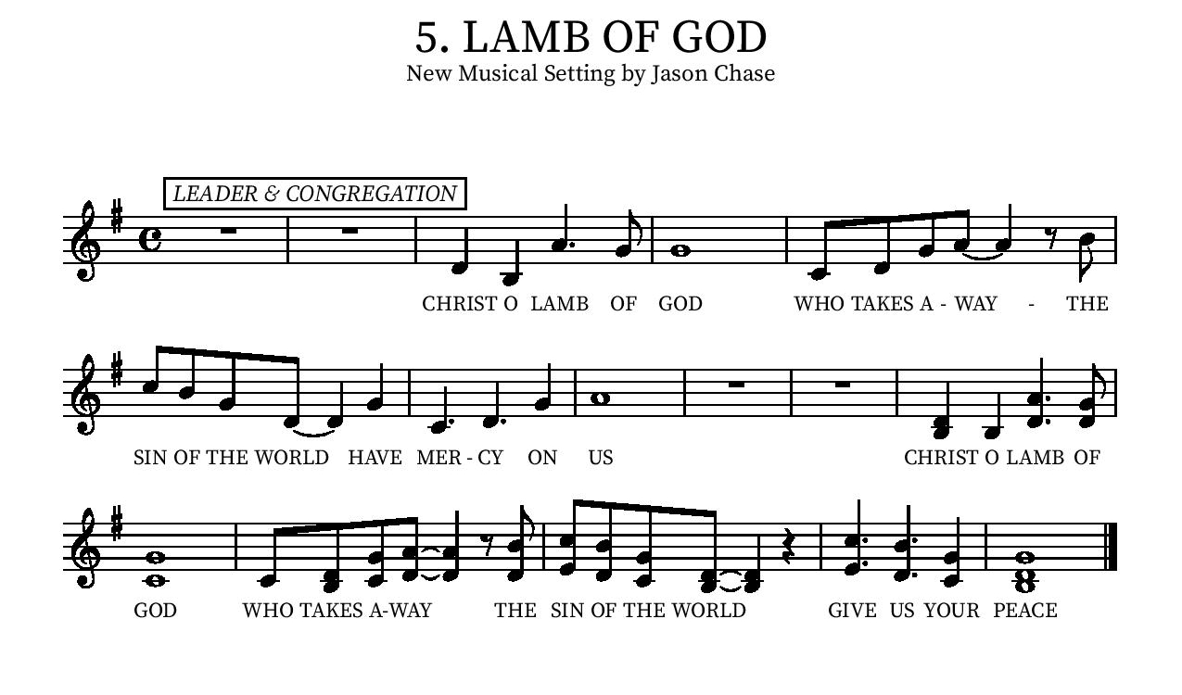
Communion Music - Logan Fountain, Piano
Table Blessing
May the grace of our Lord Jesus Christ and the gifts of his body and blood strengthen, keep and unite us, now and forever.
Amen.
Post-Communion Prayer
We give you thanks, generous God,
for in this bread and cup
we have tasted the new heaven and earth
where hunger and thirst are no more.
Send us from this table as witnesses to the resurrection,
that through our lives, all may know life in Jesus’ name.
Amen.
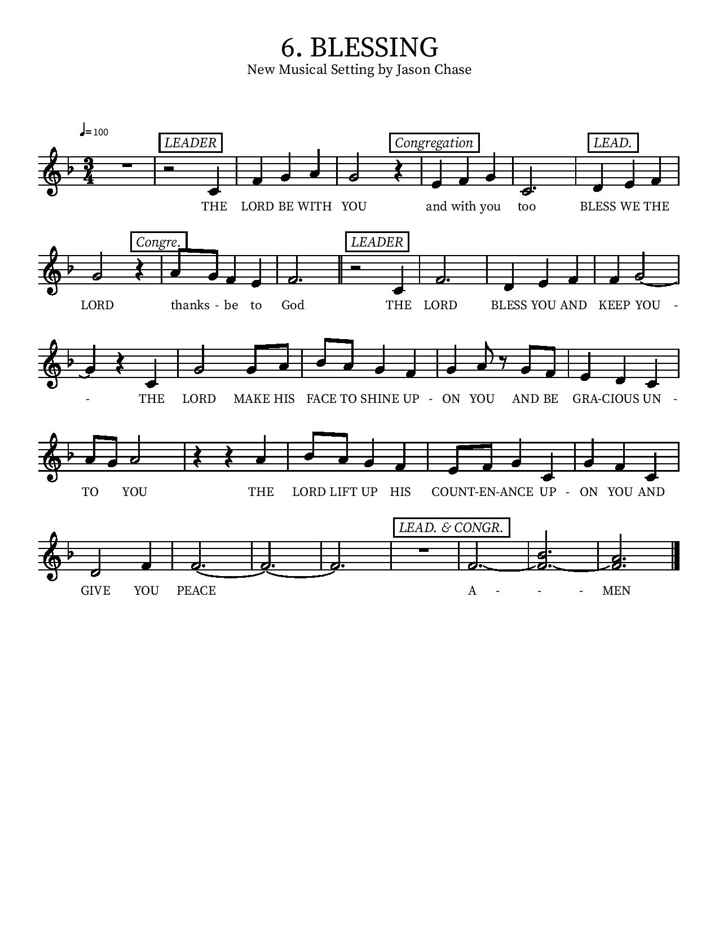

Community Time
Sending Song - On Our Way Rejoicing ELW #537

¹ On our way rejoicing
gladly let us go.
Christ our Lord has conquered;
vanquished is the foe.
Christ without, our safety;
Christ within, our joy;
who, if we be faithful,
can our hope destroy?

Refrain:
On our way rejoicing,
as we homeward move,
hearken to our praises,
O blest God of love!

² Unto God the Father
joyful songs we sing;
unto God the Savior
thankful hearts we bring;
unto God the Spirit
bow we and adore,
on our way rejoicing
now and evermore.
[Refrain]

Lic #A-735988

Sending
Alleluia! Christ is risen.
Christ is risen indeed. Alleluia!
Go in peace. Tell what God has done.
Thanks be to God.

Acolytes:
Logan Fountain, piano

*See back page for Upcoming Events
Upcoming Events

Tuesday, 3 pm - Bible Study will be on zoom every Tuesday Look for link in your email or contact Pastor Karla.

Monday, April 25, 6:00 – 8:00pm - Church Council Meeting.

Sunday, May 1 at 10:00 am - VBS planning Meeting in Jacobson Hall.

Monday, May 2, 1:00 – 2:00pm- Member Care Meeting in the Lower Level.

Tuesday, May 3, 10:00 – 11:00am - Altar Committee Meeting (Upper Conference Room).

Saturday, May 7, 8:00 – 10:00am - Landscaping Work Party!

Saturday, May 7 at 3 PM - Organ Concert and more benefitting the upcoming St. Mark’s Concert Series (begins Fall 2022) Please invite your friends to join us

Saturday, May 14, 9:00 – 11:00am - Men's Breakfast at Galley at the Marina, 550 Marina Pkwy, Chula Vista, CA 91910.

Tuesday, May 17 at 10 am - Lutheran Immigration and Refugee Services representative will speak in Jacobson Hall. Please join us and invite your friends.

Sunday, May 22, 10:00 – 11:00am - VBS Planning Meeting in Jacobson Hall.

Sunday, May 22, 10:00 – 11:00am - Child Safety Training in patio classroom.

June 20-24 - Vacation Bible School!!!

July 10-15 (Sunday- Friday) - Confirmation camp (at Luther Glen) for ALL kids in our Confirmation program

Please contact our office if you have any questions or concerns: (619) 427-5515 or email Office.stmarkscv@gmail.com

Please take this page home

