St. Mark’s Worship Sunday March 6, 2022
First Sunday in Lent

Welcome to worship inside your church!
Stationed at the tables at the entrance our greeters have hand sanitizer and masks if you need them, bulletins, and self-contained communion cups (please wait for the Pastor to direct you to open them).
We will be serving coffee after the service, all are welcome.
St. Mark’s offers this worship service live on zoom at 9 AM or recorded on Facebook or our website at 11 AM. The zoom link is published in the St. Mark's email newsletter. Let the office know if you would like to receive it. If you are worshiping at home, you may want to prepare some bread, wine, or juice to receive Holy Communion. You may commune yourself or those around you with these words:
“The body of Christ given for you; the blood of Christ shed for you.”.”

Prelude
Welcome
Mission
Celebrating God’s love and forgiveness, we serve others
Opening Song – A Mighty Fortress Is Our God (Verse 1,2,4) ELW #504

¹ A mighty fortress is our God,
a sword and shield victorious;
he breaks the cruel oppressor's rod
and wins salvation glorious.
The old satanic foe
has sworn to work us woe!
With craft and dreadful might
he arms himself to fight.
On earth he has no equal.

² No strength of ours can match his might!
We would be lost, rejected.
But now a champion comes to fight,
whom God himself elected.
You ask who this may be?
The Lord of hosts is he!
Christ Jesus, mighty Lord,
God's only Son, adored.
He holds the field victorious.

⁴ God's Word forever shall abide,
no thanks to foes, who fear it;
for God himself fights by our side
with weapons of the Spirit.
Were they to take our house,
goods, honor, child, or spouse,
though life be wrenched away,
they cannot win the day.
The kingdom's ours forever!

Lic #A-735988
Confession and Forgiveness
In the name of God,
who makes a way in the wilderness,
walks with us,
and guides us in our pilgrimage.
Amen.
Silence is kept for reflection.
Holy One,
we confess that we have wandered far from you:
we have not trusted your promises,
we have ignored your prophets in our own day,
we have squandered our inheritance of grace,
we have failed to recognize you in our midst.
Have mercy on us!
Forgive us and turn us again to you.
Teach us to follow in your ways,
assure us again of your love,
and help us to love our neighbor.
Amen
Beloved in Christ,
the Word draws near to you,
and all who call out to God shall be saved.
In Jesus, God comes to you again and again
and gathers you under wings of love.
In ☩ Jesus’ name, your sins are forgiven.
God journeys with you and teaches you how to live in love.
Amen.
Prayer of the Day
O Lord God, you led your people through the wilderness and brought them to the promised land. Guide us now, so that, following your Son, we may walk safely through the wilderness of this world toward the life you alone can give, through Jesus Christ, our Savior and Lord, who lives and reigns with you and the Holy Spirit, one God, now and forever.
Amen.
Children’s message

Reading: Deuteronomy 26:1-11
¹When you have come into the land that the Lord your God is giving you as an inheritance to possess, and you possess it, and settle in it, ²you shall take some of the first of all the fruit of the ground, which you harvest from the land that the Lord your God is giving you, and you shall put it in a basket and go to the place that the Lord your God will choose as a dwelling for his name. ³You shall go to the priest who is in office at that time, and say to him, “Today I declare to the Lord your God that I have come into the land that the Lord swore to our ancestors to give us.” ⁴When the priest takes the basket from your hand and sets it down before the altar of the Lord your God, ⁵you shall make this response before the Lord your God: “A wandering Aramean was my ancestor; he went down into Egypt and lived there as an alien, few in number, and there he became a great nation, mighty and populous. ⁶When the Egyptians treated us harshly and afflicted us, by imposing hard labor on us, ⁷we cried to the Lord, the God of our ancestors; the Lord heard our voice and saw our affliction, our toil, and our oppression. ⁸The Lord brought us out of Egypt with a mighty hand and an outstretched arm, with a terrifying display of power, and with signs and wonders; ⁹and he brought us into this place and gave us this land, a land flowing with milk and honey. ¹⁰So now I bring the first of the fruit of the ground that you, O Lord, have given me.” You shall set it down before the Lord your God and bow down before the Lord your God. ¹¹Then you, together with the Levites and the aliens who reside among you, shall celebrate with all the bounty that the Lord your God has given to you and to your house.
Psalm: Psalm 91:1-2, 9-16
¹You who dwell in the shelter of the Most High,
who abide in the shadow of the Almighty—
²you will say to the Lord, “My refuge | and my stronghold,
my God in whom I put my trust.”
⁹Because you have made the Lord your refuge,
and the Most High your habitation,
¹⁰no evil will befall you,
nor shall affliction come near your dwelling.
¹¹For God will give the angels charge over you,
to guard you in all your ways.
¹²Upon their hands they will bear you up,
lest you strike your foot against a stone.
¹³You will tread upon the lion cub and viper;
you will trample down the lion and the serpent.
¹⁴I will deliver those who cling to me;
I will uphold them, because they know my name.
¹⁵They will call me, and I will answer them;
I will be with them in trouble; I will rescue and honor them.
¹⁶With long life will I satisfy them,
and show them my salvation.

Gospel Acclamation
Return to God with all your heart, the source of grace and mercy, come seek the tender graciousness of God.

Gospel: Luke 4:1-13
¹Jesus, full of the Holy Spirit, returned from the Jordan and was led by the Spirit in the wilderness, ²where for forty days he was tempted by the devil. He ate nothing at all during those days, and when they were over, he was famished. ³The devil said to him, “If you are the Son of God, command this stone to become a loaf of bread.” ⁴Jesus answered him, “It is written, ‘One does not live by bread alone.’ ”
⁵Then the devil led him up and showed him in an instant all the kingdoms of the world. ⁶And the devil said to him, “To you I will give their glory and all this authority; for it has been given over to me, and I give it to anyone I please. ⁷If you, then, will worship me, it will all be yours.” ⁸Jesus answered him, “It is written, ‘Worship the Lord your God, and serve only him.’ ” ⁹Then the devil took him to Jerusalem, and placed him on the pinnacle of the temple, saying to him, “If you are the Son of God, throw yourself down from here, ¹⁰for it is writ ‘He will command his angels concerning you, to protect you,’ ¹¹and ‘On their hands they will bear you up, so that you will not dash your foot against a stone.’ ”
¹²Jesus answered him, “It is said, ‘Do not put the Lord your God to the test.’ ” ¹³When the devil had finished every test, he departed from him until an opportune time.
The Gospel of our Lord.
Praise to you, O Christ
Sermon Pastor Karla Halvorson
Hymn of the Day – I Want Jesus to Walk with Me ELW #325
¹ I want Jesus to walk with me;
I want Jesus to walk with me;
all along my pilgrim journey,
Lord, I want Jesus to walk with me.

²In my trials, Lord, walk with me;
in my trials, Lord, walk with me;
when my heart is almost breaking,
Lord, I want Jesus to walk with me.

³ When I'm in trouble, Lord, walk with me;
when I'm in trouble, Lord, walk with me;
when my head is bowed in sorrow,
Lord, I want Jesus to walk with me

.

Prayers of Intercession
Leader: Merciful God
Congregation: Receive our prayer.

Song - I love You, Lord
I love You, Lord, and I lift my voice,
To worship You--
O my soul, rejoice!
Take joy, my King,
In what You hear;
May it be a sweet, sweet sound
In Your ear.
Blessing of prayer quilts
Song - I love You, Lord
I love You, Lord, and I lift my voice,
To worship You--
O my soul, rejoice!
Take joy, my King,
In what You hear;
May it be a sweet, sweet sound
In Your ear.
The Peace
The peace of Christ be with you always.
And also, with you.
(you may share the peace of Christ with anyone who is with you, share the peace in the comments, text an offering of peace to someone, or simply send a prayer of blessing and peace to someone.)
Offering
Offering information
St. Mark’s Church, 580 Hilltop Dr. Chula Vista, CA 91910
Venmo: @stmarks-churchchulavista

Offering Song
Thank you for giving to the Lord
I am a life that was changed
Thank you for giving to the Lord
I am so glad you gave
Offering Prayer
Holy God,
the earth is yours and everything in it,
yet you have chosen to dwell among your creatures.
Come among us now in these gifts of bread and wine,
and strengthen us to be your body for the world
through Jesus Christ our Lord.
Amen.
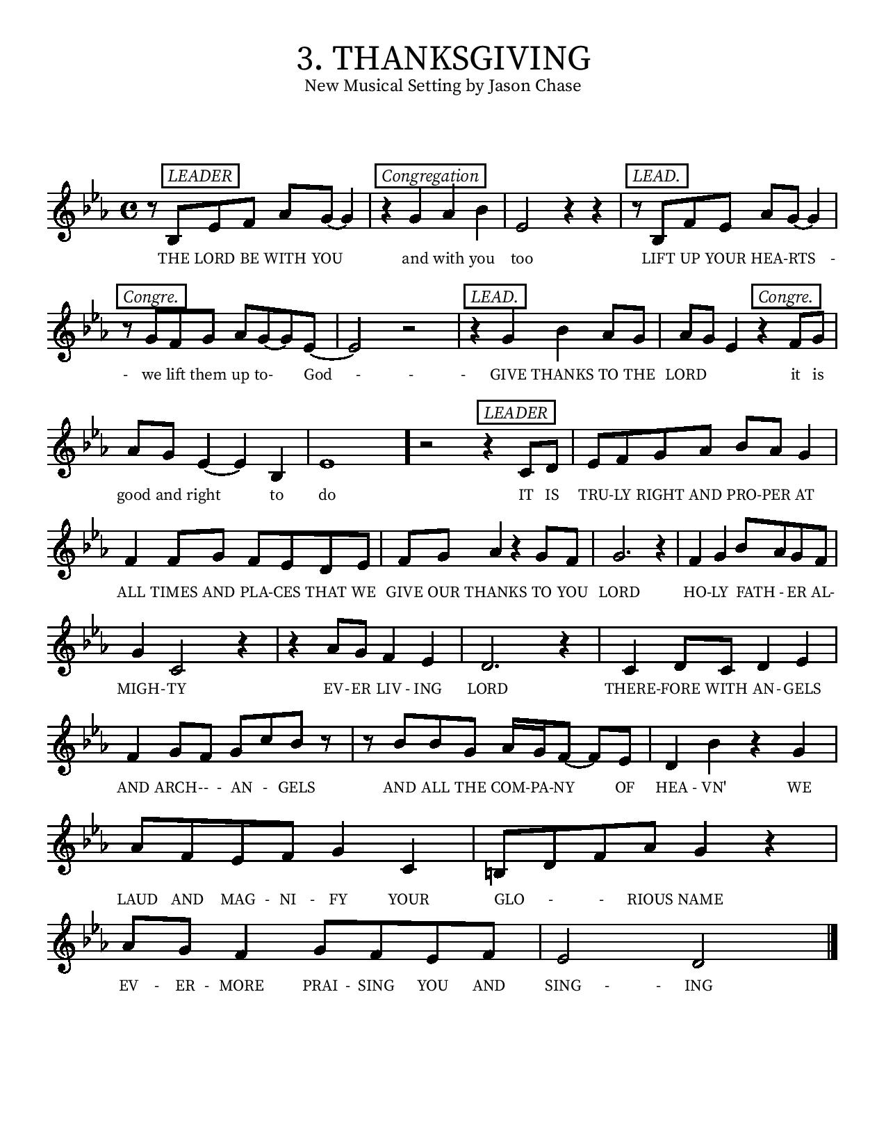
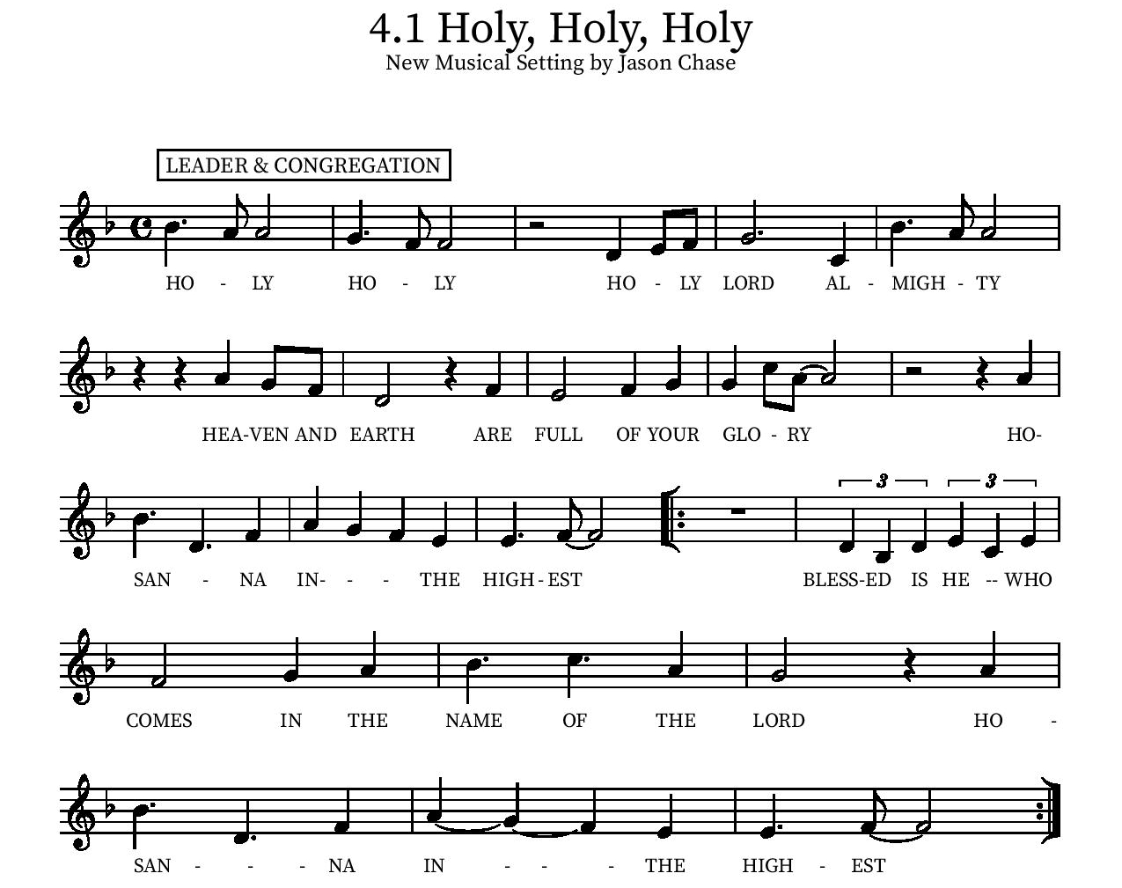

Eucharistic Prayer
P: In the night, in which he was betrayed…. Do this for the remembrance of me.
The Lord’s Prayer
Our Father in heaven, hallowed be your name, your kingdom come, your will be done, on earth as in heaven. Give us today our daily bread. Forgive us our sins as we forgive those who sin against us. Save us from the time of trial and deliver us from evil. For the kingdom, the power, and the glory are yours, now and forever.
Amen.
Invitation to the Table
You may now take the individual cups provided for communion. Please receive communion with these words: “The body of Christ given for you; the blood of Christ shed for you.”

Communion Hymn
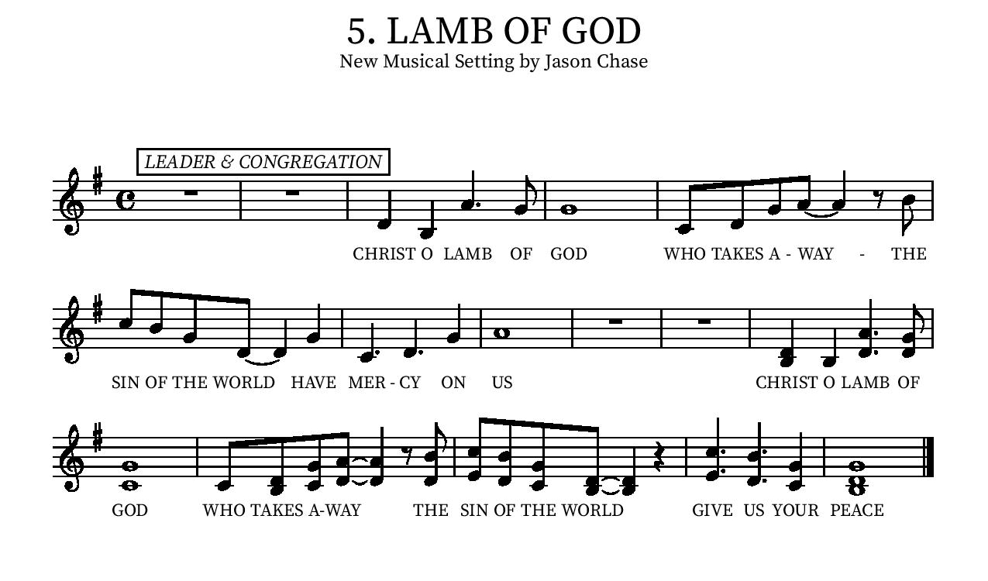
Table Blessing
May the grace of our Lord Jesus Christ and the gifts of his body and blood strengthen, keep and unite us, now and forever.
Amen.
Post-Communion Prayer
Blessed Jesus,
in this rich meal of grace,
you have fed us with your body, the bread of life.
Now send us forth to bear your life-giving hope
to a world in need.
Amen.
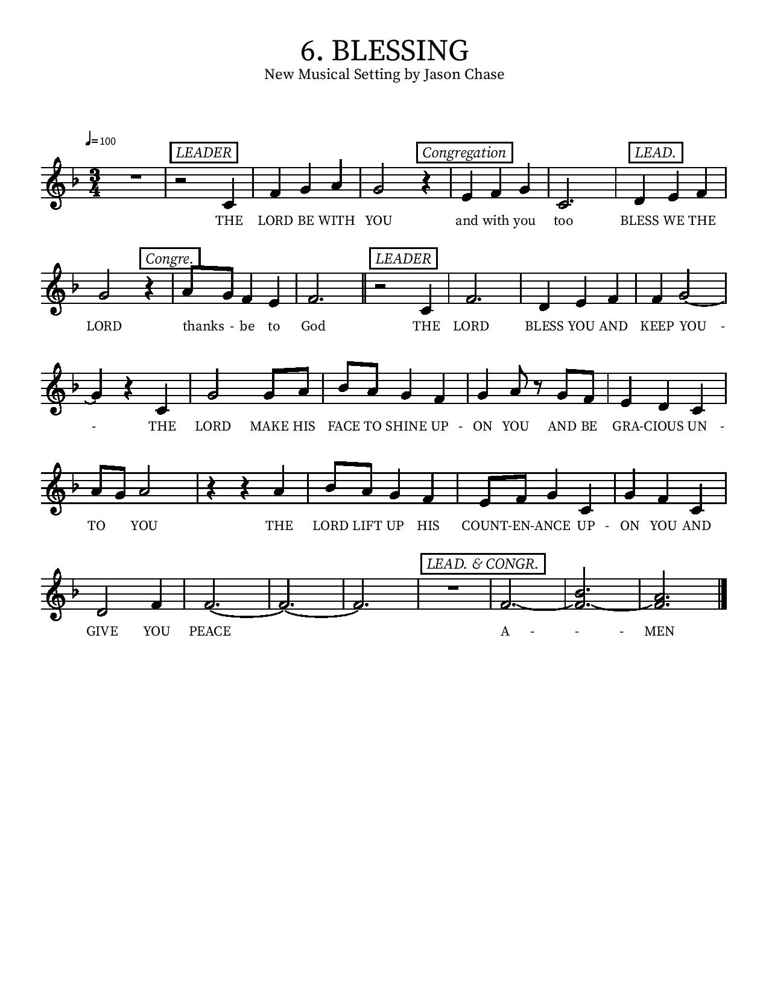

Community Time
Installation of Congregational Council
P: Dear Christian friends: Baptized into the priesthood of Christ, we all are called to offer ourselves to the Lord of the Church in Thanksgiving for what he has done and continues to do for us. It is our privilege to recognize and support those who are engaged in the work of this congregation, especially those in the ministry of Congregational Council.
The following persons, having been elected by the congregation to the positions of leadership, are asked to come forward.
P: In Holy Baptism our Lord Jesus Christ liberated you from sin and death and made you members of his Church. Through Word and Sacrament, you have been nurtured in faith.
P: St. Paul writes: There are different kinds of spiritual gifts, but the same Spirit gives them. There are different ways of serving, but the same Lord is served. There are different abilities to perform service, but the same God gives to everyone ability for particular service. The Spirit's presence is shown in some way in each person, for the good of all. (1 Cor. 12:47)
You have been elected to positions of leadership and trust in his congregation.
(To Council) P: You are to see that the words and deeds of this household of faith reflect him in whose name we gather. You are to work together with other members to see that the worship and work of Christ are done in this congregation and that God's will is done in this community and in the whole world. You are to be diligent in your specific area of serving, that the one Lord who empowers you is glorified. You are to be examples of faith active in love, to help maintain the life and harmony of this congregation.
Are you ready to accept and faithfully execute the duties of the office to which you have been elected?
If so answer “Yes, by the help of God”.
P: People of God, I ask you: Will you support these, your elected leaders, and will you share in the mutual ministry that Christ has given to all who are baptized?
If so answer Yes, by the help of God.
(To Council) P: I now declare you installed as officers/council members of this congregation.
God bless you with his Holy Spirit, that you may prove faithful servants of Christ. Amen.
Let Us Pray
P: For all who offer themselves in your name, we give thanks, 0 God. Give them the joy of service, and constant care and guidance. Help us all to be both willing servants and thankful recipients of ministry, that your name be glorified, your people live in peace, and your will be done; through Jesus Christ our Lord. Amen.
Sending Song - Lead Me, Guide Me ELW #768

Refrain
Lead me, guide me along the way
For if you lead me I cannot stray
Lord, let me walk each day with Thee.
Lead me, oh Lord, won't you lead me

I am tired and I need thy strength and power
To guide me over my darkest hour
Lord just open my eyes that I may see
Lead me, oh Lord, lead me. Refrain

I am lost if you take thy hand from me
I am blind without thy light to see
Lord just always let me thy servant be
Lead me, oh Lord, won't you lead me

Lic #A-735988

Sending
Go in peace.
Jesus meets you on the way.
Thanks be to God.

*See back page for Upcoming Events
Upcoming Events
(Subject to change per federal, state, or local guidance)

Tuesday Bible study will be on zoom every Tuesday, 3 pm. Look for link in your email or contact Pastor Karla.

TODAY, March 6, Adult Bible study Jacobson Hall, Parent/ student meeting for all Confirmation students to plan for Confirmation camp (and other upcoming events).

March 9- April 6, 5:30 Wednesday soup suppers with a community Bible study. Please plan to provide soups, breads, crackers, desserts, and water. For your convenience, there will be a sign-up sheet available each Sunday in the Narthex. All dishes and utensils will be provided. It is recommended that you bring soups ready to serve from a crock pot. If you miss the sign-up sheet, just come anyway, and bring something to share. If you have any questions at all don’t hesitate to reach out to Jean Lewis at 619-475-4799. Bell practice will follow.

March 12th, 8:00am – 10:00am - Men's Breakfast: Galley At the Marina, 550 Marina Pkwy, Chula Vista, CA 91910, USA

Saturday March 12th, from 9:00-11:00AM The women’s breakfast will be held at the home of Dorothy Geier: 3342 San Miguel Way, Bonita, CA 91902.
Please RSVP to Dorothy at 619-479-9975. Be sure to bring a dish to share.

Sunday, March 13, 10:20 am Children and Youth VBS Planning meeting in Jacobson Hall. Join us with your ideas, talents, gifts, and bring your friends! (Confirmation students will join us to help us plan)

Friday, March 18 from 6:00-7:00pm -Ecumenical Prayer vigil for peace in Ukraine, St John's Episcopal Church: 760 1st Ave, Chula Vista, CA 91910

Sunday, March 20 at 1 pm All family/ All ages event Lunch by the reflecting pool (outside the arboretum) then family fun and discovery at the International Houses (Houses of Pacific Relation). Friends are welcome!!!

Monday, March 21, 6:30 – 7:30 pm - Council meeting

Saturday, April 2, 8:00am – 10:00 am - Landscaping Work Party!

Saturday, April 9, 8:00am – 10:00am - Men's Breakfast: Galley at the Marina, 550 Marina Pkwy, Chula Vista, CA 91910, USA

Palm Sunday, April 10 will be especially unique. We will have one bilingual 10 am child friendly service with lots of interaction, songs with hand motions, and a special egg hunt for very young children following the service.
- ALSO, during that service, we will give away the cutest Bibles for 1.5-3-year olds! We have a LOT of these Bibles in both English and Spanish. We are asking you to invite your kids, grandkids, great- grandkids nieces and nephews, for this special service. You will NOT want to miss it! Begin inviting your family and friends now! Last day to reserve your child’s bible is April 3!!!

Easter Sunday, April 17 (traditional) 9 am English, 11:15 am Spanish with a pancake breakfast 10 am hosted by our youth. We thank you for your generosity as we raise enough money to send our kids to Confirmation camp!

June 20-24, Vacation Bible School!!

July 10-15 (Sunday- Friday) Confirmation camp (at Luther Glen) for ALL kids in our Confirmation program.

Please contact our office if you have any questions or concerns: (619) 427-5515
Or email Office.stmarkscv@gmail.com

