St. Mark’s Worship Christmas Youth Service
Sunday December 19, 2021
Welcome to Worship

Thank you for worshiping and celebrating with us today!
This service is bilingual and will alternate between English and Spanish.
The verses of songs will be bolded for the language in which it will be sung.
Our communion will be special for this Sunday. We will use the Santa Lucia buns for communion. If you are worshipping at home, you may want to prepare some bread, wine, or juice to receive Holy Communion. You may commune yourself or those around you with these words:
“The body of Christ given for you; the blood of Christ shed for you.”
Prelude
Welcome (English then Spanish)
- Good morning and welcome to the day the Lord has made. This is St Mark’s Lutheran Church in Chula Vista, California.
-Thank you for being a part of our youth and Children's Christmas service. Please remain seated through the service.
-Our Call to Worship will be Children’s Bells with Laci and Logan Fountain and Laurie Mansfield. Led by Lisa Mansfield.
Call to Worship
-We will begin with a reading and response.
Reading and Response
We gather today to celebrate the message and joy of Christmas
Advent is a season of hope, the promise for the future.
We can use this season to reflect on our lives, and the lives of others.
Christmas means peace and joy, glad tidings.
In troubled times we look for the ways to find truth and solace.
We can use this season to reflect on our lives, and the lives of others.
For unto us a child is born.
Jesus is born. From a humble beginning he will speak to us through parables and teaching. Jesus is the light and the way.
Bless us as we gather in your name
Bring us unity in your name.

Light the Advent Candle Song (In English)

⁴Light the Advent candle, four:
Think of joy forevermore;
Christ Child in a stable born,
gift of love that Christmas morn.

Candle, candle, burning bright,
shining in the cold winter night;
candle, candle, burning bright,
fill our hearts with Christmas light.

Prayer of the Day
-We will do the prayer of the day in English and Spanish. You may follow along in your bulletin.
Stir up our hearts oh Lord, to prepare the way for your only Son. We gather today to celebrate the message and joy of Christmas.
(Congregation) Advent is a season of hope, the promise for the future. This year we have felt many things that affect our lives. Some good and some sad. We can use this season to reflect on our lives, and the lives of others.
By his coming give us strength in our conflicts and shed light on our path through the darkness of this world: through your Son, Jesus Christ our Lord, who lives and reigns with you and the Holy Spirit, one God, now and forever.
Amen.
Peace be with you. (Spanish)
Peace be with you. (English)
Cong - And also, with you.
Please share the peace of Christ with one another
- Thank you. We will begin with our first reading
First Reading
(Narrator) A long time ago, in the land of Galilee, lived a woman named Mary.
And God sent an angel to speak to her.
(Angel) - Peace be to you Mary. You are blessed by God and have been chosen to give birth to a son and name him Jesus.
(Mary) - I will happily serve the Lord
(Narrator) - and then the angel spoke to Joseph
(Angel) - Joseph, do not be afraid. Take Mary to be your wife, she will have a baby and you will name him Jesus. He will be a gift to all people as spoken by the prophets.
(Narrator) The Roman emperor, Caesar Augustus, who ruled over the land, sent an order saying he wanted to count every single person in the country. So everyone – including Mary and Joseph – had to go back to their hometown to be counted. Because Mary was engaged to be his wife, she came with him to Bethlehem. It was a long, hard journey, especially because it was almost time for her to give birth to her baby. When they got to Bethlehem, there was no place for them to stay, but an innkeeper let them stay in a stable. There Mary gave birth to Jesus and placed him in a manger

Song – Away in a Manger (Verses 1,2) ELW #277
¹Away in a manger, no crib for his bed,
the little Lord Jesus laid down his sweet head;
the stars in the bright sky looked down where he lay,
the little Lord Jesus asleep on the hay.

²The cattle are lowing; the baby awakes,
but little Lord Jesus, no crying he makes.
I love you, Lord Jesus; look down from the sky
and stay by my cradle till morning is nigh.
Lic #A-735988

Christmas in our St. Mark’s Family
My name is Kamilla.
My family is from Mexico. In Mexico Christmas is very special. It starts on December 12 and goes to January 6th. From December 16th to Christmas Eve, children often perform the 'Posada' processions. Christmas Eve is known as 'Noche Buena' and is a family day. People often take part in the final Posada, and then in the evening have the main Christmas meal. Popular dishes for the main Christmas meal include Pozole and Tamales and a special salad.
On el Dia de los Reyes, January 6, the presents are left by the Three Kings (or Magi). If you've had a visit from Santa on Christmas Eve, you might also get some candy on el Dia de los Reyes!
There are many other celebrations too, but in America, we're still going with Santa Claus on Christmas morning, and traditional Mexican foods are still my favorites.
My name is Elsa.
My family comes from Norway and there are many interesting traditions that are celebrated in Scandinavian countries. One of them is Santa Lucia. It is celebrated by Lutherans, Roman Catholics, and Anglicans. The oldest girl in the family bakes a bread called Santa Lucia buns and wears a white gown with a red sash and has a crown made from leaves with candles in it. On Dec 13, the longest day of the year, no one works, and the family shares the bread.

My name is Erickson.
My Dad's family is from Mexico and my mom's family is from the Philippines so we basically have all the bases covered. Christmas didn't come to the Pacific Islands until Spanish explorers came and brought Christmas with them. Noche Duenna is also a huge favorite. The midnight meal shared among local families is something many people look forward to.
For my family we have tamales and Lumpia. My family came here to St. Mark’s several months ago and we are happy for that. The candlelight Christmas Eve service is one that we look forward to. One thing for sure, all the kids here love Christmas and it's important to keep the true meaning of Christmas alive. The birth of Christ - Thank you
Solo – Mary's Song
My soul glorifies the Lord my God,
My spirit rejoices in God my Savior.
He is my joy and my blessing,
He is everything to me.

He has looked with favor on the lowliness of his servant,
Surely, from now on all generations will call me blessed,
For the Mighty One has done great things for me.
And holy is his name.

^{2.}His mercy is poured out for generations
For those who fear him
He has shown strength with his arm;
He has scattered the proud in their heart’s thoughts.

My soul glorifies the Lord my God,
My spirit rejoices in God my Savior.
He is my joy and my blessing,
He is everything to me.

^{3.}He has brought down the powerful from their thrones
And he lifted up the humble and the poor.
He has filled the hungry with good things,
And sent the rich away empty.

My soul glorifies the Lord my God,
My spirit rejoices in God my Savior.
He is my joy and my blessing,
He is everything to me.
⁴Let us give glory to God because He is our Father
And his Son who died to save us
And to the Spirit that dwells among us,
Now and forever for infinite centuries.

My soul glorifies the Lord my God,
My spirit rejoices in God my Savior.
He is my joy and my blessing,
He is everything to me
Second Reading
(Narrator) - In some fields nearby, a group of shepherds were keeping watch over their flocks. It was nighttime, and they were surprised – to say the least – to see an angel of the Lord appear in front of them. You see, these shepherds were just ordinary people going about their daily lives. They weren’t considered very important. Nobody took much notice of them. So they were surprised when the angel spoke to them.
(Angel) - Do not be afraid. I bring you news of great joy. Good news for people across the world. Today in Bethlehem a Savior has been born. You will find a baby lying in a manger.
(Narrator) - So they hurried off to seek Mary and Joseph. And the baby – which they knew they would find lying in a manger. They found the stable where the young couple were – and the shepherds went in to see the baby in the manger.
Song – Angels We Have Heard on High (Verses 1,2) ELW #289
¹Angels we have heard on high,
sweetly singing o'er the plains,
and the mountains in reply,
echoing their joyous strains.

Refrain
Gloria in excelsis Deo;
Gloria in excelsis Deo.

²Shepherds, why this jubilee?
Why your joyous strains prolong?
What the gladsome tidings be
which inspire your heav'nly song? Refrain
Lic #A-735988
Communion
Liturgy Pastor Karla Halvorson/Pastor Alicia Saenz

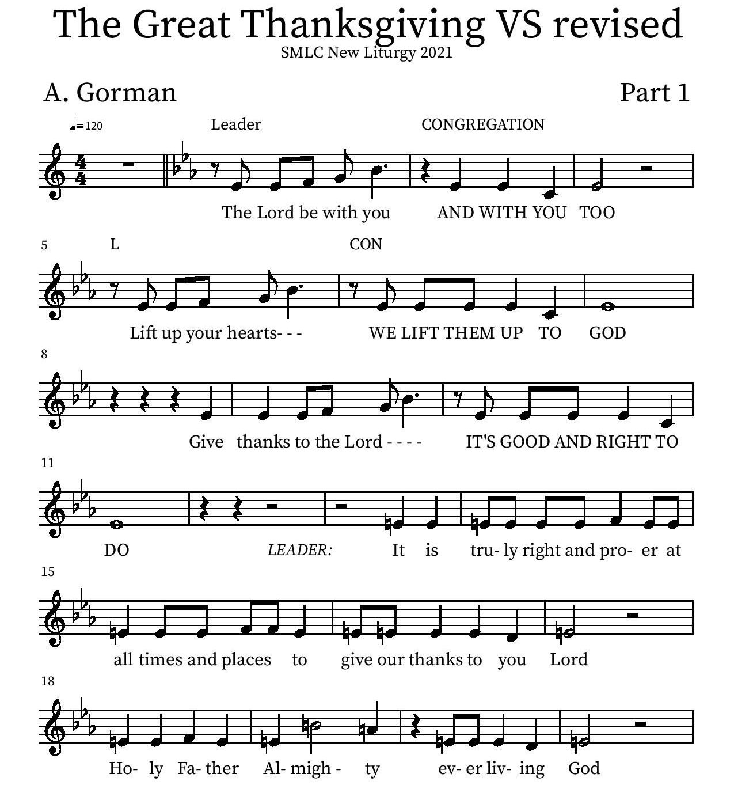

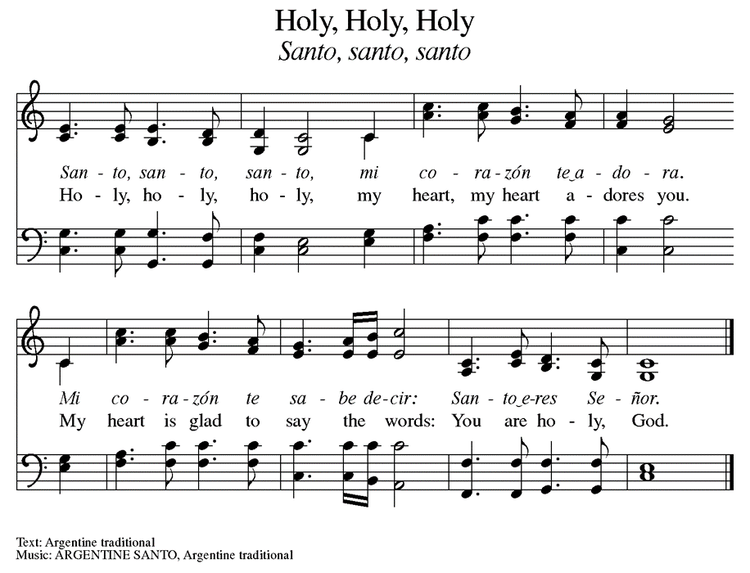

Our communion will be special for this Sunday. We will use the Santa Lucia buns for communion.
The ushers will direct you forward. Hold your hands open and we will place a piece of bread in them. Then take the wine or juice and place the empty glass in the basket. The ushers will direct you forward.
Eucharistic Prayer
P: You are indeed holy, almighty and merciful God…. Do this for the remembrance of me.
The Lord’s Prayer (Together in the language of your heart)
Our Father in heaven, hallowed be your name, your kingdom come, your will be done, on earth as in heaven. Give us today our daily bread. Forgive us our sins as we forgive those who sin against us. Save us from the time of trial and deliver us from evil. For the kingdom, the power, and the glory are yours, now and forever.
Amen.

Song During Communion – Go Tell It on the Mountain ELW #290
Refrain
Go tell it on the mountain,
over the hills and ev'rywhere;
go tell it on the mountain
that Jesus Christ is born!

¹While shepherds kept their watching
o'er silent flocks by night,
behold, throughout the heavens
there shone a holy light. Refrain

²The shepherds feared and trembled
when, lo, above the earth
rang out the angel chorus
that hailed our Savior's birth. Refrain

³Down in a lonely manger
the humble Christ was born;
and God sent us salvation
that blessed Christmas morn. Refrain

Lic #A-73598

Table Blessing
May the grace of our Lord Jesus Christ and the gifts of his body and blood strengthen, keep and unite us, now and forever.
Amen.

Third Reading
(Narrator) In those days they were very smart, educated people who studied the stars, they were called Magi. They knew from examining the heavens that an important event was taking place. A bright star rose in the sky, and they followed it to worship the person whose birth it foretold. They followed the bright star ahead of them until it stopped, and there they found the Christ child. They knelt and gave gifts
(King 1) - I bring you gold
(King 2) - I bring you myrrh
(King 3) - I bring you frankincense
Song – We Three Kings of Orient Are Verses (1,2) WOV #646
¹We three kings of Orient are;
bearing gifts we traverse afar,
field and fountain, moor and mountain,
following yonder star.

Refrain
Oh, star of wonder, star of night,
star with royal beauty bright;
westward leading, still proceeding,
guide us to thy perfect light!

²Born a king on Bethlehem’s plain,
gold I bring to crown him again;
king forever, ceasing never,
over us all to reign. Refrain
Lic #A-73598

(Narrator) The magi’s journey began the tradition of giving gifts, but the greatest gift of all is the gift of Grace. We will give our gifts now too and have our offering.
Offering - Bell Choir of St. Mark’s
Offering information
St. Mark’s Church, 580 Hilltop Dr. Chula Vista, CA 91910
Venmo: @stmarks-churchchulavista

- We hope you all enjoyed our Christmas Program. Thank you to our musicians and singers.
Thank you to Pastor Karla, Pastor Alicia, Melissa and Cindy in our office. Thank you, Debbie, for baking our communion bread.

- (In Spanish followed by English)
Thank you to those who prepared the Posada meal. Thank you to our children and their families for taking the time to practice.

- And we thank all of you for being a part of this Christmas Program.
We will sing Joy to the World, followed by our musicians playing the postlude. Please join us in Jacobson Hall for our Posada celebration.

Please stand for Joy to the World

Song – Joy to the World ELW #267
Joy to the World, the Lord is come!
Let earth receive her King;
Let every heart prepare Him room,
And Heaven and nature sing,
And Heaven and nature sing,
And Heaven, and Heaven, and nature sing.

Joy to the World, the Savior reigns!
Let men their songs employ;
While fields and floods, rocks, hills and plains
Repeat the sounding joy,
Repeat the sounding joy,
Repeat, repeat, the sounding joy.
Lic #A-73598

ALL: MERRY CHRISTMAS!!! FELIZ NAVIDAD!!!!
Postlude- (Song) Feliz Navidad

