St. Mark’s Worship Sunday December 26, 2021
Welcome to Worship

Welcome to worship inside your church!
Stationed at the tables at the entrance our greeters have hand sanitizer and masks if you need them, bulletins and self-contained communion cups (please wait for the Pastor to direct you to open them).
Following California law, all are required to wear masks regardless of vaccination status
We will be serving coffee after the service.
St. Mark’s offers worship service on Facebook live at 9 AM.
If you are worshipping at home, you may want to prepare some bread, wine, or juice to receive Holy Communion. You may commune yourself or those around you with these words:
“The body of Christ given for you; the blood of Christ shed for you.”
Prelude
Welcome
Mission
Celebrating God’s love and forgiveness, we serve others
Opening Hymn – From Heaven Above Verses 1,2,3,14 ELW #268

¹"From heav'n above to earth I come
to bear good news to ev'ry home!
Glad tidings of great joy I bring
to all the world, and gladly sing:"

²"To you this night is born a child
of Mary, chosen virgin mild;
this newborn child of lowly birth
shall be the joy of all the earth."

³"This is the Christ, God's Son most high,
who hears your sad and bitter cry,
who will himself your Savior be
and from all sin will set you free."

¹⁴"Glory to God in highest heav'n,
who unto us the Son has giv'n."
With angels sing in pious mirth
a glad new year to all the earth!

Lic #A-735988

Confession and Forgiveness
Blessed be the holy Trinity, ☩ one God,
who sends the word with angels,
who is made flesh among all peoples,
and who breathes peace on all the earth.
Amen.
In Christ, we are bold to name our sin and cry out for peace.
Silence is kept for reflection.
Holy God,
We confess our sin before you.
We replace compassion with competition.
We seek what is mighty while ignoring the meek.
We are quick to anger but slow to forgive.
We have not put on love in harmony with you.
Wrap us in the grace of your powerful Word.
Swaddle our hearts with your peace,
that all we do, in word or deed,
may reflect your love born among us.
Amen.
I bring you good news of great joy for all people:
God has come among us
in the child born of Mary, Christ the Lord.
☩ In Christ your sins are forgiven
and you are clothed in peace.
Amen.

Prayer of the Day
Shine into our hearts the light of your wisdom, O God, and open our minds to the knowledge of your word, that in all things we may think and act according to your good will and may live continually in the light of your Son, Jesus Christ, who lives and reigns with you and the Holy Spirit, one God, now and forever
Amen.
Children’s message
Psalm: Psalm 97
¹The Lord reigns; let the earth rejoice;
let the multitude of the isles be glad.
²Clouds and darkness surround the Lord,
righteousness and justice are the foundations of God’s throne.
³Fire goes before the Lord,
burning up enemies on every side.
⁴Lightnings light up the world;
the earth sees and trembles.
⁵The mountains melt like wax
before the Lord of all the earth.
⁶The heavens declare your righteousness, O Lord,
and all the peoples see your glory.
⁷Confounded be all who worship carved images and delight in false gods!
Bow down before the Lord, all you gods.
⁸Zion hears and is glad, and the cities of Judah rejoice,
because of your judgments, O Lord.
⁹For you are the Lord, most high over all the earth;
you are exalted far above all gods.
¹⁰You who love the Lord, hate evil!
God guards the lives of the saints and rescues them from the hand of the wicked.
¹¹Light dawns for the righteous,
and joy for the honest of heart.
¹²Rejoice in the Lord, you righteous,
and give thanks to God’s holy name.
Reading: Hebrews 1:1-4
¹Long ago God spoke to our ancestors in many and various ways by the prophets, ² but in these last days he has spoken to us by a Son, whom he appointed heir of all things, through whom he also created the worlds. ³ He is the reflection of God’s glory and the exact imprint of God’s very being, and he sustains all things by his powerful word. When he had made purification for sins, he sat down at the right hand of the Majesty on high, ⁴ having become as much superior to angels as the name he has inherited is more excellent than theirs.
Gospel Acclamation
Alleluia. Lord, to whom shall we go? You have the words of eternal life.
Alleluia.
The Holy Gospel according to John.
Glory to you, O Lord.

Gospel: John 1:1-14
¹In the beginning was the Word, and the Word was with God, and the Word was God. ² He was in the beginning with God. ³ All things came into being through him, and without him not one thing came into being. What has come into being ⁴ in him was life,^{[a]} and the life was the light of all people. ⁵ The light shines in the darkness, and the darkness did not overcome it.⁶ There was a man sent from God, whose name was John. ⁷ He came as a witness to testify to the light, so that all might believe through him. ⁸ He himself was not the light, but he came to testify to the light. ⁹ The true light, which enlightens everyone, was coming into the world. ¹⁰ He was in the world, and the world came into being through him; yet the world did not know him. ¹¹ He came to what was his own,^{[c]} and his own people did not accept him. ¹² But to all who received him, who believed in his name, he gave power to become children of God, ¹³ who were born, not of blood or of the will of the flesh or of the will of man, but of God.¹⁴ And the Word became flesh and lived among us, and we have seen his glory, the glory as of a father’s only son, full of grace and truth.
The Gospel of our Lord.
Praise to you, O Christ
Sermon – The Music of Christmas Pastor Karla Halvorson
Hymn – Lo, How a Rose E'er Blooming Verses 1,2,4 ELW #272

¹Lo, how a rose e'er blooming
from tender stem hath sprung!
Of Jesse's lineage coming
as seers of old have sung,
it came, a flow'r so bright,
amid the cold of winter,
when half-spent was the night.

²Isaiah had foretold it,
the rose I have in mind;
with Mary we behold it,
the virgin mother kind.
To show God's love aright,
she bore to us a Savior,
when half-spent was the night.

⁴O Savior, child of Mary,
who felt our human woe;
O Savior, king of glory,
who dost our weakness know:
bring us at length, we pray,
to the bright courts of heaven
and into endless day.

Lic #A-73598

Hymn – 'Twas in the Moon of Wintertime ELW #284

¹'Twas in the moon of wintertime
when all the birds had fled,
that *God the Lord of all the earth
sent angel choirs instead;
before their light the stars grew dim,
and wond'ring hunters heard the hymn:
Refrain
Jesus your king is born! Jesus is born,
in excelsis gloria!
²Within a lodge of broken bark
the tender babe was found;
a ragged robe of rabbit skin
enwrapped his beauty round;
but as the hunter braves drew nigh,
the angel song rang loud and high:
Refrain

³The earliest moon of wintertime
is not so round and fair
as was the ring of glory on
the helpless infant there.
The chiefs from far before him knelt
with gifts of fox and beaver pelt.
Refrain

⁴O children of the forest free,
the angel-song is true;
the holy child of earth and heav'n
is born today for you.
Come, kneel before the radiant boy,
who brings you beauty, peace, and joy. Refrain

Lic #A-73598

Hymn – What Child Is This ELW #296

¹What child is this, who, laid to rest,
on Mary's lap is sleeping?
Whom angels greet with anthems sweet
while shepherds watch are keeping?
This, this is Christ the king,
whom shepherds guard and angels sing;
haste, haste to bring him laud,
the babe, the son of Mary!

²Why lies he in such mean estate
where ox and ass are feeding?
Good Christian, fear; for sinners here
the silent Word is pleading.
Nails, spear shall pierce him through,
the cross be borne for me, for you;
hail, hail the Word made flesh,
the babe, the son of Mary!

³So bring him incense, gold, and myrrh;
come, peasant, king, to own him.
The King of kings salvation brings;
let loving hearts enthrone him.
Raise, raise the song on high,
the virgin sings her lullaby;
joy, joy, for Christ is born,
the babe, the son of Mary!

Lic #A-73598

Hymn – In the Bleak Midwinter ELW #294

¹In the bleak midwinter,
frosty wind made moan,
earth stood hard as iron,
water like a stone;
snow had fallen, snow on snow,
snow on snow,
in the bleak midwinter,
long ago.

²Heaven cannot hold him,
nor earth sustain;
heav'n and earth shall flee away
when he comes to reign;
in the bleak midwinter
a stable place sufficed
the Lord God almighty,
Jesus Christ.

³What can I give him,
poor as I am?
If I were a shepherd
I would bring a lamb;
if I were a wise man
I would do my part;
yet what I can I give him—
give my heart.

Lic #A-73598

Hymn – Of the Father's Love Begotten Verses 1,3,4 ELW #295

¹Of the Father's love begotten
ere the worlds began to be,
he is Alpha and Omega,
he the source, the ending he,
of the things that are, that have been,
and that future years shall see,
evermore and evermore.

³This is he whom seers in old time
chanted of with one accord,
whom the voices of the prophets
promised in their faithful word;
now he shines, the long-expected;
let creation praise its Lord
evermore and evermore.

⁴Let the heights of heav'n adore him;
angel hosts, his praises sing;
pow'rs, dominions, bow before him
and extol our God and King;
let no tongue on earth be silent,
ev'ry voice in concert ring
evermore and evermore

.

Lic #A-73598

Prayers of Intercession
Leader: Merciful God,
Congregation: Receive our prayer.
Song
God Is so good,
God is so good,
God is so good,
He’s so good to me!
Blessing of prayer quilts
Song
God Is so good,
God is so good,
God is so good,
He’s so good to me!

Receiving of new members
In baptism, we are welcomed into the body of Christ and sent to share in the mission of God. We are called to live among God’s faithful people, to hear the word of God and share in the Lord’s supper, to proclaim the good news of God in Christ through word and deed, to serve all people, following the example of Jesus, and to strive for justice and peace in all the earth.
Sister in Christ,
Do you intend to continue in the covenant of your baptism
among God’s people in this place?
New Member: I do, and I ask God to help and guide me.

People of God,
Do you promise to support and pray for this new member in her life in Christ?
C: We do, and we ask God to help and guide us.

Let us welcome this sister in Christ to this community of faith.
C: We rejoice with you in the life of baptism.
Together we will give thanks and praise to God
and proclaim the good news to all the world.

Prayer for new member.
We give you thanks for our new member, Krystina,
whom you have drawn to yourself by the love of Jesus Christ
and whom we have welcomed into this household of faith.
Keep us close together in your Spirit,
in the breaking of bread and the prayers,
and in service to others.
Amen
The Peace
The peace of Christ be with you always.
And also, with you.
(you may share the peace of Christ with anyone who is with you, share the peace in the comments, text an offering of peace to someone, or simply send a prayer of blessing and peace to someone.)
Offering
Offering information
St. Mark’s Church, 580 Hilltop Dr. Chula Vista, CA 91910
Venmo: @stmarks-churchchulavista

Offering Song
Thank you for giving to the Lord
I am a life that was changed
Thank you for giving to the Lord
I am so glad you gave
Offering Prayer
Gracious God,
your Word-made-flesh brings harmony to the earth.
As we offer ourselves and these your gifts,
prepare us to receive the grace and truth
you offer at this table
and renew in us the song of your salvation,
in Jesus Christ our Savior.
Amen.

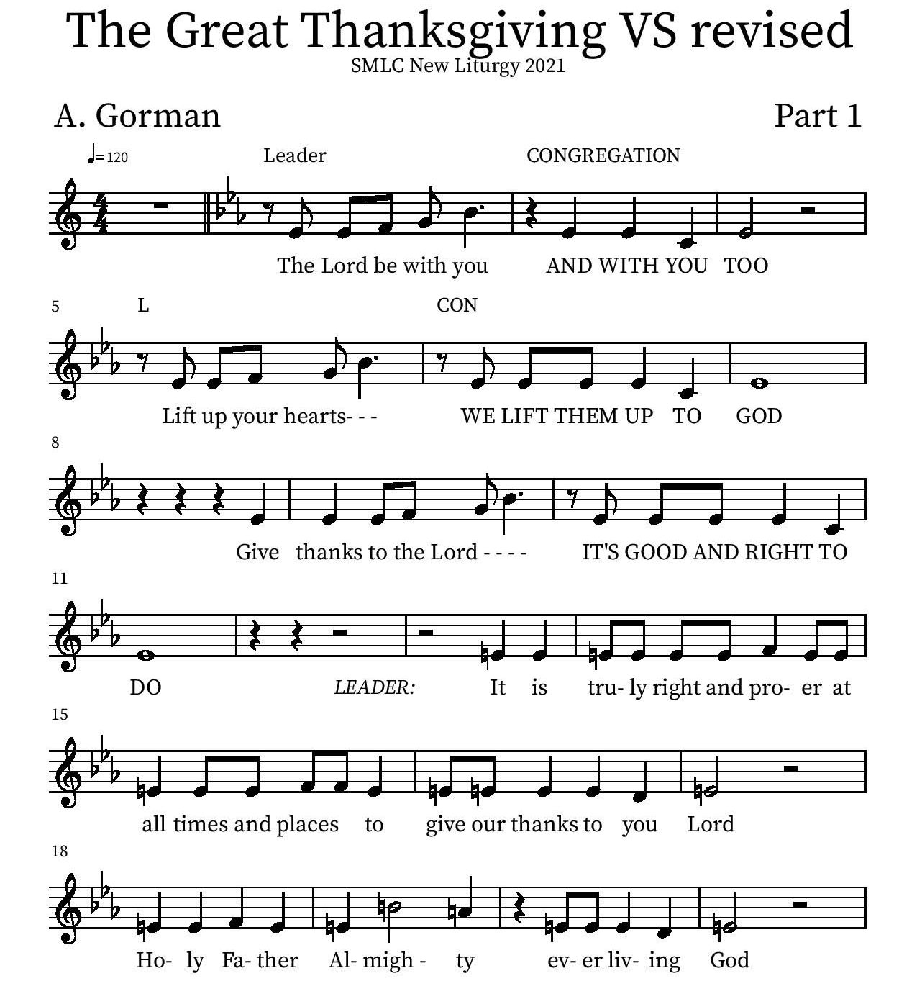

Eucharistic Prayer
P: In the night that he was betrayed…. Do this for the remembrance of me.
The Lord’s Prayer
Our Father in heaven, hallowed be your name, your kingdom come, your will be done, on earth as in heaven. Give us today our daily bread. Forgive us our sins as we forgive those who sin against us. Save us from the time of trial and deliver us from evil. For the kingdom, the power, and the glory are yours, now and forever.
Amen.
Invitation to the Table
You may now take the individual cups provided for communion. Please receive communion with these words: “The body of Christ given for you; the blood of Christ shed for you.”

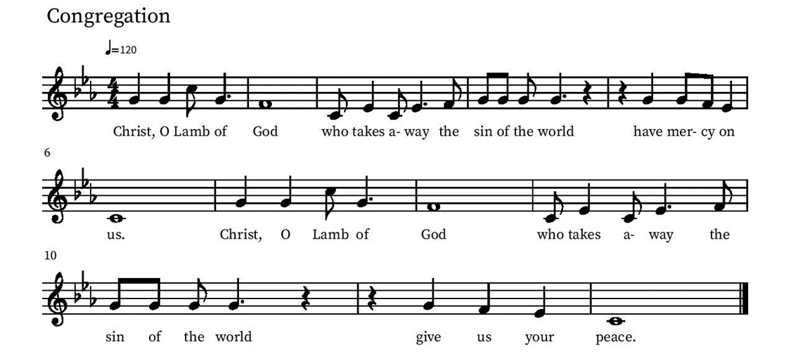
Communion Hymn – Lamb of God

Table Blessing
May the grace of our Lord Jesus Christ and the gifts of his body and blood strengthen, keep and unite us, now and forever.
Amen.
Post-Communion Prayer
We thank you, wondrous God, for Jesus,
God with us, in these gifts of bread and wine.
As we have shared this feast of love,
strengthen us to share your love with all the world.
In Jesus’ name we pray.
Amen.
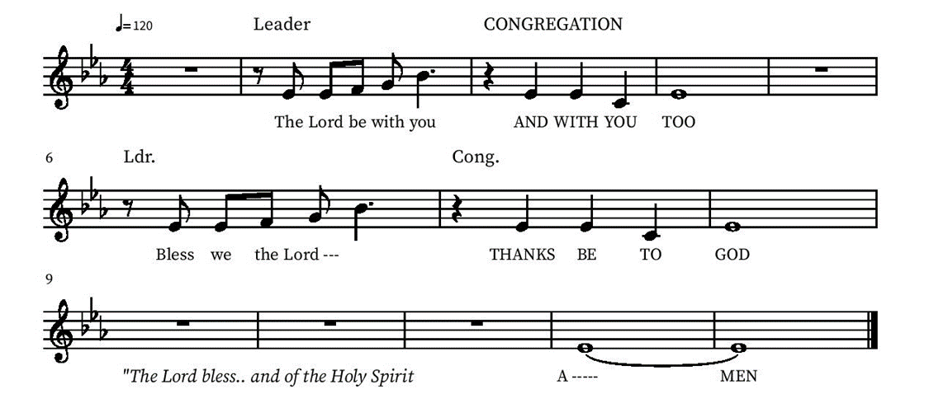
Blessing

Community Time
Sending Song - Joy to the World ELW 267

Joy to the world, the Lord is come!
Let earth receive her King;
let ev’ry heart prepare him
and heav’n and nature sing,
and heav’n and nature sing,
and heav’n, and heav’n and nature sing.

He rules the world with truth and grace
and makes the nations prove
the glories of his righteousness
and wonders of his love,
and wonders of his love,
and wonders, wonders of his love.

Lic #A-735988

Sending
Go in peace. The living Word dwells in you.
Thanks be to God.
Join us for refreshments after the service!

Upcoming Events

- Saturday, January 1 No Church Clean-Up Work Party
- Sunday, Monday, January 3 End of Year Ministry Reports due to the Office
- Tuesday, January 4, 3 pm Bible Study resumes!
- Sunday January 9 Chula Vista City Councilmember Jill Galvez, District 2 Northwest, will be speaking with us about the FREE door-to-door electric shuttle transportation for all seniors 55+ in most of Northwest Chula Vista.
- Monday, January 10, 1 PM Member Care Team meeting in the Lower Level. All are welcome!
- Saturday, January 15, 9 AM Men’s breakfast at the Galley at the J. Street Marina
- Saturday, January 15, 2022, 9:00-11:00 AM Women's Breakfast at the home of Caye Smith Bolin.
- January 16, 10 am All Congregation Event in Jacobson Hall (for all ages)
- Sunday, January 16, 1 pm All Family Event at Balboa Park
- Sunday, January 16, Annual Report available for pick up at church or in the office this week
- Monday, January 17, 6 PM Final Council Meeting of the St. Mark’s year
- Sunday, January 23, 10:15 Budget Q & A
- Sunday, January 30, 10 am ONE service, bilingual, with Bibles for 2-3 year olds (speak with Melissa, Pastor Karla or Pastor Alicia)
- Sunday, January 30, 11:00 AM Annual Meeting & Catered Brunch in Jacobson Hall

Please contact the office with any questions or additions. Office.stmarkscv@gmail.com

