St. Mark’s Worship Sunday November 28, 2021
Welcome to Worship

Welcome to worship inside your church!
Stationed at the tables at the entrance our greeters have hand sanitizer and masks if you need them, bulletins and self-contained communion cups (please wait for the Pastor to direct you to open them).
The restrooms will be open, but we request that one family group at a time uses the facilities.
We will be serving coffee after the service. We're staying masked to protect children and anyone who feels vulnerable, vaccinated or not. All are welcome, unless you aren't feeling well, then please recover at home and watch the worship service on Facebook live at 9 AM.
If you are worshipping at home, you may want to prepare some bread, wine, or juice to receive Holy Communion. You may commune yourself or those around you with these words:
“The body of Christ given for you; the blood of Christ shed for you.”

Welcome
Prelude - Lighting of The Advent Wreath
Light the Advent Candle

Light the Advent candle, one:
Now the waiting has begun;
we have started on our way,
time to think of Christmas day.

Refrain
Candle, candle, burning bright,
shining in the cold winter night;
candle, candle, burning bright,
fill our hearts with Christmas light.

Mission
Celebrating God’s love and forgiveness, we serve others
Opening Song – People, Look East All Verses ELW #248

¹People, look east. The time is near
of the crowning of the year.
Make your house fair as you are able,
trim the hearth and set the table.
People, look east, and sing today—
Love, the Guest, is on the way.

²Furrows, be glad. Though earth is bare,
one more seed is planted there.
Give up your strength the seed to nourish,
that in course the flow'r may flourish.
People, look east, and sing today—
Love, the Rose, is on the way.

³Stars, keep the watch. When night is dim,
one more light the bowl shall brim,
shining beyond the frosty weather,
bright as sun and moon together.
People, look east, and sing today—
Love, the Star, is on the way.

⁴Angels announce with shouts of mirth
him who brings new life to earth.
Set ev'ry peak and valley humming
with the word, the Lord is coming.
People, look east, and sing today—
Love, the Lord, is on the way.

Lic #A-735988

Advent Litany
Lord Jesus, you are the light of the world.
Come, Lord Jesus.
You are light in our darkness.
Come, Lord Jesus.
Son of God, save us from our sins.
Come, Lord Jesus.
Son of Mary, deepen our love.
Come, Lord Jesus.
Bring hope into the lives of all people.
Come, Lord Jesus.
Give your peace to all nations.
Come, Lord Jesus.
Be the joy of all who love you.
Come, Lord Jesus
Bring unity among all who believe in you.
Come, Lord Jesus.
Bless us as we gather here in your name.
Come, Lord Jesus.
Lord Jesus, stay with us always.
Come, Lord Jesus.

Prayer of the Day
Stir up your power, Lord Christ, and come. By your merciful protection alert us to the threatening dangers of our sins, and redeem us for your life of justice, for you live and reign with the Father and the Holy Spirit, one God, now and forever.
Amen.
Children’s message
Reading: Jeremiah 33:14-16
¹⁴The days are surely coming, says the Lord, when I will fulfill the promise I made to the house of Israel and the house of Judah. ¹⁵In those days and at that time I will cause a righteous Branch to spring up for David; and he shall execute justice and righteousness in the land. ¹⁶In those days Judah will be saved and Jerusalem will live in safety. And this is the name by which it will be called: “The Lord is our righteousness.

Psalm: Psalm 25:1-10
¹To you, O Lord,
I lift up my soul.
²My God, I put my trust in you; let me not be put to shame,
nor let my enemies triumph over me.
³Let none who look to you be put to shame;
rather let those be put to shame who are treacherous.
⁴Show me your ways, O Lord,
and teach me your paths.
⁵Lead me in your truth and teach me,
for you are the God of my salvation; in you have I trusted all the day long.
⁶Remember, O Lord, your compassion and love,
for they are from everlasting.
⁷Remember not the sins of my youth and my transgressions;
remember me according to your steadfast love and for the sake of your goodness, O Lord.
⁸You are gracious and upright, O Lord;
therefore you teach sinners in your way.
⁹You lead the lowly in justice
and teach the lowly your way.
¹⁰All your paths, O Lord, are steadfast love and faithfulness
to those who keep your covenant and your testimonies. .
Gospel Acclamation
Alleluia. Lord, to whom shall we go? You have the words of eternal life.
Alleluia.
The Holy Gospel according to Luke.
Glory to you, O Lord.

Gospel: Luke 21:25-36
[Jesus said:] ²⁵“There will be signs in the sun, the moon, and the stars, and on the earth distress among nations confused by the roaring of the sea and the waves. ²⁶People will faint from fear and foreboding of what is coming upon the world, for the powers of the heavens will be shaken. ²⁷Then they will see ‘the Son of Man coming in a cloud’ with power and great glory. ²⁸Now when these things begin to take place, stand up and raise your heads, because your redemption is drawing near.”
²⁹Then he told them a parable: “Look at the fig tree and all the trees; ³⁰as soon as they sprout leaves you can see for yourselves and know that summer is already near. ³¹So also, when you see these things taking place, you know that the kingdom of God is near. ³²Truly I tell you, this generation will not pass away until all things have taken place. ³³Heaven and earth will pass away, but my words will not pass away.
³⁴“Be on guard so that your hearts are not weighed down with dissipation and drunkenness and the worries of this life, and that day does not catch you unexpectedly, ³⁵like a trap. For it will come upon all who live on the face of the whole earth. ³⁶Be alert at all times, praying that you may have the strength to escape all these things that will take place, and to stand before the Son of Man.”
The Gospel of our Lord.
Praise to you, O Christ
Sermon Pastor Karla Halvorson
Hymn of the Day – O Come, O Come, Emmanuel Verses 1,5,6,8 ELW #257

¹O come, O come, Emmanuel,
and ransom captive Israel,
that mourns in lonely exile here
until the Son of God appear.

Refrain
Rejoice! Rejoice! Emmanuel
shall come to you, O Israel.

⁵O come, O Key of David, come,
and open wide our heav'nly home;
make safe the way that leads on high,
and close the path to misery.
Refrain

⁶ O come, O Dayspring, come and cheer;
O Sun of justice, now draw near.
Disperse the gloomy clouds of night,
and death's dark shadow put to flight.
Refrain

⁸O come, O come, Emmanuel,
and ransom captive Israel,
that mourns in lonely exile here
until the Son of God appear.
Refrain

Lic #A-735988

Prayers of Intercession
Leader: Hear us, O God
Congregation: Your mercy is great.
Song
God Is so good,
God is so good,
God is so good,
He’s so good to me!
Blessing of prayer quilts
Song
God Is so good,
God is so good,
God is so good,
He’s so good to me!
The Peace
The peace of Christ be with you always.
And also, with you.
(you may share the peace of Christ with anyone who is with you, share the peace in the comments, text an offering of peace to someone, or simply send a prayer of blessing and peace to someone.)
Offering
Thanksgiving Moment
Offering information
St. Mark’s Church, 580 Hilltop Dr. Chula Vista, CA 91910
Venmo: @stmarks-churchchulavista

Offering Song
Thank you for giving to the Lord
I am a life that was changed
Thank you for giving to the Lord
I am so glad you gave
Offering Prayer
God of our waiting and watching,
we offer the gifts of our hearts and our lives
to the service of all your people.
Prepare the way before us
as we meet you in this simple meal,
through Christ Jesus, our pathway and our peace.
Amen.

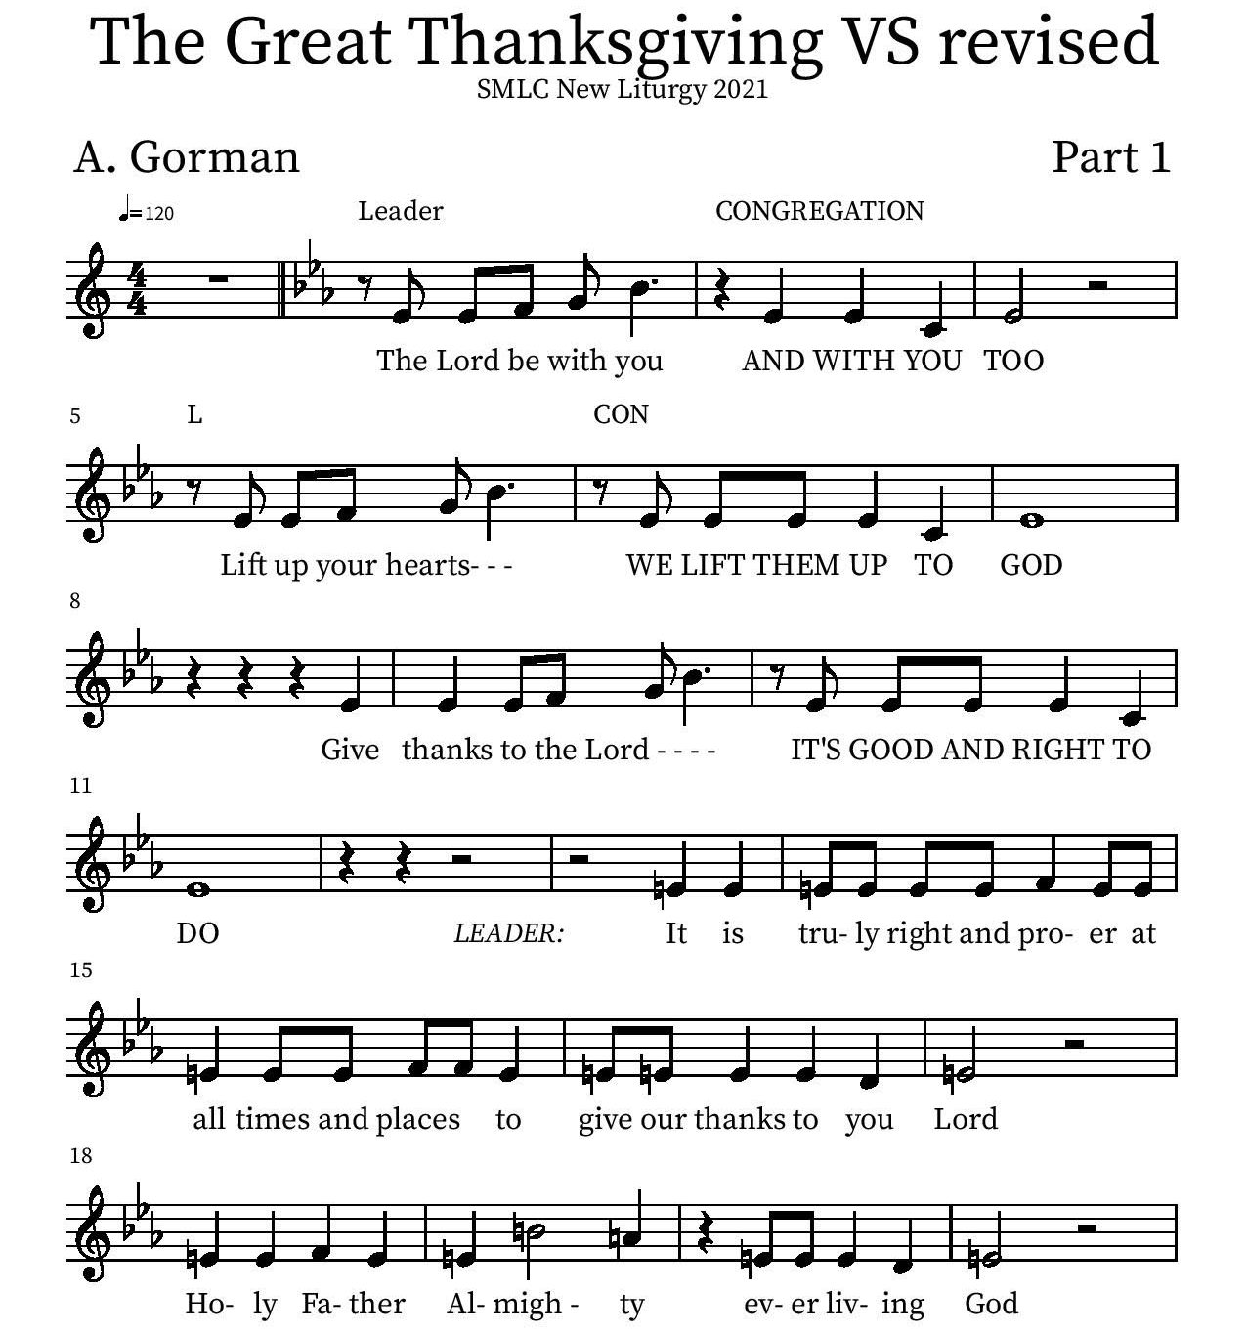
Thanksgiving

P: It is truly right and proper at all times and places… …ever more praising you and saying:
Holy Holy

Eucharistic Prayer
P: You are indeed holy, almighty and merciful God…. Do this for the remembrance of me.
The Lord’s Prayer
Our Father in heaven, hallowed be your name, your kingdom come, your will be done, on earth as in heaven. Give us today our daily bread. Forgive us our sins as we forgive those who sin against us. Save us from the time of trial and deliver us from evil. For the kingdom, the power, and the glory are yours, now and forever.
Amen.
Invitation to the Table
You may now take the individual cups provided for communion. Please receive communion with these words: “The body of Christ given for you; the blood of Christ shed for you.”

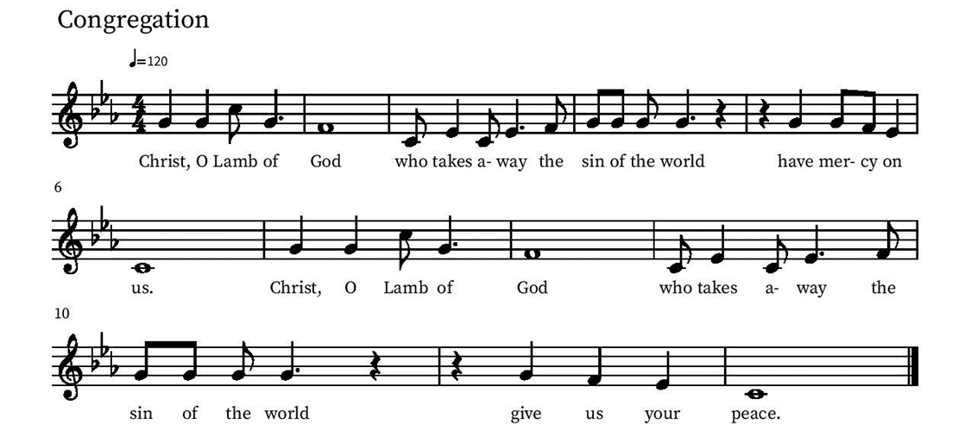
Communion Hymn – Lamb of God

Table Blessing
May the grace of our Lord Jesus Christ and the gifts of his body and blood strengthen, keep and unite us, now and forever.
Amen.
Post-Communion Prayer
Most High God,
you have come among us at this table.
By the Spirit’s power, form us to be bearers of your word,
sharing gifts of mercy and grace with all,
through Christ Jesus, our host and our guest.
Amen.
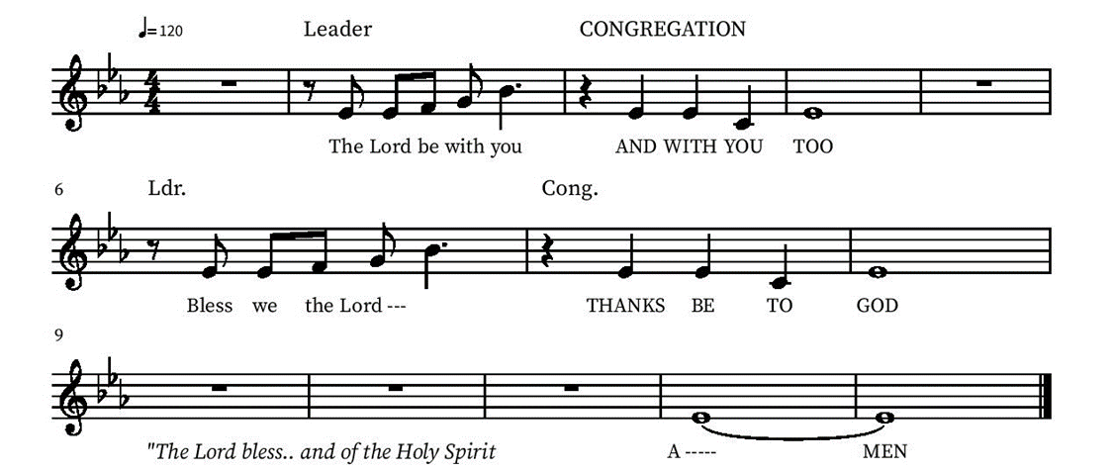
Blessing

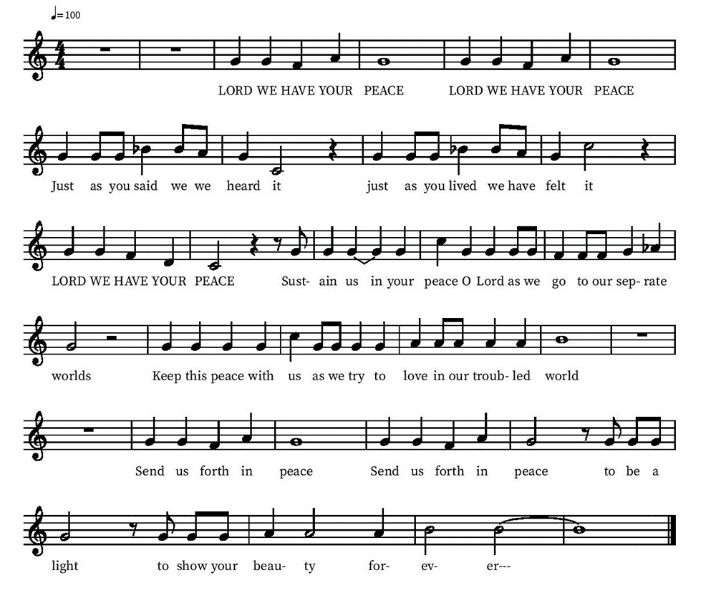
Community Time
Sending Song

Sending
Go in peace. The living Word dwells in you.
Thanks be to God.
Join us for refreshments after the service!

*See back page for Upcoming Events
Upcoming Events

Monday, November 29, 1pm Member Care Team Meeting lower level
November 30, 6 pm Advent services will begin and will be held Tuesday evenings.
Friday December 3, 6-7 PM - Snowfall and Christmas Carols at Village Walk. Contact Deb Lechner for more Info!
Sunday, December 5 - Lutheran Camps bringing farm animals!
Sunday, December 5 - Angel Tree gifts returned.
Sunday, Dec 5, 5:00 pm Christmas Tree Circle Walk we will meet at the church for hot cocoa and cookies then walk (or drive) to the Chula Vista Christmas Circle.
Tuesday, December 7, 6pm Advent Holden Evening Prayer Service
Tuesday, December 14, 6pm Advent Holden Evening Prayer Service
Sunday Dec 19 one service, 10 am Children’s Christmas Play and Bells Concert. La Posada celebration to follow.
Tuesday, Dec 21, 6 pm, the last of our Advent services, will be a Blue Christmas, or service of healing and hope. This is a special service when we can acknowledge the sadness we feel at Christmas time, recognizing that this is not a season of joy for everyone. Please speak to Pastor Karla for more information.

Friday, December 24, 5pm Christmas Eve Candlelight Service

Friday, January 7 End of Year Ministry Reports due to the Office
Tuesday Bible study each Tuesday at 3 pm on the Lower level or by Zoom (link sent by email on Tuesdays)

Please contact the office with any questions or additions. Office.stmarkscv@gmail.com

