St. Mark’s Worship Sunday November 21, 2021
Welcome to Worship

Welcome to worship inside your church!
Stationed at the tables at the entrance our greeters have hand sanitizer and masks if you need them, bulletins and self-contained communion cups (please wait for the Pastor to direct you to open them).
The restrooms will be open, but we request that one family group at a time uses the facilities.
We will be serving coffee after the service. We're staying masked to protect children and anyone who feels vulnerable, vaccinated or not. All are welcome, unless you aren't feeling well, then please recover at home and watch the worship service on Facebook live at 9 AM.
If you are worshipping at home, you may want to prepare some bread, wine, or juice to receive Holy Communion. You may commune yourself or those around you with these words:
“The body of Christ given for you; the blood of Christ shed for you.”
Prelude
Welcome
Mission
Celebrating God’s love and forgiveness, we serve others
Opening Song – Soon and Very Soon All Verses ELW #439

Soon and very soon,
We are going to see the King,
Soon and very soon,
We are going to see the King.
Soon and very soon,
We are going to see the King,
Hallelujah, hallelujah,
We are going to see the King.

No more crying there,
We are going to see the King,
No more crying there,
We are going to see the King.
No more crying there,
We are going to see the King,
Hallelujah, Hallelujah,
We are going to see the King.

No more dying there,
We are going to see the King,
No more dying there,
We are going to see the King.
No more dying there,
We are going to see the King,
Hallelujah, Hallelujah,
We are going to see the King.

Lic #A-735988

Confession and Forgiveness
In the name of the Father,
and of the ☩ Son,
and of the Holy Spirit.
Amen.
Let us confess our sins to the one who welcomes us with an open heart.
Silence is kept for reflection.
Have mercy on us, O God.
We confess that we have sinned against you
and against our neighbor.
We have built walls instead of tables
and have turned away the stranger.
We have sought glory for ourselves
and have treasured that which does not satisfy.
Help us to love as you love,
to welcome those you send,
and to treasure mercy and justice.
Turn us from our ways to your ways,
and free us to serve those in need.
Amen.
God, who makes all things new,
forgives your sins for ☩ Jesus’ sake
and remembers them no more.
Lift up your heads and your hearts.
Yours is the kingdom of God.
Amen.

Prayer of the Day
Almighty and ever-living God, you anointed your beloved Son to be priest and sovereign forever. Grant that all the people of the earth, now divided by the power of sin, may be united by the glorious and gentle rule of Jesus Christ, our Savior and Lord, who lives and reigns with you and the Holy Spirit, one God, now and forever.
Amen.
Children’s message
Psalm: Psalm 93
¹The Lord is king, robed in majesty; the Lord is robed in majesty and armed with strength.
The Lord has made the world so sure that it cannot be moved.
²Ever since the world began, your throne has been established;
you are from everlasting.
³The waters have lifted up, O Lord, the waters have lifted up their voice;
the waters have lifted up their pounding waves.
⁴Mightier than the sound of many waters, mightier than the breakers of the sea,
mightier is the Lord who dwells on high.
⁵Your testimonies are very sure,
and holiness befits your house, O Lord, forever and for evermore.
Reading: Revelation 1:4b-8
^{4b}Grace to you and peace from him who is and who was and who is to come, and from the seven spirits who are before his throne, ⁵and from Jesus Christ, the faithful witness, the firstborn of the dead, and the ruler of the kings of the earth.
To him who loves us and freed us from our sins by his blood, ⁶and made us to be a kingdom, priests serving his God and Father, to him be glory and dominion forever and ever. Amen.
⁷Look! He is coming with the clouds;
every eye will see him,
even those who pierced him;
and on his account all the tribes of the earth will wail.
So it is to be. Amen.
⁸“I am the Alpha and the Omega,” says the Lord God, who is and who was and who is to come, the Almighty.
Gospel Acclamation
Alleluia. Lord, to whom shall we go? You have the words of eternal life.
Alleluia.
The Holy Gospel according to John.
Glory to you, O Lord.

Gospel: John 18:33-37
³³Pilate entered the headquarters again, summoned Jesus, and asked him, “Are you the King of the Jews?” ³⁴Jesus answered, “Do you ask this on your own, or did others tell you about me?” ³⁵Pilate replied, “I am not a Jew, am I? Your own nation and the chief priests have handed you over to me. What have you done?” ³⁶Jesus answered, “My kingdom is not from this world. If my kingdom were from this world, my followers would be fighting to keep me from being handed over to the Jews. But as it is, my kingdom is not from here.” ³⁷Pilate asked him, “So you are a king?” Jesus answered, “You say that I am a king. For this I was born, and for this I came into the world, to testify to the truth. Everyone who belongs to the truth listens to my voice.”
The Gospel of our Lord.
Praise to you, O Christ
Sermon Pastor Karla Halvorson

Hymn of the Day – Beautiful Savior All Verses ELW #838

¹Beautiful Savior,
King of creation,
Son of God and Son of Man!
Truly I'd love thee,
truly I'd serve thee,
light of my soul, my joy, my crown.

²Fair are the meadows,
fair are the woodlands,
robed in flow'rs of blooming spring;
Jesus is fairer,
Jesus is purer,
he makes our sorrowing spirit sing.

³His Fair is the sunshine,
fair is the moonlight,
bright the sparkling stars on high;
Jesus shines brighter,
Jesus shines purer
than all the angels in the sky.

⁴Beautiful Savior,
Lord of the nations,
Son of God and Son of Man!
Glory and honor,
praise, adoration,
now and forevermore be thine!

Lic #A-735988

Prayers of Intercession
Leader: God, in your mercy,
Congregation: Hear our prayer.
Song
God Is so good,
God is so good,
God is so good,
He’s so good to me!
Blessing of prayer quilts
Song
God Is so good,
God is so good,
God is so good,
He’s so good to me!
The Peace
The peace of Christ be with you always.
And also, with you.
(you may share the peace of Christ with anyone who is with you, share the peace in the comments, text an offering of peace to someone, or simply send a prayer of blessing and peace to someone.)

Offering
Thanksgiving Moment
Offering information
St. Mark’s Church, 580 Hilltop Dr. Chula Vista, CA 91910
Venmo: @stmarks-churchchulavista

Offering Song
Thank you for giving to the Lord
I am a life that was changed
Thank you for giving to the Lord
I am so glad you gave
Offering Prayer
Holy God,
the earth is yours and everything in it,
yet you have chosen to dwell among your creatures.
Come among us now in these gifts of bread and wine,
and strengthen us to be your body for the world
through Jesus Christ our Lord.
Amen.

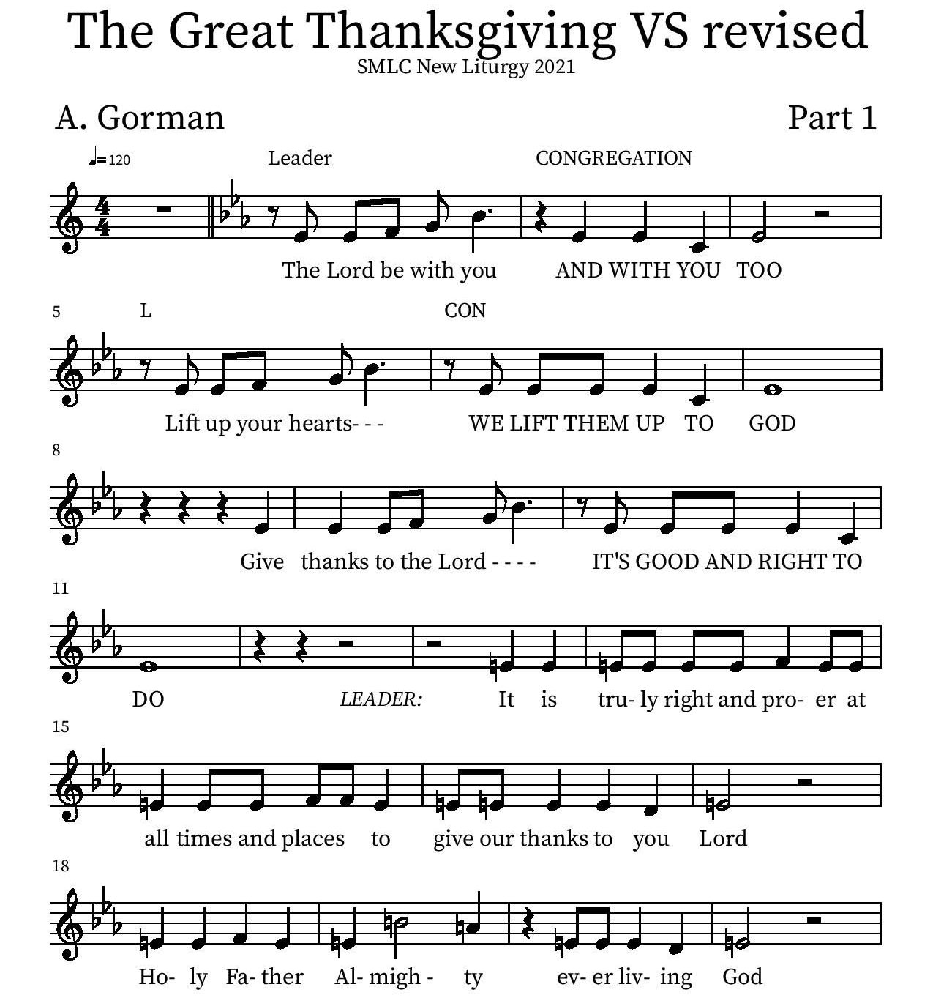
Thanksgiving

P: It is truly right and proper at all times and places… …ever more praising you and saying:
Holy Holy

Eucharistic Prayer
P: You are indeed holy, almighty and merciful God…. Do this for the remembrance of me.
The Lord’s Prayer
Our Father in heaven, hallowed be your name, your kingdom come, your will be done, on earth as in heaven. Give us today our daily bread. Forgive us our sins as we forgive those who sin against us. Save us from the time of trial and deliver us from evil. For the kingdom, the power, and the glory are yours, now and forever.
Amen.
Invitation to the Table
You may now take the individual cups provided for communion. Please receive communion with these words: “The body of Christ given for you; the blood of Christ shed for you.”

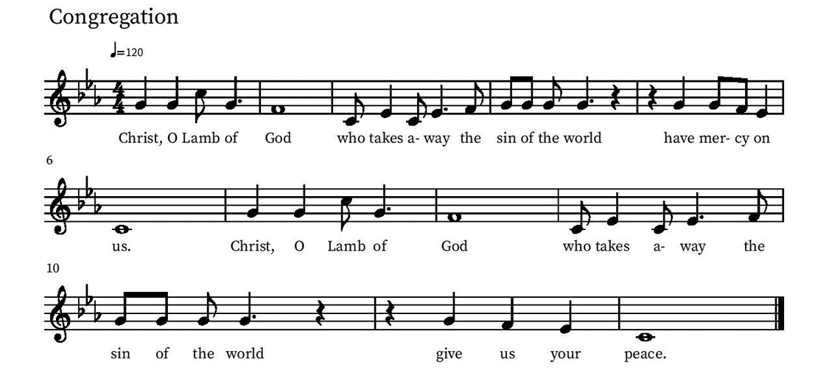
Communion Hymn – Lamb of God

Table Blessing
May the grace of our Lord Jesus Christ and the gifts of his body and blood strengthen, keep and unite us, now and forever.
Amen.
Post-Communion Prayer
Blessed Jesus,
at this table, you have been for us both host and meal.
Now send us forth to extend our tables
and to share your gifts
until that day when all feast together
at your heavenly banquet.
Amen.
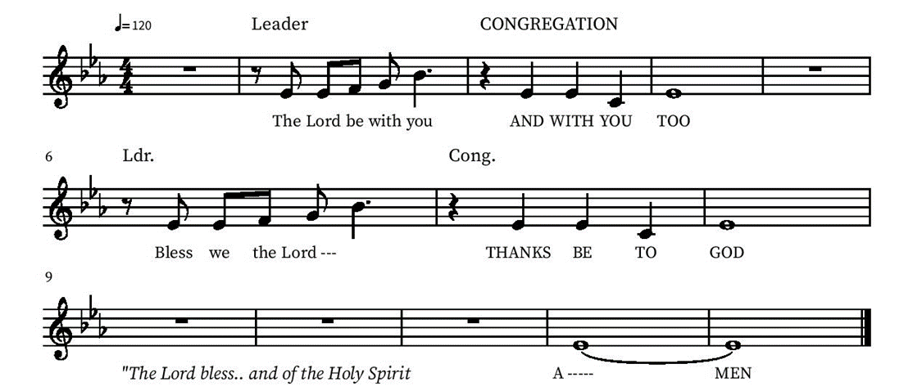
Blessing

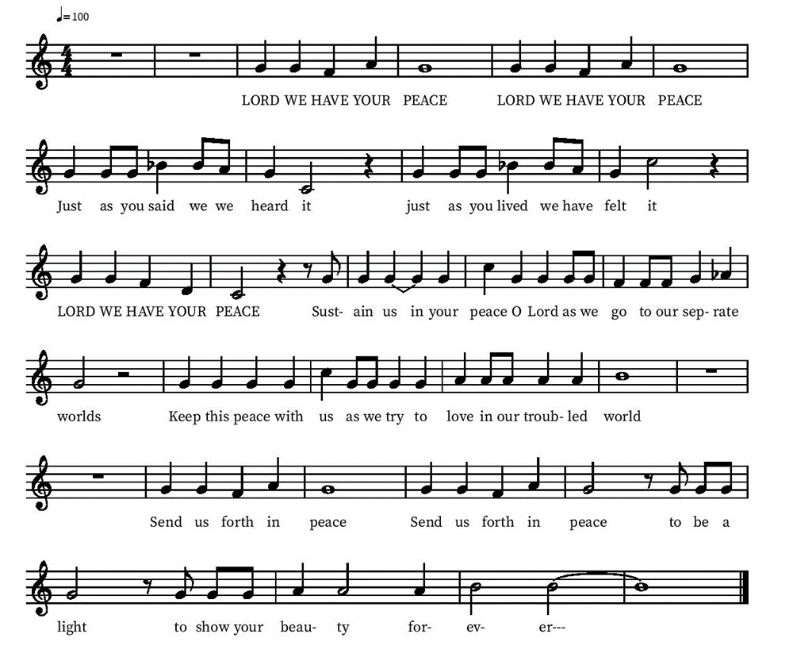
Community Time
Sending Song

Sending
Go in peace. The living Word dwells in you.
Thanks be to God.
Join us for refreshments after the service!

*See back page for upcoming events

Upcoming Events

Monday, November 29, 1pm Member Care Team Meeting lower level
November 30, 6 pm Advent services will begin and will be held Tuesday evenings. We will enjoy Holden Evening Prayer as we did last year. This will be a hybrid service, available on our facebook page and in person. We are looking for speakers and this time it is very simple. Please tell us what your favorite Bible passage is and why. A half-page explanation will suffice. Contact Pastor Karla for more info.
Friday December 3, 6-7 PM - Snowfall and Christmas Carols at Village Walk. Contact Deb Lechner for more Info!
Sunday, December 5 - Lutheran Camps bringing farm animals!
Sunday Dec 19 one service, 10 am Children’s Christmas Play and Bells Concert
Tuesday, Dec 21, 6 pm, the last of our Advent services, will be a Blue Christmas, or service of healing and hope. This is a special service when we can acknowledge the sadness we feel at Christmas time, recognizing that this is not a season of joy for everyone. Please speak to Pastor Karla for more information.

Christmas Eve will be at 5 pm, with the traditional singing of carols, celebration of Holy Communion, and pondering of the gift of Jesus. This will include the singing of Silent Night by candlelight.

Friday, January 7 End of Year Ministry Reports due to the Office
Tuesday Bible study each Tuesday at 3 pm on the Lower level or by Zoom (link sent by email on Tuesdays)

Please contact the office with any questions or additions. Office.stmarkscv@gmail.com

