St. Mark’s Worship Sunday November 14, 2021
Welcome to Worship

Welcome to worship inside your church!
Stationed at the tables at the entrance our greeters have hand sanitizer and masks if you need them, bulletins and self-contained communion cups (please wait for the Pastor to direct you to open them).
The restrooms will be open, but we request that one family group at a time uses the facilities.
We will be serving coffee after the service. We're staying masked to protect children and anyone who feels vulnerable, vaccinated or not. All are welcome, unless you aren't feeling well, then please recover at home and watch the worship service on Facebook live at 9 AM.
If you are worshipping at home, you may want to prepare some bread, wine, or juice to receive Holy Communion. You may commune yourself or those around you with these words:
“The body of Christ given for you; the blood of Christ shed for you.”
Prelude
Welcome
Mission
Celebrating God’s love and forgiveness, we serve others
Opening Song – Day by Day All Verses ELW #790

¹Day by day, your mercies, Lord, attend me,
bringing comfort to my anxious soul.
Day by day, the blessings, Lord, you send me
draw me nearer to my heav'nly goal.
Love divine, beyond all mortal measure,
brings to naught the burdens of my quest;
Savior, lead me to the home I treasure,
where at last I'll find eternal rest.

²Day by day, I know you will provide me
strength to serve and wisdom to obey;
I will seek your loving will to guide me
o'er the paths I struggle day by day.
I will fear no evil of the morrow,
I will trust in your enduring grace.
Savior, help me bear life's pain and sorrow
till in glory I behold your face.

³Oh, what joy to know that you are near me
when my burdens grow too great to bear;
oh, what joy to know that you will hear me
when I come, O Lord, to you in prayer.
Day by day, no matter what betide me,
you will hold me ever in your hand.
Savior, with your presence here to guide me,
I will reach at last the promised land.

Lic #A-735988

Confession and Forgiveness
In the name of the Father,
and of the ☩ Son,
and of the Holy Spirit.
Amen.
Let us confess our sins to the one who welcomes us with an open heart.
Silence is kept for reflection.
Have mercy on us, O God.
We confess that we have sinned against you
and against our neighbor.
We have built walls instead of tables
and have turned away the stranger.
We have sought glory for ourselves
and have treasured that which does not satisfy.
Help us to love as you love,
to welcome those you send,
and to treasure mercy and justice.
Turn us from our ways to your ways,
and free us to serve those in need.
Amen.
God, who makes all things new,
forgives your sins for ☩ Jesus’ sake
and remembers them no more.
Lift up your heads and your hearts.
Yours is the kingdom of God.
Amen.

Prayer of the Day
Almighty God, your sovereign purpose brings salvation to birth. Give us faith to be steadfast amid the tumults of this world, trusting that your kingdom comes and your will is done through your Son, Jesus Christ, our Savior and Lord.
Amen.
Children’s message
Psalm: Psalm 16
¹Protect me, O God, for I take refuge in you;
I have said to the Lord, “You are my Lord, my good above all other.”
²All my delight is in the godly that are in the land,
upon those who are noble among the people.
³But those who run after other gods
shall have their troubles multiplied.
⁴I will not pour out drink offerings to such gods,
never take their names up on my lips.
⁵O Lord, you are my portion and my cup;
it is you who up hold my lot.
⁶My boundaries enclose a pleasant land;
indeed, I have a rich inheritance.
⁷I will bless the Lord who gives me counsel;
my heart teaches me night after night.
⁸I have set the Lord always before me;
because God is at my right hand, I shall not be shaken.
⁹My heart, therefore, is glad, and my spirit rejoices;
my body also shall rest in hope.
¹⁰For you will not abandon me to the grave,
nor let your holy one see the pit.
¹¹You will show me the path of life;
in your presence there is fullness of joy, and in your right hand are pleasures
for evermore.
Reading: Hebrews 10:11-14 [15-18] 19-25
¹¹Every priest stands day after day at his service, offering again and again the same sacrifices that can never take away sins. ¹²But when Christ had offered for all time a single sacrifice for sins, “he sat down at the right hand of God,” ¹³and since then has been waiting “until his enemies would be made a footstool for his feet.” ¹⁴For by a single offering he has perfected for all time those who are sanctified. [¹⁵And the Holy Spirit also testifies to us, for after saying,
¹⁶“This is the covenant that I will make with them
after those days, says the Lord:
I will put my laws in their hearts,
and I will write them on their minds,”
¹⁷he also adds,
“I will remember their sins and their lawless deeds no more.”
¹⁸Where there is forgiveness of these, there is no longer any offering for sin.]
¹⁹Therefore, my friends, since we have confidence to enter the sanctuary by the blood of Jesus, ²⁰by the new and living way that he opened for us through the curtain (that is, through his flesh), ²¹and since we have a great priest over the house of God, ²²let us approach with a true heart in full assurance of faith, with our hearts sprinkled clean from an evil conscience and our bodies washed with pure water. ²³Let us hold fast to the confession of our hope without wavering, for he who has promised is faithful. ²⁴And let us consider how to provoke one another to love and good deeds, ²⁵not neglecting to meet together, as is the habit of some, but encouraging one another, and all the more as you see the Day approaching.

Gospel Acclamation
Alleluia. Be alert at all times, praying that you may have the strength to stand before the Son of Man.
Alleluia.
The Holy Gospel according to Mark.
Glory to you, O Lord.

Gospel: Mark 13:1-8
¹As [Jesus] came out of the temple, one of his disciples said to him, “Look, Teacher, what large stones and what large buildings!” ²Then Jesus asked him, “Do you see these great buildings? Not one stone will be left here upon another; all will be thrown down.”
³When he was sitting on the Mount of Olives opposite the temple, Peter, James, John, and Andrew asked him privately, ⁴“Tell us, when will this be, and what will be the sign that all these things are about to be accomplished?” ⁵Then Jesus began to say to them, “Beware that no one leads you astray. ⁶Many will come in my name and say, ‘I am he!’ and they will lead many astray. ⁷When you hear of wars and rumors of wars, do not be alarmed; this must take place, but the end is still to come. ⁸For nation will rise against nation, and kingdom against kingdom; there will be earthquakes in various places; there will be famines. This is but the beginning of the birth pangs.”
The Gospel of our Lord.
Praise to you, O Christ
Sermon Pastor Karla Halvorson
Hymn of the Day – My Hope Is Built on Nothing Less All Verses ELW #596

¹My hope is built on nothing less
than Jesus' blood and righteousness;
no merit of my own I claim,
but wholly lean on Jesus' name.

Refrain
On Christ, the solid rock, I stand;
all other ground is sinking sand,
all other ground is sinking sand.

²When darkness veils his lovely face,
I rest on his unchanging grace;
in ev'ry high and stormy gale
my anchor holds within the veil.
Refrain

³His oath, his covenant, his blood
sustain me in the raging flood;
when all supports are washed away,
he then is all my hope and stay.
Refrain

⁴When he shall come with trumpet sound,
oh, may I then in him be found,
clothed in his righteousness alone,
redeemed to stand before the throne!
Refrain

Lic #A-73598

Prayers of Intercession
Leader: Hear us, O God,
Congregation: Your mercy is great.
Song
God Is so good,
God is so good,
God is so good,
He’s so good to me!
Blessing of prayer quilts
Song
God Is so good,
God is so good,
God is so good,
He’s so good to me!
The Peace
The peace of Christ be with you always.
And also, with you.
(you may share the peace of Christ with anyone who is with you, share the peace in the comments, text an offering of peace to someone, or simply send a prayer of blessing and peace to someone.)
Offering
Thanksgiving Moment
Offering information
St. Mark’s Church, 580 Hilltop Dr. Chula Vista, CA 91910
Venmo: @stmarks-churchchulavista

Offering Song
Thank you for giving to the Lord
I am a life that was changed
Thank you for giving to the Lord
I am so glad you gave
Offering Prayer
Holy God,
the earth is yours and everything in it,
yet you have chosen to dwell among your creatures.
Come among us now in these gifts of bread and wine,
and strengthen us to be your body for the world
through Jesus Christ our Lord.
Amen.

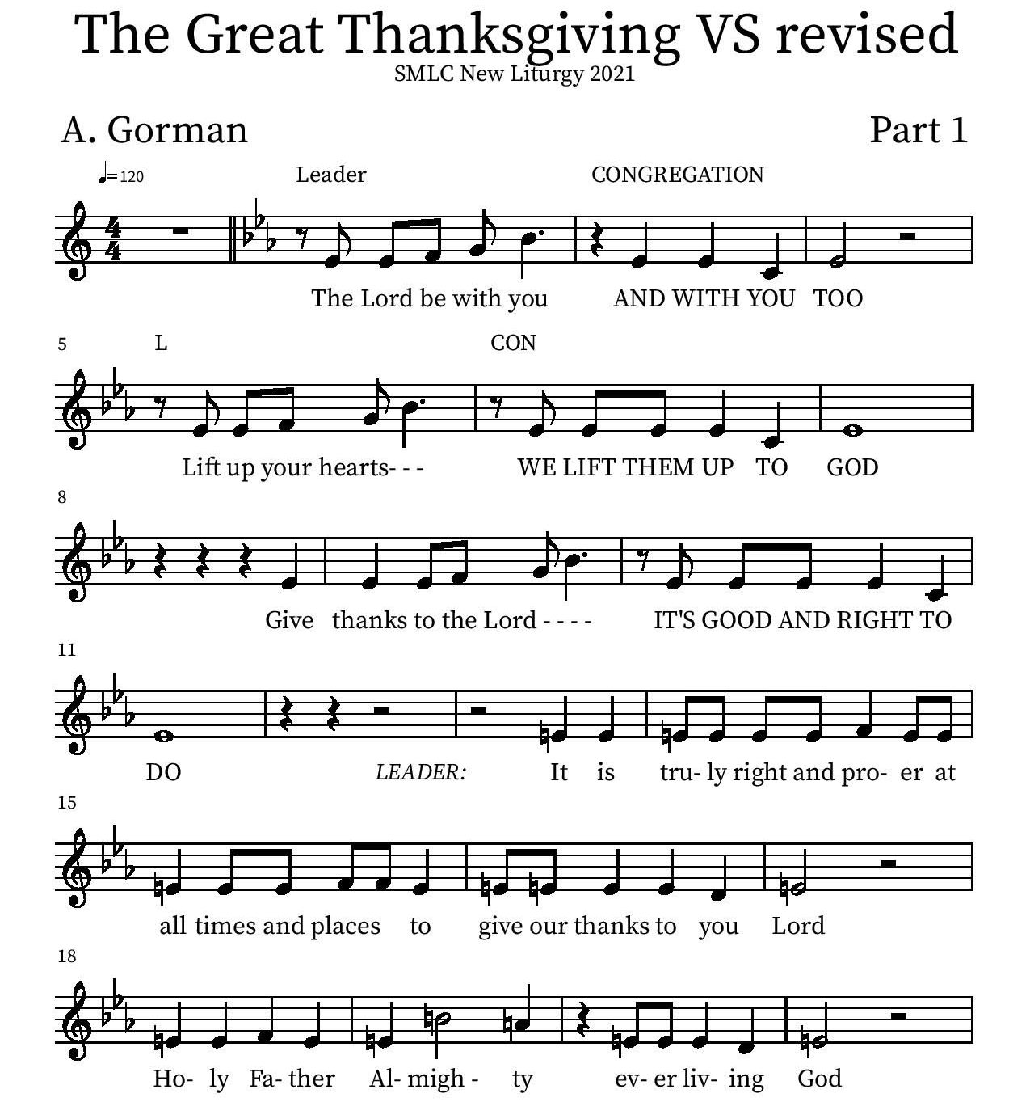
Thanksgiving

P: It is truly right and proper at all times and places… …ever more praising you and saying:
Holy Holy

Eucharistic Prayer
P: You are indeed holy, almighty and merciful God…. Do this for the remembrance of me.
The Lord’s Prayer
Our Father in heaven, hallowed be your name, your kingdom come, your will be done, on earth as in heaven. Give us today our daily bread. Forgive us our sins as we forgive those who sin against us. Save us from the time of trial and deliver us from evil. For the kingdom, the power, and the glory are yours, now and forever.
Amen.
Invitation to the Table
You may now take the individual cups provided for communion. Please receive communion with these words: “The body of Christ given for you; the blood of Christ shed for you.”

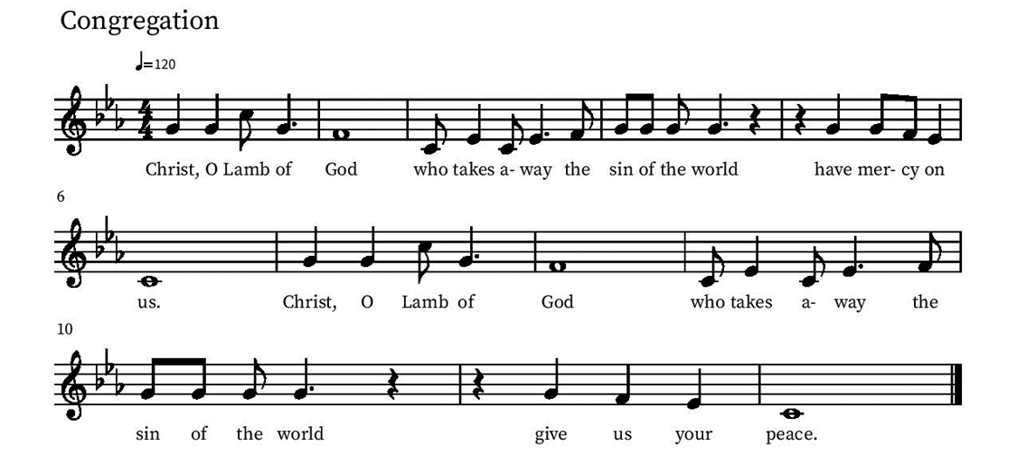
Communion Hymn – Lamb of God

Table Blessing
May the grace of our Lord Jesus Christ and the gifts of his body and blood strengthen, keep and unite us, now and forever.
Amen.
Post-Communion Prayer
Blessed Jesus,
at this table, you have been for us both host and meal.
Now send us forth to extend our tables
and to share your gifts
until that day when all feast together
at your heavenly banquet.
Amen.
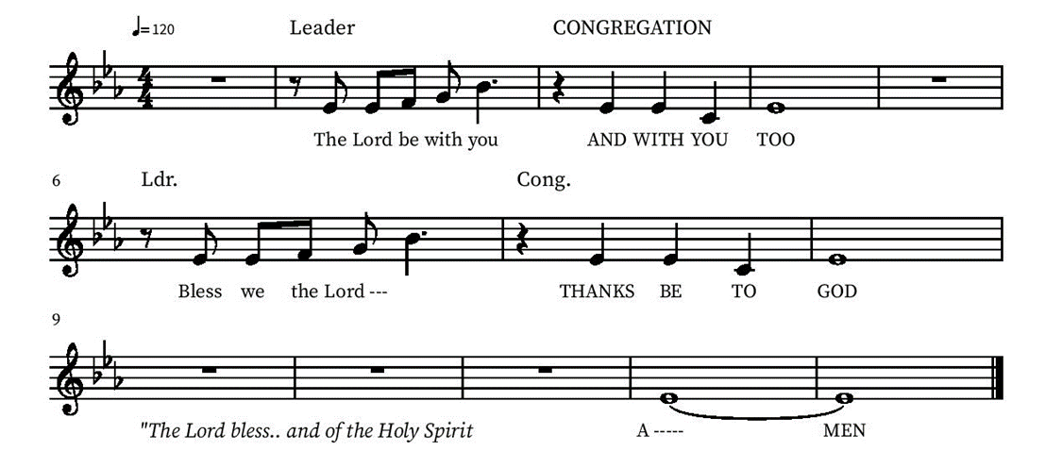
Blessing

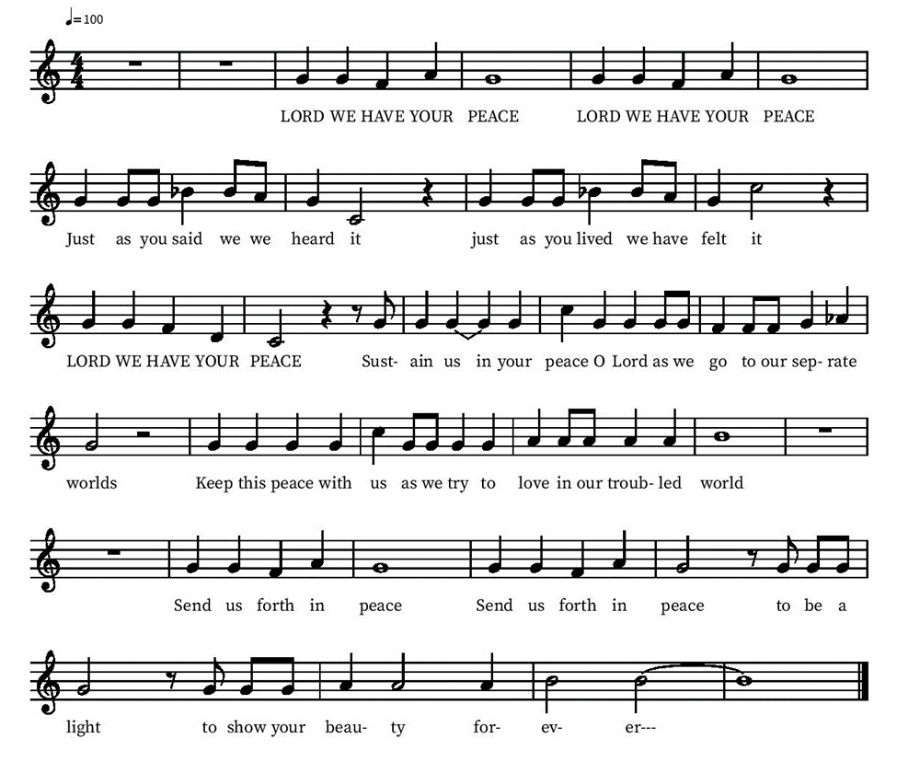
Community Time
Sending Song

Sending
Go in peace. The living Word dwells in you.
Thanks be to God.
Join us for refreshments after the service!

*See back page for upcoming events

Upcoming Events

Monday, November 15, 6pm - November Council Meeting (note new date)
Saturday, Nov 20, 2 pm Organ Concert This will be a fundraiser in support of needed organ repair featuring a multi-talented team of musicians: Margaret Galliard on organ; Jason Chase on piano; Angie Lightfoot Mulder, vocalist, as well as Lisa and Brian Mansfield, talented brass musicians who are new members of St. Mark’s and play in the U.S. Navy Band.
Sunday, November 21 Stories of Our Lives
Monday, November 29, 1pm Member Care Team Meeting lower level
Friday December 3, 6-7 PM - Snowfall and Christmas Carols at Village Walk. Contact Deb Lechner for more Info!
Sunday, December 5 - Lutheran Camps bringing farm animals!
Sunday Dec 19 one service, 10 am Children’s Christmas Play and Bells Concert
Friday, January 7 End of Year Ministry Reports due to the Office
Tuesday Bible study each Tuesday at 3 pm on the Lower level or by Zoom (link sent by email on Tuesdays)

Please contact the office with any questions or additions. Office.stmarkscv@gmail.com

