St. Mark’s Worship Sunday November 7, 2021
Welcome to Worship
All Saints Sunday

Welcome to worship inside your church!
Stationed at the tables at the entrance our greeters have hand sanitizer and masks if you need them, bulletins and self-contained communion cups (please wait for the Pastor to direct you to open them).
The restrooms will be open, but we request that one family group at a time uses the facilities.
We will be serving coffee after the service. We're staying masked to protect children and anyone who feels vulnerable, vaccinated or not. All are welcome, unless you aren't feeling well, then please recover at home and watch the worship service on Facebook live at 9 AM.
If you are worshipping at home, you may want to prepare some bread, wine, or juice to receive Holy Communion. You may commune yourself or those around you with these words:
“The body of Christ given for you; the blood of Christ shed for you.”
Prelude
Welcome
Mission
Celebrating God’s love and forgiveness, we serve others
Opening Song – For All the Saints Verses 1,3,6,7 ELW #422

¹For all the saints who from their labors rest, who thee by faith before the world confessed, thy name,
O Jesus, be forever blest.
Alleluia! Alleluia!

³Oh, blest communion, fellowship divine,
we feebly struggle, they in glory shine;
yet all are one in thee, for all are thine.
Alleluia! Alleluia!

⁶But then there breaks a yet more glorious day: the saints triumphant rise in bright array; the King of glory passes on his way.
Alleluia! Alleluia!

⁷From earth's wide bounds, from ocean's farthest coast,through gates of pearl streams in the countless host,
singing to Father, Son, and Holy Ghost:
Alleluia! Alleluia!
Lic #735988-A
Confession and Forgiveness
In the name of the Father,
and of the ☩ Son,
and of the Holy Spirit.
Amen.
Let us confess our sin in the presence of God and of one another.
Silence is kept for reflection.
Have mercy on us, O God.
We confess that we have sinned against you
and against our neighbor.
We have built walls instead of tables
and have turned away the stranger.
We have sought glory for ourselves
and have treasured that which does not satisfy.
Help us to love as you love,
to welcome those you send,
and to treasure mercy and justice.
Turn us from our ways to your ways,
and free us to serve those in need.
Amen.
God, who makes all things new,
forgives your sins for ☩ Jesus’ sake
and remembers them no more.
Lift up your heads and your hearts.
Yours is the kingdom of God.
Amen.

Prayer of the Day
Almighty God, you have knit your people together in one communion in the mystical body of your Son, Jesus Christ our Lord. Grant us grace to follow your blessed saints in lives of faith and commitment, and to know the inexpressible joys you have prepared for those who love you, through Jesus Christ, our Savior and Lord, who lives and reigns with you and the Holy Spirit, one God, now and forever.
Amen.
Children’s message
Reading: Revelation 21:1-6a
¹I saw a new heaven and a new earth; for the first heaven and the first earth had passed away, and the sea was no more. ²And I saw the holy city, the new Jerusalem, coming down out of heaven from God, prepared as a bride adorned for her husband. ³And I heard a loud voice from the throne saying,
“See, the home of God is among mortals.
He will dwell with them;
they will be his peoples,
and God himself will be with them;
⁴he will wipe every tear from their eyes.
Death will be no more;
mourning and crying and pain will be no more,
for the first things have passed away.”
⁵And the one who was seated on the throne said, “See, I am making all things new.” Also he said, “Write this, for these words are trustworthy and true.” ^{6a}Then he said to me, “It is done! I am the Alpha and the Omega, the beginning and the end.”
Gospel: Matthew 5:3-12
³"Blessed are the poor in spirit, for theirs is the kingdom of heaven.
⁴"Blessed are those who mourn, for they will be comforted.
⁵"Blessed are the meek, for they will inherit the earth.
⁶"Blessed are those who hunger and thirst for righteousness, for they will be filled.
⁷"Blessed are the merciful, for they will receive mercy.
⁸"Blessed are the pure in heart, for they will see God.
⁹"Blessed are the peacemakers, for they will be called children of God.
¹⁰"Blessed are those who are persecuted for righteousness' sake, for theirs is the kingdom of heaven.
¹¹"Blessed are you when people revile you and persecute you and utter all kinds of evil against you falsely on my account
¹²Rejoice and be glad, for your reward is great in heaven, for in the same way they persecuted the prophets who were before you.
Gospel Acclamation
Alleluia. Lord to whom shall we go? You have the words of eternal life.
Alleluia.
The Holy Gospel according to Mark.
Glory to you, O Lord.

Gospel: John 11:32-44
³²When Mary came where Jesus was and saw him, she knelt at his feet and said to him, “Lord, if you had been here, my brother would not have died.” ³³When Jesus saw her weeping, and the Jews who came with her also weeping, he was greatly disturbed in spirit and deeply moved. ³⁴He said, “Where have you laid him?” They said to him, “Lord, come and see.” ³⁵Jesus began to weep. ³⁶So the Jews said, “See how he loved him!” ³⁷But some of them said, “Could not he who opened the eyes of the blind man have kept this man from dying?”
³⁸Then Jesus, again greatly disturbed, came to the tomb. It was a cave, and a stone was lying against it. ³⁹Jesus said, “Take away the stone.” Martha, the sister of the dead man, said to him, “Lord, already there is a stench because he has been dead four days.” ⁴⁰Jesus said to her, “Did I not tell you that if you believed, you would see the glory of God?” ⁴¹So they took away the stone. And Jesus looked upward and said, “Father, I thank you for having heard me. ⁴²I knew that you always hear me, but I have said this for the sake of the crowd standing here, so that they may believe that you sent me.” ⁴³When he had said this, he cried with a loud voice, “Lazarus, come out!” ⁴⁴The dead man came out, his hands and feet bound with strips of cloth, and his face wrapped in a cloth. Jesus said to them, “Unbind him, and let him go.”
Praise to you, O Christ
Sermon Pastor Karla Halvorson
Procession of lighting candles
Hymn of the Day – Blessed Are They All Verses WOV#764

Blest are they, the poor in spirit
Theirs is the kingdom of God
Blest are they, full of sorrow
They shall be consoled
Chorus

Chorus
Rejoice and be glad
Blessed are you; holy are you
Rejoice and be glad
Yours is the Kingdom of God

Blest are they, the lowly ones
They shall inherit the earth
Blest are they, who hunger and thirst
They shall have their fill
Chorus

Blest are they who show mercy
Mercy shall be theirs
Blest are they, the pure of heart
They shall see God
Chorus

Blest are they who seek peace
They are the children of God
Blest are they who suffer in faith
The glory of God is theirs
Chorus

Blest are you who suffer hate
All because of me
Rejoice and be glad, yours is the kingdom
Shine for all to see
Chorus
Lic #735988-A

Prayers of Intercession
Leader: Hear us, O God,
Congregation: Your mercy is great.
We give thanks for all the Saints of this congregation who entered eternal life this past year.
Earl Carlovsky
Frances Prott
James Cartwright
Joan Sayers
John Maher
Lance Lindgren
Mae Trager
Marvin Holm
Mike Collins
Ralph Mendoza
Ron Nissen
Song
God Is so good,
God is so good,
God is so good,
He’s so good to me!
Blessing of prayer quilts
Song
God Is so good,
God is so good,
God is so good,
He’s so good to me!
The Peace
The peace of Christ be with you always.
And also, with you.
(you may share the peace of Christ with anyone who is with you, share the peace in the comments, text an offering of peace to someone, or simply send a prayer of blessing and peace to someone.)
Offering
Thanksgiving Moment
Offering information
St. Mark’s Church, 580 Hilltop Dr. Chula Vista, CA 91910
Venmo: @stmarks-churchchulavista

Offering Song
Thank you for giving to the Lord
I am a life that was changed
Thank you for giving to the Lord
I am so glad you gave
Offering Prayer
Holy God,
the earth is yours and everything in it,
yet you have chosen to dwell among your creatures.
Come among us now in these gifts of bread and wine,
and strengthen us to be your body for the world
through Jesus Christ our Lord.
Amen.
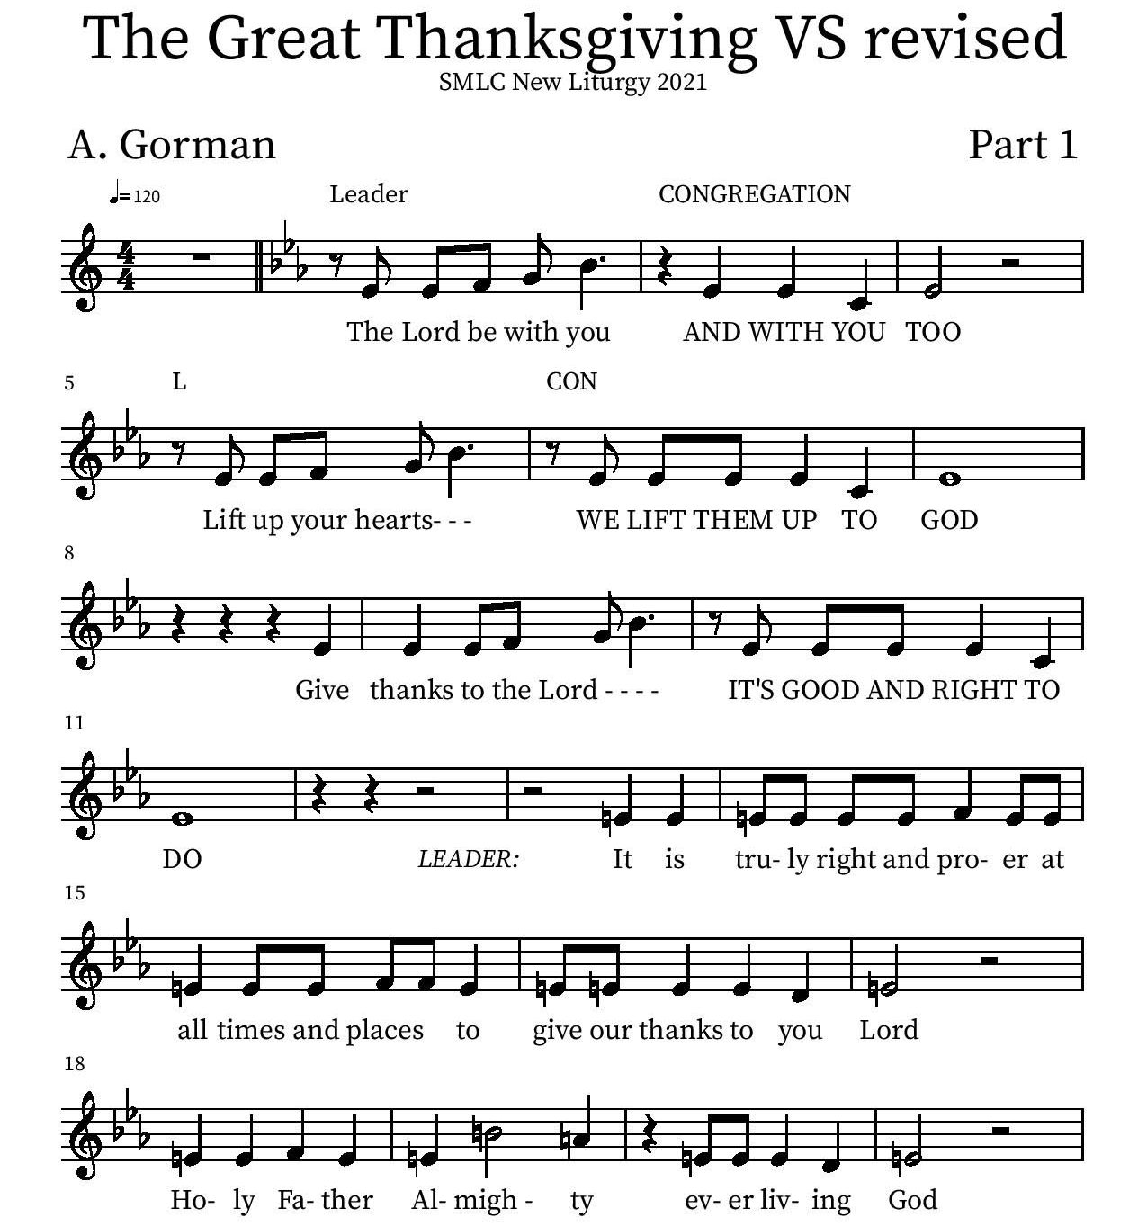
Thanksgiving

P: It is truly right and proper at all times and places… …ever more praising you and saying:
Holy Holy

Eucharistic Prayer
P: You are indeed holy, almighty and merciful God…. Do this for the remembrance of me.
The Lord’s Prayer
Our Father in heaven, hallowed be your name, your kingdom come, your will be done, on earth as in heaven. Give us today our daily bread. Forgive us our sins as we forgive those who sin against us. Save us from the time of trial and deliver us from evil. For the kingdom, the power, and the glory are yours, now and forever.
Amen.
Invitation to the Table
You may now take the individual cups provided for communion. Please receive communion with these words: “The body of Christ given for you; the blood of Christ shed for you.”

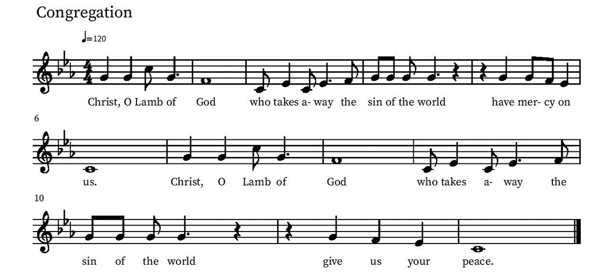
Communion Hymn – Lamb of God

Table Blessing
May the grace of our Lord Jesus Christ and the gifts of his body and blood strengthen, keep and unite us, now and forever.
Amen.
Post-Communion Prayer
Blessed Jesus,
at this table, you have been for us both host and meal.
Now send us forth to extend our tables
and to share your gifts
until that day when all feast together
at your heavenly banquet.
Amen.
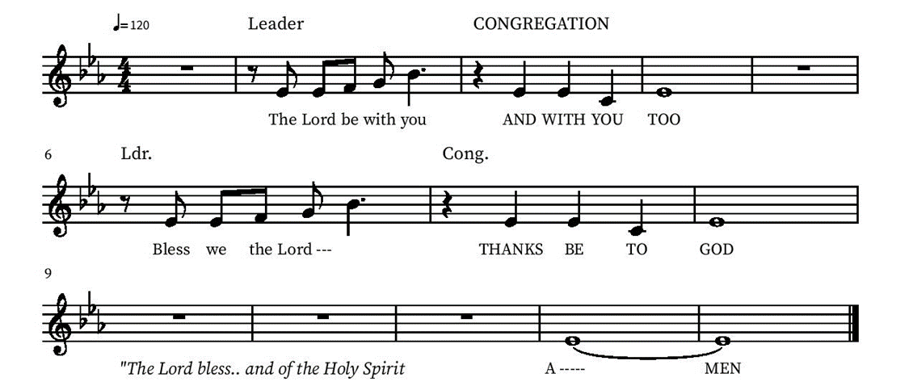
Blessing

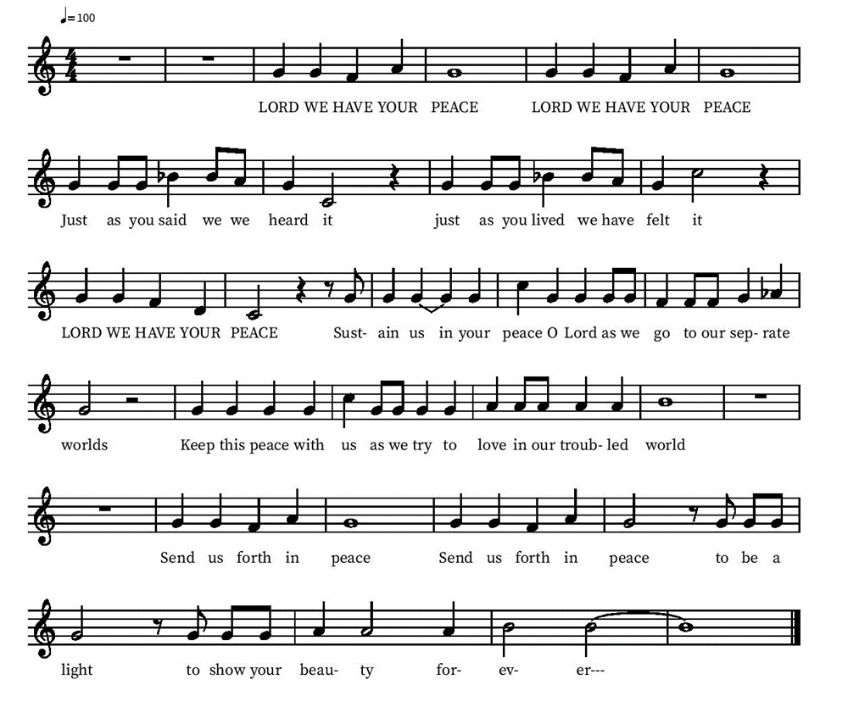
Community Time
Sending Song

Sending
Go in peace. The living Word dwells in you.
Thanks be to God.
Join us for refreshments after the service!

*See back page for upcoming events

Upcoming Events
Sunday, November 14, Honoring our Military – Recognition of our Active Duty and Veteran friends and family. Please notify Pastor Karla of current Active Duty military members you would like to have honored on November 14. You are also invited to bring photographs of Active Duty and Veterans you would like to honor. Please ensure the person’s name is attached to the photograph.
Monday, November 15, 6pm - November Council Meeting (note new date)
Saturday, Nov 20, 2 pm Organ Concert This will be a fundraiser in support of needed organ repair featuring a multi-talented team of musicians: Margaret Galliard on organ; Jason Chase on piano; Angie Lightfoot Mulder, vocalist, as well as Lisa and Brian Mansfield, talented brass musicians who are new members of St. Mark’s and play in the U.S. Navy Band.
TBA end of November Angel Tree will be happening at St. Mark’s! We just received the names of our 20 Angel Tree children today, Saturday! These children have a parent in prison and are considered “at-risk” children. Each will receive a fun gift and a clothing gift worth $20 per gift so there will be 40 Angel Tree gifts to buy. More info to come next week. Thank you for always being so supportive of this ministry!
Meredith McCall and Dorothy Geier
Friday December 3, 6-7 PM - Snowfall and Christmas Carols at Village Walk. Contact Deb Lechner for more Info!
Sunday Dec 19 one service, 10 am Children’s Christmas Play and Bells Concert
Friday, January 7 End of Year Ministry Reports due to the Office
Tuesday Bible study each Tuesday at 3 pm on the Lower level or by Zoom (link sent by email on Tuesdays)

Please contact the office with any questions or additions. Office.stmarkscv@gmail.com

