St. Mark’s Worship Sunday October 24, 2021
Welcome to Worship
Commitment Sunday

Welcome to worship inside your church! All are welcome!
Stationed at the tables at the entrance our greeters have hand sanitizer and masks, bulletins,
and self-contained communion cups.
You are also invited to attend worship on-line on our private Facebook page at 9 AM.
If you are worshipping at home, you may want to prepare some bread, wine, or juice to receive Holy Communion. You may commune yourself or those around you with these words:
“The body of Christ given for you; the blood of Christ shed for you.”

Today is Commitment Sunday. We will invite you to bring forward your financial pledge and time and talent sheets along with your weekly offering before the celebration of Holy Communion.
Extra sheets are available in the entry of the church.
Thank you for being partners in ministry with St. Mark’s!
Prelude
Welcome
Mission
Celebrating God’s love and forgiveness, we serve others

Opening Song – We All Are One in Mission All Verses ELW #576
¹We all are one in mission;
we all are one in call,
our varied gifts united
by Christ, the Lord of all.
A single great commission
compels us from above
to plan and work together
that all may know Christ's love.

²We all are called for service,
to witness in God's name.
Our ministries are diff'rent;
our purpose is the same:
to touch the lives of others
with God's surprising grace,
so ev'ry folk and nation
may feel God's warm embrace.

³Now let us be united,
and let our song be heard.
Now let us be a vessel
for God's redeeming Word.
We all are one in mission;
we all are one in call,
our varied gifts united
by Christ, the Lord of all.

Confession and Forgiveness
Blessed be the holy Trinity, ☩ one God,
whose teaching is life,
whose presence is sure,
and whose love is endless.
Amen.
Let us confess our sins to the one who welcomes us with an open heart.
Silence is kept for reflection.
God, our comforter,
like lost sheep, we have gone astray.
We gaze upon abundance and see scarcity.
We turn our faces away from injustice and oppression.
We exploit the earth with our apathy and greed.
Free us from our sin, gracious God.
Listen when we call out to you for help.
Lead us by your love to love our neighbors as ourselves.
Amen.
All have sinned and fall short of the glory of God.
By the gift of grace in ☩ Christ Jesus, God makes you righteous.
Receive with glad hearts the forgiveness of all your sins.
Amen.

Prayer of the Day
Eternal light, shine in our hearts. Eternal wisdom, scatter the darkness of our ignorance. Eternal compassion, have mercy on us. Turn us to seek your face, and enable us to reflect your goodness, through Jesus Christ, our Savior and Lord.
Amen.
Children’s message
Psalm: Psalm 126
¹When the Lord restored the fortunes of Zion,
then were we like those who dream.
²Then was our mouth filled with laughter, and our tongue with shouts of joy.
Then they said among the nations, “The Lord has done great things for them.”
³The Lord has done great things for us,
and we are glad indeed.
⁴Restore our fortunes, O Lord,
like the watercourses of the Negeb.
⁵Those who sowed with tears
will reap with songs of joy.
⁶Those who go out weeping, carrying the seed,
will come again with joy, shouldering their sheaves.

Reading: I Cor 13: 8-12
⁸ Love never ends. But as for prophecies, they will come to an end; as for tongues, they will cease; as for knowledge, it will come to an end. ⁹ For we know only in part, and we prophesy only in part; ¹⁰ but when the complete comes, the partial will come to an end. ¹¹ When I was a child, I spoke like a child, I thought like a child, I reasoned like a child; when I became an adult, I put an end to childish ways. ¹² For now we see in a mirror, dimly,^{[b]} but then we will see face to face. Now I know only in part; then I will know fully, even as I have been fully known. ¹³ And now faith, hope, and love abide, these three; and the greatest of these is love.
Word of God, Word of Life
Thanks be to God.
Gospel Acclamation
Alleluia. Lord to whom shall we go? You have the words of eternal life.
Alleluia.
The Holy Gospel according to Mark.
Glory to you, O Lord.

Gospel: Mark 10:46-52
⁴⁶As [Jesus] and his disciples and a large crowd were leaving Jericho, Bartimaeus son of Timaeus, a blind beggar, was sitting by the roadside. ⁴⁷When he heard that it was Jesus of Nazareth, he began to shout out and say, “Jesus, Son of David, have mercy on me!” ⁴⁸Many sternly ordered him to be quiet, but he cried out even more loudly, “Son of David, have mercy on me!” ⁴⁹Jesus stood still and said, “Call him here.” And they called the blind man, saying to him, “Take heart; get up, he is calling you.” ⁵⁰So throwing off his cloak, he sprang up and came to Jesus. ⁵¹Then Jesus said to him, “What do you want me to do for you?” The blind man said to him, “My teacher, let me see again.” ⁵²Jesus said to him, “Go; your faith has made you well.” Immediately he regained his sight and followed him on the way.
The Gospel of our Lord.
Praise to you, O Christ
Sermon Pastor Karla Halvorson

Hymn of the Day – Here I Am, Lord All Verses ELW #574

¹"I, the Lord of sea and sky,
I have heard my people cry.
All who dwell in dark and sin
my hand will save.
I, who made the stars of night,
I will make their darkness bright.
Who will bear my light to them?
Whom shall I send?"

Refrain
Here I am, Lord. Is it I, Lord?
I have heard you calling in the night.
I will go, Lord, if you lead me.
I will hold your people in my heart.

²"I, the Lord of snow and rain,
I have borne my people's pain.
I have wept for love of them.
They turn away.
I will break their hearts of stone,
give them hearts for love alone.
I will speak my word to them.
Whom shall I send?" Refrain

³"I, the Lord of wind and flame,
I will tend the poor and lame.
I will set a feast for them.
My hand will save.
Finest bread I will provide
till their hearts be satisfied.
I will give my life to them.
Whom shall I send?" Refrain
Prayers of Intercession
Leader: Hear us, O God,
Congregation: Your mercy is great.
Song
God Is so good,
God is so good,
God is so good,
He’s so good to me!
Blessing of prayer quilts
Song
God Is so good,
God is so good,
God is so good,
He’s so good to me!
The Peace
The peace of Christ be with you always.
And also, with you.
(you may share the peace of Christ with anyone who is with you, share the peace in the comments, text an offering of peace to someone, or simply send a prayer of blessing and peace to someone.)

Offering
Stewardship Moment
Offering information
St. Mark’s Church, 580 Hilltop Dr. Chula Vista, CA 91910
Venmo: @stmarks-churchchulavista
Offering Processional
You will be guided by the ushers to bring your financial pledge/ time and talent sheet forward and place it in the Thanksgiving basket. Thank you for your on-going and future support of St. Mark’s Lutheran Church.

Solo- Tom Larson “He Looked Beyond My Fault” by Dottie Rambo
Offering Song
Thank you for giving to the Lord
I am a life that was changed
Thank you for giving to the Lord
I am so glad you gave
Offering Prayer
God of abundance,
you cause streams to break forth in the desert
and manna to rain from the heavens.
Accept the gifts you have first given us.
Unite them with the offering of our lives
to nourish the world you love so dearly;
through Jesus Christ, our Savior and Lord.
Amen.

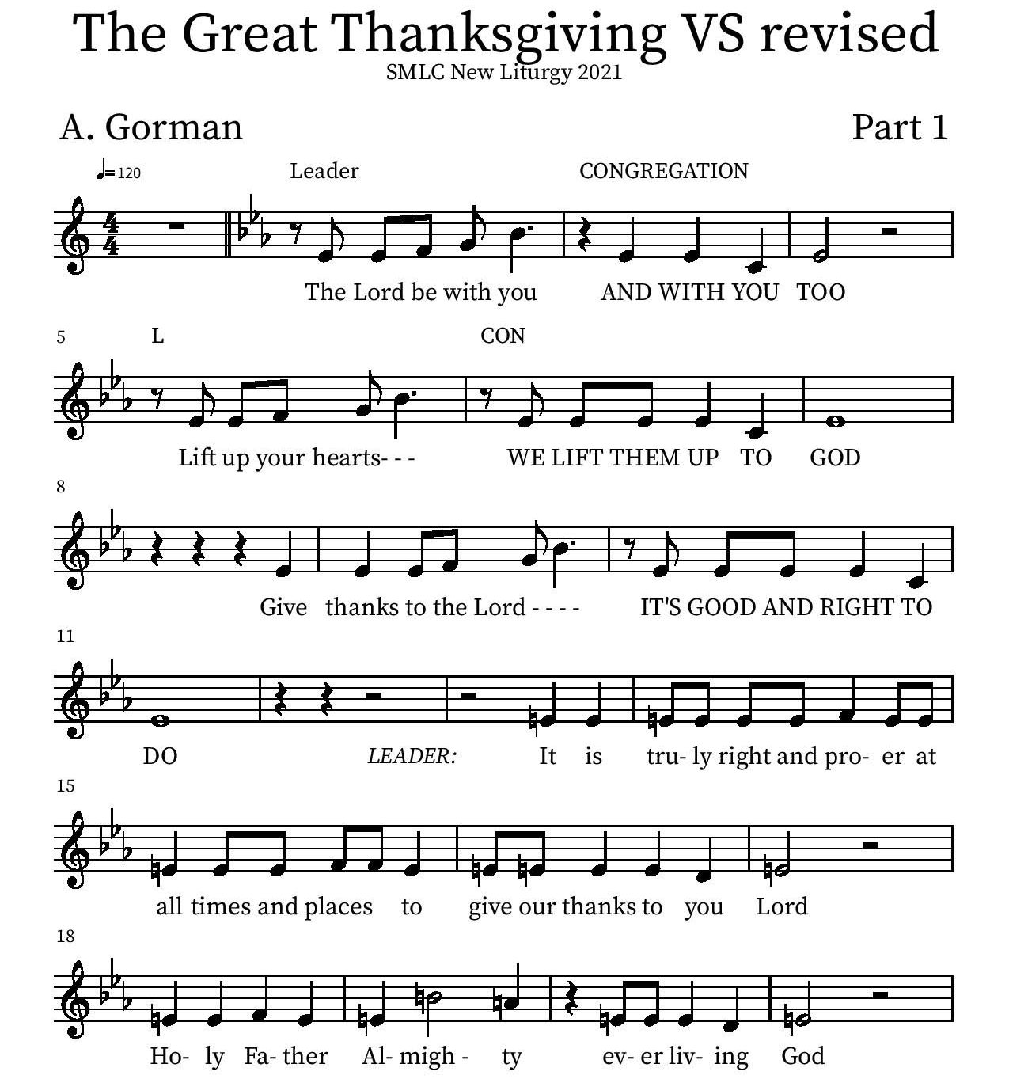

P: It is truly right and proper at all times and places… …ever more praising you and saying:

Eucharistic Prayer
P: You are indeed holy, almighty and merciful God…. Do this for the remembrance of me.
The Lord’s Prayer
Our Father in heaven, hallowed be your name, your kingdom come, your will be done, on earth as in heaven. Give us today our daily bread. Forgive us our sins as we forgive those who sin against us. Save us from the time of trial and deliver us from evil. For the kingdom, the power, and the glory are yours, now and forever.
Amen.
Invitation to the Table
You may now take the individual cups provided for communion. Please receive communion with these words: “The body of Christ given for you; the blood of Christ shed for you.”

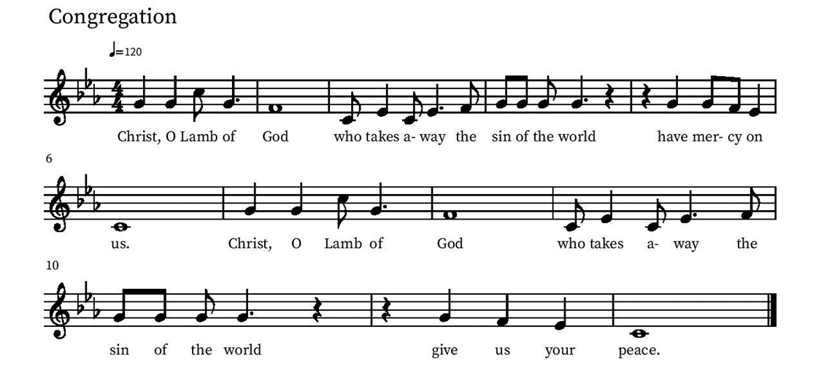
Communion Hymn – Lamb of God

Table Blessing
May the grace of our Lord Jesus Christ and the gifts of his body and blood strengthen, keep and unite us, now and forever.
Amen.
Post-Communion Prayer
Lord of life,
in the gift of your body and blood
you turn the crumbs of our faith into a feast of salvation.
Send us forth into the world with shouts of joy,
bearing witness to the abundance of your love
in Jesus Christ, our Savior and Lord.
Amen.
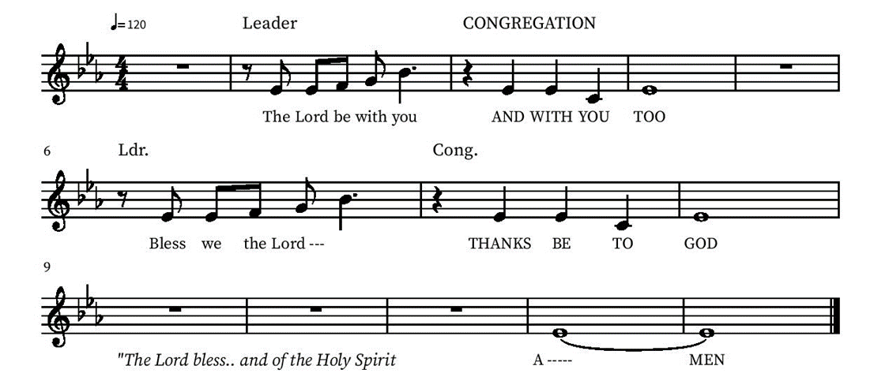
Blessing

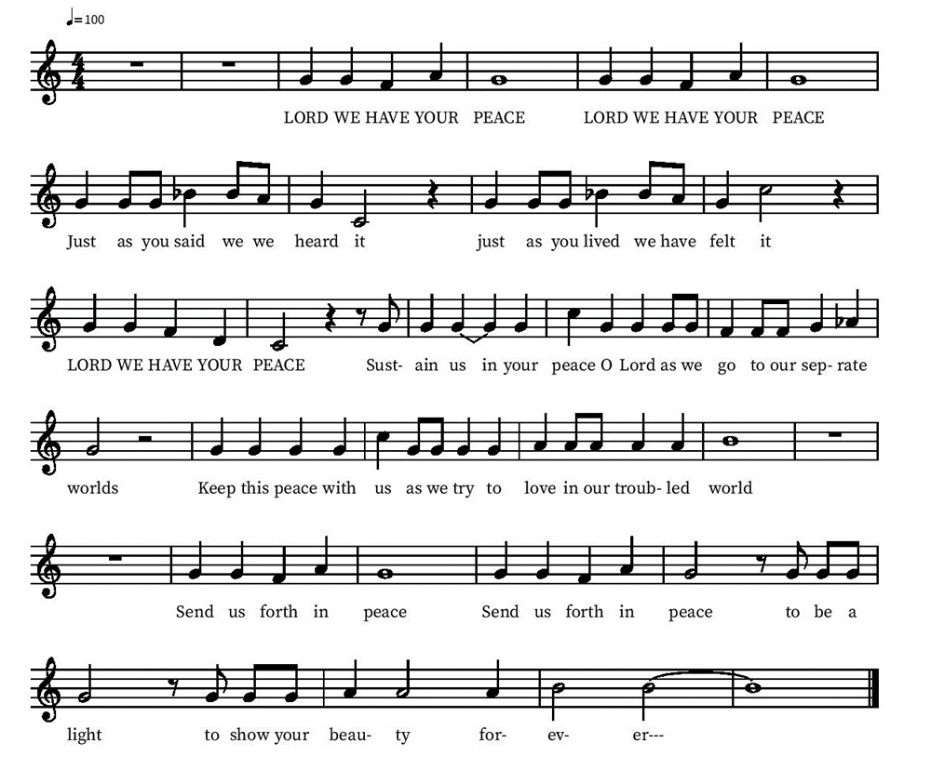
Community Time
Sending Song

Sending
Go in peace. The living Word dwells in you.
Thanks be to God.
Join us for refreshments after the service!

*See back page for upcoming events
Calendar of Events

- Sunday, October 24: Stewardship Sunday An opportunity to submit your financial pledge and time and talent sheet to St. Mark’s for 2022.
- Sunday, October 24 10:20 Stories of Our Lives Manuel Alverez
- Sunday, October 24, 3:30 PM: Pastor Karla’s Installation as the called and ordained Pastor of St. Mark’s (bilingual).
- Monday, October 25, 6 pm Church Council Meeting
- Tuesday, Oct 26, 3 pm hybrid Zoom and in-person Bible study (every Tuesday Lower level)
- Wednesday, October 27, 1-2 pm The Member Care Team meeting on the Lower Level.
- Wednesday, October 27, 5:30 Bells practice in the sanctuary
- Saturday, October 30, 10- Noon New Members Class see Pastor Karla
- Sunday, October 31 Reformation Sunday! One service, 10 AM, bilingual, receiving new members and giving Bibles to those who are in confirmation. Wear red!
- Sunday, November 7, All Saint's Sunday AND Daylight Savings time ends
- Sunday, November 14, Lutheran Camps and celebration of veterans
- Monday, November 15, 6pm - November Council Meeting (note new date)
- Saturday, Nov 20, 2 pm Organ Concert This will be a fundraiser in support of needed organ repair featuring a multi-talented team of musicians
- Sunday Dec 19 one service, 10 am Bells and Children’s Christmas pageant

- Please contact the office with any questions or additions. Office.stmarkscv@gmail.com

