St. Mark’s Worship Sunday October 17, 2021
Welcome to Worship

Welcome to worship inside your church!
Stationed at the tables at the entrance our greeters have hand sanitizer and masks if you need them, bulletins and self-contained communion cups (please wait for the Pastor to direct you to open them).
The restrooms will be open, but we request that one family group at a time uses the facilities.
We will be serving coffee after the service. We're staying masked to protect children and anyone who feels vulnerable, vaccinated or not. All are welcome, unless you aren't feeling well, then please recover at home and watch the worship service on Facebook live at 9 AM.
If you are worshipping at home, you may want to prepare some bread, wine, or juice to receive Holy Communion. You may commune yourself or those around you with these words:
“The body of Christ given for you; the blood of Christ shed for you.”
Prelude
Welcome
Opening Song – Jesu, Jesu, Fill Us with Your Love All Verses ELW #708

Refrain
Jesu, Jesu,
fill us with your love,
show us how to serve
the neighbors we have from you.
¹Kneels at the feet of his friends,
silently washes their feet,
master who acts as a slave to them.
Refrain

²Neighbors are wealthy and poor,
varied in color and race,
neighbors are near us and far away.
Refrain
³These are the ones we will serve,
these are the ones we will love;
all these are neighbors to us and you. Refrain
⁴Kneel at the feet of our friends,
silently washing their feet:
this is the way we will live with you.
Refrain

Confession and Forgiveness
Blessed be the holy Trinity, ☩ one God,
whose teaching is life,
whose presence is sure,
and whose love is endless.
Amen.
Let us confess our sins to the one who welcomes us with an open heart.
Silence is kept for reflection.
God, our comforter,
like lost sheep, we have gone astray.
We gaze upon abundance and see scarcity.
We turn our faces away from injustice and oppression.
We exploit the earth with our apathy and greed.
Free us from our sin, gracious God.
Listen when we call out to you for help.
Lead us by your love to love our neighbors as ourselves.
Amen.
All have sinned and fall short of the glory of God.
By the gift of grace in ☩ Christ Jesus, God makes you righteous.
Receive with glad hearts the forgiveness of all your sins.
Amen.
Mission
Celebrating God’s love and forgiveness, we serve others

Prayer of the Day
Sovereign God, you turn your greatness into goodness for all the peoples on earth. Shape us into willing servants of your kingdom, and make us desire always and only your will, through Jesus Christ, our Savior and Lord.
Amen.
Children’s message
Reading: Isaiah 53:4-12
⁴Surely he has borne our infirmities
and carried our diseases;
yet we accounted him stricken,
struck down by God, and afflicted.
⁵But he was wounded for our transgressions,
crushed for our iniquities;
upon him was the punishment that made us whole,
and by his bruises we are healed.
⁶All we like sheep have gone astray;
we have all turned to our own way,
and the Lord has laid on him
the iniquity of us all.
⁷He was oppressed, and he was afflicted,
yet he did not open his mouth;
like a lamb that is led to the slaughter,
and like a sheep that before its shearers is silent,
so he did not open his mouth.
⁸By a perversion of justice he was taken away.
Who could have imagined his future?
For he was cut off from the land of the living,
stricken for the transgression of my people.
⁹They made his grave with the wicked
and his tomb with the rich,
although he had done no violence,
and there was no deceit in his mouth.
¹⁰Yet it was the will of the Lord to crush him with pain.
When you make his life an offering for sin,
he shall see his offspring, and shall prolong his days;
through him the will of the Lord shall prosper.
¹¹Out of his anguish he shall see light;
he shall find satisfaction through his knowledge.
The righteous one, my servant, shall make many righteous,
and he shall bear their iniquities.
¹²Therefore I will allot him a portion with the great,
and he shall divide the spoil with the strong;
because he poured out himself to death,
and was numbered with the transgressors;
yet he bore the sin of many,
and made intercession for the transgressors.
Psalm: Psalm 91:9-16
⁹Because you have made the Lord your refuge,
and the Most High your habitation,
¹⁰no evil will befall you,
nor shall affliction come near your dwelling.
¹¹For God will give the angels charge over you,
to guard you in all your ways.
¹²Upon their hands they will bear you up,
lest you strike your foot against a stone.
¹³You will tread upon the lion cub and viper;
you will trample down the lion and the serpent.
¹⁴I will deliver those who cling to me;
I will uphold them, because they know my name.
¹⁵They will call me, and I will answer them;
I will be with them in trouble; I will rescue and honor them.
¹⁶With long life will I satisfy them,
and show them my salvation.
Word of God, Word of Life
Thanks be to God.
Gospel Acclamation
Alleluia. Lord to whom shall we go? You have the words of eternal life.
Alleluia.
The Holy Gospel according to Mark.
Glory to you, O Lord.

Gospel: Mark 10:35-45
³⁵James and John, the sons of Zebedee, came forward to him and said to him, “Teacher, we want you to do for us whatever we ask of you.” ³⁶And he said to them, “What is it you want me to do for you?” ³⁷And they said to him, “Grant us to sit, one at your right hand and one at your left, in your glory.” ³⁸But Jesus said to them, “You do not know what you are asking. Are you able to drink the cup that I drink, or be baptized with the baptism that I am baptized with?” ³⁹They replied, “We are able.” Then Jesus said to them, “The cup that I drink you will drink; and with the baptism with which I am baptized, you will be baptized; ⁴⁰but to sit at my right hand or at my left is not mine to grant, but it is for those for whom it has been prepared.”
⁴¹When the ten heard this, they began to be angry with James and John. ⁴²So Jesus called them and said to them, “You know that among the Gentiles those whom they recognize as their rulers lord it over them, and their great ones are tyrants over them. ⁴³But it is not so among you; but whoever wishes to become great among you must be your servant, ⁴⁴and whoever wishes to be first among you must be slave of all. ⁴⁵For the Son of Man came not to be served but to serve, and to give his life a ransom for many.”
The Gospel of our Lord.
Praise to you, O Christ
Sermon Pastor Karla Halvorson
Hymn of the Day – Will You Let Me Be Your Servant All Verses ELW #659

¹Will you let me be your servant,
let me be as Christ to you?
Pray that I may have the grace to
let you be my servant, too.

²We are pilgrims on a journey,
we are trav'lers on the road;
we are here to help each other
walk the mile and bear the load.

³I will hold the Christ-light for you
in the nighttime of your fear;
I will hold my hand out to you,
speak the peace you long to hear.

⁴I will weep when you are weeping;
when you laugh I'll laugh with you.
I will share your joy and sorrow
till we've seen this journey through.

⁵Will you let me be your servant,
let me be as Christ to you?
Pray that I may have the grace to
let you be my servant, too.

Prayers of Intercession
Leader: Hear us, O God,
Congregation: Your mercy is great.
Song
God Is so good,
God is so good,
God is so good,
He’s so good to me!
Blessing of prayer quilts
Song
God Is so good,
God is so good,
God is so good,
He’s so good to me!
The Peace
The peace of Christ be with you always.
And also, with you.
(you may share the peace of Christ with anyone who is with you, share the peace in the comments, text an offering of peace to someone, or simply send a prayer of blessing and peace to someone.)
Offering
Stewardship Moment
Offering information
St. Mark’s Church, 580 Hilltop Dr. Chula Vista, CA 91910
Venmo: @stmarks-churchchulavista

Offering Song
Thank you for giving to the Lord
I am a life that was changed
Thank you for giving to the Lord
I am so glad you gave
Offering Prayer
God of abundance,
you cause streams to break forth in the desert
and manna to rain from the heavens.
Accept the gifts you have first given us.
Unite them with the offering of our lives
to nourish the world you love so dearly;
through Jesus Christ, our Savior and Lord.
Amen.

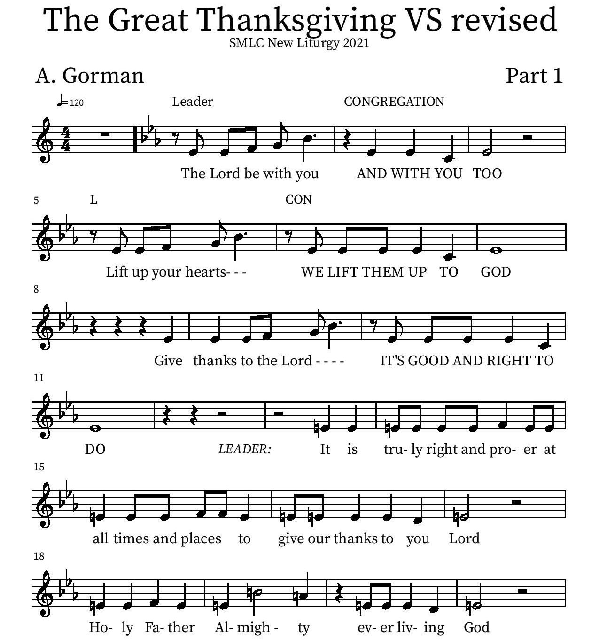
Thanksgiving

P: It is truly right and proper at all times and places… …ever more praising you and saying:
Holy Holy

Eucharistic Prayer
P: You are indeed holy, almighty and merciful God…. Do this for the remembrance of me.
The Lord’s Prayer
Our Father in heaven, hallowed be your name, your kingdom come, your will be done, on earth as in heaven. Give us today our daily bread. Forgive us our sins as we forgive those who sin against us. Save us from the time of trial and deliver us from evil. For the kingdom, the power, and the glory are yours, now and forever.
Amen.
Invitation to the Table
You may now take the individual cups provided for communion. Please receive communion with these words: “The body of Christ given for you; the blood of Christ shed for you.”

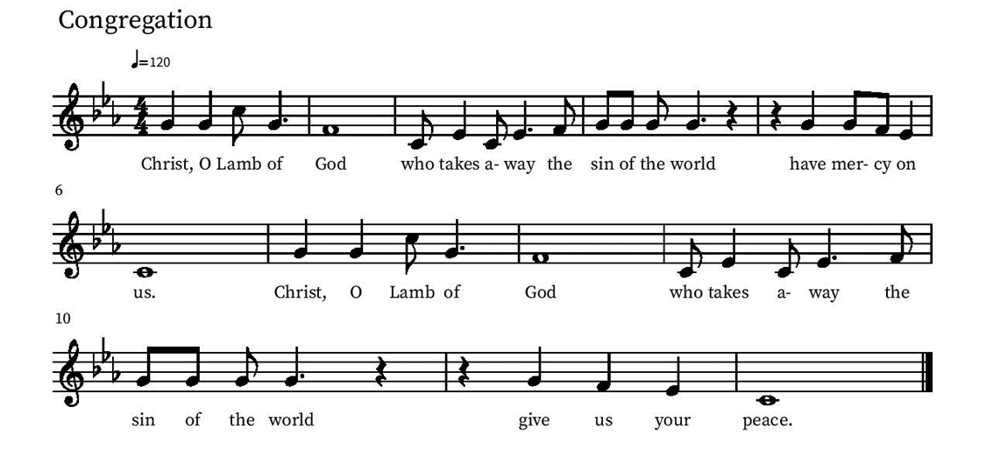
Communion Hymn – Lamb of God

Table Blessing
May the grace of our Lord Jesus Christ and the gifts of his body and blood strengthen, keep and unite us, now and forever.
Amen.
Post-Communion Prayer
Lord of life,
in the gift of your body and blood
you turn the crumbs of our faith into a feast of salvation.
Send us forth into the world with shouts of joy,
bearing witness to the abundance of your love
in Jesus Christ, our Savior and Lord.
Amen.
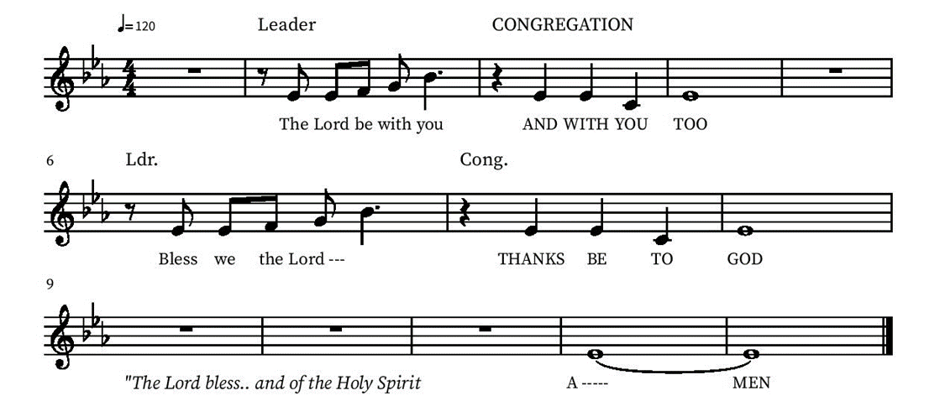
Blessing

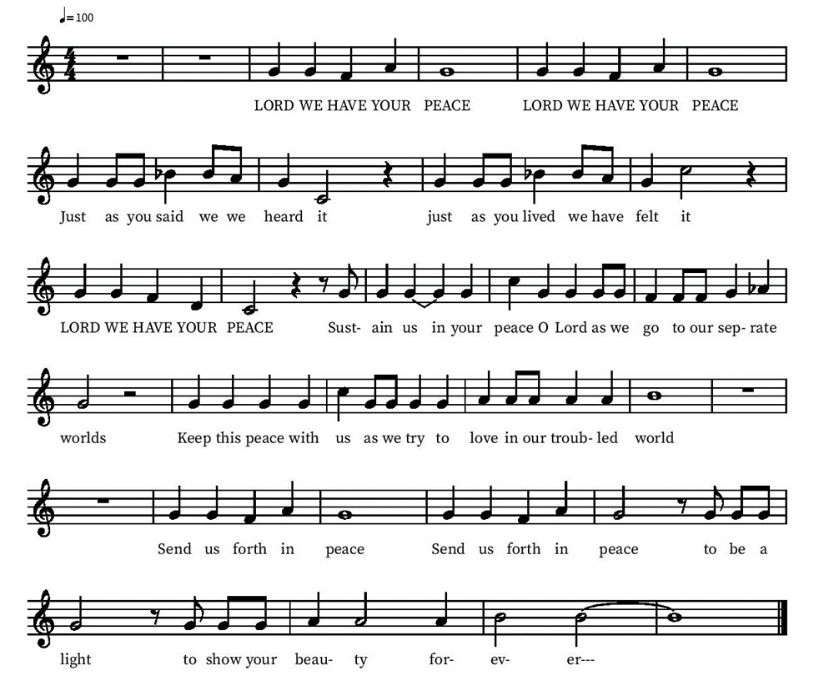
Community Time
Sending Song

Sending
Go in peace. The living Word dwells in you.
Thanks be to God.
Join us for refreshments after the service!

