St. Mark’s Worship Sunday October 10, 2021
Welcome to Worship

Welcome to worship inside your church!
Stationed at the tables at the entrance our greeters have hand sanitizer and masks if you need them, bulletins and self-contained communion cups (please wait for the Pastor to direct you to open them).
The restrooms will be open, but we request that one family group at a time uses the facilities.
We will be serving coffee after the service. We're staying masked to protect children and anyone who feels vulnerable, vaccinated or not. All are welcome, unless you aren't feeling well, then please recover at home and watch the worship service on Facebook live at 9 AM.
If you are worshipping at home, you may want to prepare some bread, wine, or juice to receive Holy Communion. You may commune yourself or those around you with these words:
“The body of Christ given for you; the blood of Christ shed for you.”
Prelude
Welcome
Opening Song – Gather Us In Verses 1,2,4 ELW #532
¹Here in this place the new light is streaming,
now is the darkness vanished away;
see in this space our fears
and our dreamings
brought here to you in the light of this day.
Gather us in, the lost and forsaken,
gather us in, the blind and the lame;
call to us now, and we shall awaken,
we shall arise at the sound of our name.

²We are the young, our lives are a myst'ry,
we are the old who yearn for your face;
we have been sung throughout all of hist'ry,
called to be light to the whole human race.
Gather us in, the rich and the haughty,
gather us in, the proud and the strong;
give us a heart, so meek and so lowly,
give us the courage to enter the song.

⁴Not in the dark of buildings confining,
not in some heaven, light years away—
here in this place the new light is shining,
now is the kingdom, and now is the day.
Gather us in and hold us forever,
gather us in and make us your own;
gather us in, all peoples together,
fire of love in our flesh and our bone.
Confession and Forgiveness
Blessed be the holy Trinity, ☩ one God,
whose teaching is life,
whose presence is sure,
and whose love is endless.
Amen.
Let us confess our sins to the one who welcomes us with an open heart.
Silence is kept for reflection.
God, our comforter,
like lost sheep, we have gone astray.
We gaze upon abundance and see scarcity.
We turn our faces away from injustice and oppression.
We exploit the earth with our apathy and greed.
Free us from our sin, gracious God.
Listen when we call out to you for help.
Lead us by your love to love our neighbors as ourselves.
Amen.
All have sinned and fall short of the glory of God.
By the gift of grace in ☩ Christ Jesus, God makes you righteous.
Receive with glad hearts the forgiveness of all your sins.
Amen.
Mission
Celebrating God’s love and forgiveness, we serve others

Prayer of the Day
Almighty and ever-living God, increase in us your gift of faith, that, forsaking what lies behind and reaching out to what lies ahead, we may follow the way of your commandments and receive the crown of everlasting joy, through Jesus Christ, our Savior and Lord.
Amen.
Children’s message
Reading: Hebrews 4:12-16
¹²Indeed, the word of God is living and active, sharper than any two-edged sword, piercing until it divides soul from spirit, joints from marrow; it is able to judge the thoughts and intentions of the heart. ¹³And before him no creature is hidden, but all are naked and laid bare to the eyes of the one to whom we must render an account.
¹⁴Since, then, we have a great high priest who has passed through the heavens, Jesus, the Son of God, let us hold fast to our confession. ¹⁵For we do not have a high priest who is unable to sympathize with our weaknesses, but we have one who in every respect has been tested as we are, yet without sin. ¹⁶Let us therefore approach the throne of grace with boldness, so that we may receive mercy and find grace to help in time of need.
Word of God, Word of Life
Thanks be to God.

Gospel Acclamation
Alleluia. Lord to whom shall we go? You have the words of eternal life.
Alleluia.
The Holy Gospel according to Mark.
Glory to you, O Lord.

Gospel: Mark 10:17-31
¹⁷As [Jesus] was setting out on a journey, a man ran up and knelt before him, and asked him, “Good Teacher, what must I do to inherit eternal life?” ¹⁸Jesus said to him, “Why do you call me good? No one is good but God alone. ¹⁹You know the commandments: ‘You shall not murder; You shall not commit adultery; You shall not steal; You shall not bear false witness; You shall not defraud; Honor your father and mother.’ ” ²⁰He said to him, “Teacher, I have kept all these since my youth.” ²¹Jesus, looking at him, loved him and said, “You lack one thing; go, sell what you own, and give the money to the poor, and you will have treasure in heaven; then come, follow me.” ²²When he heard this, he was shocked and went away grieving, for he had many possessions.
²³Then Jesus looked around and said to his disciples, “How hard it will be for those who have wealth to enter the kingdom of God!” ²⁴And the disciples were perplexed at these words. But Jesus said to them again, “Children, how hard it is to enter the kingdom of God! ²⁵It is easier for a camel to go through the eye of a needle than for someone who is rich to enter the kingdom of God.” ²⁶They were greatly astounded and said to one another, “Then who can be saved?” ²⁷Jesus looked at them and said, “For mortals it is impossible, but not for God; for God all things are possible.”
²⁸Peter began to say to him, “Look, we have left everything and followed you.” ²⁹Jesus said, “Truly I tell you, there is no one who has left house or brothers or sisters or mother or father or children or fields, for my sake and for the sake of the good news, ³⁰who will not receive a hundredfold now in this age—houses, brothers and sisters, mothers and children, and fields, with persecutions—and in the age to come eternal life. ³¹But many who are first will be last, and the last will be first.”
The Gospel of our Lord.
Praise to you, O Christ
Sermon Pastor Karla Halvorson

Hymn of the Day – Take My Life, That I May Be All Verses ELW #583

Refrain
Take my life, that I may be
consecrated, Lord, to thee;
take my moments and my days;
let them flow in ceaseless praise.

¹Take my hands and let them move
at the impulse of thy love;
take my feet and let them be
swift and beautiful for thee. Refrain

²Take my silver and my gold,
not a mite would I withhold;
take my intellect and use
ev'ry pow'r as thou shalt choose. Refrain

³Take my voice and let me sing
always, only for my King;
take my lips and let them be
filled with messages from thee. Refrain

⁴Take my will and make it thine;
it shall be no longer mine;
take my heart, it is thine own;
it shall be thy royal throne. Refrain

Prayers of Intercession
Leader: Lord, in your mercy,
Congregation: Hear our prayer.
Song
God Is so good,
God is so good,
God is so good,
He’s so good to me!
Blessing of prayer quilts
Song
God Is so good,
God is so good,
God is so good,
He’s so good to me!
The Peace
The peace of Christ be with you always.
And also, with you.
(you may share the peace of Christ with anyone who is with you, share the peace in the comments, text an offering of peace to someone, or simply send a prayer of blessing and peace to someone.)
Offering
Stewardship Moment – Gratitude for Thursday Quilters

Offering information
St. Mark’s Church, 580 Hilltop Dr. Chula Vista, CA 91910
Venmo: @stmarks-churchchulavista

Offering Song
Thank you for giving to the Lord
I am a life that was changed
Thank you for giving to the Lord
I am so glad you gave
Offering Prayer
God of abundance,
you cause streams to break forth in the desert
and manna to rain from the heavens.
Accept the gifts you have first given us.
Unite them with the offering of our lives
to nourish the world you love so dearly;
through Jesus Christ, our Savior and Lord.
Amen.

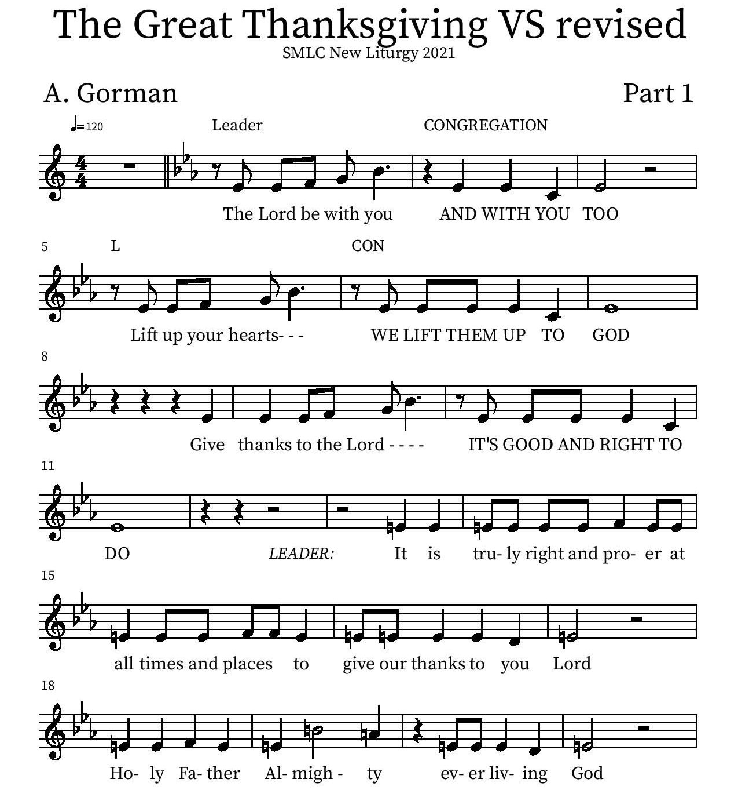
Thanksgiving

P: It is truly right and proper at all times and places… …ever more praising you and saying:
Holy Holy

Eucharistic Prayer
P: You are indeed holy, almighty and merciful God…. Do this for the remembrance of me.
The Lord’s Prayer
Our Father in heaven, hallowed be your name, your kingdom come, your will be done, on earth as in heaven. Give us today our daily bread. Forgive us our sins as we forgive those who sin against us. Save us from the time of trial and deliver us from evil. For the kingdom, the power, and the glory are yours, now and forever.
Amen.
Invitation to the Table
You may now take the individual cups provided for communion. Please receive communion with these words: “The body of Christ given for you; the blood of Christ shed for you.”

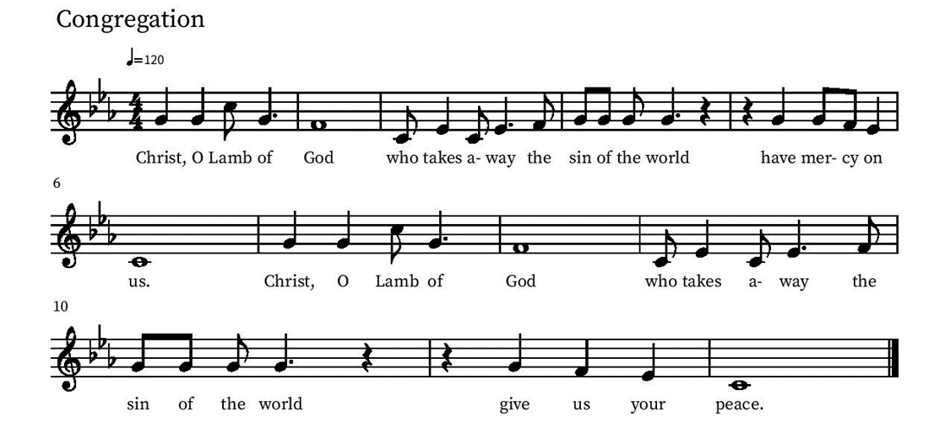
Communion Hymn – Lamb of God

Table Blessing
May the grace of our Lord Jesus Christ and the gifts of his body and blood strengthen, keep and unite us, now and forever.
Amen.
Post-Communion Prayer
Lord of life,
in the gift of your body and blood
you turn the crumbs of our faith into a feast of salvation.
Send us forth into the world with shouts of joy,
bearing witness to the abundance of your love
in Jesus Christ, our Savior and Lord.
Amen.
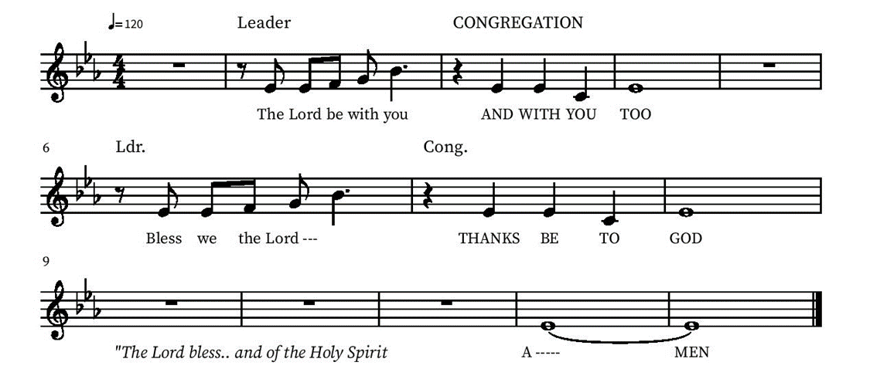
Blessing

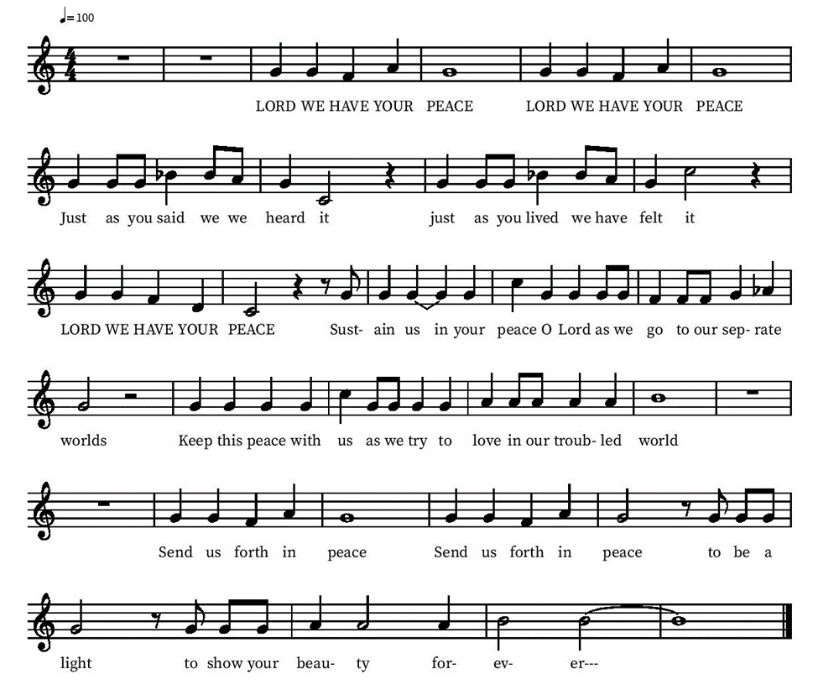
Community Time
Sending Song

Sending
Go in peace. The living Word dwells in you.
Thanks be to God.
Join us for refreshments after the service!

