St. Mark’s Worship Sunday October 3, 2021
Welcome to your Worship!

Welcome back to worship inside your church!
Stationed at the tables at the entrance our greeters have hand sanitizer and masks if you need them, bulletins and self-contained communion cups (please wait for the Pastor to direct you to open them).
The restrooms will be open, but we request that one family group at a time uses the facilities.
We will be serving coffee after the service. We're staying masked to protect children and anyone who feels vulnerable, vaccinated or not. All are welcome, unless you aren't feeling well, then please recover at home and watch the worship service on Facebook live at 9 AM.
If you are worshipping at home, you may want to prepare some bread, wine, or juice to receive Holy Communion. You may commune yourself or those around you with these words:
“The body of Christ given for you; the blood of Christ shed for you.”
Prelude
Welcome
Mission
Celebrating God’s love and forgiveness, we serve others
Opening Song – God Is Here! All Verses ELW #526
¹God is here! As we your people
meet to offer praise and prayer,
may we find in fuller measure
what it is in Christ we share.
Here, as in the world around us,
all our varied skills and arts
wait the coming of the Spirit
into open minds and hearts.

²Here are symbols to remind us
of our lifelong need of grace;
here are table, font, and pulpit;
here the cross has central place.
Here in honesty of preaching,
here in silence, as in speech,
here, in newness and renewal,
God the Spirit comes to each.

³Here our children find a welcome
in the Shepherd's flock and fold;
here as bread and wine are taken,
Christ sustains us as of old.
Here the servants of the Servant
seek in worship to explore
what it means in daily living
to believe and to adore.

⁴Lord of all, of church and kingdom,
in an age of change and doubt,
keep us faithful to the gospel;
help us work your purpose out.
Here, in this day's dedication,
all we have to give, receive;
we, who cannot live without you,
we adore you! We believe!

Confession and Forgiveness
Blessed be the holy Trinity, ☩ one God,
whose teaching is life,
whose presence is sure,
and whose love is endless.
Amen.
Let us confess our sins to the one who welcomes us with an open heart.
Silence is kept for reflection.
God, our comforter,
like lost sheep, we have gone astray.
We gaze upon abundance and see scarcity.
We turn our faces away from injustice and oppression.
We exploit the earth with our apathy and greed.
Free us from our sin, gracious God.
Listen when we call out to you for help.
Lead us by your love to love our neighbors as ourselves.
Amen.
All have sinned and fall short of the glory of God.
By the gift of grace in ☩ Christ Jesus, God makes you righteous.
Receive with glad hearts the forgiveness of all your sins.
Amen.

Prayer of the Day
Sovereign God, you have created us to live in loving community with one another. Form us for life that is faithful and steadfast, and teach us to trust like little children, that we may reflect the image of your Son, Jesus Christ, our Savior and Lord.
Amen.
Children’s message

Psalm: Psalm 8

¹O Lord our Lord,
how majestic is your name in all the earth!
²you whose glory is chanted above the heavens out of the mouths of in fants and children;
you have set up a fortress against your enemies, to silence the foe and avenger.
³When I consider your heavens, the work of your fingers,
the moon and the stars you have set in their courses,
⁴what are mere mortals that you should be mindful of them,
human beings that you should care for them?
⁵Yet you have made them little less than divine;
with glory and honor you crown them.
⁶You have made them rule over the works of your hands;
you have put all things under their feet:
⁷all flocks and cattle,
even the wild beasts of the field,
⁸the birds of the air, the fish of the sea,
and whatever passes along the paths of the sea.
⁹O Lord our Lord,
how majestic is your name in all the earth!

Reading: Hebrews 1:1-4; 2:5-12

¹Long ago God spoke to our ancestors in many and various ways by the prophets, ²but in these last days he has spoken to us by a Son, whom he appointed heir of all things, through whom he also created the worlds. ³He is the reflection of God’s glory and the exact imprint of God’s very being, and he sustains all things by his powerful word. When he had made purification for sins, he sat down at the right hand of the Majesty on high, ⁴having become as much superior to angels as the name he has inherited is more excellent than theirs.
^{2:5}Now God did not subject the coming world, about which we are speaking, to angels. ⁶But someone has testified somewhere,
“What are human beings that you are mindful of them,
or mortals, that you care for them?
⁷You have made them for a little while lower than the angels;
you have crowned them with glory and honor,
⁸subjecting all things under their feet.”
Now in subjecting all things to them, God left nothing outside their control. As it is, we do not yet see everything in subjection to them,⁹but we do see Jesus, who for a little while was made lower than the angels, now crowned with glory and honor because of the suffering of death, so that by the grace of God he might taste death for everyone.
¹⁰It was fitting that God, for whom and through whom all things exist, in bringing many children to glory, should make the pioneer of their salvation perfect through sufferings. ¹¹For the one who sanctifies and those who are sanctified all have one Father. For this reason Jesus is not ashamed to call them brothers and sisters, ¹²saying,
“I will proclaim your name to my brothers and sisters,
in the midst of the congregation I will praise you.”
Word of God, Word of Life
Thanks be to God.
Gospel Acclamation
Alleluia. Lord to whom shall we go? You have the words of eternal life.
Alleluia.
The Holy Gospel according to Mark.
Glory to you, O Lord.

Gospel: Mark 10:2-16
²Some Pharisees came, and to test [Jesus] they asked, “Is it lawful for a man to divorce his wife?” ³He answered them, “What did Moses command you?” ⁴They said, “Moses allowed a man to write a certificate of dismissal and to divorce her.” ⁵But Jesus said to them, “Because of your hardness of heart he wrote this commandment for you. ⁶But from the beginning of creation, ‘God made them male and female.’ ⁷‘For this reason a man shall leave his father and mother and be joined to his wife, ⁸and the two shall become one flesh.’ So they are no longer two, but one flesh. ⁹Therefore what God has joined together, let no one separate.”
¹⁰Then in the house the disciples asked him again about this matter. ¹¹He said to them, “Whoever divorces his wife and marries another commits adultery against her; ¹²and if she divorces her husband and marries another, she commits adultery.”
¹³People were bringing little children to him in order that he might touch them; and the disciples spoke sternly to them. ¹⁴But when Jesus saw this, he was indignant and said to them, “Let the little children come to me; do not stop them; for it is to such as these that the kingdom of God belongs. ¹⁵Truly I tell you, whoever does not receive the kingdom of God as a little child will never enter it.” ¹⁶And he took them up in his arms, laid his hands on them, and blessed them.
The Gospel of our Lord.
Praise to you, O Christ
Sermon Pastor Karla Halvorson
Hymn of the Day – Blest Be the Tie That Binds All Verses ELW #656

¹Blest be the tie that binds
our hearts in Christian love;
the unity of heart and mind
is like to that above.

²Before our Father's throne
we pour our ardent prayers;
our fears, our hopes, our aims are one,
our comforts and our cares.
³We share our mutual woes,
our mutual burdens bear,
and often for each other flows
the sympathizing tear.

⁴From sorrow, toil, and pain,
and sin we shall be free;
and perfect love and friendship reign
through all eternity.
Prayers of Intercession
Leader: Lord, in your mercy,
Congregation: Hear our prayer.
Song
God Is so good,
God is so good,
God is so good,
He’s so good to me!
Blessing of prayer quilts
Song
God Is so good,
God is so good,
God is so good,
He’s so good to me!
The Peace
The peace of Christ be with you always.
And also, with you.
(you may share the peace of Christ with anyone who is with you, share the peace in the comments, text an offering of peace to someone, or simply send a prayer of blessing and peace to someone.)
Offering
Stewardship Moment
Offering information
St. Mark’s Church, 580 Hilltop Dr. Chula Vista, CA 91910
Venmo: @stmarks-churchchulavista

Offering Song
Thank you for giving to the Lord
I am a life that was changed
Thank you for giving to the Lord
I am so glad you gave
Offering Prayer
God of abundance,
you cause streams to break forth in the desert
and manna to rain from the heavens.
Accept the gifts you have first given us.
Unite them with the offering of our lives
to nourish the world you love so dearly;
through Jesus Christ, our Savior and Lord.
Amen.

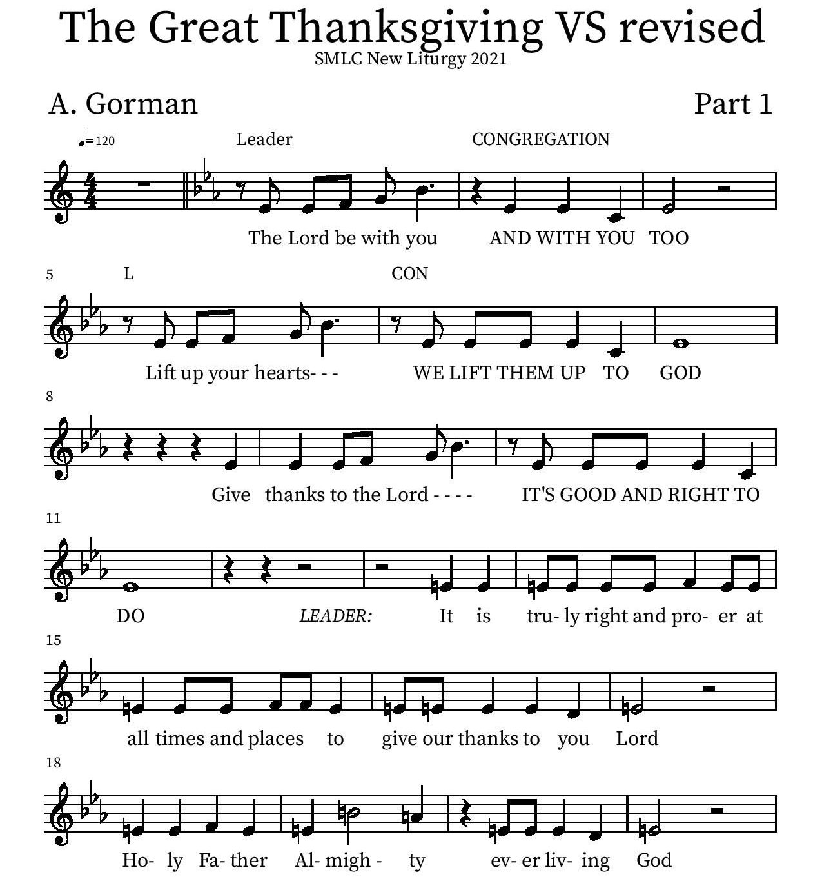
Thanksgiving

Holy Holy

Eucharistic Prayer
P: You are indeed holy, almighty and merciful God…. Do this for the remembrance of me.
The Lord’s Prayer
Our Father in heaven, hallowed be your name, your kingdom come, your will be done, on earth as in heaven. Give us today our daily bread. Forgive us our sins as we forgive those who sin against us. Save us from the time of trial and deliver us from evil. For the kingdom, the power, and the glory are yours, now and forever.
Amen.
Invitation to the Table
You may now take the individual cups provided for communion. Please receive communion with these words: “The body of Christ given for you; the blood of Christ shed for you.”

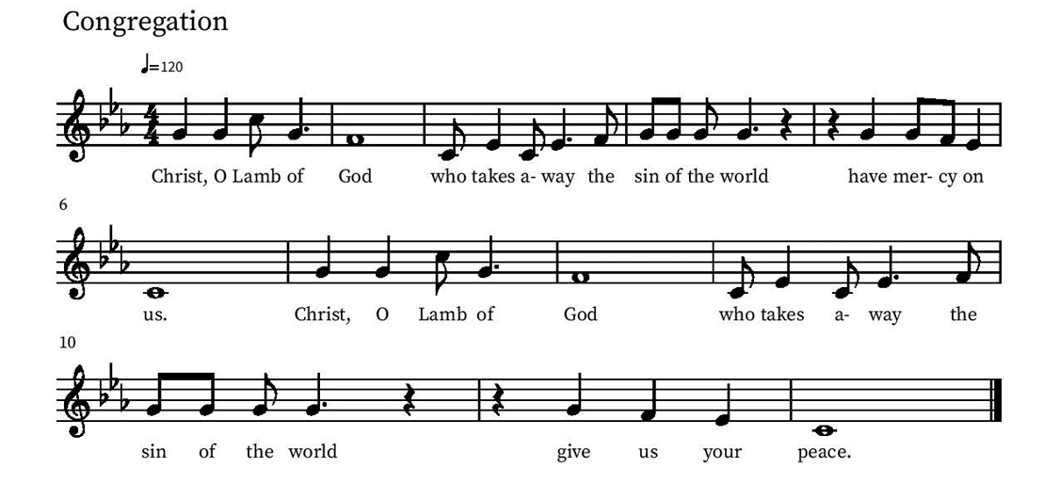
Communion Hymn – Lamb of God

Table Blessing
May the grace of our Lord Jesus Christ and the gifts of his body and blood strengthen, keep and unite us, now and forever.
Amen.
Post-Communion Prayer
Lord of life,
in the gift of your body and blood
you turn the crumbs of our faith into a feast of salvation.
Send us forth into the world with shouts of joy,
bearing witness to the abundance of your love
in Jesus Christ, our Savior and Lord.
Amen.
Blessing
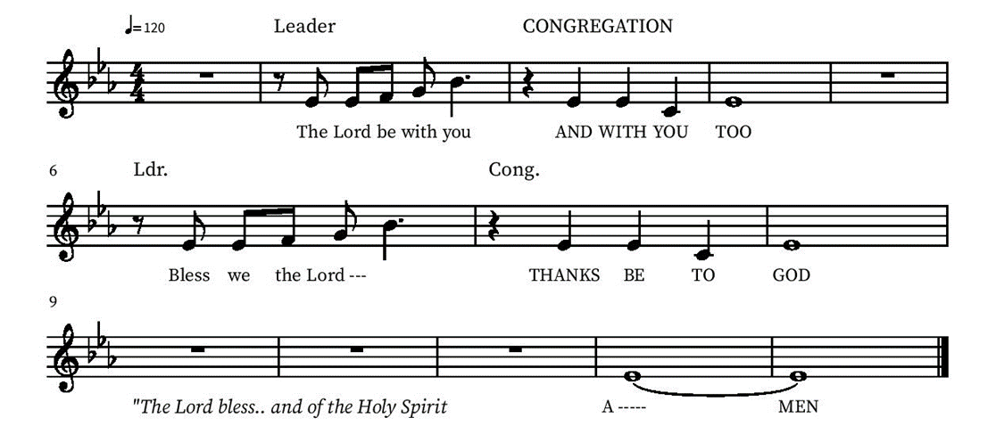

Community Time
Recognition of Pastor Alicia
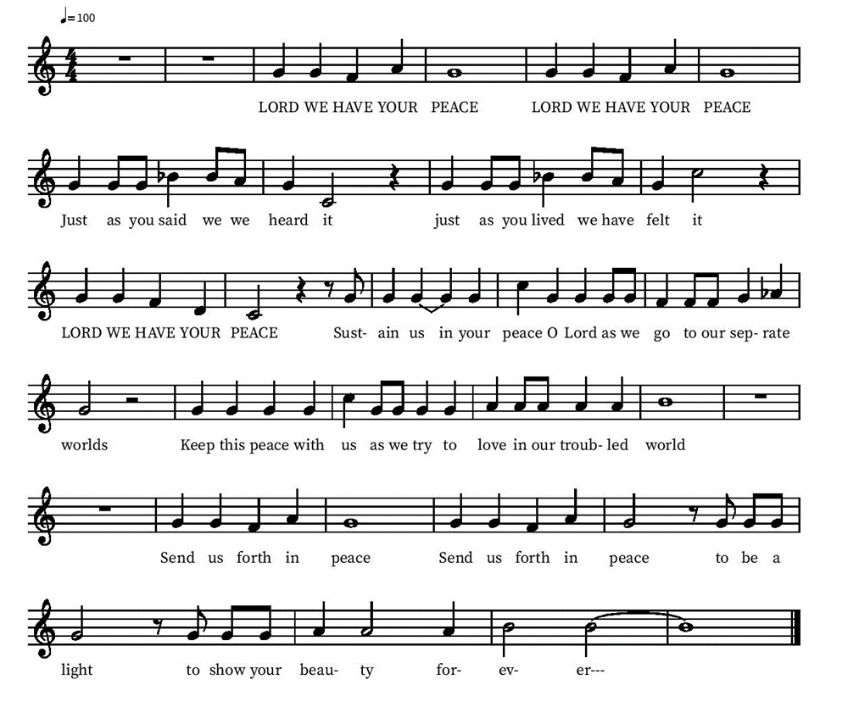
Sending Song

Sending
Go in peace. The living Word dwells in you.
Thanks be to God.
Join us for refreshments and Christian education after the service!

*See reverse for Upcoming Events

God is good! So many great things are happening at St. Mark's!

Oct 3 Celebration of Pastor Alicia’s 10 years of leading Spanish speaking ministry at St. Mark’s! Confirmation students and volunteers will be hosting a breakfast in her honor. Regular Sunday school after celebration
Oct 3 12:30 pm Pool party and lunch for all youth and families at the Geiers!
Oct 6 10 am- 2 pm NEW KEYS for upper camps (Jacobson Hall area) distributed by Bobb Briggs (The Sanctuary building will NOT be rekeyed at this time).
Oct 6 5:30 Bells in the Sanctuary
Oct 9 Men’s breakfast/ women’s breakfast
Oct 10 All congregation event Thursday Quilters, celebrating and honoring their many years of making quilts for people around the world with Lutheran World Relief. Sale of quilted items, opportunities to volunteer, slideshow
Oct 10 Last Day of key exchange for all buildings around patio
Oct 13 5:30 Bells in the Sanctuary
Oct 17 Regular Sunday school confirmation Adult Ed
Oct 20 5:30 Bells in the Sanctuary
Oct 24 Stewardship commitment Sunday and stories of Our Lives Manuel Alverez
Oct 24 3:30 p.m. Installation service of Pastor Karla ( bilingual)
Oct 27 5:30 Bells in the Sanctuary
Oct 30 10 a.m. new members class- please speak to Pastor Karla if you are interested in membership at St Mark’s
Oct 31 Reformation Sunday! One service, 10 AM, bilingual, receiving new members and giving Bibles to those who are in confirmation. Wear red!

Looking ahead- Organ (and more) concert Saturday, Nov 20, 2 pm This will be a fundraiser in support of needed organ repair.

Bells and Children’s Christmas pageant, Sunday Dec 19 one service, 10 am

If you have other items for the calendar, please call or email the office at office.stmarkscv@gmail.com

