St. Mark’s Worship Sunday September 26, 2021
Welcome to our Online Worship
Celebration of 1st Communion

Welcome back to worship inside your church!
Stationed at the tables at the entrance our greeters have hand sanitizer and masks if you need them, bulletins and self-contained communion cups (please wait for the Pastor to direct you to open them).
The restrooms will be open, but we request that one family group at a time uses the facilities.
We will be serving coffee after the service. We're staying masked to protect children and anyone who feels vulnerable, vaccinated or not. All are welcome, unless you aren't feeling well, then please recover at home and watch the worship service on Facebook live at 9 AM.
If you are worshipping at home, you may want to prepare some bread, wine, or juice to receive Holy Communion. You may commune yourself or those around you with these words:
“The body of Christ given for you; the blood of Christ shed for you.”
Prelude
Welcome
Mission
Celebrating God’s love and forgiveness, we serve others
Opening Song – Oh, Sing to the Lord Verses 1,2,4,5 ELW #822
¹Oh, sing to the Lord, oh, sing God
a new song.
Oh, sing to the Lord, oh, sing God
a new song.
Oh, sing to the Lord, oh, sing God
a new song.
Oh, sing to our God, oh, sing to our God.

²For God is the Lord, and God
has done wonders.
For God is the Lord, and God
has done wonders.
For God is the Lord, and God
has done wonders.
Oh, sing to our God, oh, sing to our God.
⁴Oh, shout to our God, who gave us the Spirit.
Oh, shout to our God, who gave us the Spirit.
Oh, shout to our God, who gave us the Spirit.
Oh, sing to our God, oh, sing to our God.

⁵For Jesus is Lord! Amen! Alleluia!
For Jesus is Lord! Amen! Alleluia!
For Jesus is Lord! Amen! Alleluia!
Oh, sing to our God, oh, sing to our God.

Prayer of the Day
Generous God, your Son gave his life that we might come to peace with you. Give us a share of your Spirit, and in all we do empower us to bear the name of Jesus Christ, our Savior and Lord.
Amen.
Children’s message

Reading: Psalm 19:7-14

⁷The teaching of the Lord is perfect and revives the soul;
the testimony of the Lord is sure and gives wisdom to the simple.
⁸The statutes of the Lord are just and rejoice the heart;
the commandment of the Lord is clear and gives light to the eyes.
⁹The fear of the Lord is clean and endures forever;
the judgments of the Lord are true and righteous altogether.
¹⁰More to be desired are they than gold, more than much fine gold,
sweeter far than honey, than honey in the comb.
¹¹By them also is your servant enlightened,
and in keeping them there is great reward.
¹²Who can detect one’s own offenses?
Cleanse me from my secret faults.
¹³Above all, keep your servant from presumptuous sins; let them not get dominion over me;
then shall I be whole and sound, and innocent of a great offense.
¹⁴Let the words of my mouth and the meditation of my heart be acceptable in your sight,
O Lord, my strength and my redeemer.
Word of God, Word of Life
Thanks be to God.
Gospel Acclamation
Alleluia. Lord to whom shall we go? You have the words of eternal life.
Alleluia.
The Holy Gospel according to Mark.
Glory to you, O Lord.

Gospel: Mark 9:38-50
³⁸John said to [Jesus,] “Teacher, we saw someone casting out demons in your name, and we tried to stop him, because he was not following us.” ³⁹But Jesus said, “Do not stop him; for no one who does a deed of power in my name will be able soon afterward to speak evil of me. ⁴⁰Whoever is not against us is for us. ⁴¹For truly I tell you, whoever gives you a cup of water to drink because you bear the name of Christ will by no means lose the reward.
⁴²“If any of you put a stumbling block before one of these little ones who believe in me, it would be better for you if a great millstone were hung around your neck and you were thrown into the sea. ⁴³If your hand causes you to stumble, cut it off; it is better for you to enter life maimed than to have two hands and to go to hell, to the unquenchable fire. ⁴⁵And if your foot causes you to stumble, cut it off; it is better for you to enter life lame than to have two feet and to be thrown into hell. ⁴⁷And if your eye causes you to stumble, tear it out; it is better for you to enter the kingdom of God with one eye than to have two eyes and to be thrown into hell, ⁴⁸where their worm never dies, and the fire is never quenched.
⁴⁹“For everyone will be salted with fire. ⁵⁰Salt is good; but if salt has lost its saltiness, how can you season it? Have salt in yourselves, and be at peace with one another.”
The Gospel of our Lord.
Praise to you, O Christ
Sermon Pastor Karla Halvorson
Hymn of the Day – Lord, Whose Love in Humble Service All Verses ELW #712

¹Lord, whose love in humble service
bore the weight of human need,
who upon the cross, forsaken,
worked your mercy's perfect deed:
we, your servants, bring the worship
not of voice alone, but heart;
consecrating to your purpose
ev'ry gift which you impart.

²Still your children wander homeless;
still the hungry cry for bread;
still the captives long for freedom;
still in grief we mourn our dead.
As you, Lord, in deep compassion
healed the sick and freed the soul,
by your Spirit send your power
to our world to make it whole.

³As we worship, grant us vision,
till your love's revealing light
in its height and depth and greatness
dawns upon our quickened sight,
making known the needs and burdens
your compassion bids us bear,
stirring us to ardent service,
your abundant life to share.

⁴Called by worship to your service,
forth in your dear name we go,
to the child, the youth, the aged,
love in living deeds to show;
hope and health, good will and comfort,
counsel, aid and peace we give,
that your servants, Lord, in freedom
may your mercy know and live.
Prayers of Intercession
Leader: Lord, in your mercy,
Congregation: Hear our prayer.
Song
God Is so good,
God is so good,
God is so good,
He’s so good to me!
Blessing of prayer quilts
Song
God Is so good,
God is so good,
God is so good,
He’s so good to me!
The Peace
The peace of Christ be with you always.
And also, with you.
(you may share the peace of Christ with anyone who is with you, share the peace in the comments, text an offering of peace to someone, or simply send a prayer of blessing and peace to someone.)
Offering
Thanksgiving Moment
Offering information
St. Mark’s Church, 580 Hilltop Dr. Chula Vista, CA 91910
Venmo: @stmarks-churchchulavista

Offering Song
Thank you for giving to the Lord
I am a life that was changed
Thank you for giving to the Lord
I am so glad you gave
Offering Prayer
God of abundance,
you cause streams to break forth in the desert
and manna to rain from the heavens.
Accept the gifts you have first given us.
Unite them with the offering of our lives
to nourish the world you love so dearly;
through Jesus Christ, our Savior and Lord.
Amen.
First Communion Liturgy
Pastor Alicia: We invite all those receiving first communion and their parents and sponsors to come forward and face the altar
Pastor Alicia: We begin with Scripture - Matthew 26:26-28
²⁶ While they were eating, Jesus took a loaf of bread, and after blessing it he broke it, gave it to the disciples, and said, ‘Take, eat; this is my body.’ ²⁷Then he took a cup, and after giving thanks he gave it to them, saying, ‘Drink from it, all of you; ²⁸for this is my blood of the covenant, which is poured out for many for the forgiveness of sins.
Pastor Karla: Paul writes in 1 Corinthians 11:
For I received from the Lord what I also handed on to you, that the Lord Jesus on the night when he was betrayed took a loaf of bread, ²⁴and when he had given thanks, he broke it and said, ‘This is my body that is for you. Do this in remembrance of me.’ ²⁵In the same way he took the cup also, after supper, saying, ‘This cup is the new covenant in my blood. Do this, as often as you drink it, in remembrance of me.’ ²⁶For as often as you eat this bread and drink the cup, you proclaim the Lord’s death until he comes.
Pastor Alicia: You today are receiving the gift of Holy Communion, the body and blood of our Lord Jesus Christ. We believe that this is an extraordinary moment of grace. For Christ is in, with, and under the bread and fruit of the vine.
Pastor Karla: When we receive the gift of Holy Communion, we have just what the word means- union with God and the forgiveness of sins. This meal also binds us to all believers through all times and in all places, making us one in the body of Christ.
Pastor Alicia: Jesus Christ’s introduction of the Lord’s Supper is found in Matthew, Mark, Luke, and in Paul’s First Letter to the Corinthians. Jesus took bread and wine and presented it as his body and blood to his disciples. The Christian church continues this sacrament to this day. We now ask those receiving communion and their parents. What is the gift we receive from such eating and drinking?
First Communion Parents & Families: Jesus tells us the gifts we receive in Holy Communion are forgiveness of sins, life and salvation.
Pastor Karla: We ask you all, including the congregation…How can bodily eating and drinking do such great things?
Everyone: It is not the eating and drinking that does this, but the words here written, “Given and shed FOR YOU for the remission of sins.” These words, along with the eating and drinking, are the main thing in the Sacrament; and whoever believes these words has exactly what they say, namely, the forgiveness of sins.
The Affirmation of Baptism
Pastor Alicia: Let us pray.
Merciful God, we thank you for these sisters and brothers,
whom you have made your own by water and the Word in baptism.
You have called them to yourself,
enlightened them with the gifts of your Spirit,
and nourished them in the community of faith.
Uphold your servants in the gifts and promises of baptism,
and unite the hearts of all whom you have brought to new birth.
We ask this in the name of Christ.
Amen.
Congregational Profession of Faith
Pastor Karla: I ask you to profess your faith in Christ Jesus, reject sin, and confess the faith of the church.

Do you renounce the devil and all the forces that defy God?
Response:
I renounce them.
Do you renounce the powers of this world that rebel against God?
Response:
I renounce them.
Do you renounce the ways of sin that draw you from God?
Response:
I renounce them.
Do you believe in God the Father?
I believe in God, the Father almighty,
creator of heaven and earth.
Do you believe in Jesus Christ, the Son of God?
I believe in Jesus Christ, God’s only Son, our Lord,
who was conceived by the Holy Spirit,
born of the virgin Mary,
suffered under Pontius Pilate,
was crucified, died, and was buried;
he descended to the dead.*
On the third day he rose again;
he ascended into heaven,
he is seated at the right hand of the Father,
and he will come to judge the living and the dead.
Do you believe in God the Holy Spirit?
I believe in the Holy Spirit,
the holy catholic church,
the communion of saints,
the forgiveness of sins,
the resurrection of the body,
and the life everlasting.
Affirmation in the Presence of the Assembly
Pastor Alicia: You have made public profession of your faith. Do you intend to continue in the covenant God made with you in holy baptism:
to live among God’s faithful people,
to hear the word of God and share in the Lord’s supper,
to proclaim the good news of God in Christ through word and deed,
to serve all people, following the example of Jesus,
and to strive for justice and peace in all the earth?
Each person responds:
I do, and I ask God to help and guide me.
The minister addresses the assembly.
People of God, do you promise to support these sisters and brothers and pray for them in their life in Christ?
We do, and we ask God to help and guide us.
Those making affirmation may kneel. The presiding minister prays for God’s blessing.
Pastor Alicia: Let us pray.
We give you thanks, O God, that through water and the Holy Spirit you give us new birth, cleanse us from sin, and raise us to eternal life.
The blessing is repeated for each person.
Pastors Together: Father in heaven, for Jesus’ sake, stir up in (NAME) the gift of your Holy Spirit; confirm them in their faith, guide their lives, empower them in their serving, give them patience in suffering and bring them to eternal life.
Amen.
Those making public affirmation stand and face the assembly.
Pastor Alicia: Would those receiving their First Communion and their family members please face the congregation.
Congregation: We welcome you as communing members of St Mark’s Lutheran Church and the world-wide Christian community. Together we will explore the mystery and wonder of Holy Communion and accept Christ’s gifts of grace and salvation that come to us through this holy sacrament.
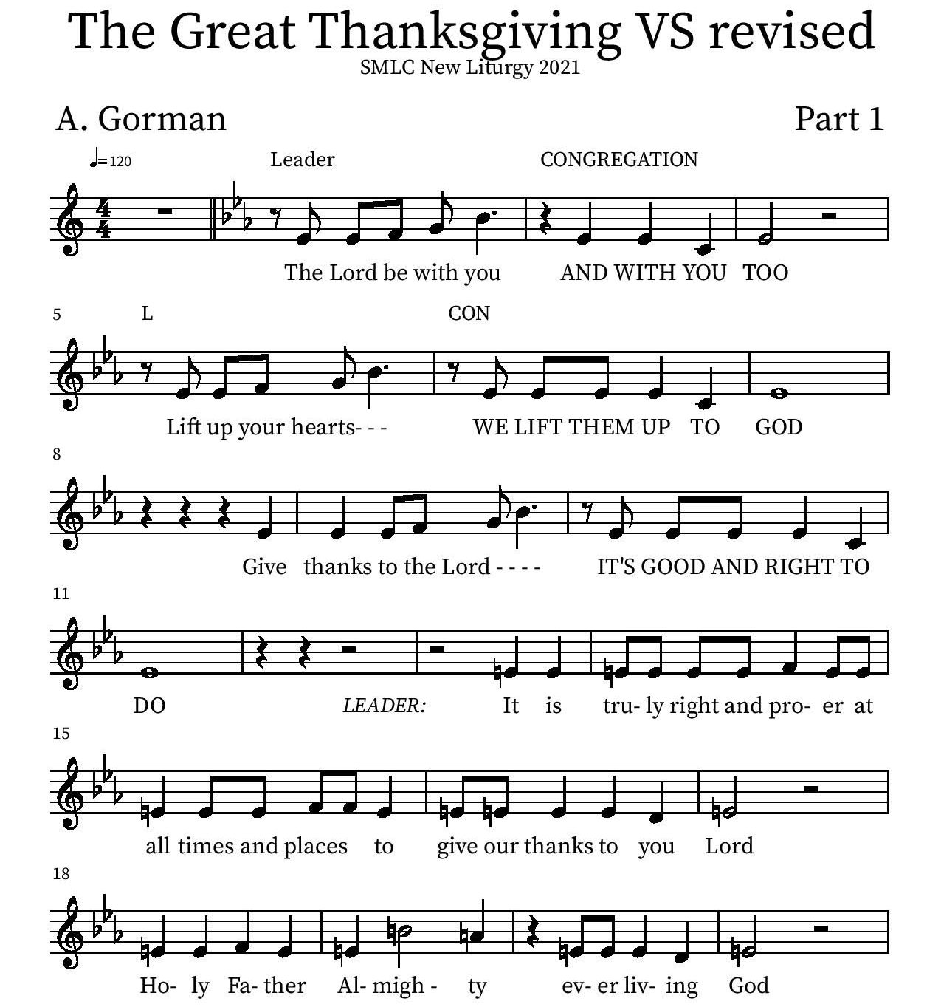
Thanksgiving

Holy Holy

Eucharistic Prayer
P: You are indeed holy, almighty and merciful God…. Do this for the remembrance of me.

The Lord’s Prayer
Our Father in heaven, hallowed be your name, your kingdom come, your will be done, on earth as in heaven. Give us today our daily bread. Forgive us our sins as we forgive those who sin against us. Save us from the time of trial and deliver us from evil. For the kingdom, the power, and the glory are yours, now and forever.
Amen.
Invitation to the Table
You may now take the individual cups provided for communion. Please receive communion with these words: “The body of Christ given for you; the blood of Christ shed for you.”

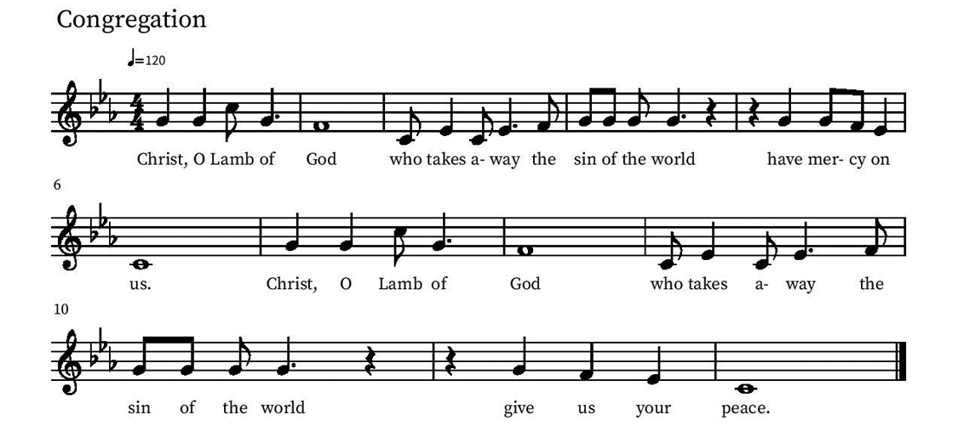
Communion Hymn – Lamb of God

Table Blessing
May the grace of our Lord Jesus Christ and the gifts of his body and blood strengthen, keep and unite us, now and forever.
Amen.
Post-Communion Prayer
Lord of life,
in the gift of your body and blood
you turn the crumbs of our faith into a feast of salvation.
Send us forth into the world with shouts of joy,
bearing witness to the abundance of your love
in Jesus Christ, our Savior and Lord.
Amen.
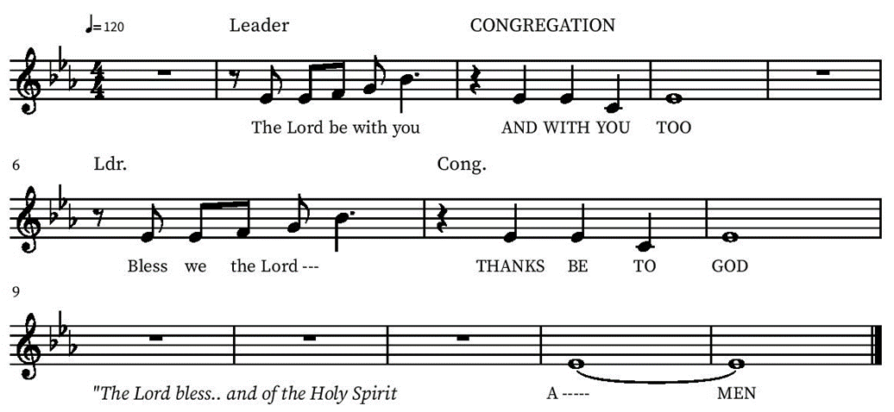
Blessing

Community Time
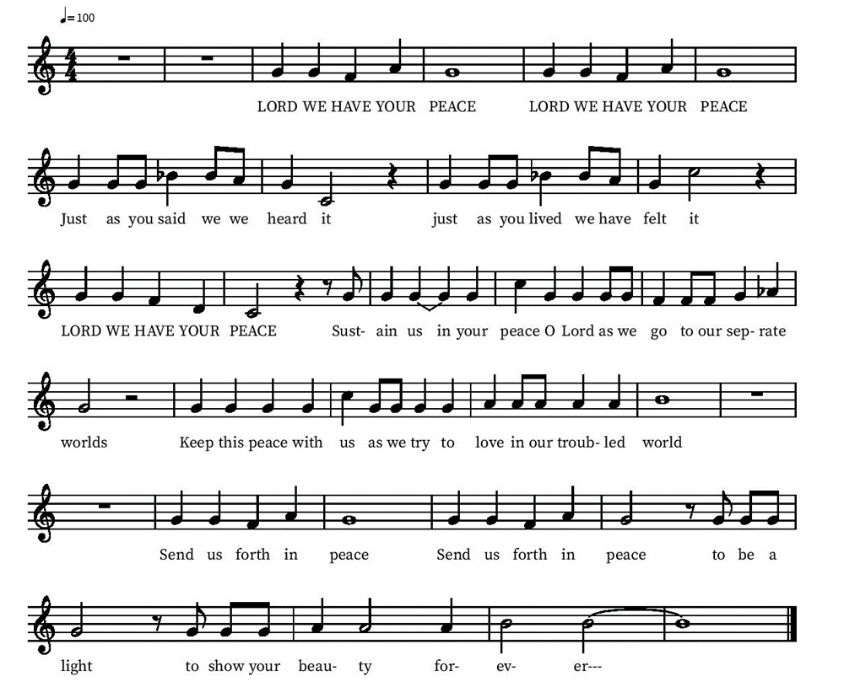
Sending Song

Sending
Go in peace. The living Word dwells in you.
Thanks be to God.
Share the Peace of the Lord in the comments below!

