St. Mark’s Worship Sunday September 19, 2021
Welcome to our Online Worship

Welcome back to worship inside your church!
Stationed at the tables at the entrance our greeters have hand sanitizer and masks if you need them, bulletins and self-contained communion cups (please wait for the Pastor to direct you to open them).
The restrooms will be open, but we request that one family group at a time uses the facilities.
We will be serving coffee after the service. We're staying masked to protect children and anyone who feels vulnerable, vaccinated or not. All are welcome, unless you aren't feeling well, then please recover at home and watch the worship service on Facebook live at 9 AM.
If you are worshipping at home, you may want to prepare some bread, wine, or juice to receive Holy Communion. You may commune yourself or those around you with these words:
“The body of Christ given for you; the blood of Christ shed for you.”
Prelude
Welcome
Mission
Celebrating God’s love and forgiveness, we serve others
Opening Song – Children of the Heavenly Father All Verses ELW #781
¹Children of the heav'nly Father
safely in his bosom gather;
nestling bird nor star in heaven
such a refuge e'er was given.

²God his own doth tend and nourish,
in his holy courts they flourish.
From all evil things he spares them,
in his mighty arms he bears them.

³Neither life nor death shall ever
from the Lord his children sever;
unto them his grace he showeth,
and their sorrows all he knoweth.

⁴Though he giveth or he taketh,
God his children ne'er forsaketh;
his the loving purpose solely
to preserve them pure and holy.

Confession and Forgiveness
Blessed be the holy Trinity, ☩ one God,
whose teaching is life,
whose presence is sure,
and whose love is endless.
Amen.
Let us confess our sins to the one who welcomes us with an open heart.
Silence is kept for reflection.

God, our comforter,
like lost sheep, we have gone astray.
We gaze upon abundance and see scarcity.
We turn our faces away from injustice and oppression.
We exploit the earth with our apathy and greed.
Free us from our sin, gracious God.
Listen when we call out to you for help.
Lead us by your love to love our neighbors as ourselves.
Amen.
All have sinned and fall short of the glory of God.
By the gift of grace in ☩ Christ Jesus, God makes you righteous.
Receive with glad hearts the forgiveness of all your sins.
Amen.

Prayer of the Day
O God, our teacher and guide, you draw us to yourself and welcome us as beloved children. Help us to lay aside all envy and selfish ambition, that we may walk in your ways of wisdom and understanding as servants of your Son, Jesus Christ, our Savior and Lord.
Amen.
Children’s message

Reading: James 3:13--4:3, 7-8a

¹³Who is wise and understanding among you? Show by your good life that your works are done with gentleness born of wisdom. ¹⁴But if you have bitter envy and selfish ambition in your hearts, do not be boastful and false to the truth. ¹⁵Such wisdom does not come down from above, but is earthly, unspiritual, devilish. ¹⁶For where there is envy and selfish ambition, there will also be disorder and wickedness of every kind. ¹⁷But the wisdom from above is first pure, then peaceable, gentle, willing to yield, full of mercy and good fruits, without a trace of partiality or hypocrisy. ¹⁸And a harvest of righteousness is sown in peace for those who make peace.

^{4:1}Those conflicts and disputes among you, where do they come from? Do they not come from your cravings that are at war within you? ²You want something and do not have it; so you commit murder. And you covet something and cannot obtain it; so you engage in disputes and conflicts. You do not have, because you do not ask. ³You ask and do not receive, because you ask wrongly, in order to spend what you get on your pleasures.

⁷Submit yourselves therefore to God. Resist the devil, and he will flee from you. ^{8a}Draw near to God, and he will draw near to you.
Word of God, Word of Life
Thanks be to God.
Gospel Acclamation
Alleluia. Lord to whom shall we go? You have the words of eternal life.
Alleluia.
The Holy Gospel according to Mark.
Glory to you, O Lord.

Gospel: Mark 9:30-37
³⁰[Jesus and the disciples went on] and passed through Galilee. He did not want anyone to know it;³¹for he was teaching his disciples, saying to them, “The Son of Man is to be betrayed into human hands, and they will kill him, and three days after being killed, he will rise again.” ³²But they did not understand what he was saying and were afraid to ask him.
³³Then they came to Capernaum; and when he was in the house he asked them, “What were you arguing about on the way?” ³⁴But they were silent, for on the way they had argued with one another who was the greatest. ³⁵He sat down, called the twelve, and said to them, “Whoever wants to be first must be last of all and servant of all.” ³⁶Then he took a little child and put it among them; and taking it in his arms, he said to them, ³⁷“Whoever welcomes one such child in my name welcomes me, and whoever welcomes me welcomes not me but the one who sent me.”
The Gospel of our Lord.
Praise to you, O Christ
Sermon Pastor Karla Halvorson
Hymn of the Day – Jesus Loves Me! / Amazing Grace, How Sweet the Sound ELW #595/ 779

¹Jesus loves me! this I know,
for the Bible tells me so;
little ones to him belong,
they are weak, but he is strong.

^{1a}Amazing grace! how sweet the sound
that saved a wretch like me!
I once was lost, but now am found;
was blind, but now I see.
²'Twas grace that taught my heart to fear,
and grace my fears relieved;
how precious did that grace appear
the hour I first believed!

³Jesus loves me! he will stay
close beside me all the way;
when at last I come to die,
he will take me home on high.
Prayers of Intercession
Leader: Lord, in your mercy,
Congregation: Hear our prayer.
Song
God Is so good,
God is so good,
God is so good,
He’s so good to me!
Blessing of prayer quilts
Song
God Is so good,
God is so good,
God is so good,
He’s so good to me!
The Peace
The peace of Christ be with you always.
And also, with you.
(you may share the peace of Christ with anyone who is with you, share the peace in the comments, text an offering of peace to someone, or simply send a prayer of blessing and peace to someone.)
Offering
Thanksgiving Moment
Offering information
St. Mark’s Church, 580 Hilltop Dr. Chula Vista, CA 91910
Venmo: @stmarks-churchchulavista

Offering Song
Thank you for giving to the Lord
I am a life that was changed
Thank you for giving to the Lord
I am so glad you gave
Offering Prayer
God of abundance,
you cause streams to break forth in the desert
and manna to rain from the heavens.
Accept the gifts you have first given us.
Unite them with the offering of our lives
to nourish the world you love so dearly;
through Jesus Christ, our Savior and Lord.
Amen.

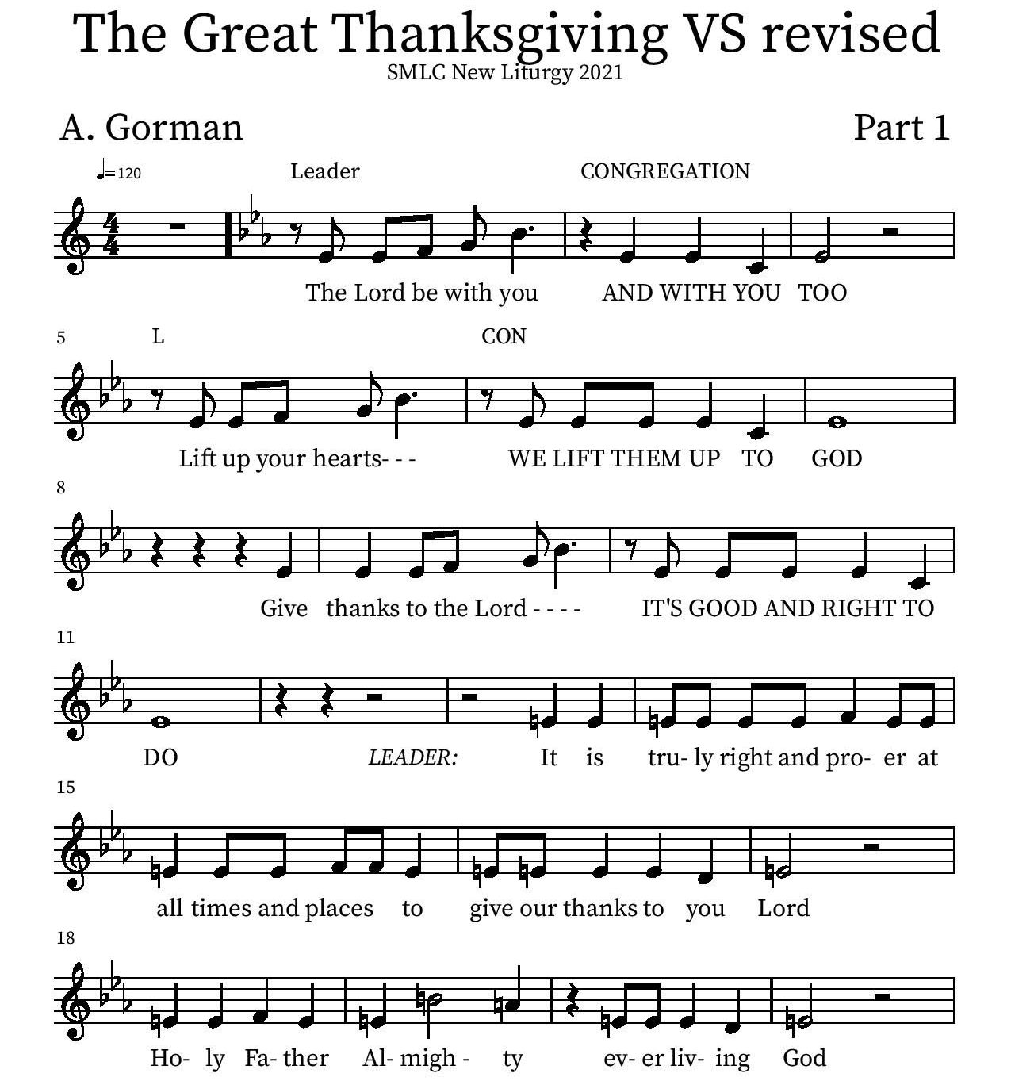
Thanksgiving

Holy Holy

Eucharistic Prayer
P: You are indeed holy, almighty and merciful God…. Do this for the remembrance of me.
The Lord’s Prayer
Our Father in heaven, hallowed be your name, your kingdom come, your will be done, on earth as in heaven. Give us today our daily bread. Forgive us our sins as we forgive those who sin against us. Save us from the time of trial and deliver us from evil. For the kingdom, the power, and the glory are yours, now and forever.
Amen.
Invitation to the Table
You may now take the individual cups provided for communion. Please receive communion with these words: “The body of Christ given for you; the blood of Christ shed for you.”

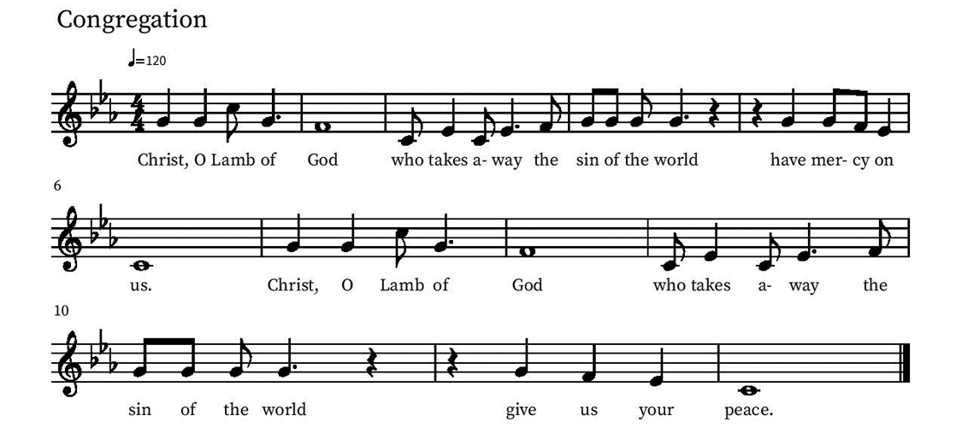
Communion Hymn – Lamb of God

Table Blessing
May the grace of our Lord Jesus Christ and the gifts of his body and blood strengthen, keep and unite us, now and forever.
Amen.
Post-Communion Prayer
Lord of life,
in the gift of your body and blood
you turn the crumbs of our faith into a feast of salvation.
Send us forth into the world with shouts of joy,
bearing witness to the abundance of your love
in Jesus Christ, our Savior and Lord.
Amen.
Blessing
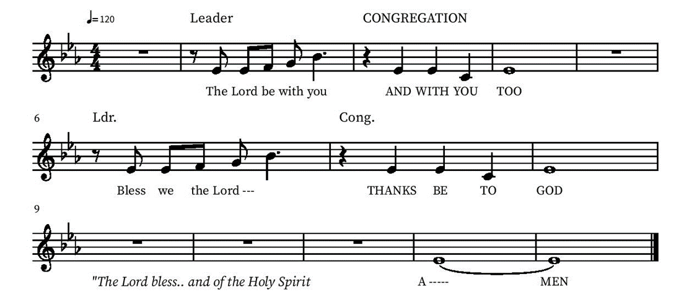

Community Time
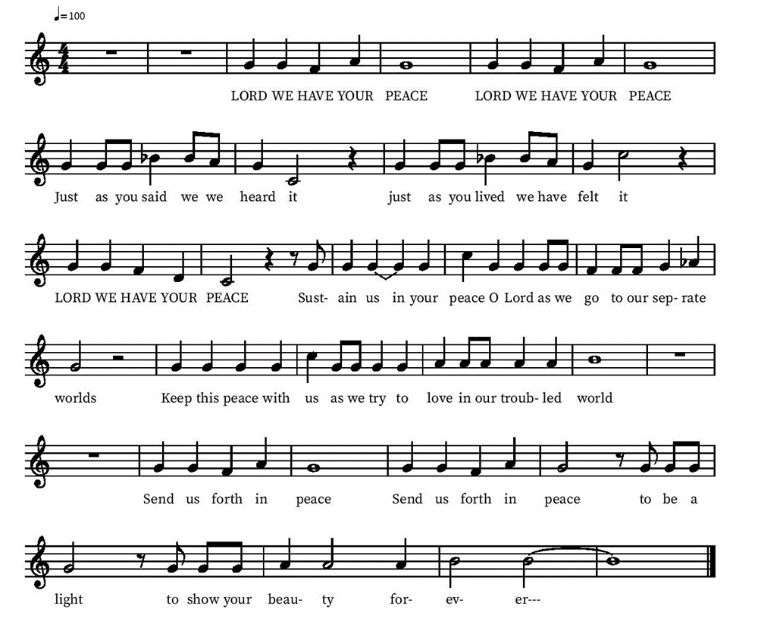
Sending Song

Sending
Go in peace. The living Word dwells in you.
Thanks be to God.
Share the Peace of the Lord in the comments below!

