St. Mark’s Worship Sunday September 05, 2021
Welcome to Online Worship

Welcome back to worship inside your church!
Stationed at the tables at the entrance our greeters have hand sanitizer and masks if you need them, bulletins and self-contained communion cups (please wait for the Pastor to direct you to open them) and they have a plate and envelopes where you can drop off your offering. We also are collecting your name and contact information. Please follow the direction of the ushers who will seat family groups six feet apart and refrain from hugs and handshakes.
The restrooms will be open, but we request that one family group at a time uses the facilities.
We will be serving coffee after the service. We're staying masked to protect children and anyone who feels vulnerable, vaccinated or not. All are welcome, unless you aren't feeling well, then please recover at home and watch the worship service on Facebook live at 9 AM.
If you are worshipping at home, you may want to prepare some bread, wine, or juice to receive Holy Communion. You may commune yourself or those around you with these words:
“The body of Christ given for you; the blood of Christ shed for you.”
Prelude
Welcome
Opening Song – For All the Faithful Women Verses 1,8,2, Last ELW #419
¹For all the faithful women
who served in days of old,
to you shall thanks be given;
to all, their story told.
They served with strength and gladness
in tasks your wisdom gave.
To you their lives bore witness,
proclaimed your pow'r to save.

⁸Recall the outcast woman
with whom our Lord conversed:
Christ gave her living water
to quench her deepest thirst.
Like hers, our hearts are yearning;
Christ offers us his word.
Then may our lips be burning
to witness to our Lord.
²O God, for saints and servants,
those named and those unknown,
in whom through all the ages
your light of glory shone,
we offer glad thanksgiving
and fervent prayer we raise
that, faithful in your service,
our lives may sing your praise.

^{Last} All praise to God the Father!
All praise to Christ the Son!
All praise to God the Spirit,
who binds the church as one!
With saints who went before us,
with saints who witness still,
we sing glad alleluias
and strive to do your will.

Sacrament of Holy Baptism for Ava Marie Shepherd
Profession of Faith
Pastor addresses the congregation:
I ask you to profess your faith in Christ Jesus, reject sin, and confess the faith of the church.
Do you renounce the devil and all the forces that defy God?
Response: I renounce them.
Do you renounce the powers of this world that rebel against God?
Response: I renounce them.
Do you renounce the ways of sin that draw you from God?
Response: I renounce them.
The Creed
Do you believe in God the Father?
I believe in God, the Father almighty,
creator of heaven and earth.

Do you believe in Jesus Christ, the Son of God?
I believe in Jesus Christ, God's only Son, our Lord,
who was conceived by the Holy Spirit,
born of the virgin Mary,
suffered under Pontius Pilate,
was crucified, died, and was buried;
he descended to the dead.
On the third day he rose again;
he ascended into heaven,
he is seated at the right hand of the Father,
and he will come to judge the living and the dead.

Do you believe in God the Holy Spirit?
I believe in the Holy Spirit,
the holy catholic church,
the communion of saints,
the forgiveness of sins,
the resurrection of the body,
and the life everlasting.
Thanksgiving at the Font
Pastor: The Lord be with you.
And also with you.
Let us give thanks to the Lord our God.
It is right to give our thanks and praise.
Pastor: We give you thanks… … in the unity of the Holy Spirit, now and forever.
Amen.
Baptism
Anointing with Oil
Welcome - A lighted candle is given
Pastor: Jesus said, I am the light of the world. Whoever follows me will have the light of life.
Let us welcome the newly baptized.
We welcome you into the body of Christ and into the mission we share:
join us in giving thanks and praise to God
and bearing God's creative and redeeming word to all the world.
Mission
Celebrating God’s love and forgiveness, we serve others

Prayer of the Day
Gracious God, throughout the ages you transform sickness into health and death into life. Open us to the power of your presence, and make us a people ready to proclaim your promises to the whole world, through Jesus Christ, our healer and Lord.
Amen.
Children’s message

Psalm: Psalm 146
¹Hallelujah!
Praise the Lord, O my soul!
²I will praise the Lord as long as I live;
I will sing praises to my God while I have my being.
³Put not your trust in rulers,
in mortals in whom there is no help.
⁴When they breathe their last, they return to earth,
and in that day their thoughts perish.
⁵Happy are they who have the God of Jacob for their help,
whose hope is in the Lord their God;
⁶who made heaven and earth, the seas, and all that is in them;
who keeps promises forever;
⁷who gives justice to those who are oppressed, and food to those who hunger.
The Lord sets the captive free.
⁸The Lord opens the eyes of the blind; the Lord lifts up those who are bowed down;
the Lord loves the righteous.
⁹The Lord cares for the stranger;
the Lord sustains the orphan and widow, but frustrates the way of the wicked.
¹⁰The Lord shall reign forever,
your God, O Zion, throughout all generations. Hallelujah!

Lesson 2: James 2:1-10 [11-13] 14-17
¹My brothers and sisters, do you with your acts of favoritism really believe in our glorious Lord Jesus Christ? ²For if a person with gold rings and in fine clothes comes into your assembly, and if a poor person in dirty clothes also comes in, ³and if you take notice of the one wearing the fine clothes and say, “Have a seat here, please,” while to the one who is poor you say, “Stand there,” or, “Sit at my feet,” ⁴have you not made distinctions among yourselves, and become judges with evil thoughts? ⁵Listen, my beloved brothers and sisters. Has not God chosen the poor in the world to be rich in faith and to be heirs of the kingdom that he has promised to those who love him? ⁶But you have dishonored the poor. Is it not the rich who oppress you? Is it not they who drag you into court? ⁷Is it not they who blaspheme the excellent name that was invoked over you?
⁸You do well if you really fulfill the royal law according to the scripture, “You shall love your neighbor as yourself.” ⁹But if you show partiality, you commit sin and are convicted by the law as transgressors. ¹⁰For whoever keeps the whole law but fails in one point has become accountable for all of it. [¹¹For the one who said, “You shall not commit adultery,” also said, “You shall not murder.” Now if you do not commit adultery but if you murder, you have become a transgressor of the law. ¹²So speak and so act as those who are to be judged by the law of liberty. ¹³For judgment will be without mercy to anyone who has shown no mercy; mercy triumphs over judgment.]
¹⁴What good is it, my brothers and sisters, if you say you have faith but do not have works? Can faith save you? ¹⁵If a brother or sister is naked and lacks daily food, ¹⁶and one of you says to them, “Go in peace; keep warm and eat your fill,” and yet you do not supply their bodily needs, what is the good of that? ¹⁷So faith by itself, if it has no works, is dead.
Word of God, Word of Life
Thanks be to God.
Gospel Acclamation
Alleluia. Lord to whom shall we go? You have the words of eternal life.
Alleluia.
The Holy Gospel according to Mark.
Glory to you, O Lord.

Gospel: Mark 7:24-37
²⁴[Jesus] set out and went away to the region of Tyre. He entered a house and did not want anyone to know he was there. Yet he could not escape notice,²⁵but a woman whose little daughter had an unclean spirit immediately heard about him, and she came and bowed down at his feet. ²⁶Now the woman was a Gentile, of Syrophoenician origin. She begged him to cast the demon out of her daughter. ²⁷He said to her, “Let the children be fed first, for it is not fair to take the children’s food and throw it to the dogs.” ²⁸But she answered him, “Sir, even the dogs under the table eat the children’s crumbs.” ²⁹Then he said to her, “For saying that, you may go—the demon has left your daughter.” ³⁰So she went home, found the child lying on the bed, and the demon gone.
³¹Then he returned from the region of Tyre, and went by way of Sidon towards the Sea of Galilee, in the region of the Decapolis. ³²They brought to him a deaf man who had an impediment in his speech; and they begged him to lay his hand on him. ³³He took him aside in private, away from the crowd, and put his fingers into his ears, and he spat and touched his tongue. ³⁴Then looking up to heaven, he sighed and said to him, “Ephphatha,” that is, “Be opened.” ³⁵And immediately his ears were opened, his tongue was released, and he spoke plainly. ³⁶Then Jesus ordered them to tell no one; but the more he ordered them, the more zealously they proclaimed it. ³⁷They were astounded beyond measure, saying, “He has done everything well; he even makes the deaf to hear and the mute to speak.”
The Gospel of our Lord.
Praise to you, O Christ
Sermon Pastor Karla Halvorson
Hymn of the Day – Healer of Our Every Ill All Verses ELW #612

Refrain
Healer of our ev'ry ill,
light of each tomorrow,
give us peace beyond our fear,
and hope beyond our sorrow.

¹You who know our fears and sadness,
grace us with your peace and gladness;
Spirit of all comfort, fill our hearts. Refrain

²In the pain and joy beholding
how your grace is still unfolding,
give us all your vision, God of love. Refrain

³Give us strength to love each other,
ev'ry sister, ev'ry brother;
Spirit of all kindness, be our guide. Refrain

⁴You who know each thought and feeling,
teach us all your way of healing;
Spirit of compassion, fill each heart. Refrain
Prayers of Intercession
Leader: Lord, in your mercy,
Congregation: Hear our prayer.
Song
God Is so good,
God is so good,
God is so good,
He’s so good to me!
Blessing of prayer quilts
Song
God Is so good,
God is so good,
God is so good,
He’s so good to me!

The Peace
The peace of Christ be with you always.
And also, with you.
(you may share the peace of Christ with anyone who is with you, share the peace in the comments, text an offering of peace to someone, or simply send a prayer of blessing and peace to someone.)
Offering
Thanksgiving Moment
Offering information
St. Mark’s Church, 580 Hilltop Dr. Chula Vista, CA 91910
Venmo: @stmarks-churchchulavista

Offering Song
Thank you for giving to the Lord
I am a life that was changed
Thank you for giving to the Lord
I am so glad you gave
Offering Prayer
God of abundance,
you cause streams to break forth in the desert
and manna to rain from the heavens.
Accept the gifts you have first given us.
Unite them with the offering of our lives
to nourish the world you love so dearly;
through Jesus Christ, our Savior and Lord.
Amen.
The Great Thanksgiving
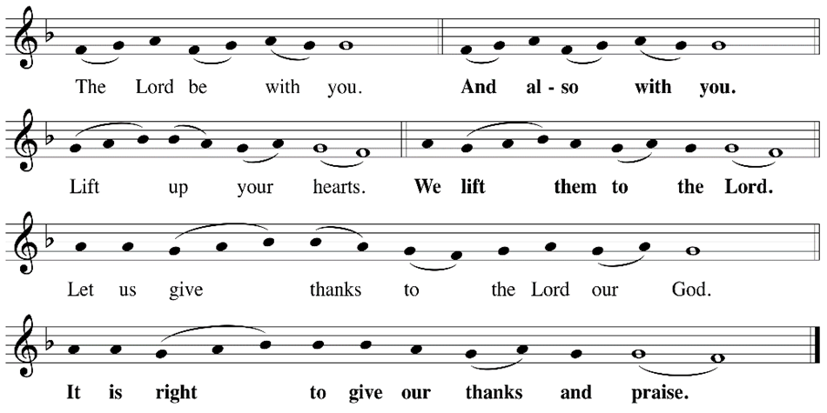
P: It is indeed right, our duty and our joy, that we should, at all times and in all places
give thanks and praise ... we praise your name and join their unending hymn:
Holy Holy
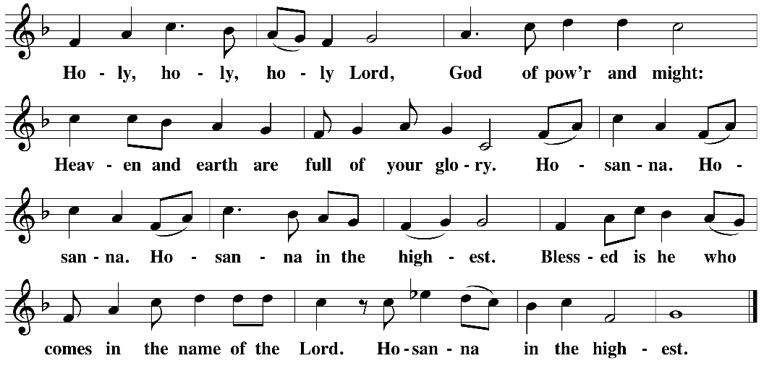

Eucharistic Prayer
The Lord’s Prayer
Our Father in heaven, hallowed be your name, your kingdom come, your will be done, on earth as in heaven. Give us today our daily bread. Forgive us our sins as we forgive those who sin against us. Save us from the time of trial and deliver us from evil. For the kingdom, the power, and the glory are yours, now and forever.
Amen.
Invitation to the Table
You may now take the individual cups provided for communion. Please receive communion with these words: “The body of Christ given for you; the blood of Christ shed for you.”
Communion Hymn – Lamb of God
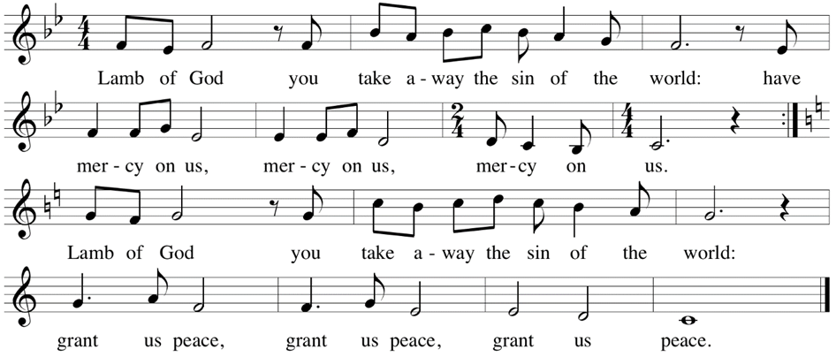

Table Blessing
May the grace of our Lord Jesus Christ and the gifts of his body and blood strengthen, keep and unite us, now and forever.
Amen.
Post-Communion Prayer
Lord of life,
in the gift of your body and blood
you turn the crumbs of our faith into a feast of salvation.
Send us forth into the world with shouts of joy,
bearing witness to the abundance of your love
in Jesus Christ, our Savior and Lord.
Amen.
Community Time
Blessing
People of God,
you are Christ’s body,
bringing new life to a suffering world.
The holy Trinity, ☩ one God,
bless you now and forever.
Amen.
Sending Song – Lord, Dismiss Us with Your Blessing All Verses ELW #545

¹Lord, dismiss us with your blessing,
fill our hearts with joy and peace;
let us each, your love possessing,
triumph in redeeming grace.
Oh, refresh us; oh, refresh us,
trav'ling through this wilderness.

²Thanks we give and adoration
for your gospel's joyful sound.
May the fruits of your salvation
in our hearts and lives abound.
Ever faithful, ever faithful
to your truth may we be found.
³Savior, when your love shall call us
from our struggling pilgrim way,
let no fear of death appall us,
glad your summons to obey.
May we ever, may we ever
reign with you in endless day.

Sending
Go in peace. The living Word dwells in you.
Thanks be to God.
Share the Peace of the Lord in the comments below!

