St. Mark’s Worship Sunday August 22, 2021
Welcome to our Online Worship

Welcome back to worship inside your church!
Stationed at the tables at the entrance our greeters have hand sanitizer and masks if you need them, bulletins and self-contained communion cups (please wait for the Pastor to direct you to open them) and they have a plate and envelopes where you can drop off your offering. We also are collecting your name and contact information. Please follow the direction of the ushers who will seat family groups six feet apart and refrain from hugs and handshakes.
The restrooms will be open, but we request that one family group at a time uses the facilities.
We will be serving coffee after the service. We're staying masked to protect children and anyone who feels vulnerable, vaccinated or not. All are welcome, unless you aren't feeling well, then please recover at home and watch the worship service on Facebook live at 9 AM.
If you are worshipping at home, you may want to prepare some bread, wine, or juice to receive Holy Communion. You may commune yourself or those around you with these words:
“The body of Christ given for you; the blood of Christ shed for you.”
Prelude
Welcome
Opening Song – Blessed Assurance All Verses ELW #638
¹Blessed assurance, Jesus is mine!
Oh, what a foretaste of glory divine!
Heir of salvation, purchase of God,
born of his Spirit, washed in his blood.

Refrain
This is my story, this is my song,
praising my Savior, all the day long:
this is my story, this is my song,
praising my Savior all the day long.

²Perfect submission, perfect delight,
visions of rapture now burst on my sight;
angels descending bring from above
echoes of mercy, whispers of love.
Refrain

³Perfect submission, all is at rest;
I in my Savior am happy and blest,
watching and waiting, looking above,
filled with his goodness, lost in his love. Refrain
Confession and Forgiveness
Blessed be the holy Trinity, ☩ one God,
the God of manna,
the God of miracles,
the God of mercy.
Amen.
Drawn to Christ and seeking God’s abundance,
let us confess our sin.
Silence is kept for reflection.
God, our provider,
help us.
It is hard to believe there is enough to share.
We question your ways when they differ from the ways
of the world in which we live.
We turn to our own understanding
rather than trusting in you.
We take offense at your teachings and your ways.
Turn us again to you.
Where else can we turn?
Share with us the words of eternal life
and feed us for life in the world.
Amen.
Beloved people of God:
in Jesus, the manna from heaven,
you are fed and nourished.
By Jesus, the worker of miracles,
there is always more than enough.
Through Jesus, ☩ the bread of life,
you are shown God’s mercy:
you are forgiven and loved into abundant life.
Amen.
Mission
Celebrating God’s love and forgiveness, we serve others

Prayer of the Day
Holy God, your word feeds your people with life that is eternal. Direct our choices and preserve us in your truth, that, renouncing what is false and evil, we may live in you, through your Son, Jesus Christ, our Savior and Lord. Amen.
Children’s message
Lesson 1: Joshua 24:1-2a, 14-18
¹Then Joshua gathered all the tribes of Israel to Shechem, and summoned the elders, the heads, the judges, and the officers of Israel; and they presented themselves before God. ^{2a}And Joshua said to all the people, ¹⁴“Now therefore revere the Lord, and serve him in sincerity and in faithfulness; put away the gods that your ancestors served beyond the River and in Egypt, and serve the Lord. ¹⁵Now if you are unwilling to serve the Lord, choose this day whom you will serve, whether the gods your ancestors served in the region beyond the River or the gods of the Amorites in whose land you are living; but as for me and my household, we will serve the Lord.”
¹⁶Then the people answered, “Far be it from us that we should forsake the Lord to serve other gods; ¹⁷for it is the Lord our God who brought us and our ancestors up from the land of Egypt, out of the house of slavery, and who did those great signs in our sight. He protected us along all the way that we went, and among all the peoples through whom we passed; ¹⁸and the Lord drove out before us all the peoples, the Amorites who lived in the land. Therefore we also will serve the Lord, for he is our God.”

Psalm: Psalm 34:15-22

¹⁵The eyes of the Lord are upon the righteous,
and God’s ears are open to their cry.
¹⁶The face of the Lord is against those who do evil,
to erase the remembrance of them from the earth.
¹⁷The righteous cry, and the Lord hears them
and delivers them from all their troubles.
¹⁸The Lord is near to the brokenhearted
and saves those whose spirits are crushed.
¹⁹Many are the troubles of the righteous,
but the Lord delivers them from every one.
²⁰God will keep safe all their bones;
not one of them shall be broken.
²¹Evil will bring death to the wicked
and those who hate the righteous will be punished.
²²O Lord, you redeem the life of your servants,
and those who put their trust in you will not be punished.
Word of God, Word of Life
Thanks be to God.
Gospel Acclamation
Alleluia. Lord to whom shall we go? You have the words of eternal life.
Alleluia.
The Holy Gospel according to John.
Glory to you, O Lord.

Gospel: John 6:56-69
[Jesus said,] ⁵⁶“Those who eat my flesh and drink my blood abide in me, and I in them. ⁵⁷Just as the living Father sent me, and I live because of the Father, so whoever eats me will live because of me. ⁵⁸This is the bread that came down from heaven, not like that which your ancestors ate, and they died. But the one who eats this bread will live forever.” ⁵⁹He said these things while he was teaching in the synagogue at Capernaum.
⁶⁰When many of his disciples heard it, they said, “This teaching is difficult; who can accept it?” ⁶¹But Jesus, being aware that his disciples were complaining about it, said to them, “Does this offend you? ⁶²Then what if you were to see the Son of Man ascending to where he was before? ⁶³It is the spirit that gives life; the flesh is useless. The words that I have spoken to you are spirit and life. ⁶⁴But among you there are some who do not believe.” For Jesus knew from the first who were the ones that did not believe, and who was the one that would betray him. ⁶⁵And he said, “For this reason I have told you that no one can come to me unless it is granted by the Father.”
⁶⁶Because of this many of his disciples turned back and no longer went about with him. ⁶⁷So Jesus asked the twelve, “Do you also wish to go away?” ⁶⁸Simon Peter answered him, “Lord, to whom can we go? You have the words of eternal life. ⁶⁹We have come to believe and know that you are the Holy One of God.”
The Gospel of our Lord.
Praise to you, O Christ
Sermon Pastor Alicia Saenz
Hymn of the Day – Come, Thou Fount of Every Blessing All Verses ELW #807

¹Come, thou Fount of ev'ry blessing,
tune my heart to sing thy grace;
streams of mercy, never ceasing,
call for songs of loudest praise.
While the hope of endless glory
fills my heart with joy and love,
teach me ever to adore thee;
may I still thy goodness prove.

²Here I raise my Ebenezer:
"Hither by thy help I've come";
and I hope, by thy good pleasure,
safely to arrive at home.
Jesus sought me when a stranger,
wand'ring from the fold of God;
he, to rescue me from danger,
interposed his precious blood.

³Oh, to grace how great a debtor
daily I'm constrained to be;
let that grace now like a fetter
bind my wand'ring heart to thee.
Prone to wander, Lord, I feel it;
prone to leave the God I love.
Here's my heart, oh, take and seal it;
seal it for thy courts above.

Prayers of Intercession
Leader: Lord, in your mercy,
Congregation: Hear our prayer.
Blessing of prayer quilts
Song
God Is so good,
God is so good,
God is so good,
He’s so good to me!
The Peace
The peace of Christ be with you always.
And also, with you.
(you may share the peace of Christ with anyone who is with you, share the peace in the comments, text an offering of peace to someone, or simply send a prayer of blessing and peace to someone.)
Offering
Thanksgiving Moment
Offering information
St. Mark’s Church, 580 Hilltop Dr. Chula Vista, CA 91910
Venmo: @stmarks-churchchulavista

Offering Song
Thank you for giving to the Lord
I am a life that was changed
Thank you for giving to the Lord
I am so glad you gave
Offering Prayer
Jesus, Bread of life, you have set this table with your very self, and called us to the feast of plenty. Gather what has been sown among us, and strengthen us in this meal. Make us to be what we receive here, your body for the life of the world. Amen.
The Great Thanksgiving
The Lord be with you.
And also with you.

Lift up your hearts.
We lift them to the Lord.

Let us give thanks to the Lord our God.
It is right to give our thanks and praise.

P: It is indeed right, our duty and our joy, that we should, at all times and in all places
give thanks and praise ... we praise your name and join their unending hymn:

Holy Holy
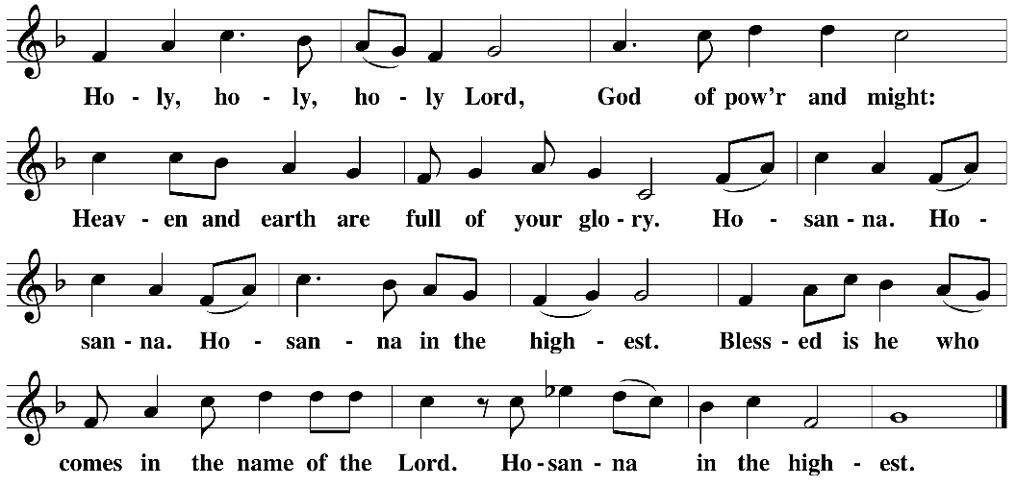

Eucharistic Prayer
The Lord’s Prayer
Our Father in heaven, hallowed be your name, your kingdom come, your will be done, on earth as in heaven. Give us today our daily bread. Forgive us our sins as we forgive those who sin against us. Save us from the time of trial and deliver us from evil. For the kingdom, the power, and the glory are yours, now and forever. Amen.
Invitation to the Table
You may now take the individual cups provided for communion. Please receive communion with these words: “The body of Christ given for you; the blood of Christ shed for you.”
Communion Hymn – Lamb of God
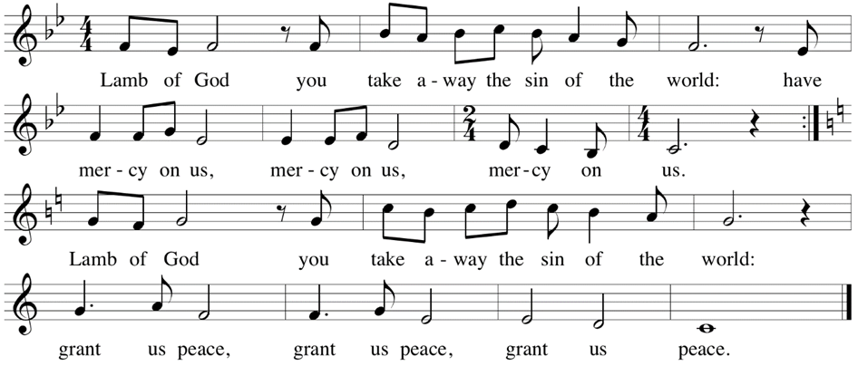

Table Blessing
May the grace of our Lord Jesus Christ and the gifts of his body and blood strengthen, keep and unite us, now and forever. Amen.

Post-Communion Prayer
Jesus, Bread of life, we have received from your table more than we could ever ask. As you have nourished us in this meal, now strengthen us to love the world with your own life.
In your name we pray. Amen.
Community Time – Sheri Barker
Blessing
The blessing of God,
Who provides for us, feeds us, and journeys with us,
☩ be upon you now and forever.
Amen.
Sending Song – How Sweet the Name of Jesus Sounds Verses 1, 5, 6 ELW #620

¹How sweet the name of Jesus sounds
in a believer's ear!
It soothes our sorrows, heals our wounds,
and drives away all fear.

⁵O Jesus, shepherd, guardian, friend,
my prophet, priest, and king,
my Lord, my life, my way, my end,
accept the praise I bring.
⁶How weak the effort of my heart,
how cold my warmest thought;
but when I see thee as thou art,
I'll praise thee as I ought.

Sending
Go in peace. You are the body of Christ.
Thanks be to God.
Share the Peace of the Lord in the comments below!

