St. Mark’s Worship Sunday August 16, 2021
Welcome to our Online Worship

Welcome back to worship inside your church!
Stationed at the tables at the entrance our greeters have hand sanitizer and masks if you need them, bulletins and self-contained communion cups (please wait for the Pastor to direct you to open them) and they have a plate and envelopes where you can drop off your offering. We also are collecting your name and contact information. Please follow the direction of the ushers who will seat family groups six feet apart and refrain from hugs and handshakes.
The restrooms will be open, but we request that one family group at a time uses the facilities.
We will be serving coffee after the service. We're staying masked to protect children and anyone who feels vulnerable, vaccinated or not. All are welcome, unless you aren't feeling well, then please recover at home and watch the worship service on Facebook live at 9 AM.
If you are worshipping at home, you may want to prepare some bread, wine, or juice to receive Holy Communion. You may commune yourself or those around you with these words:
“The body of Christ given for you; the blood of Christ shed for you.”
Prelude
Welcome
Opening Song – I Come with Joy All Verses ELW #482
¹I come with joy, a child of God,
forgiven, loved, and free,
the life of Jesus to recall
in love laid down for me,
in love laid down for me.

²I come with Christians far and near
to find, as all are fed,
the new community of love
in Christ's communion bread,
in Christ's communion bread.

³As Christ breaks bread and bids us share,
each proud division ends.
The love that made us, makes us one,
and strangers now are friends,
and strangers now are friends.
⁴The Spirit of the risen Christ,
unseen, but ever near,
is in such friendship better known,
alive among us here,
alive among us here.

⁵Together met, together bound
by all that God has done,
we'll go with joy, to give the world
the love that makes us one,
the love that makes us one.

Confession and Forgiveness
Blessed be the holy Trinity, ☩ one God,
the God of manna,
the God of miracles,
the God of mercy.
Amen.
Drawn to Christ and seeking God’s abundance,
let us confess our sin.
Silence is kept for reflection.
God, our provider,
help us.
It is hard to believe there is enough to share.
We question your ways when they differ from the ways
of the world in which we live.
We turn to our own understanding
rather than trusting in you.
We take offense at your teachings and your ways.
Turn us again to you.
Where else can we turn?
Share with us the words of eternal life
and feed us for life in the world.
Amen.
Beloved people of God:
in Jesus, the manna from heaven,
you are fed and nourished.
By Jesus, the worker of miracles,
there is always more than enough.
Through Jesus, ☩ the bread of life,
you are shown God’s mercy:
you are forgiven and loved into abundant life.
Amen.
Mission
Celebrating God’s love and forgiveness, we serve others

Prayer of the Day
Ever-loving God, your Son gives himself as living bread for the life of the world. Fill us with such a knowledge of his presence that we may be strengthened and sustained by his risen life to serve you continually, through Jesus Christ, our Savior and Lord. Amen.
Children’s message

Psalm: Psalm 34:9-14

⁹Fear the Lord, you saints of the Lord,
for those who fear the Lord lack nothing.
¹⁰The lions are in want and suffer hunger,
but those who seek the Lord lack nothing that is good.
¹¹Come, children, and listen to me;
I will teach you reverence for the Lord.
¹²Who among you takes pleasure in life
and desires long life to enjoy prosperity?
¹³Keep your | tongue from evil
and your lips from lying words.
¹⁴Turn from evil and do good;
seek peace and pursue it.

Lesson 2: Proverbs 9:1-6
¹Wisdom has built her house,
she has hewn her seven pillars.
²She has slaughtered her animals, she has mixed her wine,
she has also set her table.
³She has sent out her servant-girls, she calls
from the highest places in the town,
⁴“You that are simple, turn in here!”
To those without sense she says,
⁵“Come, eat of my bread
and drink of the wine I have mixed.
⁶Lay aside immaturity, and live,
and walk in the way of insight.”
Word of God, Word of Life
Thanks be to God.
Gospel Acclamation
Alleluia. Lord to whom shall we go? You have the words of eternal life.
Alleluia.
The Holy Gospel according to John.
Glory to you, O Lord.

Gospel: John 6:51-58
[Jesus said,] ⁵¹“I am the living bread that came down from heaven. Whoever eats of this bread will live forever; and the bread that I will give for the life of the world is my flesh.”
⁵²The Jews then disputed among themselves, saying, “How can this man give us his flesh to eat?” ⁵³So Jesus said to them, “Very truly, I tell you, unless you eat the flesh of the Son of Man and drink his blood, you have no life in you. ⁵⁴Those who eat my flesh and drink my blood have eternal life, and I will raise them up on the last day; ⁵⁵for my flesh is true food and my blood is true drink. ⁵⁶Those who eat my flesh and drink my blood abide in me, and I in them. ⁵⁷Just as the living Father sent me, and I live because of the Father, so whoever eats me will live because of me. ⁵⁸This is the bread that came down from heaven, not like that which your ancestors ate, and they died. But the one who eats this bread will live forever.”
The Gospel of our Lord.
Praise to you, O Christ
Sermon Pastor Karla Halvorson

Hymn of the Day – Let All Mortal Flesh Keep Silence All Verses ELW #490

¹Let all mortal flesh keep silence,
and with fear and trembling stand;
ponder nothing earthly-minded,
for with blessing in his hand
Christ our God to earth descending
comes full homage to demand.

²King of kings, yet born of Mary,
as of old on earth he stood,
Lord of lords in human vesture,
in the body and the blood,
he will give to all the faithful
his own self for heav'nly food.

³Rank on rank the host of heaven
spreads its vanguard on the way;
as the Light of light, descending
from the realms of endless day,
comes, the pow'rs of hell to vanquish,
as the darkness clears away.

⁴At his feet the six-winged seraph,
cherubim with sleepless eye,
veil their faces to the presence,
as with ceaseless voice they cry:
"Alleluia! Alleluia!
Alleluia, Lord Most High!"
Prayers of Intercession
Leader: God, in your mercy,
Congregation: Hear our prayer.
Blessing of prayer quilts
Song
God Is so good,
God is so good,
God is so good,
He’s so good to me!

The Peace
The peace of Christ be with you always.
And also, with you.
(you may share the peace of Christ with anyone who is with you, share the peace in the comments, text an offering of peace to someone, or simply send a prayer of blessing and peace to someone.)
Offering
Thanksgiving Moment
Offering information
St. Mark’s Church, 580 Hilltop Dr. Chula Vista, CA 91910
Venmo: @stmarks-churchchulavista

Offering Song
Thank you for giving to the Lord
I am a life that was changed
Thank you for giving to the Lord
I am so glad you gave
Offering Prayer
Jesus, Bread of life, you have set this table with your very self, and called us to the feast of plenty. Gather what has been sown among us, and strengthen us in this meal. Make us to be what we receive here, your body for the life of the world. Amen.
The Great Thanksgiving
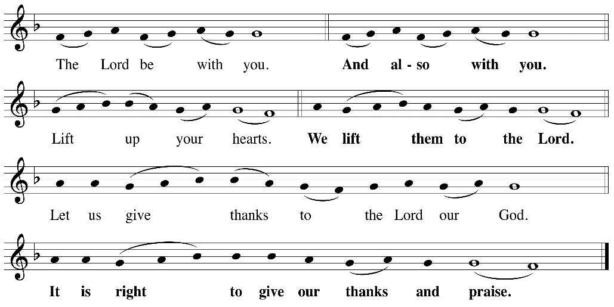

P: It is indeed right, our duty and our joy, that we should, at all times and in all places
give thanks and praise ... we praise your name and join their unending hymn:

Holy Holy
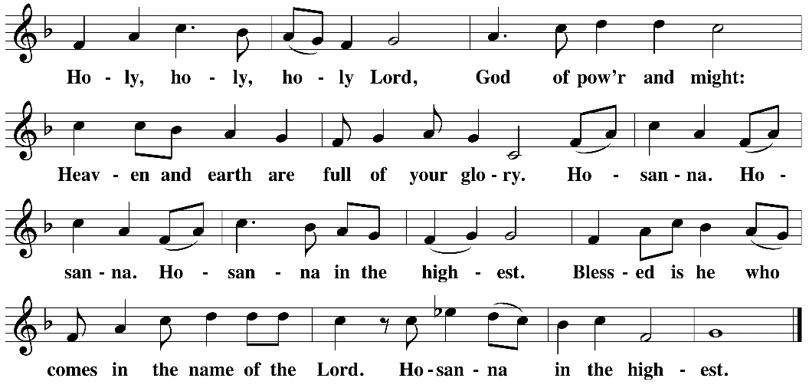

Eucharistic Prayer
The Lord’s Prayer
Our Father in heaven, hallowed be your name, your kingdom come, your will be done, on earth as in heaven. Give us today our daily bread. Forgive us our sins as we forgive those who sin against us. Save us from the time of trial and deliver us from evil. For the kingdom, the power, and the glory are yours, now and forever. Amen.
Invitation to the Table
You may now take the individual cups provided for communion. Please receive communion with these words: “The body of Christ given for you; the blood of Christ shed for you.”
Communion Hymn – Lamb of God
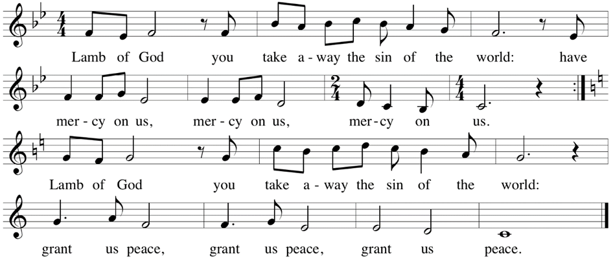

Table Blessing
May the grace of our Lord Jesus Christ and the gifts of his body and blood strengthen, keep and unite us, now and forever. Amen.

Post-Communion Prayer
Jesus, Bread of life, we have received from your table more than we could ever ask. As you have nourished us in this meal, now strengthen us to love the world with your own life.
In your name we pray. Amen.
Community Time
Blessing
The blessing of God,
Who provides for us, feeds us, and journeys with us,
☩ be upon you now and forever.
Amen.
Sending Song – On Our Way Rejoicing All Verses ELW #537

¹On our way rejoicing
gladly let us go.
Christ our Lord has conquered;
vanquished is the foe.
Christ without, our safety;
Christ within, our joy;
who, if we be faithful,
can our hope destroy?

Refrain
On our way rejoicing;
as we forward move,
hearken to our praises,
O blest God of love!
²Unto God the Father
joyful songs we sing;
unto God the Savior
thankful hearts we bring;
unto God the Spirit
bow we and adore,
on our way rejoicing
now and evermore. Refrain

Sending
Go in peace. You are the body of Christ.
Thanks be to God.
Share the Peace of the Lord in the comments below!

