St. Mark’s Worship Sunday August 8, 2021
Welcome to our Online Worship
Christian Education begins

Welcome back to worship inside your church!
Stationed at the tables at the entrance our greeters have hand sanitizer and masks if you need them, bulletins and self-contained communion cups (please wait for the Pastor to direct you to open them) and they have a plate and envelopes where you can drop off your offering. We also are collecting your name and contact information. Please follow the direction of the ushers who will seat family groups six feet apart and refrain from hugs and handshakes.
The restrooms will be open, but we request that one family group at a time uses the facilities.
We will be serving coffee after the service. We're staying masked to protect children and anyone who feels vulnerable, vaccinated or not. All are welcome, unless you aren't feeling well, then please recover at home and watch the worship service on Facebook live at 9 AM.
If you are worshipping at home, you may want to prepare some bread, wine, or juice to receive Holy Communion. You may commune yourself or those around you with these words:
“The body of Christ given for you; the blood of Christ shed for you.”
Prelude
Welcome
Opening Song – By Your Hand You Feed Your People All Verses ELW #469
¹By your hand you feed your people,
food of angels, heaven's bread.
For these gifts we did not labor,
by your grace have we been fed:

Refrain
Christ's own body, blessed and broken,
cup o'er flowing, life outpoured,
given as a living token
of your world redeemed, restored.
²In this meal we taste your sweetness,
bread for hunger, wine of peace.
Holy word and holy wisdom
satisfy our deepest needs. Refrain

³Send us now with faith and courage
to the hungry, lost, bereaved.
In our living and our dying,
we become what we receive: Refrain

Confession and Forgiveness
Blessed be the holy Trinity, ☩ one God,
the God of manna,
the God of miracles,
the God of mercy.
Amen.
Drawn to Christ and seeking God’s abundance,
let us confess our sin.
Silence is kept for reflection.
God, our provider,
help us.
It is hard to believe there is enough to share.
We question your ways when they differ from the ways
of the world in which we live.
We turn to our own understanding
rather than trusting in you.
We take offense at your teachings and your ways.
Turn us again to you.
Where else can we turn?
Share with us the words of eternal life
and feed us for life in the world.
Amen.
Beloved people of God:
in Jesus, the manna from heaven,
you are fed and nourished.
By Jesus, the worker of miracles,
there is always more than enough.
Through Jesus, ☩ the bread of life,
you are shown God’s mercy:
you are forgiven and loved into abundant life.
Amen.
Mission
Celebrating God’s love and forgiveness, we serve others

Prayer of the Day
Gracious God, your blessed Son came down from heaven to be the true bread that gives life to the world. Give us this bread always, that he may live in us and we in him, and that, strengthened by this food, we may live as his body in the world, through Jesus Christ, our Savior and Lord. Amen.
Children’s message

Psalm: Psalm 34:1-8

¹I will bless the Lord at all times;
the praise of God shall ever be in my mouth.
²I will glory in the Lord;
let the lowly hear and rejoice.
³Proclaim with me the greatness of the Lord;
let us exalt God’s name together.
⁴I sought the Lord, who answered me
and delivered me from all my terrors.
⁵Look upon the Lord and be radiant,
and let not your faces be ashamed.
⁶I called in my affliction, and the Lord heard me
and saved me from all my troubles.
⁷The angel of the Lord encamps around those who fear the Lord
and delivers them.
⁸Taste and see that the Lord is good;
happy are they who take refuge in God!

Lesson 2: Ephesians 4:25--5:2
²⁵So then, putting away falsehood, let all of us speak the truth to our neighbors, for we are members of one another. ²⁶Be angry but do not sin; do not let the sun go down on your anger, ²⁷and do not make room for the devil. ²⁸Thieves must give up stealing; rather let them labor and work honestly with their own hands, so as to have something to share with the needy. ²⁹Let no evil talk come out of your mouths, but only what is useful for building up, as there is need, so that your words may give grace to those who hear. ³⁰And do not grieve the Holy Spirit of God, with which you were marked with a seal for the day of redemption. ³¹Put away from you all bitterness and wrath and anger and wrangling and slander, together with all malice, ³²and be kind to one another, tenderhearted, forgiving one another, as God in Christ has forgiven you. ^{5:1}Therefore be imitators of God, as beloved children, ²and live in love, as Christ loved us and gave himself up for us, a fragrant offering and sacrifice to God.
Word of God, Word of Life
Thanks be to God.
Gospel Acclamation
Alleluia. Lord to whom shall we go? You have the words of eternal life.
Alleluia.
The Holy Gospel according to John.
Glory to you, O Lord.

Gospel: John 6:35, 41-51
³⁵Jesus said to [the crowd,] “I am the bread of life. Whoever comes to me will never be hungry, and whoever believes in me will never be thirsty.
⁴¹Then the Jews began to complain about him because he said, “I am the bread that came down from heaven.” ⁴²They were saying, “Is not this Jesus, the son of Joseph, whose father and mother we know? How can he now say, ‘I have come down from heaven’?” ⁴³Jesus answered them, “Do not complain among yourselves. ⁴⁴No one can come to me unless drawn by the Father who sent me; and I will raise that person up on the last day. ⁴⁵It is written in the prophets, ‘And they shall all be taught by God.’ Everyone who has heard and learned from the Father comes to me. ⁴⁶Not that anyone has seen the Father except the one who is from God; he has seen the Father. ⁴⁷Very truly, I tell you, whoever believes has eternal life. ⁴⁸I am the bread of life. ⁴⁹Your ancestors ate the manna in the wilderness, and they died. ⁵⁰This is the bread that comes down from heaven, so that one may eat of it and not die. ⁵¹I am the living bread that came down from heaven. Whoever eats of this bread will live forever; and the bread that I will give for the life of the world is my flesh.”
The Gospel of our Lord.
Praise to you, O Christ
Sermon Pastor Karla Halvorson
Hymn of the Day – I Am the Bread of Life Verses 1, 2, 4, 5 ELW #485

¹"I am the Bread of life.
You who come to me shall not hunger,
and who believe in me shall not thirst.
No one can come to me
unless the Father beckons."

Refrain
"And I will raise you up,
and I will raise you up,
and I will raise you up on the last day."

²"The bread that I will give
is my flesh for the life of the world,
and if you eat of this bread,
you shall live forever, you shall live forever." Refrain
⁴"I am the resurrection,
I am the life.
If you believe in me,
even though you die, you shall live forever." Refrain

⁵Yes, Lord, I believe
that you are the Christ,
the Son of God,
who have come into the world.
Refrain

Prayers of Intercession
Leader: God, in your mercy,
Congregation: Hear our prayer.
Blessing of prayer quilts
Song
God Is so good,
God is so good,
God is so good,
He’s so good to me!
The Peace
The peace of Christ be with you always.
And also, with you.
(you may share the peace of Christ with anyone who is with you, share the peace in the comments, text an offering of peace to someone, or simply send a prayer of blessing and peace to someone.)
Offering
Thanksgiving Moment
Offering information
St. Mark’s Church, 580 Hilltop Dr. Chula Vista, CA 91910
Venmo: @stmarks-churchchulavista

Offering Song
Thank you for giving to the Lord
I am a life that was changed
Thank you for giving to the Lord
I am so glad you gave
Offering Prayer
Jesus, Bread of life, you have set this table with your very self, and called us to the feast of plenty. Gather what has been sown among us, and strengthen us in this meal. Make us to be what we receive here, your body for the life of the world. Amen.
The Great Thanksgiving
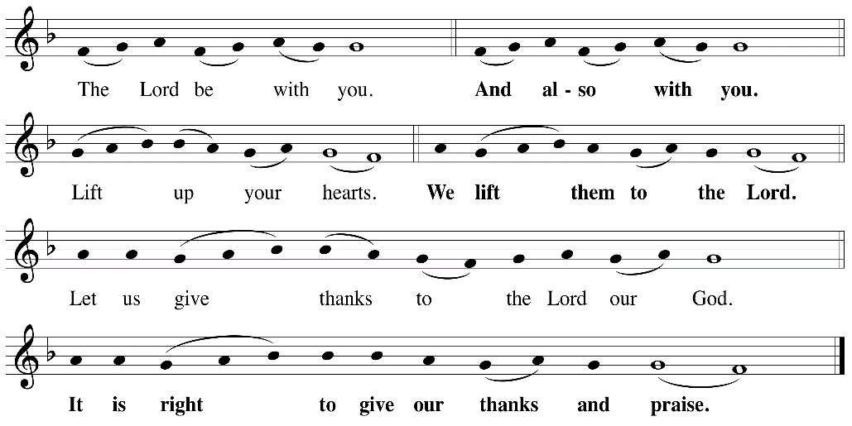

P: It is indeed right, our duty and our joy, that we should, at all times and in all places
give thanks and praise ... we praise your name and join their unending hymn:

Holy Holy
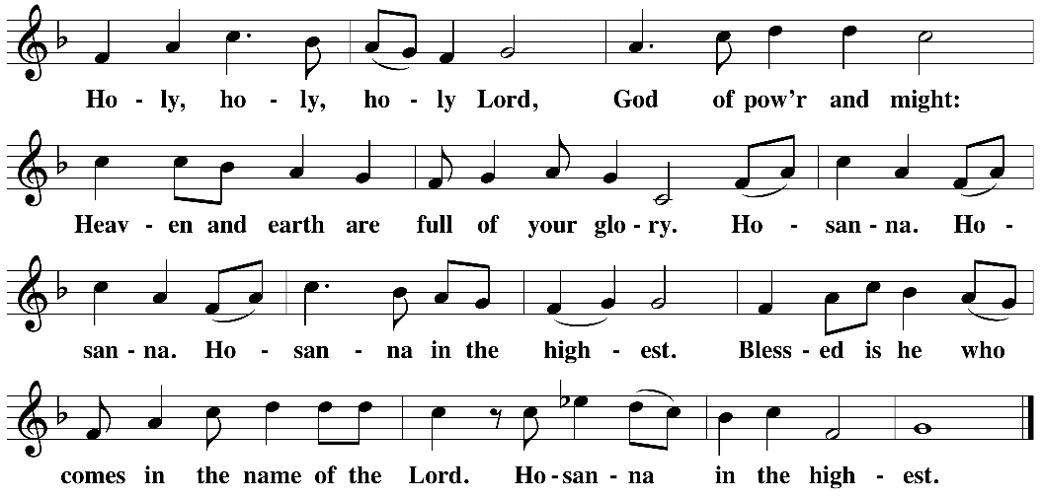

Eucharistic Prayer
The Lord’s Prayer
Our Father in heaven, hallowed be your name, your kingdom come, your will be done, on earth as in heaven. Give us today our daily bread. Forgive us our sins as we forgive those who sin against us. Save us from the time of trial and deliver us from evil. For the kingdom, the power, and the glory are yours, now and forever. Amen.
Invitation to the Table
You may now take the individual cups provided for communion. Please receive communion with these words: “The body of Christ given for you; the blood of Christ shed for you.”
Communion Hymn – Lamb of God
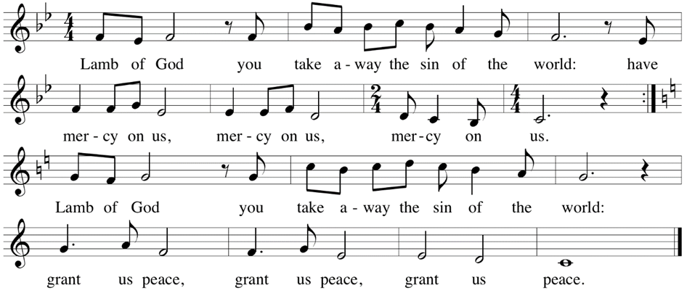

Table Blessing
May the grace of our Lord Jesus Christ and the gifts of his body and blood strengthen, keep and unite us, now and forever. Amen.

Post-Communion Prayer
Jesus, Bread of life, we have received from your table more than we could ever ask. As you have nourished us in this meal, now strengthen us to love the world with your own life.
In your name we pray. Amen.
Community Time
Blessing
The blessing of God,
Who provides for us, feeds us, and journeys with us,
☩ be upon you now and forever.
Amen.
Sending Song – Be Thou My Vision All Verses ELW #793

¹Be thou my vision, O Lord of my heart;
naught be all else to me, save that thou art:
thou my best thought
both by day and by night,
waking or sleeping, thy presence my light.

²Be thou my wisdom,
and thou my true word;
I ever with thee and thou with me, Lord.
Thou my soul's shelter,
and thou my high tow'r,
raise thou me heav'nward, O Pow'r of my pow'r.

³Riches I heed not, nor vain, empty praise,
thou mine inheritance, now and always:
thou and thou only, the first in my heart,
great God of heaven, my treasure thou art.

⁴Light of my soul, after victory won,
may I reach heaven's joys, O heaven's Sun!
Heart of my own heart, whatever befall,
still be my vision, O Ruler of all.

Sending
Go in peace. You are the body of Christ.
Thanks be to God.
Share the Peace of the Lord in the comments below!

