St. Mark’s Worship Sunday August 1, 2021
Welcome to our Online Worship
Grand Re-Opening!

Welcome back to worship inside your church!
Stationed at the tables at the entrance our greeters have hand sanitizer and masks if you need them, bulletins and self-contained communion cups (please wait for the Pastor to direct you to open them) and they have a plate and envelopes where you can drop off your offering. We also are collecting your name and contact information. Please follow the direction of the ushers who will seat family groups six feet apart and refrain from hugs and handshakes. The restrooms will be open, but we request that one family group at a time uses the facilities.
We will be serving coffee after the service. We also have a mask free zone, for fully vaccinated folks, in front of the organ on the right side of the church. We're staying masked to protect children and anyone who feels vulnerable on the other side of the church, vaccinated or not. All are welcome, unless you aren't feeling well, then please recover at home and watch the worship service on Facebook live at 9 AM.
If you are worshipping at home, you may want to prepare some bread, wine, or juice to receive Holy Communion. You may commune yourself or those around you with these words:
“The body of Christ given for you; the blood of Christ shed for you.”
Prelude
Welcome
Opening Song – When Peace like a River All Verses ELW #785
¹When peace like a river
attendeth my way,
When sorrows like sea billows roll,
whatever my lot, thou hast taught
me to say,
it is well, it is well with my soul.

Refrain
It is well (it is well)
with my soul, (with my soul,)
it is well, it is well with my soul.

²Though Satan should buffet,
though trials should come,
let this blest assurance control,
that Christ has regarded my helpless estate,
and has shed his own blood for my soul.
Refrain

³He lives--oh, the bliss
of this glorious thought;
my sin, not in part, but the whole,
is nailed to his cross and I bear it no more.
Praise the Lord, praise the Lord, O my soul! Refrain

⁴Lord, hasten the day when
our faith shall be sight,
the clouds be rolled back as a scroll,
the trumpet shall sound
and the Lord shall descend;
even so it is well with my soul.
Refrain

Confession and Forgiveness
Blessed be the holy Trinity, ☩ one God,
the God of manna,
the God of miracles,
the God of mercy.
Amen.
Drawn to Christ and seeking God’s abundance,
let us confess our sin.
Silence is kept for reflection.
God, our provider,
help us.
It is hard to believe there is enough to share.
We question your ways when they differ from the ways
of the world in which we live.
We turn to our own understanding
rather than trusting in you.
We take offense at your teachings and your ways.
Turn us again to you.
Where else can we turn?
Share with us the words of eternal life
and feed us for life in the world.
Amen.
Beloved people of God:
in Jesus, the manna from heaven,
you are fed and nourished.
By Jesus, the worker of miracles,
there is always more than enough.
Through Jesus, ☩ the bread of life,
you are shown God’s mercy:
you are forgiven and loved into abundant life.
Amen.
Mission
Celebrating God’s love and forgiveness, we serve others

Prayer of the Day
O God, eternal goodness, immeasurable love, you place your gifts before us; we eat and are satisfied. Fill us and this world in all its need with the life that comes only from you, through Jesus Christ, our Savior and Lord. Amen.
Children’s message

Lesson 1: Exodus 16:2-4, 9-15

²The whole congregation of the Israelites complained against Moses and Aaron in the wilderness. ³The Israelites said to them, “If only we had died by the hand of the Lord in the land of Egypt, when we sat by the fleshpots and ate our fill of bread; for you have brought us out into this wilderness to kill this whole assembly with hunger.”
⁴Then the Lord said to Moses, “I am going to rain bread from heaven for you, and each day the people shall go out and gather enough for that day. In that way I will test them, whether they will follow my instruction or not.”
⁹Then Moses said to Aaron, “Say to the whole congregation of the Israelites, ‘Draw near to the Lord, for he has heard your complaining.’ ” ¹⁰And as Aaron spoke to the whole congregation of the Israelites, they looked toward the wilderness, and the glory of the Lord appeared in the cloud. ¹¹The Lord spoke to Moses and said, ¹²“I have heard the complaining of the Israelites; say to them, ‘At twilight you shall eat meat, and in the morning you shall have your fill of bread; then you shall know that I am the Lord your God.’ ”
¹³In the evening quails came up and covered the camp; and in the morning there was a layer of dew around the camp. ¹⁴When the layer of dew lifted, there on the surface of the wilderness was a fine flaky substance, as fine as frost on the ground. ¹⁵When the Israelites saw it, they said to one another, “What is it?” For they did not know what it was. Moses said to them, “It is the bread that the Lord has given you to eat.”

Lesson 2: Ephesians 4:1-16
¹I therefore, the prisoner in the Lord, beg you to lead a life worthy of the calling to which you have been called, ²with all humility and gentleness, with patience, bearing with one another in love, ³making every effort to maintain the unity of the Spirit in the bond of peace. ⁴There is one body and one Spirit, just as you were called to the one hope of your calling, ⁵one Lord, one faith, one baptism, ⁶one God and Father of all, who is above all and through all and in all.
⁷But each of us was given grace according to the measure of Christ’s gift. ⁸Therefore it is said,
“When he ascended on high he made captivity itself a captive;
he gave gifts to his people.”
⁹(When it says, “He ascended,” what does it mean but that he had also descended into the lower parts of the earth? ¹⁰He who descended is the same one who ascended far above all the heavens, so that he might fill all things.) ¹¹The gifts he gave were that some would be apostles, some prophets, some evangelists, some pastors and teachers, ¹²to equip the saints for the work of ministry, for building up the body of Christ, ¹³until all of us come to the unity of the faith and of the knowledge of the Son of God, to maturity, to the measure of the full stature of Christ. ¹⁴We must no longer be children, tossed to and fro and blown about by every wind of doctrine, by people’s trickery, by their craftiness in deceitful scheming. ¹⁵But speaking the truth in love, we must grow up in every way into him who is the head, into Christ, ¹⁶from whom the whole body, joined and knit together by every ligament with which it is equipped, as each part is working properly, promotes the body’s growth in building itself up in love.
Word of God, Word of Life
Thanks be to God.
Gospel Acclamation
Alleluia. Lord to whom shall we go? You have the words of eternal life.
Alleluia.
The Holy Gospel according to John.
Glory to you, O Lord.

Gospel: John 6:24-35
²⁴When the crowd saw that neither Jesus nor his disciples were [beside the sea,] they themselves got into the boats and went to Capernaum looking for Jesus.
²⁵When they found him on the other side of the sea, they said to him, “Rabbi, when did you come here?” ²⁶Jesus answered them, “Very truly, I tell you, you are looking for me, not because you saw signs, but because you ate your fill of the loaves. ²⁷Do not work for the food that perishes, but for the food that endures for eternal life, which the Son of Man will give you. For it is on him that God the Father has set his seal.” ²⁸Then they said to him, “What must we do to perform the works of God?” ²⁹Jesus answered them, “This is the work of God, that you believe in him whom he has sent.” ³⁰So they said to him, “What sign are you going to give us then, so that we may see it and believe you? What work are you performing? ³¹Our ancestors ate the manna in the wilderness; as it is written, ‘He gave them bread from heaven to eat.’ ” ³²Then Jesus said to them, “Very truly, I tell you, it was not Moses who gave you the bread from heaven, but it is my Father who gives you the true bread from heaven. ³³For the bread of God is that which comes down from heaven and gives life to the world.” ³⁴They said to him, “Sir, give us this bread always.”
³⁵Jesus said to them, “I am the bread of life. Whoever comes to me will never be hungry, and whoever believes in me will never be thirsty.”
The Gospel of our Lord.
Praise to you, O Christ
Sermon Pastor Karla Halvorson

Hymn of the Day – How Firm a Foundation All Verses ELW #796

¹How firm a foundation,
O saints of the Lord,
Is laid for your faith in Christ Jesus,
the Word!
What more can he say than to you
he has said
Who unto the Savior for
refuge have fled?

²"Fear not, I am with you,
oh, be not dismayed,
For I am your God
and will still give you aid;
I'll strengthen you, help you,
and cause you to stand,
Upheld by my righteous,
omnipotent hand."
³"When through fiery trials
your pathway shall lie,
My grace, all-sufficient,
shall be your supply.
The flames shall not hurt you;
I only design
Your dross to consume and
your gold to refine."

⁴"Throughout all their lifetime
my people shall prove
My sov'reign, eternal, unchangeable love;
And then, when gray hairs
shall their temples adorn,
Like lambs they shall still
in my bosom be borne."

Prayers of Intercession
Leader: Hear us, O God.
Congregation: Your Mercy is great.
Blessing of prayer quilts
Song
God Is so good,
God is so good,
God is so good,
He’s so good to me!
The Peace
The peace of Christ be with you always.
And also, with you.
(you may share the peace of Christ with anyone who is with you, share the peace in the comments, text an offering of peace to someone, or simply send a prayer of blessing and peace to someone.)
Offering
Thanksgiving Moment
Offering information
St. Mark’s Church, 580 Hilltop Dr. Chula Vista, CA 91910
Venmo: @stmarks-churchchulavista

Offering Song
Thank you for giving to the Lord
I am a life that was changed
Thank you for giving to the Lord
I am so glad you gave
Offering Prayer
Jesus, Bread of life, you have set this table with your very self, and called us to the feast of plenty. Gather what has been sown among us, and strengthen us in this meal. Make us to be what we receive here, your body for the life of the world. Amen.
The Great Thanksgiving
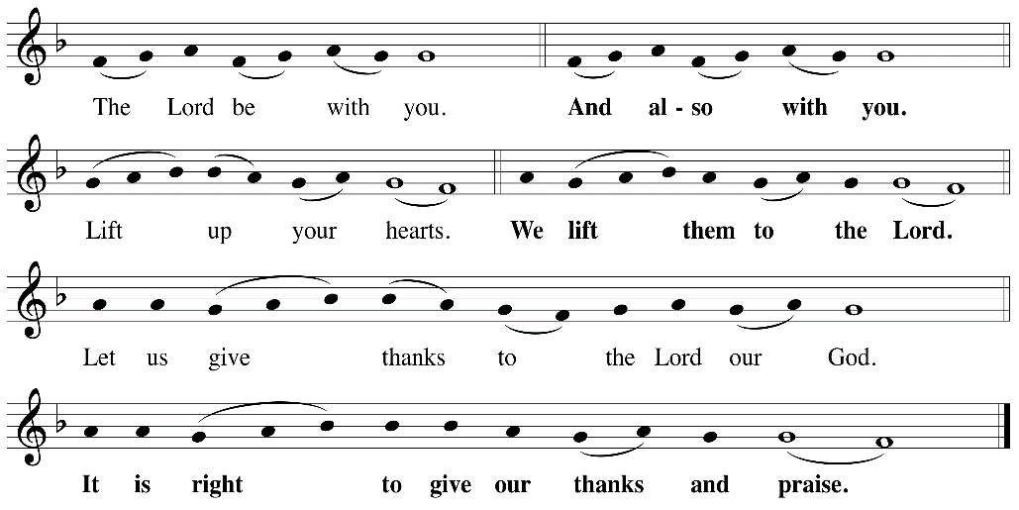

P: It is indeed right, our duty and our joy, that we should, at all times and in all places
give thanks and praise ... we praise your name and join their unending hymn:
Holy Holy
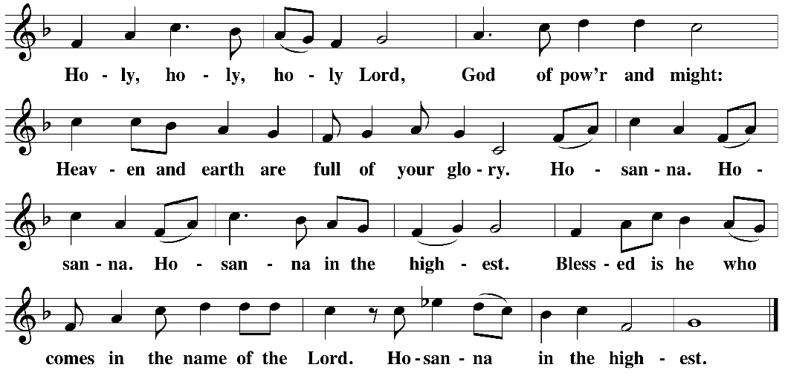

Eucharistic Prayer
The Lord’s Prayer
Our Father in heaven, hallowed be your name, your kingdom come, your will be done, on earth as in heaven. Give us today our daily bread. Forgive us our sins as we forgive those who sin against us. Save us from the time of trial and deliver us from evil. For the kingdom, the power, and the glory are yours, now and forever. Amen.
Invitation to the Table
You may now take the individual cups provided for communion. Please receive communion with these words: “The body of Christ given for you; the blood of Christ shed for you.”
Communion Hymn – Lamb of God
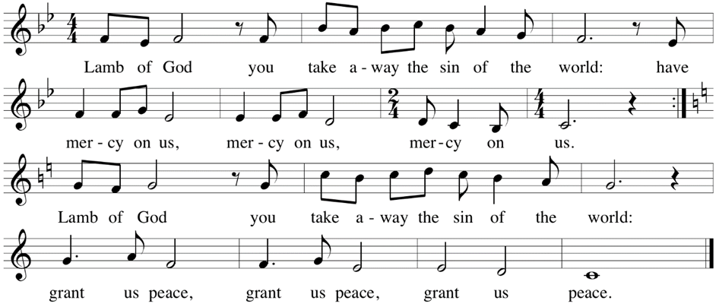

Table Blessing
May the grace of our Lord Jesus Christ and the gifts of his body and blood strengthen, keep and unite us, now and forever. Amen.
Post-Communion Prayer
Jesus, Bread of life, we have received from your table more than we could ever ask. As you have nourished us in this meal, now strengthen us to love the world with your own life.
In your name we pray. Amen.
Community Time
Blessing
The blessing of God,
Who provides for us, feeds us, and journeys with us,
☩ be upon you now and forever.
Amen.

Sending Song – I Love to Tell the Story All Verses ELW #661

¹I love to tell the story
Of unseen things above,
Of Jesus and his glory,
Of Jesus and his love.
I love to tell the story,
Because I know it's true;
It satisfies my longings
As nothing else would do.

Refrain
I love to tell the story;
'Twill be my theme in glory
To tell the old, old story
Of Jesus and his love.

²I love to tell the story:
How pleasant to repeat
What seems, each time I tell it,
More wonderfully sweet!
I love to tell the story,
For some have never heard
The message of salvation
From God's own holy word. Refrain

³I love to tell the story,
For those who know it best
Seem hungering and thirsting
To hear it like the rest.
And when, in scenes of glory,
I sing the new, new song,
I'll sing the old, old story
That I have loved so long. Refrain

Sending
Go in peace. You are the body of Christ.
Thanks be to God.
Share the Peace of the Lord in the comments below!

