St. Mark’s Worship Sunday July 25, 2021
Welcome to our Online Worship

Welcome back to worship inside your church!
Stationed at the tables at the entrance our greeters have hand sanitizer and masks if you need them, bulletins and self-contained communion cups (please wait for the Pastor to direct you to open them) and they have a plate and envelopes where you can drop off your offering. We also are collecting your name and contact information. Please follow the direction of the ushers who will seat family groups six feet apart and refrain from hugs and handshakes. The restrooms will be open, but we request that one family group at a time uses the facilities.
We will be serving coffee after the service. We also have a mask free zone, for fully vaccinated folks, in front of the organ on the right side of the church. We're staying masked to protect children and anyone who feels vulnerable on the other side of the church, vaccinated or not. All are welcome, unless you aren't feeling well, then please recover at home and watch the worship service on Facebook live at 9 AM.
If you are worshipping at home, you may want to prepare some bread, wine, or juice to receive Holy Communion. You may commune yourself or those around you with these words:
“The body of Christ given for you; the blood of Christ shed for you.”
Prelude
Welcome
Opening Song – Jesus Calls Us; o'er the Tumult Verses 1, 4, 5 ELW #696
¹Jesus calls us; o'er the tumult
Of our life's wild, restless sea,
Day by day his clear voice sounding,
Saying, "Christian, follow me":

⁴In our joys and in our sorrows,
Days of toil and hours of ease,
Still he calls, in cares and pleasures,
"Christian, love me more than these."
⁵Jesus calls us! By your mercy,
Savior, may we hear your call,
Give our hearts to your obedience,
Serve and love you best of all.

Confession and Forgiveness
Blessed be the holy Trinity, ☩ one God,
the God of manna,
the God of miracles,
the God of mercy.
Amen.
Drawn to Christ and seeking God’s abundance,
let us confess our sin.
Silence is kept for reflection.
God, our provider,
help us.
It is hard to believe there is enough to share.
We question your ways when they differ from the ways
of the world in which we live.
We turn to our own understanding
rather than trusting in you.
We take offense at your teachings and your ways.
Turn us again to you.
Where else can we turn?
Share with us the words of eternal life
and feed us for life in the world.
Amen.
Beloved people of God:
in Jesus, the manna from heaven,
you are fed and nourished.
By Jesus, the worker of miracles,
there is always more than enough.
Through Jesus, ☩ the bread of life,
you are shown God’s mercy:
you are forgiven and loved into abundant life.
Amen.
Mission
Celebrating God’s love and forgiveness, we serve others

Prayer of the Day
Gracious God, you have placed within the hearts of all your children a longing for your word and a hunger for your truth. Grant that we may know your Son to be the true bread of heaven and share this bread with all the world, through Jesus Christ, our Savior and Lord. Amen.
Children’s message

Psalm: Psalm 145:10-18
¹⁰All your works shall praise you, O Lord,
and your faithful ones shall bless you.
¹¹They shall tell of the glory of your kingdom
and speak of your power,
¹²that all people may know of your power
and the glorious splendor of your kingdom.
¹³Your kingdom is an everlasting kingdom; your dominion endures throughout all ages.
You, Lord, are faithful in all your words, and loving in all your works.
¹⁴The Lord upholds all those who fall
and lifts up those who are bowed down.
¹⁵The eyes of all wait upon you, O Lord,
and you give them their food in due season.
¹⁶You open wide your hand
and satisfy the desire of every living thing.
¹⁷You are righteous in all your ways
and loving in all your works.
¹⁸You are near to all who call upon you,
to all who call upon you faithfully.

Lesson 2: Ephesians 3:14-21

¹⁴For this reason I bow my knees before the Father, ¹⁵from whom every family in heaven and on earth takes its name. ¹⁶I pray that, according to the riches of his glory, he may grant that you may be strengthened in your inner being with power through his Spirit, ¹⁷and that Christ may dwell in your hearts through faith, as you are being rooted and grounded in love. ¹⁸I pray that you may have the power to comprehend, with all the saints, what is the breadth and length and height and depth, ¹⁹and to know the love of Christ that surpasses knowledge, so that you may be filled with all the fullness of God.
²⁰Now to him who by the power at work within us is able to accomplish abundantly far more than all we can ask or imagine, ²¹to him be glory in the church and in Christ Jesus to all generations, forever and ever. Amen.
Word of God, Word of Life
Thanks be to God.
Gospel Acclamation
Alleluia. Lord to whom shall we go? You have the words of eternal life.
Alleluia.
The Holy Gospel according to John.
Glory to you, O Lord.

Gospel: John 6:1-21
¹Jesus went to the other side of the Sea of Galilee, also called the Sea of Tiberias. ²A large crowd kept following him, because they saw the signs that he was doing for the sick. ³Jesus went up the mountain and sat down there with his disciples. ⁴Now the Passover, the festival of the Jews, was near. ⁵When he looked up and saw a large crowd coming toward him, Jesus said to Philip, “Where are we to buy bread for these people to eat?” ⁶He said this to test him, for he himself knew what he was going to do. ⁷Philip answered him, “Six months’ wages would not buy enough bread for each of them to get a little.” ⁸One of his disciples, Andrew, Simon Peter’s brother, said to him, ⁹“There is a boy here who has five barley loaves and two fish. But what are they among so many people?” ¹⁰Jesus said, “Make the people sit down.” Now there was a great deal of grass in the place; so they sat down, about five thousand in all. ¹¹Then Jesus took the loaves, and when he had given thanks, he distributed them to those who were seated; so also the fish, as much as they wanted. ¹²When they were satisfied, he told his disciples, “Gather up the fragments left over, so that nothing may be lost.” ¹³So they gathered them up, and from the fragments of the five barley loaves, left by those who had eaten, they filled twelve baskets. ¹⁴When the people saw the sign that he had done, they began to say, “This is indeed the prophet who is to come into the world.”
¹⁵When Jesus realized that they were about to come and take him by force to make him king, he withdrew again to the mountain by himself.
¹⁶When evening came, his disciples went down to the sea, ¹⁷got into a boat, and started across the sea to Capernaum. It was now dark, and Jesus had not yet come to them. ¹⁸The sea became rough because a strong wind was blowing. ¹⁹When they had rowed about three or four miles, they saw Jesus walking on the sea and coming near the boat, and they were terrified. ²⁰But he said to them, “It is I; do not be afraid.” ²¹Then they wanted to take him into the boat, and immediately the boat reached the land toward which they were going.
The Gospel of our Lord.
Praise to you, O Christ
Sermon Pastor Karla Halvorson
Hymn of the Day – We Come to the Hungry Feast All Verses ELW #479

¹We come to the hungry feast
Hungry for a word of peace.
To hungry hearts unsatisfied
The love of God is not denied.
We come, we come to the hungry feast.

²We come to the hungry feast
Hungry for a world released
From hungry folk of ev'ry kind,
The poor in body, poor in mind.
We come, we come to the hungry feast.

³We come to the hungry feast
Hungry that the hunger cease,
And knowing, though we eat our fill,
The hunger will stay with us; still
We come, we come to the hungry feast.

Prayers of Intercession
Leader: Hear us, O God.
Congregation: Your Mercy is great.
Blessing of prayer quilts
Song
God Is so good,
God is so good,
God is so good,
He’s so good to me!
The Peace
The peace of Christ be with you always.
And also, with you.
(you may share the peace of Christ with anyone who is with you, share the peace in the comments, text an offering of peace to someone, or simply send a prayer of blessing and peace to someone.)
Offering
Thanksgiving Moment
Offering information
St. Mark’s Church, 580 Hilltop Dr. Chula Vista, CA 91910
Venmo: @stmarks-churchchulavista

Offering Song
Thank you for giving to the Lord
I am a life that was changed
Thank you for giving to the Lord
I am so glad you gave
Offering Prayer
Jesus, Bread of life, you have set this table with your very self, and called us to the feast of plenty. Gather what has been sown among us, and strengthen us in this meal. Make us to be what we receive here, your body for the life of the world. Amen.
The Great Thanksgiving
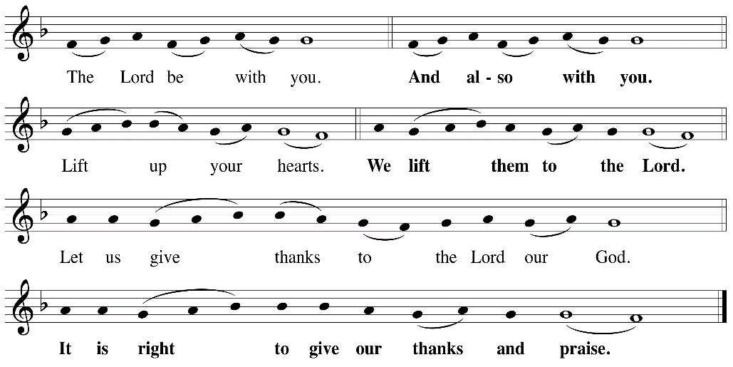

P: It is indeed right, our duty and our joy, that we should, at all times and in all places
give thanks and praise ... we praise your name and join their unending hymn:

Holy Holy
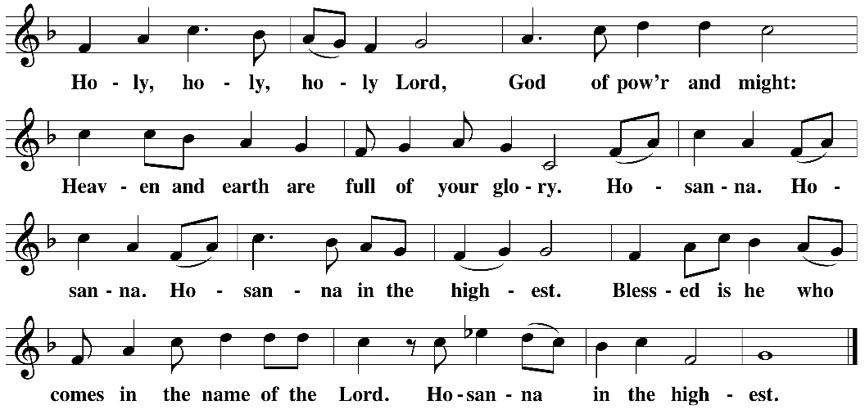

Eucharistic Prayer
The Lord’s Prayer
Our Father in heaven, hallowed be your name, your kingdom come, your will be done, on earth as in heaven. Give us today our daily bread. Forgive us our sins as we forgive those who sin against us. Save us from the time of trial and deliver us from evil. For the kingdom, the power, and the glory are yours, now and forever. Amen.
Invitation to the Table
You may now take the individual cups provided for communion. Please receive communion with these words: “The body of Christ given for you; the blood of Christ shed for you.”
Table Blessing
May the grace of our Lord Jesus Christ and the gifts of his body and blood strengthen, keep and unite us, now and forever. Amen.
Communion Hymn – Lamb of God
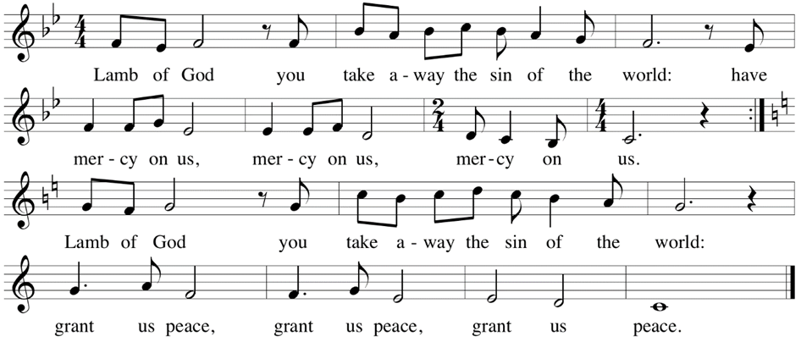

Post-Communion Prayer
Jesus, Bread of life, we have received from your table more than we could ever ask. As you have nourished us in this meal, now strengthen us to love the world with your own life.
In your name we pray. Amen.
Community Time – Herb Geier
Blessing
The blessing of God,
Who provides for us, feeds us, and journeys with us,
☩ be upon you now and forever.
Amen.
Sending Song – We Are Called All Verses ELW 720

¹Come! Live in the light!
Shine with the joy and the love of the Lord!
We are called to be light for the kingdom,
To live in the freedom of the city of God.

^{Refrain}
We are called to act with justice,
We are called to love tenderly;
We are called to serve one another,
To walk humbly with God.

²Come! Open your heart!
Show your mercy to all those in fear!
We are called to be hope for the hopeless
So hatred and blindness will be no more.

^{Refrain}
We are called to act with justice,
We are called to love tenderly;
We are called to serve one another,
To walk humbly with God.

³Sing! Sing a new song!
Sing of that great day when all will be one!
God will reign, and we'll walk
with each other
As sisters and brothers united in love.

^{Refrain}
We are called to act with justice,
We are called to love tenderly;
We are called to serve one another,
To walk humbly with God.

Sending
Go in peace. You are the body of Christ.
Thanks be to God.
Share the Peace of the Lord in the comments below!

