St. Mark’s Worship Sunday July 11, 2021
Welcome to our Online Worship

Welcome back to worship inside your church!
Stationed at the tables at the entrance our greeters have hand sanitizer and masks if you need them, bulletins and self-contained communion cups (please wait for the Pastor to direct you to open them) and they have a plate and envelopes where you can drop off your offering. We also are collecting your name and contact information. Please follow the direction of the ushers who will seat family groups six feet apart and refrain from hugs and handshakes. The restrooms will be open, but we request that one family group at a time uses the facilities. Unfortunately, we will not be serving coffee or refreshments before or after the services at this time.

If you are worshipping at home, you may want to prepare some bread, wine, or juice to receive Holy Communion. You may commune yourself or those around you with these words: “The body of Christ given for you; the blood of Christ shed for you.”
Prelude
Welcome
Opening Song – Let Justice Flow like Streams All Verses ELW 717
¹Let justice flow like streams
of sparkling water, pure,
enabling growth, refreshing life,
abundant, cleansing, sure.

²Let righteousness roll on
as others' cares we heed,
an ever-flowing stream of faith
translated into deed.

³So may God's plumb line, straight,
define our measure true,
and justice, right, and peace pervade
this world our whole life through.

Confession and Forgiveness
Blessed be the holy Trinity, ☩ one God,
the God of manna,
the God of miracles,
the God of mercy.
Amen.
Drawn to Christ and seeking God’s abundance,
let us confess our sin.
Silence is kept for reflection.

God, our provider,
help us.
It is hard to believe there is enough to share.
We question your ways when they differ from the ways
of the world in which we live.
We turn to our own understanding
rather than trusting in you.
We take offense at your teachings and your ways.
Turn us again to you.
Where else can we turn?
Share with us the words of eternal life
and feed us for life in the world.
Amen.
Beloved people of God:
in Jesus, the manna from heaven,
you are fed and nourished.
By Jesus, the worker of miracles,
there is always more than enough.
Through Jesus, ☩ the bread of life,
you are shown God’s mercy:
you are forgiven and loved into abundant life.
Amen.
Mission
Celebrating God’s love and forgiveness, we serve others

Prayer of the Day
O God, from you come all holy desires, all good counsels, and all just works. Give to us, your servants, that peace which the world cannot give, that our hearts may be set to obey your commandments; and also that we, being defended from the fear of our enemies, may live in peace and quietness, through Jesus Christ, our Savior and Lord. Amen.
Children’s message

Psalm: Psalm 85:8-13

⁸I will listen to what the Lord God is saying;
for you speak peace to your faithful people and to those who turn their hearts to you.
⁹Truly, your salvation is very near to those who fear you,
that your glory may dwell in our land.
¹⁰Steadfast love and faithfulness have met together;
righteousness and peace have kissed each other.
¹¹Faithfulness shall spring up from the earth,
and righteousness shall look down from heaven.
¹²The Lord will indeed grant prosperity,
and our land will yield its increase.
¹³Righteousness shall go before the Lord
and shall prepare for God a pathway.

Lesson 2: Ephesians 1:3-14
³Blessed be the God and Father of our Lord Jesus Christ, who has blessed us in Christ with every spiritual blessing in the heavenly places, ⁴just as he chose us in Christ before the foundation of the world to be holy and blameless before him in love. ⁵He destined us for adoption as his children through Jesus Christ, according to the good pleasure of his will, ⁶to the praise of his glorious grace that he freely bestowed on us in the Beloved. ⁷In him we have redemption through his blood, the forgiveness of our trespasses, according to the riches of his grace ⁸that he lavished on us. With all wisdom and insight ⁹he has made known to us the mystery of his will, according to his good pleasure that he set forth in Christ, ¹⁰as a plan for the fullness of time, to gather up all things in him, things in heaven and things on earth. ¹¹In Christ we have also obtained an inheritance, having been destined according to the purpose of him who accomplishes all things according to his counsel and will, ¹²so that we, who were the first to set our hope on Christ, might live for the praise of his glory. ¹³In him you also, when you had heard the word of truth, the gospel of your salvation, and had believed in him, were marked with the seal of the promised Holy Spirit; ¹⁴this is the pledge of our inheritance toward redemption as God’s own people, to the praise of his glory.
Word of God, Word of Life
Thanks be to God.
Gospel Acclamation
Alleluia. Lord to whom shall we go? You have the words of eternal life.
Alleluia.
The Holy Gospel according to Mark.
Glory to you, O Lord.

Gospel: Mark 6:14-29
¹⁴King Herod heard of [the disciples’ preaching,] for Jesus’ name had become known. Some were saying, “John the baptizer has been raised from the dead; and for this reason these powers are at work in him.” ¹⁵But others said, “It is Elijah.” And others said, “It is a prophet, like one of the prophets of old.” ¹⁶But when Herod heard of it, he said, “John, whom I beheaded, has been raised.”
¹⁷For Herod himself had sent men who arrested John, bound him, and put him in prison on account of Herodias, his brother Philip’s wife, because Herod had married her. ¹⁸For John had been telling Herod, “It is not lawful for you to have your brother’s wife.” ¹⁹And Herodias had a grudge against him, and wanted to kill him. But she could not, ²⁰for Herod feared John, knowing that he was a righteous and holy man, and he protected him. When he heard him, he was greatly perplexed; and yet he liked to listen to him. ²¹But an opportunity came when Herod on his birthday gave a banquet for his courtiers and officers and for the leaders of Galilee. ²²When his daughter Herodias came in and danced, she pleased Herod and his guests; and the king said to the girl, “Ask me for whatever you wish, and I will give it.” ²³And he solemnly swore to her, “Whatever you ask me, I will give you, even half of my kingdom.” ²⁴She went out and said to her mother, “What should I ask for?” She replied, “The head of John the baptizer.” ²⁵Immediately she rushed back to the king and requested, “I want you to give me at once the head of John the Baptist on a platter.” ²⁶The king was deeply grieved; yet out of regard for his oaths and for the guests, he did not want to refuse her. ²⁷Immediately the king sent a soldier of the guard with orders to bring John’s head. He went and beheaded him in the prison, ²⁸brought his head on a platter, and gave it to the girl. Then the girl gave it to her mother. ²⁹When his disciples heard about it, they came and took his body, and laid it in a tomb.
The Gospel of our Lord.
Praise to you, O Christ
Sermon Pastor Karla Halvorson
Hymn of the Day – Faith of Our Fathers All Verses ELW 813

¹Faith of our fathers, living still
in spite of dungeon, fire, and sword.
Oh, how our hearts beat high with joy
whene'er we hear that glorious word.
Faith of our fathers, holy faith,
we will be true to you till death.

²Faith of our mothers, daring faith,
your work for Christ is love revealed,
spreading God's word from pole to pole,
making love known and freedom real.
Faith of our mothers, holy faith,
we will be true to you till death.

³Faith of our sisters, brothers too,
who still must bear oppression's might,
raising on high, in prisons dark,
the cross of Christ still burning bright.
Faith for today, O living faith,
we will be true to you till death.

⁴Faith born of God, oh, call us yet,
bind us with all who follow you,
sharing the struggle of your cross
until the world is made anew.
Faith born of God, O living faith,
we will be true to you till death.
Prayers of Intercession
Leader: Lord, in your mercy.
Congregation: Hear our prayer.
Blessing of prayer quilts
The Peace
The peace of Christ be with you always.
And also, with you.
(you may share the peace of Christ with anyone who is with you, share the peace in the comments, text an offering of peace to someone, or simply send a prayer of blessing and peace to someone.)
Offering
Thanksgiving Moment
Offering information
St. Mark’s Church, 580 Hilltop Dr. Chula Vista, CA 91910
Venmo: @stmarks-churchchulavista

Offering Song – Praise and Thanksgiving ELW 689
Praise and thanksgiving, God, we would offer
for all things living, you have made good:
harvest of sown fields, fruits of the orchard,
hay from the mown fields, blossom and wood.
Offering Prayer
Jesus, Bread of life, you have set this table with your very self, and called us to the feast of plenty. Gather what has been sown among us, and strengthen us in this meal. Make us to be what we receive here, your body for the life of the world. Amen.
The Great Thanksgiving
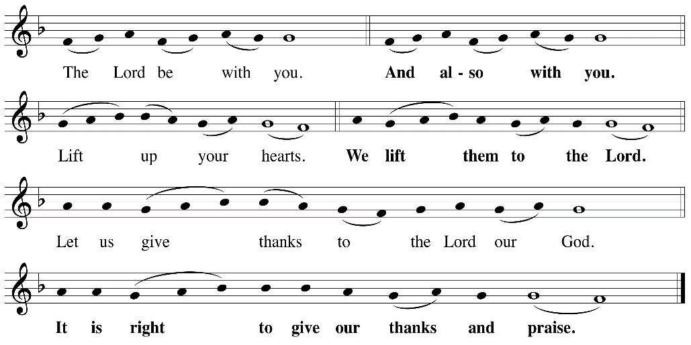

P: It is indeed right, our duty and our joy, that we should, at all times and in all places
give thanks and praise ... we praise your name and join their unending hymn:

Holy Holy
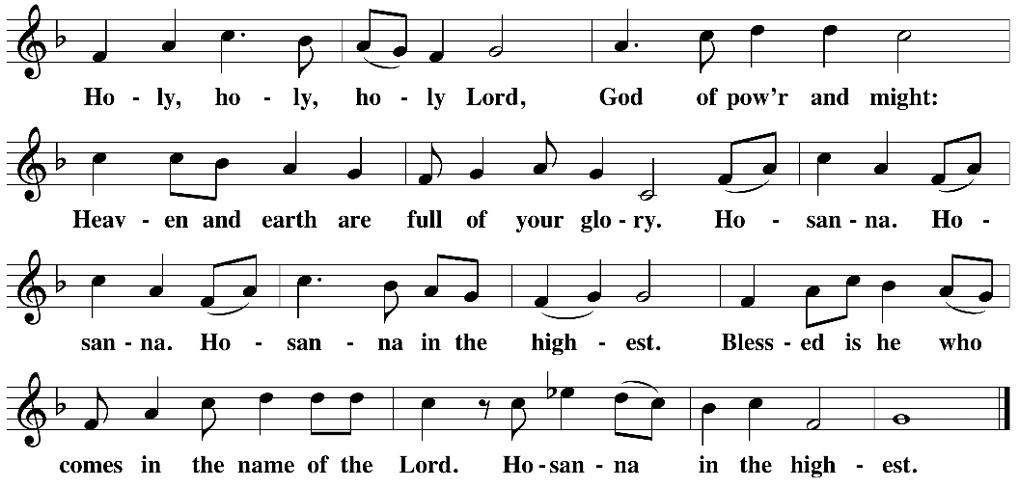

Eucharistic Prayer
The Lord’s Prayer
Our Father in heaven, hallowed be your name, your kingdom come, your will be done, on earth as in heaven. Give us today our daily bread. Forgive us our sins as we forgive those who sin against us. Save us from the time of trial and deliver us from evil. For the kingdom, the power, and the glory are yours, now and forever. Amen.
Invitation to the Table
You may now take the individual cups provided for communion. Please receive communion with these words: “The body of Christ given for you; the blood of Christ shed for you.”
Table Blessing
May the grace of our Lord Jesus Christ and the gifts of his body and blood strengthen, keep and unite us, now and forever. Amen.
Communion Hymn – Lamb of God
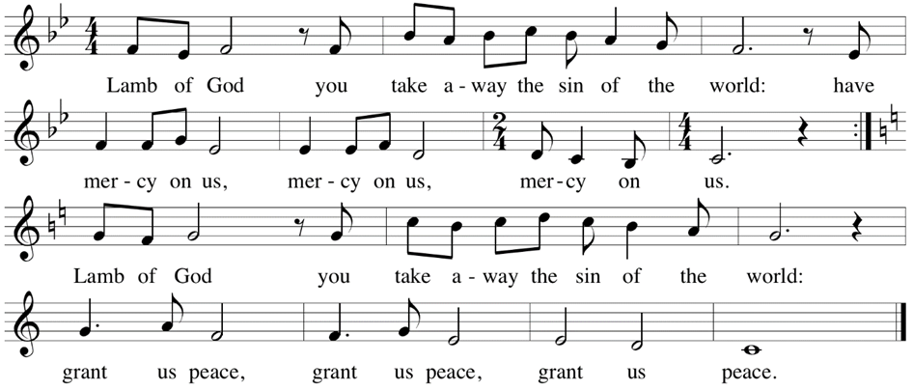

Post-Communion Prayer
Jesus, Bread of life, we have received from your table more than we could ever ask. As you have nourished us in this meal, now strengthen us to love the world with your own life.
In your name we pray. Amen.
Community Time
Blessing
The blessing of God,
who provides for us, feeds us, and journeys with us,
☩ be upon you now and forever.
Amen.
Sending Song – Just a Closer Walk with Thee All Verses ELW 697

^{Refrain}
Just a closer walk with thee,
grant it, Jesus, is my plea;
daily walking close to thee,
let it be, dear Lord, let it be.

¹I am weak but thou art strong:
Jesus, keep me from all wrong;
I'll be satisfied as long
as I walk, let me walk close to thee. Refrain

²Through this world of toil and snares,
if I falter, Lord, who cares?
Who with me my burden shares?
None but thee, dear Lord, none but thee. Refrain

³When my feeble life is o'er,
time for me will be no more;
guide me gently, safely o'er
to thy kingdom shore, to thy shore. Refrain

Sending
Go in peace. You are the body of Christ.
Thanks be to God.
Share the Peace of the Lord in the comments below!

