St. Mark’s Worship Sunday July 04, 2021
Welcome to our Online Worship
Happy Independence Day!

Welcome back to worship inside your church!
Stationed at the tables at the entrance our greeters have hand sanitizer and masks if you need them, bulletins and self-contained communion cups (please wait for the Pastor to direct you to open them) and they have a plate and envelopes where you can drop off your offering. We also are collecting your name and contact information. Please follow the direction of the ushers who will seat family groups six feet apart and refrain from hugs and handshakes. The restrooms will be open, but we request that one family group at a time uses the facilities. Unfortunately, we will not be serving coffee or refreshments before or after the services at this time.

If you are worshipping at home, you may want to prepare some bread, wine, or juice to receive Holy Communion. You may commune yourself or those around you with these words: “The body of Christ given for you; the blood of Christ shed for you.”
Prelude
Welcome
Opening Song – O Beautiful for Spacious Skies All Verses ELW 888
¹O beautiful for spacious skies,
For amber waves of grain,
For purple mountain majesties
Above the fruited plain:
America! America!
God shed his grace on thee,
And crown thy good with brotherhood
From sea to shining sea.

²O beautiful for heroes proved
In liberating strife,
Who more than self their country loved,
And mercy more than life:
America! America!
May God thy gold refine,
Till all success be nobleness,
And ev'ry gain divine.

³O beautiful for patriot dream
That sees beyond the years
Thine alabaster cities gleam,
Undimmed by human tears:
America! America!
God mend thine ev'ry flaw,
Confirm thy soul in self-control,
Thy liberty in law.

Confession and Forgiveness
Blessed be the holy Trinity, ☩ one God,
the God of manna,
the God of miracles,
the God of mercy.
Amen.
Drawn to Christ and seeking God’s abundance,
let us confess our sin.
Silence is kept for reflection.
God, our provider,
help us.
It is hard to believe there is enough to share.
We question your ways when they differ from the ways
of the world in which we live.
We turn to our own understanding
rather than trusting in you.
We take offense at your teachings and your ways.
Turn us again to you.
Where else can we turn?
Share with us the words of eternal life
and feed us for life in the world.
Amen.
Beloved people of God:
in Jesus, the manna from heaven,
you are fed and nourished.
By Jesus, the worker of miracles,
there is always more than enough.
Through Jesus, ☩ the bread of life,
you are shown God’s mercy:
you are forgiven and loved into abundant life.
Amen.
Mission Statement
“Celebrating God’s love and forgiveness, we serve others”

Prayer of the Day
God of the covenant, in our baptism you call us to proclaim the coming of your kingdom. Give us the courage you gave the apostles, that we may faithfully witness to your love and peace in every circumstance of life, in the name of Jesus Christ, our Savior and Lord. Amen.
Children’s message

Lesson 1: Ezekiel 2:1-5

¹[A voice] said to me: O mortal, stand up on your feet, and I will speak with you.²And when he spoke to me, a spirit entered into me and set me on my feet; and I heard him speaking to me. ³He said to me, Mortal, I am sending you to the people of Israel, to a nation of rebels who have rebelled against me; they and their ancestors have transgressed against me to this very day. ⁴The descendants are impudent and stubborn. I am sending you to them, and you shall say to them, “Thus says the Lord God.” ⁵Whether they hear or refuse to hear (for they are a rebellious house), they shall know that there has been a prophet among them.

Lesson 2: 2 Corinthians 12:2-10
²I know a person in Christ who fourteen years ago was caught up to the third heaven—whether in the body or out of the body I do not know; God knows. ³And I know that such a person—whether in the body or out of the body I do not know; God knows—⁴was caught up into Paradise and heard things that are not to be told, that no mortal is permitted to repeat. ⁵On behalf of such a one I will boast, but on my own behalf I will not boast, except of my weaknesses. ⁶But if I wish to boast, I will not be a fool, for I will be speaking the truth. But I refrain from it, so that no one may think better of me than what is seen in me or heard from me, ⁷even considering the exceptional character of the revelations. Therefore, to keep me from being too elated, a thorn was given me in the flesh, a messenger of Satan to torment me, to keep me from being too elated. ⁸Three times I appealed to the Lord about this, that it would leave me, ⁹but he said to me, “My grace is sufficient for you, for power is made perfect in weakness.” So, I will boast all the more gladly of my weaknesses, so that the power of Christ may dwell in me. ¹⁰Therefore I am content with weaknesses, insults, hardships, persecutions, and calamities for the sake of Christ; for whenever I am weak, then I am strong.
Word of God, Word of Life
Thanks be to God.
Gospel Acclamation
Alleluia. Lord to whom shall we go? You have the words of eternal life.
Alleluia.
The Holy Gospel according to Mark.
Glory to you, O Lord.

Gospel: Mark 6:1-13
¹[Jesus] came to his hometown, and his disciples followed him.²On the sabbath he began to teach in the synagogue, and many who heard him were astounded. They said, “Where did this man get all this? What is this wisdom that has been given to him? What deeds of power are being done by his hands! ³Is not this the carpenter, the son of Mary and brother of James and Joses and Judas and Simon, and are not his sisters here with us?” And they took offense at him. ⁴Then Jesus said to them, “Prophets are not without honor, except in their hometown, and among their own kin, and in their own house.”
⁵And he could do no deed of power there, except that he laid his hands on a few sick people and cured them. ⁶And he was amazed at their unbelief.
Then he went about among the villages teaching. ⁷He called the twelve and began to send them out two by two, and gave them authority over the unclean spirits. ⁸He ordered them to take nothing for their journey except a staff; no bread, no bag, no money in their belts; ⁹but to wear sandals and not to put on two tunics. ¹⁰He said to them, “Wherever you enter a house, stay there until you leave the place. ¹¹If any place will not welcome you and they refuse to hear you, as you leave, shake off the dust that is on your feet as a testimony against them.” ¹²So they went out and proclaimed that all should repent. ¹³They cast out many demons, and anointed with oil many who were sick and cured them.
The Gospel of our Lord.
Praise to you, O Christ
Sermon Pastor Karla Halvorson
Hymn of the Day – This Is My Song All Verses ELW 887

¹This is my song, O God of all the nations,
A song of peace for lands afar and mine.
This is my home, the country where
my heart is;
Here are my hopes, my dreams,
my holy shrine;
But other hearts in other lands are beating
With hopes and dreams as true and
high as mine.

² My country's skies are bluer than the ocean,
And sunlight beams on cloverleaf and pine.
But other lands have sunlight too, and clover,
And skies are ev'rywhere as blue as mine.
So hear my song, O God of all the nations,
A song of peace for their land and for mine.

³This is my prayer, O God of all
earth's kingdoms,
Your kingdom come; on earth your
will be done.
O God, be lifted up till all shall serve you,
And hearts united learn to live as one.
So hear my prayer, O God of all the nations;
Myself I give you; let your will be done.

Prayers of Intercession
Leader: Lord, in your mercy.
Congregation: Hear our prayer.
Blessing of prayer quilts
The Peace
The peace of Christ be with you always.
And also, with you.
(you may share the peace of Christ with anyone who is with you, share the peace in the comments, text an offering of peace to someone, or simply send a prayer of blessing and peace to someone.)
Offering
Thanksgiving Moment
Offering information
St. Mark’s Church, 580 Hilltop Dr. Chula Vista, CA 91910
Venmo: @stmarks-churchchulavista

Offering Song – Lord, Let my Heart be Good Soil ELW 512
Lord, let my heart be good soil, open to the seed of your word.
Lord, let my heart be good soil, Where love can grow and peace is understood.
When my heart is hard, break the stone away.
When my heart is cold, warm it with the day.
When my heart is lost, lead me on your way.
Lord, let my heart, Lord, let my heart,
Lord, let my heart be good soil.
Offering Prayer
Jesus, Bread of life, you have set this table with your very self, and called us to the feast of plenty. Gather what has been sown among us, and strengthen us in this meal. Make us to be what we receive here, your body for the life of the world. Amen.
The Great Thanksgiving
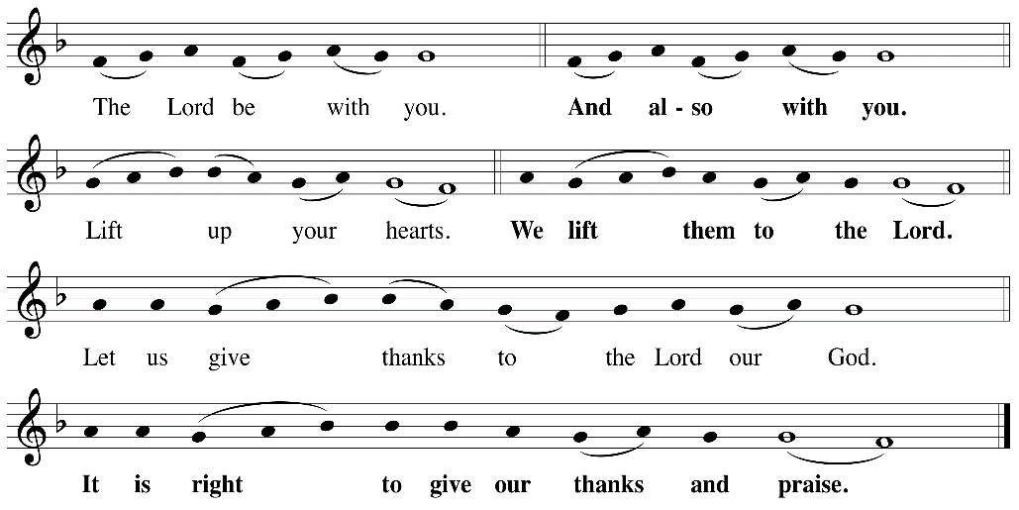

P: It is indeed right, our duty and our joy, that we should, at all times and in all places
give thanks and praise ... we praise your name and join their unending hymn:

Holy Holy
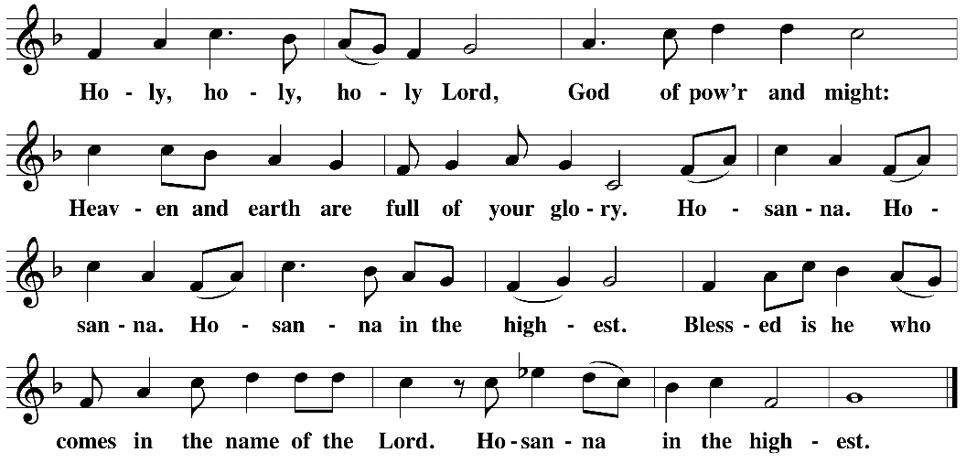

Eucharistic Prayer
The Lord’s Prayer
Our Father in heaven, hallowed be your name, your kingdom come, your will be done, on earth as in heaven. Give us today our daily bread. Forgive us our sins as we forgive those who sin against us. Save us from the time of trial and deliver us from evil. For the kingdom, the power, and the glory are yours, now and forever. Amen.
Invitation to the Table
You may now take the individual cups provided for communion. Please receive communion with these words: “The body of Christ given for you; the blood of Christ shed for you.”
Table Blessing
May the grace of our Lord Jesus Christ and the gifts of his body and blood strengthen, keep and unite us, now and forever. Amen.
Communion Hymn – Lamb of God
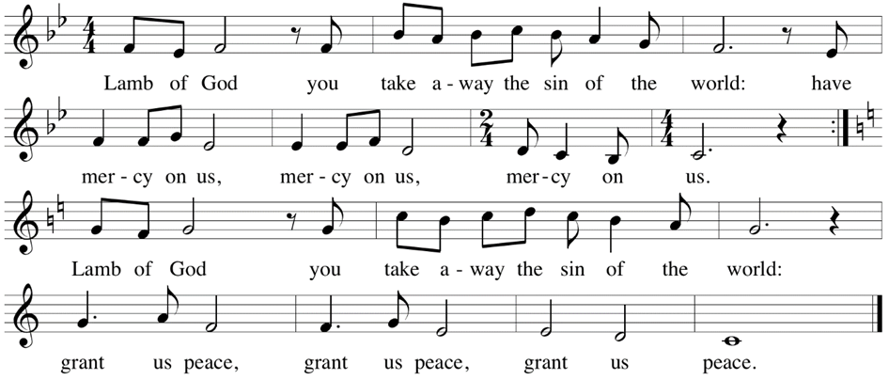

Post-Communion Prayer
Jesus, Bread of life, we have received from your table more than we could ever ask. As you have nourished us in this meal, now strengthen us to love the world with your own life.
In your name we pray. Amen.
Community Time
Blessing
The blessing of God, who provides for us, feeds us, and journeys with us, ☩ be upon you now and forever. Amen.
Sending Song – Mine Eyes Have Seen the Glory All Verses ELW 890

¹Mine eyes have seen the glory of the coming of the Lord;
He is trampling out the vintage where the grapes of wrath are stored;
He has loosed the fateful lightning of his terrible swift sword:
His truth is marching on.

^{Refrain}
Glory, glory! Hallelujah!
Glory, glory! Hallelujah!
Glory, glory! Hallelujah!
His truth is marching on.

²He has sounded forth the trumpet that shall never call retreat;
He is sifting out the hearts of men before his judgment seat.
Oh, be swift, my soul, to answer him; be jubilant, my feet!
Our God is marching on. Refrain

³In the beauty of the lilies Christ was born across the sea,
With a glory in his bosom that transfigures you and me.
As he died to make men holy, let us live to make men free,
While God is marching on. Refrain

Sending
Go in peace. You are the body of Christ.
Thanks be to God.
Share the Peace of the Lord in the comments below!

