St. Mark’s Worship Sunday June 27, 2021
Welcome to our Online Worship

Welcome back to worship inside your church!
Stationed at the tables at the entrance our greeters have hand sanitizer and masks if you need them, bulletins and self-contained communion cups (please wait for the Pastor to direct you to open them) and they have a plate and envelopes where you can drop off your offering. We also are collecting your name and contact information. Please follow the direction of the ushers who will seat family groups six feet apart and refrain from hugs and handshakes. The restrooms will be open, but we request that one family group at a time uses the facilities. Unfortunately, we will not be serving coffee or refreshments before or after the services at this time.

If you are worshipping at home, you may want to prepare some bread, wine, or juice to receive Holy Communion. You may commune yourself or those around you with these words: “The body of Christ given for you; the blood of Christ shed for you.”
Prelude
Welcome
Opening Song – Great Is Thy Faithfulness All Verses ELW 733
¹Great is thy faithfulness, O God my Father;
There is no shadow of turning with thee;
Thou changest not, thy compassions
they fail not;
As thou hast been, thou forever wilt be.

^{Refrain}
Great is thy faithfulness!
Great is thy faithfulness!
Morning by morning new mercies I see;
All I have needed thy hand hath provided;
Great is thy faithfulness, Lord, unto me!

²Summer and winter and springtime
and harvest,
Sun, moon, and stars in their courses above
Join with all nature in manifold witness
To thy great faithfulness, mercy, and love. Refrain

³Pardon for sin and a peace that endureth,
Thine own dear presence to cheer and
to guide;
Strength for today and bright hope
for tomorrow,
Blessings all mine, with ten thousand beside! Refrain

Confession and Forgiveness
Blessed be the holy Trinity,☩ one God,
the God of manna,
the God of miracles,
the God of mercy.
Amen.
Drawn to Christ and seeking God’s abundance,
let us confess our sin.
Silence is kept for reflection.
God, our provider,
help us.
It is hard to believe there is enough to share.
We question your ways when they differ from the ways
of the world in which we live.
We turn to our own understanding
rather than trusting in you.
We take offense at your teachings and your ways.
Turn us again to you.
Where else can we turn?
Share with us the words of eternal life
and feed us for life in the world.
Amen.
Beloved people of God:
in Jesus, the manna from heaven,
you are fed and nourished.
By Jesus, the worker of miracles,
there is always more than enough.
Through Jesus, ☩ the bread of life,
you are shown God’s mercy:
you are forgiven and loved into abundant life.
Amen.
Mission Statement
“Celebrating God’s love and forgiveness, we serve others”

Prayer of the Day
Almighty and merciful God, we implore you to hear the prayers of your people. Be our strong defense against all harm and danger, that we may live and grow in faith and hope, through Jesus Christ, our Savior and Lord. Amen.
Children’s message

Lesson 1: Lamentations 3:22-33

²²The steadfast love of the Lord never ceases,
his mercies never come to an end;
²³they are new every morning;
great is your faithfulness.
²⁴“The Lord is my portion,” says my soul,
“therefore I will hope in him.”
²⁵The Lord is good to those who wait for him,
to the soul that seeks him.
²⁶It is good that one should wait quietly
for the salvation of the Lord.
²⁷It is good for one to bear
the yoke in youth,
²⁸to sit alone in silence
when the Lord has imposed it,
²⁹to put one’s mouth to the dust
(there may yet be hope),
³⁰to give one’s cheek to the smiter,
and be filled with insults.
³¹For the Lord will not
reject forever.
³²Although he causes grief, he will have compassion
according to the abundance of his steadfast love;
³³for he does not willingly afflict
or grieve anyone.

Psalm: Psalm 30
¹I will exalt you, O Lord, because you have lifted me up
and have not let my enemies triumph over me.
²O Lord my God, I cried out to you,
and you restored me to health.
³You brought me up, O Lord, from the dead;
you restored my life as I was going down to the grave.
⁴Sing praise to the Lord, all you faithful;
give thanks in holy remembrance.
⁵God’s wrath is short; God’s favor lasts a lifetime.
Weeping spends the night, but joy comes in the morning.
⁶While I felt secure, I said,
“I shall never be disturbed.
⁷You, Lord, with your favor, made me as strong as the mountains.”
Then you hid your face, and I was filled with fear.
⁸I cried to you, O Lord;
I pleaded with | my Lord, saying,
⁹“What profit is there in my blood, if I go down to the pit?
Will the dust praise you or declare your faithfulness?
¹⁰Hear, O Lord, and have mercy upon me;
O Lord, be my helper.”
¹¹You have turned my wailing into dancing;
you have put off my sackcloth and clothed me with joy.
¹²Therefore my heart sings to you without ceasing;
O Lord my God, I will give you thanks forever.
Word of God, Word of Life
Thanks be to God.
Gospel Acclamation
Alleluia. Lord to whom shall we go? You have the words of eternal life.
Alleluia.
The Holy Gospel according to Mark.
Glory to you, O Lord.

Gospel: Mark 5:21-43
²¹When Jesus had crossed again in the boat to the other side, a great crowd gathered around him; and he was by the sea. ²²Then one of the leaders of the synagogue named Jairus came and, when he saw him, fell at his feet ²³and begged him repeatedly, “My little daughter is at the point of death. Come and lay your hands on her, so that she may be made well, and live.” ²⁴So he went with him.
And a large crowd followed him and pressed in on him. ²⁵Now there was a woman who had been suffering from hemorrhages for twelve years. ²⁶She had endured much under many physicians, and had spent all that she had; and she was no better, but rather grew worse. ²⁷She had heard about Jesus, and came up behind him in the crowd and touched his cloak, ²⁸for she said, “If I but touch his clothes, I will be made well.” ²⁹Immediately her hemorrhage stopped; and she felt in her body that she was healed of her disease. ³⁰Immediately aware that power had gone forth from him, Jesus turned about in the crowd and said, “Who touched my clothes?” ³¹And his disciples said to him, “You see the crowd pressing in on you; how can you say, ‘Who touched me?’ ” ³²He looked all around to see who had done it. ³³But the woman, knowing what had happened to her, came in fear and trembling, fell down before him, and told him the whole truth. ³⁴He said to her, “Daughter, your faith has made you well; go in peace, and be healed of your disease.”
³⁵While he was still speaking, some people came from the leader’s house to say, “Your daughter is dead. Why trouble the teacher any further?” ³⁶But overhearing what they said, Jesus said to the leader of the synagogue, “Do not fear, only believe.” ³⁷He allowed no one to follow him except Peter, James, and John, the brother of James. ³⁸When they came to the house of the leader of the synagogue, he saw a commotion, people weeping and wailing loudly. ³⁹When he had entered, he said to them, “Why do you make a commotion and weep? The child is not dead but sleeping.” ⁴⁰And they laughed at him. Then he put them all outside, and took the child’s father and mother and those who were with him, and went in where the child was. ⁴¹He took her by the hand and said to her, “Talitha cum,” which means, “Little girl, get up!” ⁴²And immediately the girl got up and began to walk about (she was twelve years of age). At this they were overcome with amazement. ⁴³He strictly ordered them that no one should know this, and told them to give her something to eat.
The Gospel of our Lord.
Praise to you, O Christ
Sermon Pastor Karla Halvorson
Hymn of the Day – Healer of Our Every Ill All Verses ELW 612

^{Refrain}
Healer of our ev'ry ill,
Light of each tomorrow,
Give us peace beyond our fear,
And hope beyond our sorrow.

¹You who know our fears and sadness,
Grace us with your peace and gladness;
Spirit of all comfort, fill our hearts. Refrain

²In the pain and joy beholding
How your grace is still unfolding,
Give us all your vision, God of love. Refrain

³Give us strength to love each other,
Ev'ry sister, ev'ry brother;
Spirit of all kindness, be our guide. Refrain

⁴You who know each thought and feeling,
Teach us all your way of healing;
Spirit of compassion, fill each heart. Refrain

Prayers of Intercession
Leader: Lord, in your mercy.
Congregation: Hear our prayer.
Blessing of prayer quilts
The Peace
The peace of Christ be with you always.
And also, with you.
(you may share the peace of Christ with anyone who is with you, share the peace in the comments, text an offering of peace to someone, or simply send a prayer of blessing and peace to someone.)
Offering
Thanksgiving Moment
Offering information
St. Mark’s Church, 580 Hilltop Dr. Chula Vista, CA 91910
Venmo: @stmarks-churchchulavista

Offering Song – Lord, Let my Heart be Good Soil ELW 512
Lord, let my heart be good soil, open to the seed of your word.
Lord, let my heart be good soil, Where love can grow and peace is understood.
When my heart is hard, break the stone away.
When my heart is cold, warm it with the day.
When my heart is lost, lead me on your way.
Lord, let my heart, Lord, let my heart,
Lord, let my heart be good soil.
Offering Prayer
Jesus, Bread of life, you have set this table with your very self, and called us to the feast of plenty. Gather what has been sown among us, and strengthen us in this meal. Make us to be what we receive here, your body for the life of the world. Amen.
The Great Thanksgiving
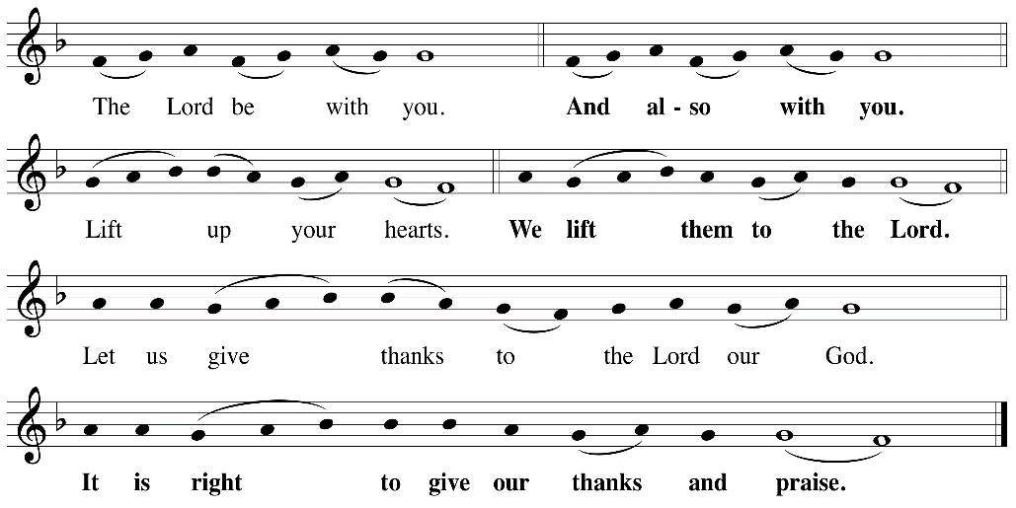

P: It is indeed right, our duty and our joy, that we should, at all times and in all places
give thanks and praise ... we praise your name and join their unending hymn:
Holy Holy
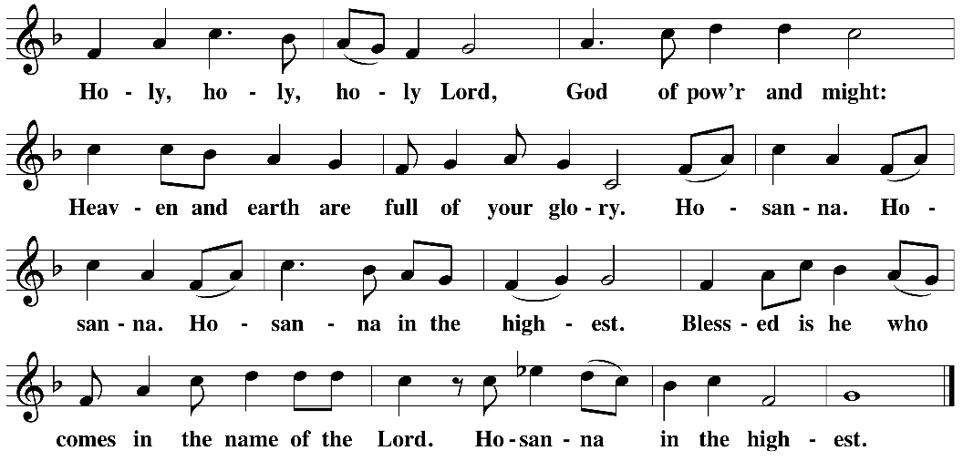

Eucharistic Prayer
The Lord’s Prayer
Our Father in heaven, hallowed be your name, your kingdom come, your will be done, on earth as in heaven. Give us today our daily bread. Forgive us our sins as we forgive those who sin against us. Save us from the time of trial and deliver us from evil. For the kingdom, the power, and the glory are yours, now and forever. Amen.
Invitation to the Table
You may now take the individual cups provided for communion. Please receive communion with these words: “The body of Christ given for you; the blood of Christ shed for you.”
Table Blessing
May the grace of our Lord Jesus Christ and the gifts of his body and blood strengthen, keep and unite us, now and forever. Amen.
Communion Hymn – Lamb of God
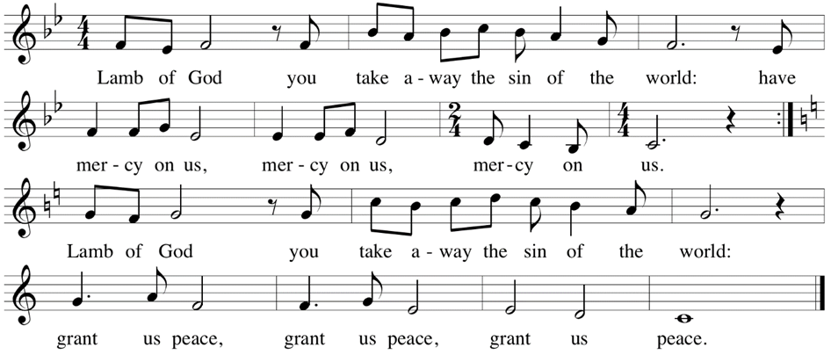

Post-Communion Prayer
Jesus, Bread of life, we have received from your table more than we could ever ask. As you have nourished us in this meal, now strengthen us to love the world with your own life.
In your name we pray. Amen.
Community Time
Blessing
The blessing of God, who provides for us, feeds us, and journeys with us, ☩ be upon you now and forever. Amen.

Sending Song – Oh, for a Thousand Tongues to Sing Verses 1, 3, 4, 6 ELW 886

¹Oh, for a thousand tongues to sing
My great Redeemer's praise,
The glories of my God and King,
The triumphs of his grace!

³The name of Jesus charms our fears
And bids our sorrows cease,
Sings music in the sinner's ears,
Brings life and health and peace.

⁴He speaks, and list'ning to his voice,
New life the dead receive;
The mournful, broken hearts rejoice,
The humble poor believe.
⁶To God all glory, praise, and love
Be now and ever giv'n
By saints below and saints above,
The church in earth and heav'n.

Sending
Go in peace. You are the body of Christ.
Thanks be to God.
Share the Peace of the Lord in the comments below!

