St. Mark’s Worship Sunday June 20, 2021
Welcome to our Online Worship
Happy Fathers Day!

Welcome back to worship inside your church!
Stationed at the tables at the entrance our greeters have hand sanitizer and masks if you need them, bulletins and self-contained communion cups (please wait for the Pastor to direct you to open them) and they have a plate and envelopes where you can drop off your offering. We also are collecting your name and contact information. Please follow the direction of the ushers who will seat family groups six feet apart and refrain from hugs and handshakes. The restrooms will be open, but we request that one family group at a time uses the facilities. Unfortunately, we will not be serving coffee or refreshments before or after the services at this time.

If you are worshipping at home, you may want to prepare some bread, wine, or juice to receive Holy Communion. You may commune yourself or those around you with these words: “The body of Christ given for you; the blood of Christ shed for you.”
Prelude – Margaret Gaillard
Welcome
Opening Song – Eternal Father, Strong to Save All Verses ELW 756
¹Eternal Father, strong to save,
Whose arm has bound the restless wave,
Who bade the mighty ocean deep
Its own appointed limits keep:
Oh, hear us when we cry to thee
For those in peril on the sea.

²O Savior, whose almighty word
The winds and waves submissive heard,
Who walked upon the foaming deep,
And calm amid the storm didst sleep:
Oh, hear us when we cry to thee
For those in peril on the sea.

³O Holy Spirit, who didst brood
Upon the chaos dark and rude,
And bid its angry tumult cease,
And give, for wild confusion, peace:
Oh, hear us when we cry to thee
For those in peril on the sea.

⁴O Trinity of love and pow'r,
All trav'lers guard in danger's hour
From rock and tempest, fire and foe,
Protect them wheresoe'er they go;
Thus evermore shall rise to thee
Glad hymns and praise from land and sea
Confession and Forgiveness
Blessed be the holy Trinity,☩ one God,
the God of manna,
the God of miracles,
the God of mercy.
Amen.
Drawn to Christ and seeking God’s abundance,
let us confess our sin.
Silence is kept for reflection.
God, our provider,
help us.
It is hard to believe there is enough to share.
We question your ways when they differ from the ways
of the world in which we live.
We turn to our own understanding
rather than trusting in you.
We take offense at your teachings and your ways.
Turn us again to you.
Where else can we turn?
Share with us the words of eternal life
and feed us for life in the world.
Amen.
Beloved people of God:
in Jesus, the manna from heaven,
you are fed and nourished.
By Jesus, the worker of miracles,
there is always more than enough.
Through Jesus, ☩ the bread of life,
you are shown God’s mercy:
you are forgiven and loved into abundant life.
Amen.
Mission Statement
“Celebrating God’s love and forgiveness, we serve others”

Prayer of the Day
O God of creation, eternal majesty, you preside over land and sea, sunshine and storm. By your strength pilot us, by your power preserve us, by your wisdom instruct us, and by your hand protect us, through Jesus Christ, our Savior and Lord. Amen.
Children’s message

Lesson 1: Job 38:1-11
¹The Lord answered Job out of the whirlwind:
²“Who is this that darkens counsel by words without knowledge?
³Gird up your loins like a man, I will question you, and you shall declare to me.
⁴“Where were you when I laid the foundation of the earth? Tell me, if you have understanding.
⁵Who determined its measurements—surely you know! Or who stretched the line upon it?
⁶On what were its bases sunk, or who laid its cornerstone
⁷when the morning stars sang together and all the heavenly beings shouted for joy?
⁸“Or who shut in the sea with doors when it burst out from the womb?—
⁹when I made the clouds its garment, and thick darkness its swaddling band,
¹⁰and prescribed bounds for it, and set bars and doors,
¹¹and said, ‘Thus far shall you come, and no farther, and here shall your proud waves be stopped’?”

Lesson 2: 2 Corinthians 6:1-13
¹As we work together with him, we urge you also not to accept the grace of God in vain. ²For he says,
“At an acceptable time I have listened to you, and on a day of salvation I have helped you.”
See, now is the acceptable time; see, now is the day of salvation! ³We are putting no obstacle in anyone’s way, so that no fault may be found with our ministry, ⁴but as servants of God we have commended ourselves in every way: through great endurance, in afflictions, hardships, calamities, ⁵beatings, imprisonments, riots, labors, sleepless nights, hunger; ⁶by purity, knowledge, patience, kindness, holiness of spirit, genuine love, ⁷truthful speech, and the power of God; with the weapons of righteousness for the right hand and for the left; ⁸in honor and dishonor, in ill repute and good repute. We are treated as impostors, and yet are true; ⁹as unknown, and yet are well known; as dying, and see—we are alive; as punished, and yet not killed; ¹⁰as sorrowful, yet always rejoicing; as poor, yet making many rich; as having nothing, and yet possessing everything.
¹¹We have spoken frankly to you Corinthians; our heart is wide open to you. ¹²There is no restriction in our affections, but only in yours. ¹³In return—I speak as to children—open wide your hearts also.
Word of God, Word of Life
Thanks be to God.
Gospel Acclamation
Alleluia. Lord to whom shall we go? You have the words of eternal life.
Alleluia.
The Holy Gospel according to Mark.
Glory to you, O Lord.

Gospel: Mark 4:35-41
³⁵When evening had come, [Jesus said to the disciples,] “Let us go across to the other side.” ³⁶And leaving the crowd behind, they took him with them in the boat, just as he was. Other boats were with him. ³⁷A great windstorm arose, and the waves beat into the boat, so that the boat was already being swamped. ³⁸But he was in the stern, asleep on the cushion; and they woke him up and said to him, “Teacher, do you not care that we are perishing?” ³⁹He woke up and rebuked the wind, and said to the sea, “Peace! Be still!” Then the wind ceased, and there was a dead calm. ⁴⁰He said to them, “Why are you afraid? Have you still no faith?” ⁴¹And they were filled with great awe and said to one another, “Who then is this, that even the wind and the sea obey him?”
The Gospel of our Lord.
Praise to you, O Christ
Sermon Pastor Karla Halvorson
Hymn of the Day – Precious Lord, Take My Hand Verse 1-3 ELW 773

¹Precious Lord, take my hand
Lead me on, let me stand
I am tired, I am weak, I am worn
Through the storm, through the night
Lead me on to the light
Take my hand precious Lord, lead me home
²When my way grows drear precious Lord linger near
When my life is almost gone
Hear my cry, hear my call
Hold my hand lest I fall
Take my hand precious Lord, lead me home
³When the darkness appears and the night draws near
And the day is past and gone
At the river I stand
Guide my feet, hold my hand
Take my hand precious Lord, lead me home

Prayers of Intercession
Leader: Lord, in your mercy.
Congregation: Hear our prayer.
Blessing of prayer quilts
The Peace
The peace of Christ be with you always.
And also, with you.
(you may share the peace of Christ with anyone who is with you, share the peace in the comments, text an offering of peace to someone, or simply send a prayer of blessing and peace to someone.)
Offering
Thanksgiving Moment
Offering information
St. Mark’s Church, 580 Hilltop Dr. Chula Vista, CA 91910
Venmo: @stmarks-churchchulavista

Offering Song – Lord, Let my Heart be Good Soil ELW 512
Lord, let my heart be good soil, open to the seed of your word.
Lord, let my heart be good soil, Where love can grow and peace is understood.
When my heart is hard, break the stone away.
When my heart is cold, warm it with the day.
When my heart is lost, lead me on your way.
Lord, let my heart, Lord, let my heart,
Lord, let my heart be good soil.
Offering Prayer
Jesus, Bread of life, you have set this table with your very self, and called us to the feast of plenty. Gather what has been sown among us and strengthen us in this meal. Make us to be what we receive here, your body for the life of the world.
Amen.
The Great Thanksgiving
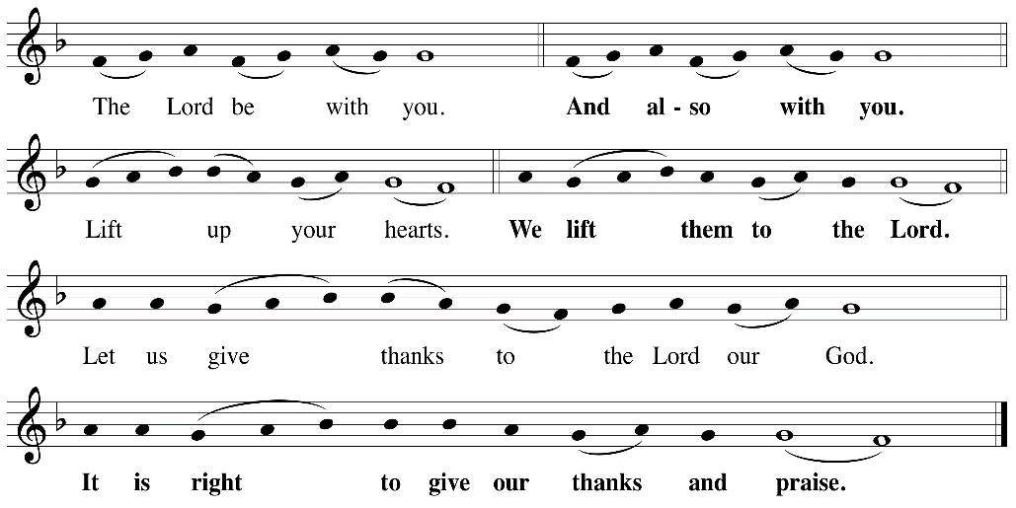

P: It is indeed right, our duty and our joy, that we should, at all times and in all places
give thanks and praise ... we praise your name and join their unending hymn:
Holy Holy
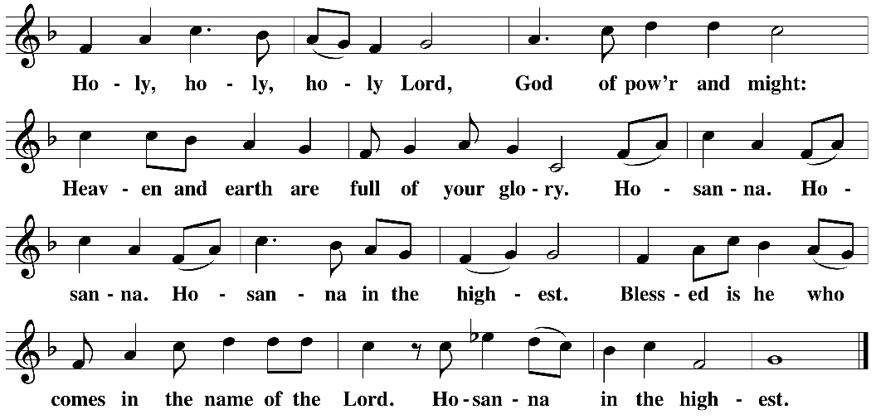

Eucharistic Prayer
The Lord’s Prayer
Our Father in heaven, hallowed be your name, your kingdom come, your will be done, on earth as in heaven. Give us today our daily bread. Forgive us our sins as we forgive those who sin against us. Save us from the time of trial and deliver us from evil. For the kingdom, the power, and the glory are yours, now and forever. Amen.
Invitation to the Table
You may now take the individual cups provided for communion. Please receive communion with these words: “The body of Christ given for you; the blood of Christ shed for you.”
Table Blessing
May the grace of our Lord Jesus Christ and the gifts of his body and blood strengthen, keep and unite us, now and forever. Amen.
Communion Hymn – Lamb of God
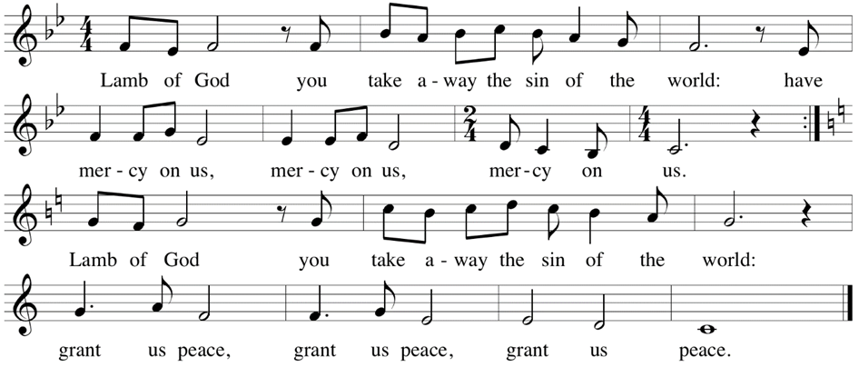

Post-Communion Prayer
Jesus, Bread of life, we have received from your table more than we could ever ask. As you have nourished us in this meal, now strengthen us to love the world with your own life.
In your name we pray. Amen.
Community Time
Blessing
The blessing of God, who provides for us, feeds us, and journeys with us, ☩ be upon you now and forever. Amen.

Sending Song – My Life Flows On in Endless Song All Verses ELW 763

¹My life flows on in endless song;
above earth's lamentation,
I catch the sweet, though far-off hymn
that hails a new creation.

^{Refrain}
No storm can shake my inmost calm
while to that Rock I'm clinging.
Since Christ is Lord of heaven and earth,
how can I keep from singing?

²Through all the tumult and the strife,
I hear that music ringing.
It finds an echo in my soul.
How can I keep from singing? Refrain

³What though my joys and comforts die?
The Lord my Savior liveth.
What though the darkness gather round?
Songs in the night he giveth. Refrain

⁴The peace of Christ makes fresh my heart,
a fountain ever springing!
All things are mine since I am his!
How can I keep from singing? Refrain

Sending
Go in peace. You are the body of Christ.
Thanks be to God.
Postlude – Margaret Gaillard
Share the Peace of the Lord in the comments below!

