St. Mark’s Worship Sunday June 13, 2021
Welcome to our Online Worship
Back to indoor Worship!

Welcome back to worship inside your church!
Stationed at the tables at the entrance our greeters have hand sanitizer and masks if you need them, bulletins and self-contained communion cups (please wait for the Pastor to direct you to open them). We also are collecting your name and contact information. Please follow the direction of the ushers who will seat family groups six feet apart and refrain from hugs and handshakes. The restrooms will be open, but we request that one family group at a time uses the facilities. Unfortunately, we will not be serving coffee or refreshments before or after the services at this time.

If you are worshipping at home, you may want to prepare some bread, wine, or juice to receive Holy Communion. You may commune yourself or those around you with these words: “The body of Christ given for you; the blood of Christ shed for you.”
Prelude
Welcome
Opening Song – All are Welcome Verses 1-3 ELW 641
¹Let us build a house where love can dwell
And all can safely live,
A place where saints and children tell
How hearts learn to forgive.
Built of hopes and dreams and visions,
Rock of faith and vault of grace;
Here the love of Christ shall end divisions:

Refrain
All are welcome, all are welcome,
all are welcome in this place.

²Let us build a house where prophets speak,
And words are strong and true,
Where all God's children dare to seek
To dream God's reign anew.
Here the cross shall stand as witness
And as symbol of God's grace;
Here as one we claim the faith of Jesus: Refrain

³Let us build a house where love is found
In water, wine and wheat:
A banquet hall on holy ground
Where peace and justice meet.
Here the love of God, through Jesus,
Is revealed in time and space;
As we share in Christ the feast that frees us: Refrain

Confession and Forgiveness
Blessed be the holy Trinity,☩ one God,
the God of manna,
the God of miracles,
the God of mercy.
Amen.
Drawn to Christ and seeking God’s abundance,
let us confess our sin.
Silence is kept for reflection.
God, our provider,
help us.
It is hard to believe there is enough to share.
We question your ways when they differ from the ways
of the world in which we live.
We turn to our own understanding
rather than trusting in you.
We take offense at your teachings and your ways.
Turn us again to you.
Where else can we turn?
Share with us the words of eternal life
and feed us for life in the world.
Amen.
Beloved people of God:
in Jesus, the manna from heaven,
you are fed and nourished.
By Jesus, the worker of miracles,
there is always more than enough.
Through Jesus, ☩ the bread of life,
you are shown God’s mercy:
you are forgiven and loved into abundant life.
Amen.
Mission Statement
“Celebrating God’s love and forgiveness, we serve others”

Prayer of the Day
O God, you are the tree of life, offering shelter to all the world. Graft us into yourself and nurture our growth, that we may bear your truth and love to those in need, through Jesus Christ, our Savior and Lord. Amen.
Children’s message

Lesson 1: Ezekiel 17:22-24

²²Thus says the Lord God: I myself will take a sprig from the lofty top of a cedar;
I will set it out. I will break off a tender one from the topmost of its young twigs;
I myself will plant it on a high and lofty mountain.
²³On the mountain height of Israel I will plant it, in order that it may produce boughs and bear fruit, and become a noble cedar.
Under it every kind of bird will live; in the shade of its branches will nest winged creatures of every kind.
²⁴All the trees of the field shall know that I am the Lord.
I bring low the high tree, I make high the low tree; I dry up the green tree and make the dry tree flourish.
I the Lord have spoken; I will accomplish it.

Lesson 2: 2 Corinthians 5:6-10 [11-13] 14-17
⁶So we are always confident; even though we know that while we are at home in the body we are away from the Lord—⁷for we walk by faith, not by sight. ⁸Yes, we do have confidence, and we would rather be away from the body and at home with the Lord. ⁹So whether we are at home or away, we make it our aim to please him. ¹⁰For all of us must appear before the judgment seat of Christ, so that each may receive recompense for what has been done in the body, whether good or evil.
[¹¹Therefore, knowing the fear of the Lord, we try to persuade others; but we ourselves are well known to God, and I hope that we are also well known to your consciences. ¹²We are not commending ourselves to you again, but giving you an opportunity to boast about us, so that you may be able to answer those who boast in outward appearance and not in the heart. ¹³For if we are beside ourselves, it is for God; if we are in our right mind, it is for you. ] ¹⁴For the love of Christ urges us on, because we are convinced that one has died for all; therefore all have died. ¹⁵And he died for all, so that those who live might live no longer for themselves, but for him who died and was raised for them.
¹⁶From now on, therefore, we regard no one from a human point of view; even though we once knew Christ from a human point of view, we know him no longer in that way. ¹⁷So if anyone is in Christ, there is a new creation: everything old has passed away; see, everything has become new!
Word of God, Word of Life
Thanks be to God.
Gospel Acclamation
Alleluia. Lord to whom shall we go? You have the words of eternal life.
Alleluia.

The Holy Gospel according to Mark.
Glory to you, O Lord.

Gospel: Mark 4:26-34
²⁶[Jesus] said, “The kingdom of God is as if someone would scatter seed on the ground,²⁷and would sleep and rise night and day, and the seed would sprout and grow, he does not know how. ²⁸The earth produces of itself, first the stalk, then the head, then the full grain in the head. ²⁹But when the grain is ripe, at once he goes in with his sickle, because the harvest has come.”
³⁰He also said, “With what can we compare the kingdom of God, or what parable will we use for it? ³¹It is like a mustard seed, which, when sown upon the ground, is the smallest of all the seeds on earth; ³²yet when it is sown it grows up and becomes the greatest of all shrubs, and puts forth large branches, so that the birds of the air can make nests in its shade.”
³³With many such parables he spoke the word to them, as they were able to hear it; ³⁴he did not speak to them except in parables, but he explained everything in private to his disciples.
The Gospel of our Lord.
Praise to you, O Christ
Sermon Pastor Karla Halvorson
Hymn of the Day – For the Fruit of All Creation All Verses ELW 679

¹For the fruit of all creation,
Thanks be to God.
For these gifts to ev'ry nation,
Thanks be to God.
For the plowing, sowing, reaping,
Silent growth while we are sleeping,
Future needs in earth's safekeeping,
Thanks be to God.

²In the just reward of labor,
God's will is done.
In the help we give our neighbor,
God's will is done.
In our worldwide task of caring
For the hungry and despairing,
In the harvests we are sharing,
God's will is done.

³For the harvests of the Spirit,
Thanks be to God.
For the good we all inherit,
Thanks be to God.
For the wonders that astound us,
For the truths that still confound us,
Most of all, that love has found us,
Thanks be to God.

Prayers of Intercession
Leader: Lord, in your mercy.
Congregation: Hear our prayer.
Blessing of prayer quilts
The Peace
The peace of Christ be with you always.
And also, with you.
(you may share the peace of Christ with anyone who is with you, share the peace in the comments, text an offering of peace to someone, or simply send a prayer of blessing and peace to someone.)
Offering
Thanksgiving Moment
Offering information
St. Mark’s Church, 580 Hilltop Dr. Chula Vista, CA 91910
Venmo: @stmarks-churchchulavista

Offering Song – Lord, Let my Heart be Good Soil ELW 512
Lord, let my heart be good soil, open to the seed of your word.
Lord, let my heart be good soil, Where love can grow and peace is understood.
When my heart is hard, break the stone away.
When my heart is cold, warm it with the day.
When my heart is lost, lead me on your way.
Lord, let my heart, Lord, let my heart,
Lord, let my heart be good soil.
Offering Prayer
Jesus, Bread of life, you have set this table with your very self, and called us to the feast of plenty. Gather what has been sown among us and strengthen us in this meal. Make us to be what we receive here, your body for the life of the world.
Amen.
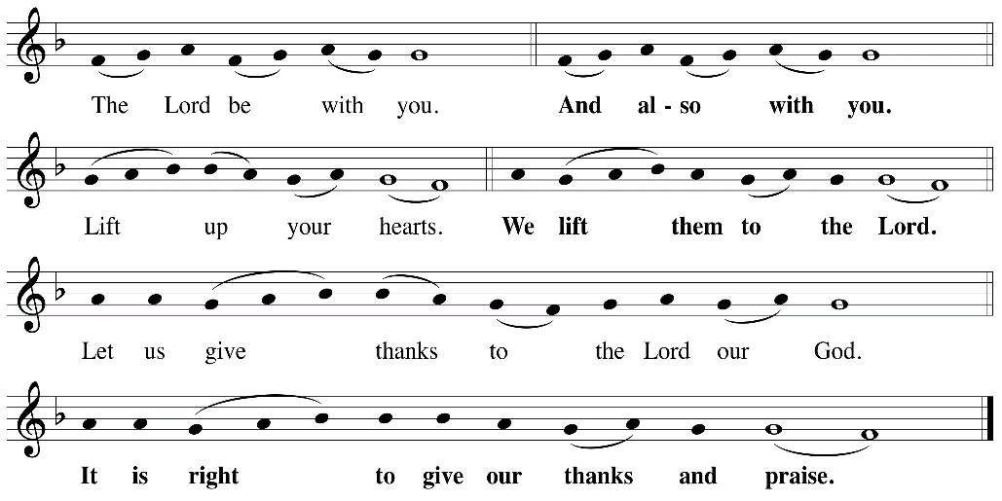
The Great Thanksgiving

P: It is indeed right, our duty and our joy, that we should, at all times and in all places
give thanks and praise ... we praise your name and join their unending hymn:
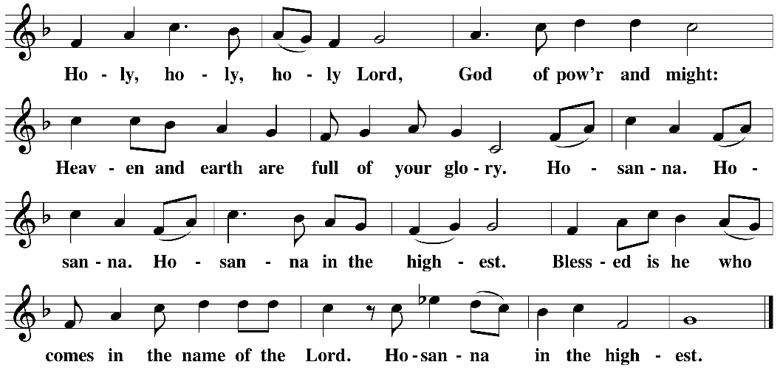
Holy, Holy

Eucharistic Prayer
The Lord’s Prayer
Our Father in heaven, hallowed be your name, your kingdom come, your will be
done, on earth as in heaven. Give us today our daily bread. Forgive us our sins as
we forgive those who sin against us. Save us from the time of trial and deliver us
from evil. For the kingdom, the power, and the glory are yours, now and forever.
Amen.
Invitation to the Table
You may now take the individual cups provided for communion. Please receive communion with these words: “The body of Christ given for you; the blood of Christ shed for you.”
Communion Hymn – Lamb of God
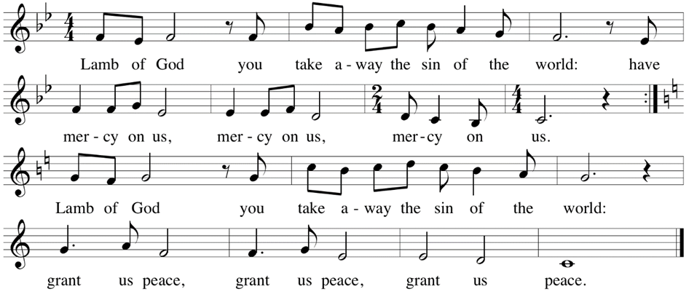

Table Blessing
May the grace of our Lord Jesus Christ and the gifts of his body and blood strengthen, keep and unite us, now and forever. Amen.
Post-Communion Prayer
Jesus, Bread of life, we have received from your table more than we could ever ask. As you have nourished us in this meal, now strengthen us to love the world with your own life.
In your name we pray. Amen.
Community Time
Sending Song – All are Welcome Verses 4-5 ELW 641

⁴Let us build a house where hands will reach
beyond the wood and stone
to heal and strengthen, serve and teach,
and live the Word they've known.
Here the outcast and the stranger
bear the image of God's face;
let us bring an end to fear and danger: Refrain

Refrain
All are welcome, all are welcome,
all are welcome in this place.

⁵Let us build a house where all are named,
their songs and visions heard
and loved and treasured, taught
and claimed
as words within the Word.
Built of tears and cries and laughter,
prayers of faith and songs of grace,
let this house proclaim from floor to rafter: Refrain

Sending
Go in peace. You are the body of Christ.
Thanks be to God.
Share the Peace of the Lord in the comments below!

