St. Mark’s Worship Sunday June 6, 2021
Welcome to our Online Worship

Welcome to our worship! Stationed at the tables at the entrance to the patio our greeters have hand sanitizer and masks if you need them, bulletins and self-contained communion cups (please wait for the Pastor to direct you to open them) and they have a plate and envelopes where you can drop off your offering. We also are collecting your name and contact information if you haven't made a reservation. Please follow the direction of the ushers who will seat family groups six feet apart and refrain from hugs and handshakes. The restrooms will be open, but we request that one family group at a time uses the facilities. Unfortunately, we will not be serving coffee or refreshments before or after the services at this time. Outdoors, with masks on, we are allowed to sing and recite during the worship service!

If you are worshipping at home, you may want to prepare some bread, wine, or juice to receive Holy Communion. You may commune yourself or those around you with these words: “The body of Christ given for you; the blood of Christ shed for you.”
Prelude
Welcome
Opening Song – Lead me, Guide Me All Verses ELW 768
Refrain
Lead me, Guide me, A long the way
For if you lead me, I cannot stray
Lord, let me walk each day with thee
Lead me O Lord, lead me.

¹I am weak and I need thy strength and pow’r
To help me over my weakest hour.
Help me through the darkness thy face to see.
Lead me O Lord, lead me. Refrain

²Help me tread in the paths of righteousness,
Be my aid when Satan and sin oppress.
I am putting all my trust in thee.
Lead me O Lord, lead me. Refrain

³I am lost if you take your hand from me,
I am blind without thy light to see.
Lord, just always let me thy servant be.
Lead me O Lord, lead me. Refrain

Confession and Forgiveness
Blessed be the holy Trinity,☩ one God,
the God of manna,
the God of miracles,
the God of mercy.
Amen.
Drawn to Christ and seeking God’s abundance,
let us confess our sin.
Silence is kept for reflection.
God, our provider,
help us.
It is hard to believe there is enough to share.
We question your ways when they differ from the ways
of the world in which we live.
We turn to our own understanding
rather than trusting in you.
We take offense at your teachings and your ways.
Turn us again to you.
Where else can we turn?
Share with us the words of eternal life
and feed us for life in the world.
Amen.
Beloved people of God:
in Jesus, the manna from heaven,
you are fed and nourished.
By Jesus, the worker of miracles,
there is always more than enough.
Through Jesus, ☩ the bread of life,
you are shown God’s mercy:
you are forgiven and loved into abundant life.
Amen.
Mission Statement
“Celebrating God’s love and forgiveness, we serve others”

Prayer of the Day
All-powerful God, in Jesus Christ you turned death into life and defeat into victory. Increase our faith and trust in him, that we may triumph over all evil in the strength of the same Jesus Christ, our Savior and Lord.
Amen.
Children’s message

Psalm: Psalm 130
¹Out of the depths
I cry to you, O Lord;
²O Lord, hear my voice!
Let your ears be attentive to the voice of my supplication.
³If you were to keep watch over sins,
O Lord, who could stand?
⁴Yet with you is forgiveness,
in order that you may be feared.
⁵I wait for you, O Lord; my soul waits;
in your word is my hope.
⁶My soul waits for the Lord more than those who keep watch for the morning,
more than those who keep watch | for the morning.
⁷O Israel, wait for the Lord, for with the Lord there is steadfast love;
with the Lord there is plenteous redemption.
⁸For the Lord shall redeem Israel
from all their sins.

Lesson 2: 2 Corinthians 4:13--5:1
¹³Just as we have the same spirit of faith that is in accordance with scripture—“I believed, and so I spoke”—we also believe, and so we speak, ¹⁴because we know that the one who raised the Lord Jesus will raise us also with Jesus, and will bring us with you into his presence. ¹⁵Yes, everything is for your sake, so that grace, as it extends to more and more people, may increase thanksgiving, to the glory of God.
¹⁶So we do not lose heart. Even though our outer nature is wasting away, our inner nature is being renewed day by day. ¹⁷For this slight momentary affliction is preparing us for an eternal weight of glory beyond all measure, ¹⁸because we look not at what can be seen but at what cannot be seen; for what can be seen is temporary, but what cannot be seen is eternal.
^{5:1}For we know that if the earthly tent we live in is destroyed, we have a building from God, a house not made with hands, eternal in the heavens.
Word of God, Word of Life
Thanks be to God.
Gospel Acclamation
Alleluia. Lord to whom shall we go? You have the words of eternal life.
Alleluia.
The Holy Gospel according to Mark.
Glory to you, O Lord.

Gospel: Mark 3:20-35
[Jesus went home;] ²⁰and the crowd came together again, so that [Jesus and the disciples] could not even eat. ²¹When his family heard it, they went out to restrain him, for people were saying, “He has gone out of his mind.” ²²And the scribes who came down from Jerusalem said, “He has Beelzebul, and by the ruler of the demons he casts out demons.” ²³And he called them to him, and spoke to them in parables, “How can Satan cast out Satan? ²⁴If a kingdom is divided against itself, that kingdom cannot stand. ²⁵And if a house is divided against itself, that house will not be able to stand. ²⁶And if Satan has risen up against himself and is divided, he cannot stand, but his end has come. ²⁷But no one can enter a strong man’s house and plunder his property without first tying up the strong man; then indeed the house can be plundered.
²⁸“Truly I tell you, people will be forgiven for their sins and whatever blasphemies they utter; ²⁹but whoever blasphemes against the Holy Spirit can never have forgiveness, but is guilty of an eternal sin”—³⁰for they had said, “He has an unclean spirit.”
³¹Then his mother and his brothers came; and standing outside, they sent to him and called him. ³²A crowd was sitting around him; and they said to him, “Your mother and your brothers and sisters are outside, asking for you.” ³³And he replied, “Who are my mother and my brothers?” ³⁴And looking at those who sat around him, he said, “Here are my mother and my brothers! ³⁵Whoever does the will of God is my brother and sister and mother.”
The Gospel of our Lord.
Praise to you, O Christ
Sermon Pastor Karla Halvorson
Hymn of the Day – A Mighty Fortress Is Our God All Verses ELW 504

¹A mighty fortress is our God,
A sword and shield victorious;
He breaks the cruel oppressor's rod
And wins salvation glorious.
The old satanic foe
Has sworn to work us woe!
With craft and dreadful might
He arms himself to fight.
On earth he has no equal.

²No strength of ours can match his might!
We would be lost, rejected.
But now a champion comes to fight,
Whom God himself elected.
You ask who this may be?
The Lord of hosts is he!
Christ Jesus, mighty Lord,
God's only Son, adored.
He holds the field victorious.

³Though hordes of devils fill the land
All threat'ning to devour us,
We tremble not, unmoved we stand;
They cannot overpow'r us.
Let this world's tyrant rage;
In battle we'll engage!
His might is doomed to fail;
God's judgment must prevail!
One little word subdues him.

⁴God's Word forever shall abide,
No thanks to foes, who fear it;
For God himself fights by our side
With weapons of the Spirit.
Were they to take our house,
Goods, honor, child, or spouse,
Though life be wrenched away,
They cannot win the day.

The kingdom's ours forever!

Prayers of Intercession
Leader: Lord, in your mercy.
Congregation: Hear our prayer.
Blessing of prayer quilts
The Peace
The peace of Christ be with you always.
And also, with you.
(you may share the peace of Christ with anyone who is with you, share the peace in the comments, text an offering of peace to someone, or simply send a prayer of blessing and peace to someone.)
Offering
Thanksgiving Moment
Offering information
St. Mark’s Church, 580 Hilltop Dr. Chula Vista, CA 91910
Venmo: @stmarks-churchchulavista

Offering Song – Lord, Let my Heart be Good Soil ELW 512
Lord, let my heart be good soil, open to the seed of your word.
Lord, let my heart be good soil, Where love can grow and peace is understood.
When my heart is hard, break the stone away.
When my heart is cold, warm it with the day.
When my heart is lost, lead me on your way.
Lord, let my heart, Lord, let my heart,
Lord, let my heart be good soil.
Offering Prayer
Jesus, Bread of life, you have set this table with your very self, and called us to the feast of plenty. Gather what has been sown among us and strengthen us in this meal. Make us to be what we receive here, your body for the life of the world.
Amen.
The Great Thanksgiving
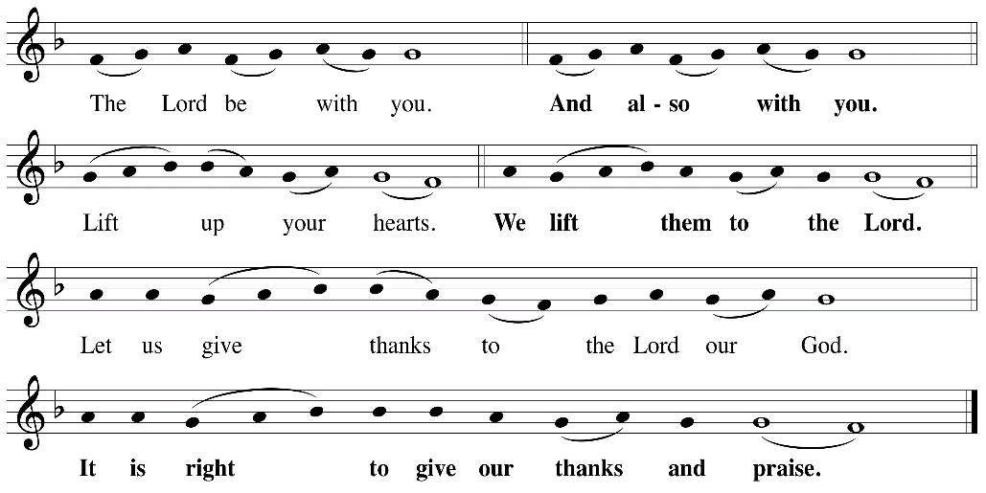

P: It is indeed right, our duty and our joy, that we should, at all times and in all places
give thanks and praise ... we praise your name and join their unending hymn:

Holy Holy
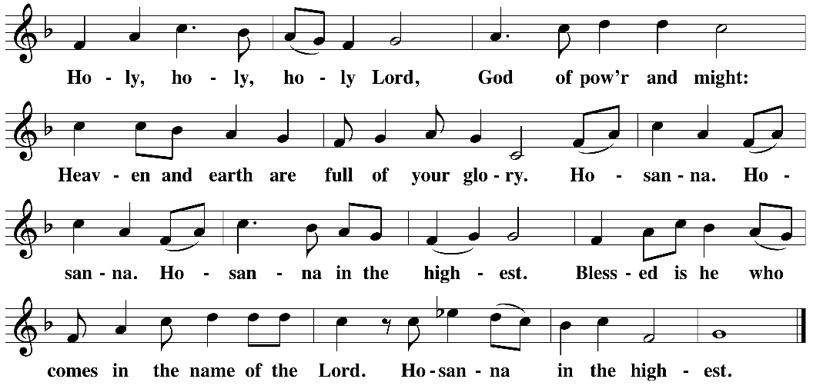

Eucharistic Prayer
The Lord’s Prayer
Our Father in heaven, hallowed be your name, your kingdom come, your will be
done, on earth as in heaven. Give us today our daily bread. Forgive us our sins as
we forgive those who sin against us. Save us from the time of trial and deliver us
from evil. For the kingdom, the power, and the glory are yours, now and forever.
Amen.
Invitation to the Table
You may now take the individual cups provided for communion. Please receive communion with these words: “The body of Christ given for you; the blood of Christ shed for you.”
Table Blessing
May the grace of our Lord Jesus Christ and the gifts of his body and blood strengthen, keep and unite us, now and forever. Amen.
Communion Hymn – Lamb of God
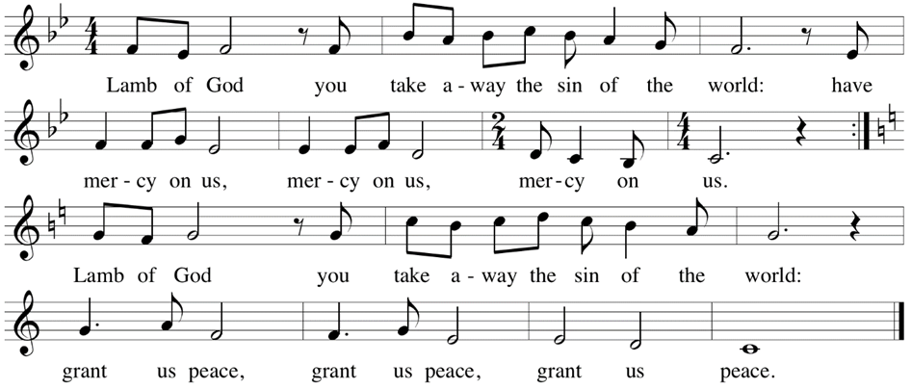

Post-Communion Prayer
Jesus, Bread of life, we have received from your table more than we could ever ask. As you have nourished us in this meal, now strengthen us to love the world with your own life.
In your name we pray. Amen.
Community Time
Blessing
The blessing of God, who provides for us, feeds us, and journeys with us, ☩ be upon you now and forever. Amen.
Sending Song – I'm So Glad Jesus Lifted Me All Verses ELW 860

¹I'm so glad Jesus lifted me.
I'm so glad Jesus lifted me.
I'm so glad Jesus lifted me,
Singing glory, hallelujah! Jesus lifted me.

²Satan had me bound, Jesus lifted me.
Satan had me bound, Jesus lifted me.
Satan had me bound, Jesus lifted me,
Singing glory, hallelujah! Jesus lifted me.

³When I was in trouble, Jesus lifted me.
When I was in trouble, Jesus lifted me.
When I was in trouble, Jesus lifted me,
Singing glory, hallelujah! Jesus lifted me.

Sending
Go in peace. You are the body of Christ.
Thanks be to God.
Share the Peace of the Lord in the comments below!

