St. Mark’s Worship Sunday May 30, 2021
Welcome to our Online Worship
Holy Trinity

Welcome to our worship! Stationed at the tables at the entrance to the patio our greeters have hand sanitizer and masks if you need them, bulletins and self-contained communion cups (please wait for the Pastor to direct you to open them) and they have a plate and envelopes where you can drop off your offering. We also are collecting your name and contact information if you haven't made a reservation. Please follow the direction of the ushers who will seat family groups six feet apart and refrain from hugs and handshakes. The restrooms will be open, but we request that one family group at a time uses the facilities. Unfortunately, we will not be serving coffee or refreshments before or after the services at this time. Outdoors, with masks on, we are allowed to sing and recite during the worship service!

If you are worshipping at home, you may want to prepare some bread, wine, or juice to receive Holy Communion. You may commune yourself or those around you with these words: “The body of Christ given for you; the blood of Christ shed for you.”
Prelude
Welcome
Opening Song – Come, Join the Dance of Trinity Verse 1-4 ELW 412

¹Come, join the dance of Trinity,
Before all worlds begun—
The interweaving of the Three,
The Father, Spirit, Son.
The universe of space and time
Did not arise by chance,
But as the Three, in love and hope,
Made room within their dance.

²Come, see the face of Trinity,
Newborn in Bethlehem;
Then bloodied by a crown of thorns
Outside Jerusalem.
The dance of Trinity is meant
For human flesh and bone;
When fear confines the dance in death,
God rolls away the stone.
³Come, speak aloud of Trinity,
As wind and tongues of flame
Set people free at Pentecost
To tell the Savior's name.
We know the yoke of sin and death,
Our necks have worn it smooth;
Go tell the world of weight and woe
That we are free to move!

⁴Within the dance of Trinity,
Before all worlds begun,
We sing the praises of the Three,
The Father, Spirit, Son.
Let voices rise and interweave,
By love and hope set free,
To shape in song this joy, this life:
The dance of Trinity.

Sacrament of Holy Baptism – Kassy Mae Alincastre
(The Sacrament begins with prayer and profession of faith from parents and sponsors)
The sacrament continues with the whole congregation:
Do you believe in God the Father?
I believe in God, the Father almighty,
creator of heaven and earth.

Do you believe in Jesus Christ, the Son of God?
I believe in Jesus Christ, God's only Son, our Lord,
who was conceived by the Holy Spirit,
born of the virgin Mary,
suffered under Pontius Pilate,
was crucified, died, and was buried;
he descended to the dead.
On the third day he rose again;
he ascended into heaven,
he is seated at the right hand of the Father,
and he will come to judge the living and the dead.

Do you believe in God the Holy Spirit?
I believe in the Holy Spirit,
the holy catholic church,
the communion of saints,
the forgiveness of sins,
the resurrection of the body,
and the life everlasting.
Thanksgiving at the Font
Pastor: The Lord be with you.
And also with you.
Let us give thanks to the Lord our God.
It is right to give our thanks and praise.
Pastor: We give you thanks… … in the unity of the Holy Spirit, now and forever.
Amen.
Baptism
Anointing with Oil
Welcome
A lighted candle is given
Pastor: Jesus said, I am the light of the world. Whoever follows me will have the light of life.
Let us welcome the newly baptized.
We welcome you into the body of Christ and into the mission we share:
join us in giving thanks and praise to God
and bearing God's creative and redeeming word to all the world.
Greet newly baptized with applause!
Mission Statement
“Celebrating God’s love and forgiveness, we serve others”

Prayer of the Day
Almighty Creator and ever-living God: we worship your glory, eternal Three-in-One, and we praise your power, majestic One-in-Three. Keep us steadfast in this faith, defend us in all adversity, and bring us at last into your presence, where you live in endless joy and love, Father, Son, and Holy Spirit, one God, now and forever.
Amen.
Children’s message

Lesson 1: Isaiah 6:1-8
¹In the year that King Uzziah died, I saw the Lord sitting on a throne, high and lofty; and the hem of his robe filled the temple. ²Seraphs were in attendance above him; each had six wings: with two they covered their faces, and with two they covered their feet, and with two they flew. ³And one called to another and said:
“Holy, holy, holy is the Lord of hosts;
the whole earth is full of his glory.”
⁴The pivots on the thresholds shook at the voices of those who called, and the house filled with smoke. ⁵And I said: “Woe is me! I am lost, for I am a man of unclean lips, and I live among a people of unclean lips; yet my eyes have seen the King, the Lord of hosts!”
⁶Then one of the seraphs flew to me, holding a live coal that had been taken from the altar with a pair of tongs. ⁷The seraph touched my mouth with it and said: “Now that this has touched your lips, your guilt has departed and your sin is blotted out.” ⁸Then I heard the voice of the Lord saying, “Whom shall I send, and who will go for us?” And I said, “Here am I; send me!”
Lesson 2: Romans 8:12-17
¹²Brothers and sisters, we are debtors, not to the flesh, to live according to the flesh—¹³for if you live according to the flesh, you will die; but if by the Spirit you put to death the deeds of the body, you will live. ¹⁴For all who are led by the Spirit of God are children of God. ¹⁵For you did not receive a spirit of slavery to fall back into fear, but you have received a spirit of adoption. When we cry, “Abba! Father!” ¹⁶it is that very Spirit bearing witness with our spirit that we are children of God, ¹⁷and if children, then heirs, heirs of God and joint heirs with Christ—if, in fact, we suffer with him so that we may also be glorified with him.
Word of God, Word of Life
Thanks be to God.

Gospel Acclamation
Alleluia. Lord to whom shall we go? You have the words of eternal life.
Alleluia.
The Holy Gospel according to John.
Glory to you, O Lord.
Gospel: John 3:1-17
¹Now there was a Pharisee named Nicodemus, a leader of the Jews. ²He came to Jesus by night and said to him, “Rabbi, we know that you are a teacher who has come from God; for no one can do these signs that you do apart from the presence of God.” ³Jesus answered him, “Very truly, I tell you, no one can see the kingdom of God without being born from above.” ⁴Nicodemus said to him, “How can anyone be born after having grown old? Can one enter a second time into the mother’s womb and be born?” ⁵Jesus answered, “Very truly, I tell you, no one can enter the kingdom of God without being born of water and Spirit. ⁶What is born of the flesh is flesh, and what is born of the Spirit is spirit. ⁷Do not be astonished that I said to you, ‘You must be born from above.’ ⁸The wind blows where it chooses, and you hear the sound of it, but you do not know where it comes from or where it goes. So it is with everyone who is born of the Spirit.” ⁹Nicodemus said to him, “How can these things be?” ¹⁰Jesus answered him, “Are you a teacher of Israel, and yet you do not understand these things?
¹¹“Very truly, I tell you, we speak of what we know and testify to what we have seen; yet you do not receive our testimony. ¹²If I have told you about earthly things and you do not believe, how can you believe if I tell you about heavenly things? ¹³No one has ascended into heaven except the one who descended from heaven, the Son of Man. ¹⁴And just as Moses lifted up the serpent in the wilderness, so must the Son of Man be lifted up, ¹⁵that whoever believes in him may have eternal life.
¹⁶“For God so loved the world that he gave his only Son, so that everyone who believes in him may not perish but may have eternal life.
¹⁷“Indeed, God did not send the Son into the world to condemn the world, but in order that the world might be saved through him.”
The Gospel of our Lord.
Praise to you, O Christ
Sermon Pastor Karla Halvorson

Hymn of the Day – Holy, Holy, Holy, Lord God Almighty! Verses – 1-4 ELW 413

¹Holy, holy, holy, Lord God Almighty!
Early in the morning our song shall
rise to thee.
Holy, holy, holy, merciful and mighty!
God in three persons, blessed Trinity!

²Holy, holy, holy! All the saints adore thee,
Casting down their golden crowns around
The glassy sea;
Cherubim and seraphim falling down
Before thee,
Which wert and art, and evermore shalt be.

³Holy, holy, holy! Though the darkness
hide thee,
Though the eye of sinfulness thy glory may
not see,
Only thou art holy; there is none
beside thee,
Perfect in pow'r, in love and purity.

⁴Holy, holy, holy! Lord God Almighty!
All thy works shall praise thy name in earth
And sky and sea.
Holy, holy, holy, merciful and mighty!
God in three persons, blessed Trinity!

Prayers of Intercession
Leader: Lord, in your mercy.
Congregation: Hear our prayer.
Blessing of prayer quilts
The Peace
The peace of Christ be with you always.
And also, with you.
(you may share the peace of Christ with anyone who is with you, share the peace in the comments, text an offering of peace to someone, or simply send a prayer of blessing and peace to someone.)
Offering
Thanksgiving Moment
Offering information
St. Mark’s Church, 580 Hilltop Dr. Chula Vista, CA 91910
Venmo: @stmarks-churchchulavista

Offering Song – Lord, Let my Heart be Good Soil ELW 512
Lord, let my heart be good soil, open to the seed of your word.
Lord, let my heart be good soil, Where love can grow and peace is understood.
When my heart is hard, break the stone away.
When my heart is cold, warm it with the day.
When my heart is lost, lead me on your way.
Lord, let my heart, Lord, let my heart,
Lord, let my heart be good soil.

Offering Prayer
Jesus, Bread of life, you have set this table with your very self, and called us to the feast of plenty. Gather what has been sown among us and strengthen us in this meal. Make us to be what we receive here, your body for the life of the world.
Amen.
The Great Thanksgiving
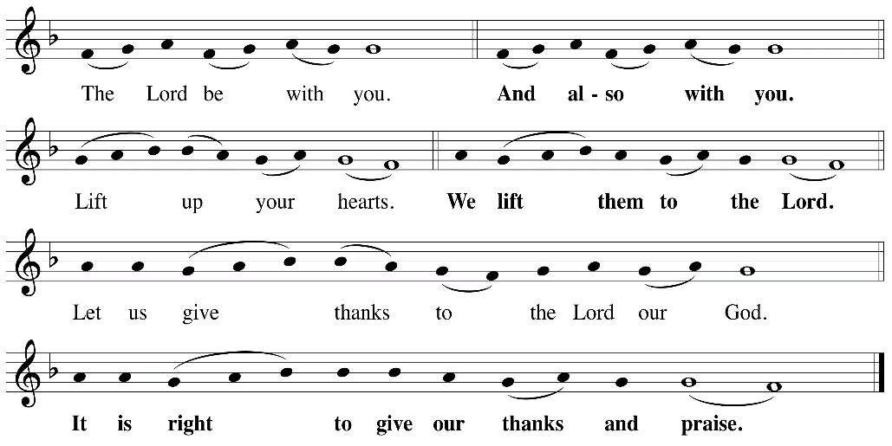

P: It is indeed right, our duty and our joy, that we should, at all times and in all places
give thanks and praise ... we praise your name and join their unending hymn:
Holy Holy
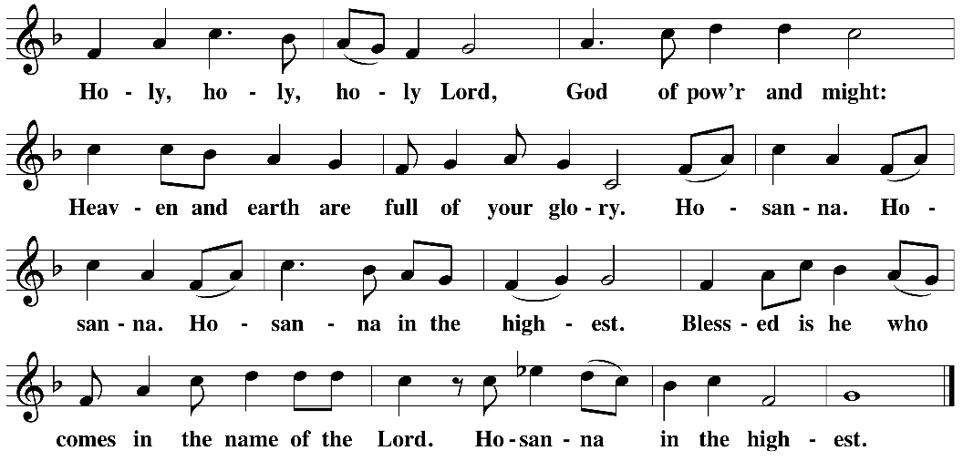

Eucharistic Prayer

The Lord’s Prayer
Our Father in heaven, hallowed be your name, your kingdom come, your will be
done, on earth as in heaven. Give us today our daily bread. Forgive us our sins as
we forgive those who sin against us. Save us from the time of trial and deliver us
from evil. For the kingdom, the power, and the glory are yours, now and forever.
Amen.
Invitation to the Table
You may now take the individual cups provided for communion. Please receive communion with these words: “The body of Christ given for you; the blood of Christ shed for you.”
Communion Hymn – Lamb of God
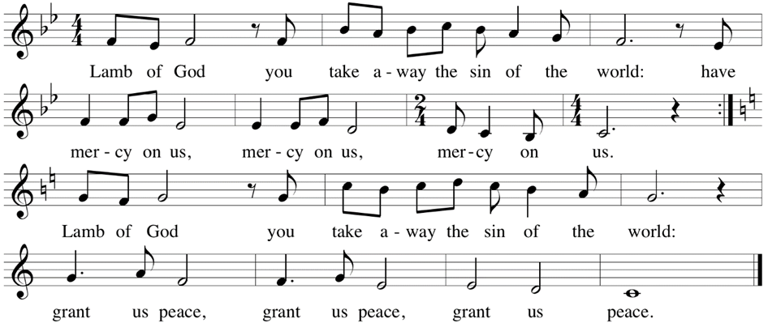

Table Blessing
May the grace of our Lord Jesus Christ and the gifts of his body and blood strengthen, keep and unite us, now and forever. Amen.

Post-Communion Prayer
Wellspring of joy, through this meal you have put gladness in our hearts. Satisfy the hunger still around us, and send us as joyful witnesses, that your love may bring joy to the hearts of all people, through Jesus Christ our Lord. Amen.
Community Time
Blessing
The blessing of God, who provides for us, feeds us, and journeys with us, ☩ be upon you now and forever. Amen.

Sending Song – Thy Strong Word Verse 1,4,6 ELW 511

¹Thy strong word did cleave the darkness;
At thy speaking it was done.
For created light we thank thee,
While thine ordered seasons run.
Alleluia! Alleluia!
Praise to thee who light dost send!
Alleluia! Alleluia!
Alleluia without end!

⁴From the cross thy wisdom shining
Breaketh forth in conqu’ring might;
From the cross forever beameth
All thy bright redeeming light.
Alleluia! Alleluia!
Praise to thee who light dost send!
Alleluia! Alleluia!
Alleluia without end!

⁶God the Father, light-creator,
To thee laud and honor be.
To thee, Light of Light begotten,
praise be sung eternally.
Holy Spirit, light-revealer,
Glory, glory be to thee.
Mortals, angels, now and ever
Praise the holy Trinity!

Sending
Go in peace. You are the body of Christ.
Thanks be to God.
Share the Peace of the Lord in the comments below!

