St. Mark’s Worship Sunday May 16, 2021
Welcome to our Online Worship

Welcome to our worship! Stationed at the tables at the entrance to the patio our greeters have hand sanitizer and masks if you need them, bulletins and self-contained communion cups (please wait for the Pastor to direct you to open them) and they have a plate and envelopes where you can drop off your offering. We also are collecting your name and contact information if you haven't made a reservation. Please follow the direction of the ushers who will seat family groups six feet apart and refrain from hugs and handshakes. The restrooms will be open, but we request that one family group at a time uses the facilities. Unfortunately, we will not be serving coffee or refreshments before or after the services at this time. Outdoors, with masks on, we are allowed to sing and recite during the worship service!

If you are worshipping at home, you may want to prepare some bread, wine, or juice to receive Holy Communion. You may commune yourself or those around you with these words: “The body of Christ given for you; the blood of Christ shed for you.”
Prelude
Welcome and Call to Worship
Opening Song – Praise the Lord! O Heavens Verse 1,2 ELW 823

¹Praise the Lord! O heav'ns, adore him;
Praise him, angels, in the height;
Sun and moon, rejoice before him;
Praise him, gleaming stars and light.
Praise the Lord, for he has spoken;
Worlds his mighty voice obeyed;
Laws which never shall be broken
For their guidance he has made.

²Praise the Lord, for he is gracious;
Never shall his promise fail.
God has made his saints victorious;
Sin and death shall not prevail.
Praise the God of our salvation;
Hosts on high, his pow'r proclaim;
Heav'n and earth, and all creation,
Laud and magnify his name!

Mission Statement
“Celebrating God’s love and forgiveness, we serve others”
Thanksgiving for Baptism
All may make the sign of the cross, the sign marked at baptism, as the presiding minister begins.
Alleluia! Christ is risen.
Christ is risen indeed. Alleluia!
Refreshed by the resurrection life we share in Christ,
let us give thanks for the gift of baptism.
Water may be poured into the font as the presiding minister gives thanks.
We thank you, risen Christ,
for these waters where you make us new,
leading us from death to life, from tears to joy.

We bless you, risen Christ, that your Spirit comes to us
in the grace-filled waters of rebirth,
like rains to our thirsting earth,
like streams that revive our souls,
like cups of cool water shared with strangers.

Breathe your peace on your church when we hide in fear.
Clothe us with your mercy and forgiveness.
Send us companions on our journey as we share your life.

Make us one, risen Christ.
Cleanse our hearts.
Shower us with life.

To you be given all praise,
with the Holy Spirit,
in the glory of God,
now and forever.
Amen.

Greeting
From the one who is and who was and who is to come, the Almighty; grace and peace be with you all.
And also, with you.
Prayer of the Day
Almighty God, your blessed Son, our Savior Jesus Christ, ascended far above all heavens that he might fill all things. Mercifully give us faith to trust that, as he promised, he abides with us on earth to the end of time, who lives and reigns with you and the Holy Spirit, one God, now and forever.
Amen.
Children’s message

Lesson 1: Acts 1:1-11
[Luke writes:] ¹In the first book, Theophilus, I wrote about all that Jesus did and taught from the beginning ²until the day when he was taken up to heaven, after giving instructions through the Holy Spirit to the apostles whom he had chosen. ³After his suffering he presented himself alive to them by many convincing proofs, appearing to them during forty days and speaking about the kingdom of God. ⁴While staying with them, he ordered them not to leave Jerusalem, but to wait there for the promise of the Father. “This,” he said, “is what you have heard from me; ⁵for John baptized with water, but you will be baptized with the Holy Spirit not many days from now.”
⁶So when they had come together, they asked him, “Lord, is this the time when you will restore the kingdom to Israel?” ⁷He replied, “It is not for you to know the times or periods that the Father has set by his own authority. ⁸But you will receive power when the Holy Spirit has come upon you; and you will be my witnesses in Jerusalem, in all Judea and Samaria, and to the ends of the earth.” ⁹When he had said this, as they were watching, he was lifted up, and a cloud took him out of their sight. ¹⁰While he was going and they were gazing up toward heaven, suddenly two men in white robes stood by them. ¹¹They said, “Men of Galilee, why do you stand looking up toward heaven? This Jesus, who has been taken up from you into heaven, will come in the same way as you saw him go into heaven.”
Lesson 2: Ephesians 1:15-23
¹⁵I have heard of your faith in the Lord Jesus and your love toward all the saints, and for this reason ¹⁶I do not cease to give thanks for you as I remember you in my prayers. ¹⁷I pray that the God of our Lord Jesus Christ, the Father of glory, may give you a spirit of wisdom and revelation as you come to know him, ¹⁸so that, with the eyes of your heart enlightened, you may know what is the hope to which he has called you, what are the riches of his glorious inheritance among the saints, ¹⁹and what is the immeasurable greatness of his power for us who believe, according to the working of his great power. ²⁰God put this power to work in Christ when he raised him from the dead and seated him at his right hand in the heavenly places, ²¹far above all rule and authority and power and dominion, and above every name that is named, not only in this age but also in the age to come. ²²And he has put all things under his feet and has made him the head over all things for the church, ²³which is his body, the fullness of him who fills all in all.
Word of God, Word of Life
Thanks be to God.
Gospel Acclamation
Alleluia. Lord to whom shall we go? You have the words of eternal life.
Alleluia.
The Holy Gospel according to Luke.
Glory to you, O Lord.
Gospel – Luke 24:44-53
⁴⁴[Jesus said to the eleven and those with them,] “These are my words that I spoke to you while I was still with you—that everything written about me in the law of Moses, the prophets, and the psalms must be fulfilled.”⁴⁵Then he opened their minds to understand the scriptures, ⁴⁶and he said to them, “Thus it is written, that the Messiah is to suffer and to rise from the dead on the third day, ⁴⁷and that repentance and forgiveness of sins is to be proclaimed in his name to all nations, beginning from Jerusalem. ⁴⁸You are witnesses of these things. ⁴⁹And see, I am sending upon you what my Father promised; so stay here in the city until you have been clothed with power from on high.”
⁵⁰Then he led them out as far as Bethany, and, lifting up his hands, he blessed them. ⁵¹While he was blessing them, he withdrew from them and was carried up into heaven. ⁵²And they worshiped him, and returned to Jerusalem with great joy; ⁵³and they were continually in the temple blessing God.
The Gospel of our Lord.
Praise to you, O Christ
Sermon Pastor Karla Halvorson
Hymn of the Day – Rise, O Sun of Righteousness Verses – 1,3,4 ELW 657

¹Rise, O Sun of righteousness;
With your might creation bless.
Shine upon your church today,
Showing all your gentle way.
Have mercy, Lord.

³Gather in your scattered flock;
Give us water from the rock.
Bless the unity we share
In our shepherd's loving care.
Have mercy, Lord.

4 Burst the bars of stubborn pride;
make the heav'nly pathway wide.
Raise us up from sin and death
with your Spirit's living breath.
Have mercy, Lord.

Prayers of Intercession
Leader: Hear us, O God.
Congregation: Your mercy is great.
Blessing of prayer quilts
The Peace
The peace of Christ be with you always.
And also, with you.
(you may share the peace of Christ with anyone who is with you, share the peace in the comments, text an offering of peace to someone, or simply send a prayer of blessing and peace to someone.)
Offering
Thanksgiving Moment
Offering information
St. Mark’s Church, 580 Hilltop Dr. Chula Vista, CA 91910
Venmo: @stmarks-churchchulavista

Offering Song – Lord, Listen to Your Children
Lord, listen to your children praying,
Lord, send your spirit in this place,
Lord, listen to your children praying,
Send us power, send us love, send us grace.

Offering Prayer
God of love, you call us beloved children and welcome us to your table. Receive our lives and the gifts we offer. Abide with us and send us in service to a suffering world, for the sake of your beloved Child, Jesus Christ. Amen.
The Great Thanksgiving
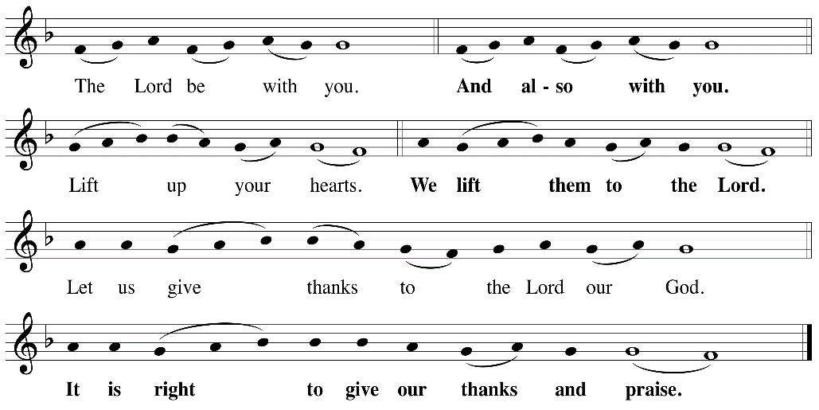

P: It is indeed right, our duty and our joy, that we should at all times and in all places
give thanks and praise ... we praise your name and join their unending hymn:

Holy Holy
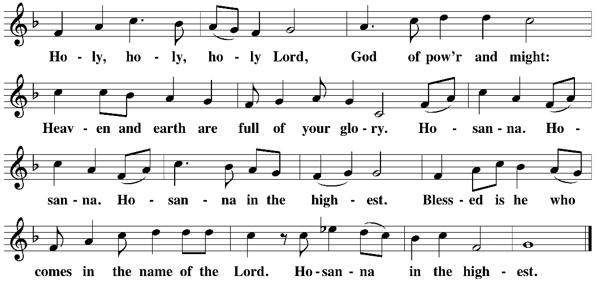

Eucharistic Prayer
The Lord’s Prayer
Our Father in heaven, hallowed be your name, your kingdom come, your will be
done, on earth as in heaven. Give us today our daily bread. Forgive us our sins as
we forgive those who sin against us. Save us from the time of trial and deliver us
from evil. For the kingdom, the power, and the glory are yours, now and forever.
Amen.
Invitation to the Table
You may now take the individual cups provided for communion. Please receive communion with these words: “The body of Christ given for you; the blood of Christ shed for you.”
Communion Hymn – Lamb of God
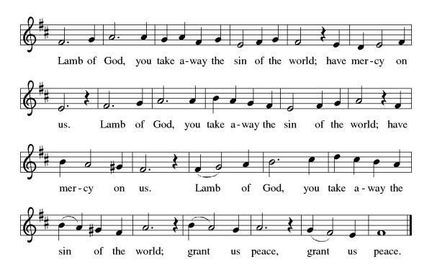
Table Blessing
May the grace of our Lord Jesus Christ and the gifts of his body and blood strengthen, keep and unite us, now and forever. Amen.

Post-Communion Prayer
Wellspring of joy, through this meal you have put gladness in our hearts. Satisfy the hunger still around us, and send us as joyful witnesses, that your love may bring joy to the hearts of all people, through Jesus Christ our Lord. Amen.
Community Time
Blessing
May our glorious God grant you a spirit of wisdom to know and to love the risen Lord Jesus. The God of life, Father, ☩ Son, and Holy Spirit, bless you now and forever. Amen.
Sending Song – Lord I Lift Your Name on High Sung twice ELW 857

Lord, I lift Your name on high
Lord, I love to sing Your praises
I'm so glad You're in my life
I'm so glad You came to save us

You came from Heaven to earth
to show the way
From the earth to the cross
my debt to pay
From the cross to the grave
From the grave to the sky
Lord, I lift Your name on high

Sending
Alleluia! Christ is risen.
Christ is risen indeed. Alleluia!
Go in peace. Share the good news. Alleluia!
Thanks be to God. Alleluia!
Share the Peace of the Lord in the comments below!

