St. Mark’s Worship Sunday May 2, 2021
Welcome to our Online Worship

Welcome to our worship! Stationed at the tables at the entrance to the patio our greeters have hand sanitizer and masks if you need them, bulletins and self-contained communion cups (please wait for the Pastor to direct you to open them) and they have a plate and envelopes where you can drop off your offering. We also are collecting your name and contact information if you haven't made a reservation. Please follow the direction of the ushers who will seat family groups six feet apart and refrain from hugs and handshakes. The restrooms will be open, but we request that one family group at a time uses the facilities. Unfortunately, we will not be serving coffee or refreshments before or after the services at this time. Outdoors, with masks on, we are allowed to sing and recite during the worship service!

If you are worshipping at home, you may want to prepare some bread, wine, or juice to receive Holy Communion. You may commune yourself or those around you with these words: “The body of Christ given for you; the blood of Christ shed for you.”
Prelude
Welcome and Call to Worship
Opening Song – Abide With Me Verse 1,3,4 ELW 629

¹Abide with me, fast falls the eventide.
The darkness deepens;
Lord, with me abide.
When other helpers fail
and comforts flee,
Help of the helpless, oh, abide with me.

³I need thy presence ev'ry passing hour;
What but thy grace can foil the
tempter's pow'r?
Who like thyself my guide
and stay can be?
Through cloud and sunshine, oh, abide
with me.

⁴I fear no foe, with thee at hand to bless;
Ills have no weight,
and tears no bitterness.
Where is death's sting? Where, grave,
thy victory?
I triumph still, if thou abide with me!

Mission Statement
“Celebrating God’s Love and Forgiveness, We serve others”
Thanksgiving for Baptism
All may make the sign of the cross, the sign marked at baptism, as the presiding minister begins.
Alleluia! Christ is risen.
Christ is risen indeed. Alleluia!
Refreshed by the resurrection life we share in Christ,
let us give thanks for the gift of baptism.
Water may be poured into the font as the presiding minister gives thanks.
We thank you, risen Christ,
for these waters where you make us new,
leading us from death to life, from tears to joy.

We bless you, risen Christ, that your Spirit comes to us
in the grace-filled waters of rebirth,
like rains to our thirsting earth,
like streams that revive our souls,
like cups of cool water shared with strangers.

Breathe your peace on your church when we hide in fear.
Clothe us with your mercy and forgiveness.
Send us companions on our journey as we share your life.

Make us one, risen Christ.
Cleanse our hearts.
Shower us with life.

To you be given all praise,
with the Holy Spirit,
in the glory of God,
now and forever.
Amen.

Greeting
From the one who is and who was and who is to come, the Almighty; grace and peace be with you all.
And also, with you.
Prayer of the Day

O God, you give us your Son as the vine apart from whom we cannot live. Nourish our life in his resurrection, that we may bear the fruit of love and know the fullness of your joy, through Jesus Christ, our Savior and Lord, who lives and reigns with you and the Holy Spirit, one God, now and forever. Amen.
Children’s message

Lesson 1: Acts 8:26-40
²⁶An angel of the Lord said to Philip, “Get up and go toward the south to the road that goes down from Jerusalem to Gaza.” (This is a wilderness road.) ²⁷So he got up and went. Now there was an Ethiopian eunuch, a court official of the Candace, queen of the Ethiopians, in charge of her entire treasury. He had come to Jerusalem to worship ²⁸and was returning home; seated in his chariot, he was reading the prophet Isaiah. ²⁹Then the Spirit said to Philip, “Go over to this chariot and join it.” ³⁰So Philip ran up to it and heard him reading the prophet Isaiah. He asked, “Do you understand what you are reading?” ³¹He replied, “How can I, unless someone guides me?” And he invited Philip to get in and sit beside him. ³²Now the passage of the scripture that he was reading was this:
“Like a sheep he was led to the slaughter,
and like a lamb silent before its shearer,
so he does not open his mouth.
³³In his humiliation justice was denied him.
Who can describe his generation?
For his life is taken away from the earth.”
³⁴The eunuch asked Philip, “About whom, may I ask you, does the prophet say this, about himself or about someone else?” ³⁵Then Philip began to speak, and starting with this scripture, he proclaimed to him the good news about Jesus. ³⁶As they were going along the road, they came to some water; and the eunuch said, “Look, here is water! What is to prevent me from being baptized?” ³⁸He commanded the chariot to stop, and both of them, Philip and the eunuch, went down into the water, and Philip baptized him. ³⁹When they came up out of the water, the Spirit of the Lord snatched Philip away; the eunuch saw him no more, and went on his way rejoicing. ⁴⁰But Philip found himself at Azotus, and as he was passing through the region, he proclaimed the good news to all the towns until he came to Caesarea.
Lesson 2: 1 John 4:7-21
⁷Beloved, let us love one another, because love is from God; everyone who loves is born of God and knows God. ⁸Whoever does not love does not know God, for God is love. ⁹God’s love was revealed among us in this way: God sent his only Son into the world so that we might live through him. ¹⁰In this is love, not that we loved God but that he loved us and sent his Son to be the atoning sacrifice for our sins. ¹¹Beloved, since God loved us so much, we also ought to love one another. ¹²No one has ever seen God; if we love one another, God lives in us, and his love is perfected in us. ¹³By this we know that we abide in him and he in us, because he has given us of his Spirit. ¹⁴And we have seen and do testify that the Father has sent his Son as the Savior of the world. ¹⁵God abides in those who confess that Jesus is the Son of God, and they abide in God. ¹⁶So we have known and believe the love that God has for us. God is love, and those who abide in love abide in God, and God abides in them. ¹⁷Love has been perfected among us in this: that we may have boldness on the day of judgment, because as he is, so are we in this world. ¹⁸There is no fear in love, but perfect love casts out fear; for fear has to do with punishment, and whoever fears has not reached perfection in love. ¹⁹We love because he first loved us. ²⁰Those who say, “I love God,” and hate their brothers or sisters, are liars; for those who do not love a brother or sister whom they have seen, cannot love God whom they have not seen. ²¹The commandment we have from him is this: those who love God must love their brothers and sisters also.
Word of God, Word of Life
Thanks be to God.
Gospel Acclamation
Alleluia. Lord to whom shall we go? You have the words of eternal life.
Alleluia.
The Holy Gospel according to John.
Glory to you, O Lord.
Gospel – John 15:1-8
[Jesus said:] ¹“I am the true vine, and my Father is the vinegrower. ²He removes every branch in me that bears no fruit. Every branch that bears fruit he prunes to make it bear more fruit. ³You have already been cleansed by the word that I have spoken to you. ⁴Abide in me as I abide in you. Just as the branch cannot bear fruit by itself unless it abides in the vine, neither can you unless you abide in me. ⁵I am the vine, you are the branches. Those who abide in me and I in them bear much fruit, because apart from me you can do nothing. ⁶Whoever does not abide in me is thrown away like a branch and withers; such branches are gathered, thrown into the fire, and burned. ⁷If you abide in me, and my words abide in you, ask for whatever you wish, and it will be done for you. ⁸My Father is glorified by this, that you bear much fruit and become my disciples.”
The Gospel of our Lord.
Praise to you, O Christ
Sermon Pastor Karla Halvorson

Hymn of the Day – You Are Mine Verses – All ELW 581

¹I will come to you in the silence
I will lift you from all your fear
You will hear My voice
I claim you as My choice
Be still, and know I am near

²I am hope for all who are hopeless
I am eyes for all who long to see
In the shadows of the night,
I will be your light
Come and rest in Me

^{Refrain}
Do not be afraid, I am with you
I have called you each by name
Come and follow Me
I will bring you home
I love you and you are mine

³I am strength for all the despairing
Healing for the ones who dwell in shame
All the blind will see,
the lame will all run free
And all will know My name

^{Refrain}
Do not be afraid, I am with you
I have called you each by name
Come and follow Me
I will bring you home
I love you and you are mine

⁴I am the Word that leads all to freedom
I am the peace the world cannot give
I will call your name,
embracing all your pain
Stand up, now, walk, and live

^{Refrain}
Do not be afraid, I am with you
I have called you each by name
Come and follow Me
I will bring you home
I love you and you are mine

Prayers of Intercession
Leader: Hear us, O God.
Congregation: Your mercy is great.
Blessing of prayer quilts
The Peace
The peace of Christ be with you always.
And also, with you.
(you may share the peace of Christ with anyone who is with you, share the peace in the comments, text an offering of peace to someone, or simply send a prayer of blessing and peace to someone.)
Offering
Thanksgiving Moment
Offering information
St. Mark’s Church, 580 Hilltop Dr. Chula Vista, CA 91910
Venmo: @stmarks-churchchulavista

Offering Song – Lord, Listen to Your Children
Lord, listen to your children praying,
Lord, send your spirit in this place,
Lord, listen to your children praying,
Send us power, send us love, send us grace.

Offering Prayer
God of love, you call us beloved children and welcome us to your table. Receive our lives and the gifts we offer. Abide with us and send us in service to a suffering world; for the sake of your beloved Child, Jesus Christ. Amen.
The Great Thanksgiving
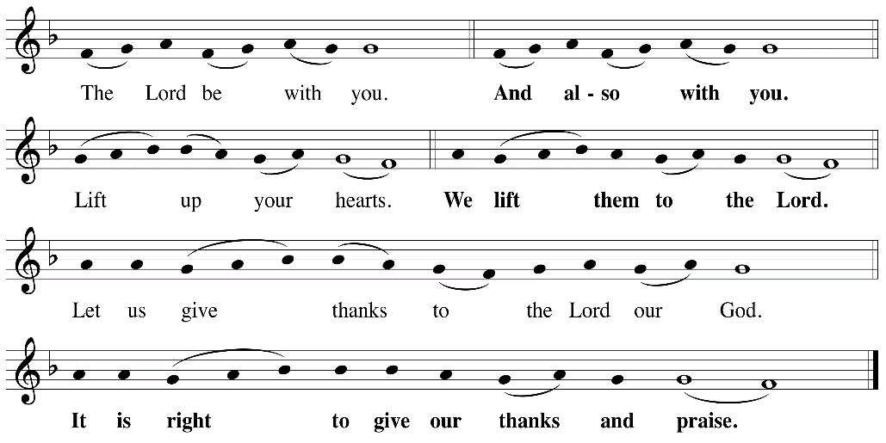

P: It is indeed right, our duty and our joy, that we should at all times and in all places
give thanks and praise ... we praise your name and join their unending hymn:
Holy Holy
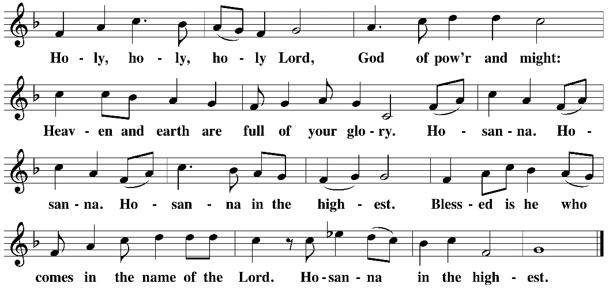

Eucharistic Prayer
The Lord’s Prayer
Our Father in heaven, hallowed be your name, your kingdom come, your will be
done, on earth as in heaven. Give us today our daily bread. Forgive us our sins as
we forgive those who sin against us. Save us from the time of trial and deliver us
from evil. For the kingdom, the power, and the glory are yours, now and forever.
Amen.
Invitation to the Table
You may now take the individual cups provided for communion. Please receive communion with these words: “The body of Christ given for you; the blood of Christ shed for you.”
Communion Hymn – Lamb of God
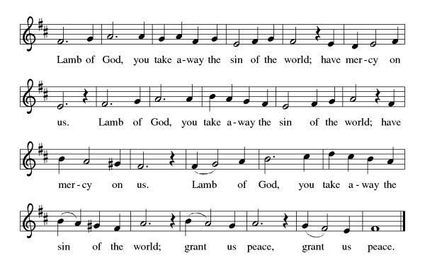
Table Blessing
May the grace of our Lord Jesus Christ and the gifts of his body and blood strengthen, keep and unite us, now and forever. Amen.

Post-Communion Prayer
Wellspring of joy, through this meal you have put gladness in our hearts. Satisfy the hunger still around us, and send us as joyful witnesses, that your love may bring joy to the hearts of all people, through Jesus Christ our Lord. Amen.
Community Time
Blessing
May our glorious God grant you a spirit of wisdom to know and to love the risen Lord Jesus. The God of life, Father, ☩ Son, and Holy Spirit, bless you now and forever. Amen.
Sending Song – Blessed Assurance Verse 1-3 ELW 638

¹Blessed assurance, Jesus is mine!
Oh, what a foretaste of glory divine!
Heir of salvation, purchase of God,
Born of his Spirit, washed in his blood.

Refrain
This is my story, this is my song,
Praising my Savior, all the day long:
This is my story, this is my song,
Praising my Savior all the day long.

²Perfect submission, perfect delight,
Visions of rapture now burst on my sight;
Angels descending bring from above
Echoes of mercy, whispers of love.
Refrain

³Perfect submission, all is at rest;
I in my Savior am happy and blest,
Watching and waiting, looking above,
Filled with his goodness, lost in his love.
Refrain

Alleluia! Christ is risen.
Christ is risen indeed. Alleluia!
Go in peace. Share the good news. Alleluia!
Thanks be to God. Alleluia!
Share the Peace of the Lord in the comments below!

