St. Mark’s Worship Sunday April 18, 2021
Welcome to our Online Worship

Welcome to our worship! Stationed at the tables at the entrance to the patio our greeters have hand sanitizer and masks if you need them, bulletins and self-contained communion cups (please wait for the Pastor to direct you to open them) and they have a plate and envelopes where you can drop off your offering. We also are collecting your name and contact information if you haven't made a reservation. Please follow the direction of the ushers who will seat family groups six feet apart and refrain from hugs and handshakes. The restrooms will be open, but we request that one family group at a time uses the facilities. Unfortunately, we will not be serving coffee or refreshments before or after the services at this time. Outdoors, with masks on, we are allowed to sing and recite during the worship service!

If you are worshipping at home, you may want to prepare some bread, wine, or juice to receive Holy Communion. You may commune yourself or those around you with these words: “The body of Christ given for you; the blood of Christ shed for you.”
Prelude
Welcome and Call to Worship
Opening Song – We know that Christ is Raised Verse All ELW 449

1. We know that Christ is raised and dies no more.
Embraced by death, he broke its fearful hold,
And our despair he turned to blazing joy.
Hallelujah!

2. We share by water in his saving death.
Reborn, we share with him an Easter life,
As living members of our Savior Christ.
Hallelujah!

3. The Father's splendor clothes the Son with life.
The Spirit's fission shakes the church of God.
Baptized, we live with God the Three in One.
Hallelujah!

4. A new creation comes to life and grows
as Christ's new body takes on flesh and blood.
The universe restored and whole will sing:
Hallelujah!

Mission Statement
“Celebrating God’s Love and Forgiveness, We serve others”

Thanksgiving for Baptism
All may make the sign of the cross, the sign marked at baptism, as the presiding minister begins.
Alleluia! Christ is risen.
Christ is risen indeed. Alleluia!
Refreshed by the resurrection life we share in Christ,
let us give thanks for the gift of baptism.
Water may be poured into the font as the presiding minister gives thanks.
We thank you, risen Christ,
for these waters where you make us new,
leading us from death to life, from tears to joy.

We bless you, risen Christ, that your Spirit comes to us
in the grace-filled waters of rebirth,
like rains to our thirsting earth,
like streams that revive our souls,
like cups of cool water shared with strangers.

Breathe your peace on your church when we hide in fear.
Clothe us with your mercy and forgiveness.
Send us companions on our journey as we share your life.

Make us one, risen Christ.
Cleanse our hearts.
Shower us with life.

To you be given all praise,
with the Holy Spirit,
in the glory of God,
now and forever.
Amen.

Greeting
From the one who is and who was and who is to come, the Almighty; grace and peace be with you all.
And also, with you.
Prayer of the Day
Holy and righteous God, you are the author of life, and you adopt us to be your children. Fill us with your words of life, that we may live as witnesses to the resurrection of your Son, Jesus Christ, our Savior and Lord, who lives and reigns with you and the Holy Spirit, one God, now and forever. Amen.

Lesson 1 – Acts 3:12-19
After healing a man unable to walk, Peter preaches to the people, describing how God’s promises to Israel have been fulfilled in Jesus. Through the proclamation of Christ’s death and resurrection, God is offering them forgiveness and restoration in Jesus’ name.
¹²[Peter] addressed the people, “You Israelites, why do you wonder at this, or why do you stare at us, as though by our own power or piety we had made him walk?¹³The God of Abraham, the God of Isaac, and the God of Jacob, the God of our ancestors has glorified his servant Jesus, whom you handed over and rejected in the presence of Pilate, though he had decided to release him. ¹⁴But you rejected the Holy and Righteous One and asked to have a murderer given to you, ¹⁵and you killed the Author of life, whom God raised from the dead. To this we are witnesses. ¹⁶And by faith in his name, his name itself has made this man strong, whom you see and know; and the faith that is through Jesus has given him this perfect health in the presence of all of you.
¹⁷“And now, friends, I know that you acted in ignorance, as did also your rulers. ¹⁸In this way God fulfilled what he had foretold through all the prophets, that his Messiah would suffer. ¹⁹Repent therefore, and turn to God so that your sins may be wiped out.”
Word of God, Word of Life
Thanks be to God.
Gospel Acclamation
Alleluia. Lord to whom shall we go? You have the words of eternal life.
Alleluia.
The Holy Gospel according to Luke.
Glory to you, O Lord.
Gospel – Luke 24:36^{b}-48
In this account of an appearance after his resurrection, Jesus opens the minds of the disciples to understand him as Messiah. Jesus convinces them that he has been raised and sends them on a mission to proclaim the message of repentance and forgiveness.
^{36b}Jesus himself stood among [the disciples] and said to them, “Peace be with you.” ³⁷They were startled and terrified, and thought that they were seeing a ghost. ³⁸He said to them, “Why are you frightened, and why do doubts arise in your hearts? ³⁹Look at my hands and my feet; see that it is I myself. Touch me and see; for a ghost does not have flesh and bones as you see that I have.” ⁴⁰And when he had said this, he showed them his hands and his feet. ⁴¹While in their joy they were disbelieving and still wondering, he said to them, “Have you anything here to eat?” ⁴²They gave him a piece of broiled fish, ⁴³and he took it and ate in their presence.
⁴⁴Then he said to them, “These are my words that I spoke to you while I was still with you—that everything written about me in the law of Moses, the prophets, and the psalms must be fulfilled.” ⁴⁵Then he opened their minds to understand the scriptures, ⁴⁶and he said to them, “Thus it is written, that the Messiah is to suffer and to rise from the dead on the third day, ⁴⁷and that repentance and forgiveness of sins is to be proclaimed in his name to all nations, beginning from Jerusalem. ⁴⁸You are witnesses of these things.”
The Gospel of our Lord.
Praise to you, O Christ
Sermon Pastor Karla Halvorson
Hymn of the Day – Lord, You Give the Great Commission Verses – 1,2,3,5 ELW 579

1 Lord, you give the great commission:
"Heal the sick and preach the word."
Lest the church neglect its mission,
and the gospel go unheard,
help us witness to your purpose
with renewed integrity:

Refrain
With the Spirit's gifts empow'r us
For the work of ministry.

2 Lord, you call us to your service:
"In my name baptize and teach."
That the world may trust your promise,
Life abundant meant for each,
Give us all new fervor, draw us
Closer in community: Refrain

3 Lord, you make the common holy:
"This my body, this my blood."
Let us all, for earth's true glory,
Daily lift life heavenward,
Asking that the world around us
Share your children's liberty: Refrain

5 Lord, you bless with words assuring:
"I am with you to the end."
Faith and hope and love restoring,
May we serve as you intend
And, amid the cares that claim us,
Hold in mind eternity: Refrain

Prayers of Intercession
Leader: Hear us, O God.
Congregation: Your mercy is great.
Blessing of prayer quilts
The Peace
The peace of Christ be with you always.
And also, with you.
(you may share the peace of Christ with anyone who is with you, share the peace in the comments, text an offering of peace to someone, or simply send a prayer of blessing and peace to someone.)
Offering
St. Mark’s Church, 580 Hilltop Dr. Chula Vista, CA 91910
Venmo: @stmarks-churchchulavista

Offering Song – Lord, Listen to Your Children
Lord, listen to your children praying,
Lord, send your spirit in this place,
Lord, listen to your children praying,
Send us power, send us love, send us grace.

OFFERING PRAYER
God of love, you call us beloved children and welcome us to your table. Receive our lives and the gifts we offer. Abide with us and send us in service to a suffering world; for the sake of your beloved Child, Jesus Christ. Amen.
The Great Thanksgiving
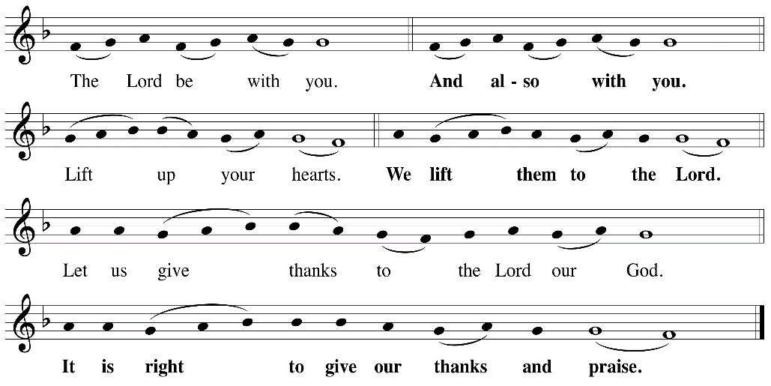

P: It is indeed right, our duty and our joy, that we should at all times and in all places
give thanks and praise ... we praise your name and join their unending hymn:
Holy Holy
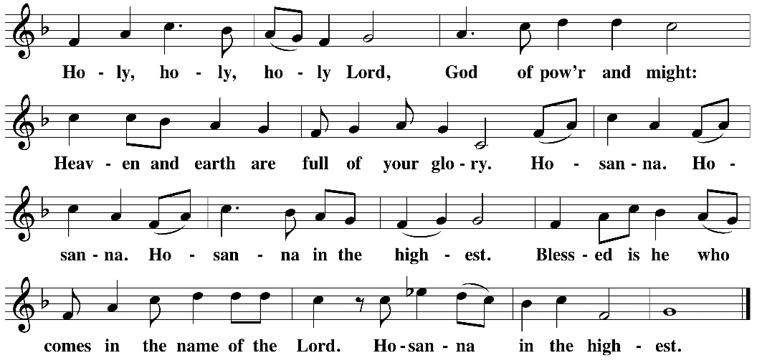

Eucharistic Prayer
The Lord’s Prayer
Our Father in heaven, hallowed be your name, your kingdom come, your will be
done, on earth as in heaven. Give us today our daily bread. Forgive us our sins as
we forgive those who sin against us. Save us from the time of trial and deliver us
from evil. For the kingdom, the power, and the glory are yours, now and forever.
Amen.
Invitation to the Table
You may now take the individual cups provided for communion. Please receive communion with these words: “The body of Christ given for you; the blood of Christ shed for you.”
Communion Hymn – Lamb of God
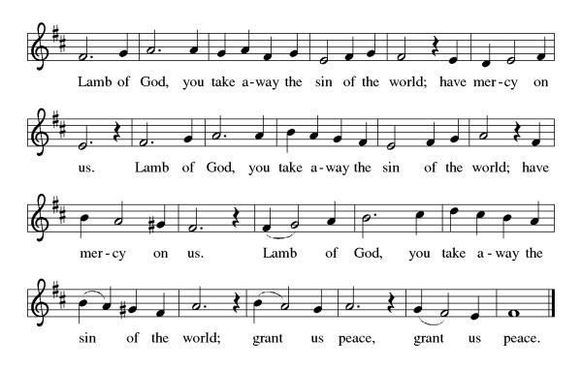
Table Blessing
May the grace of our Lord Jesus Christ and the gifts of his body and blood strengthen, keep and unite us, now and forever. Amen.

Post-Communion Prayer
Wellspring of joy, through this meal you have put gladness in our hearts. Satisfy the hunger still around us, and send us as joyful witnesses, that your love may bring joy to the hearts of all people, through Jesus Christ our Lord. Amen.
Community Time

Blessing
May our glorious God grant you a spirit of wisdom to know and to love the risen Lord Jesus. The God of life, Father, ☩ Son, and Holy Spirit, bless you now and forever. Amen.
Sending Song – Halleluiah! We Sing Your Praises Verse All ELW 535

Refrain
Hallelujah! We sing your praises,
All our hearts are filled with gladness.
Hallelujah! We sing your praises,
All our hearts are filled with gladness.

Hallelujah! We sing your praises,
All our hearts are filled with gladness.
Hallelujah! We sing your praises,
All our hearts are filled with gladness.

1 Christ the Lord to us said:
I am wine, I am bread,
I am wine, I am bread,
Give to all who thirst and hunger.

Christ the Lord to us said:
I am wine, I am bread,
I am wine, I am bread,
Give to all who thirst and hunger.
Refrain

2 Now he sends us all out,
Strong in faith, free of doubt,
Strong in faith, free of doubt.
Tell to all the joyful gospel.

Now he sends us all out,
Strong in faith, free of doubt,
Strong in faith, free of doubt.
Tell to all the joyful gospel.
Refrain

Alleluia! Christ is risen.
Christ is risen indeed. Alleluia!
Go in peace. Share the good news. Alleluia!
Thanks be to God. Alleluia!
Share the Peace of the Lord in the comments below!

