St. Mark’s Worship Sunday April 11, 2021
Welcome to our Online Worship

Welcome to our worship! Stationed at the tables at the entrance to the patio our greeters have hand sanitizer and masks if you need them, bulletins and self-contained communion cups (please wait for the Pastor to direct you to open them) and they have a plate and envelopes where you can drop off your offering. We also are collecting your name and contact information if you haven't made a reservation. Please follow the direction of the ushers who will seat family groups six feet apart and refrain from hugs and handshakes. The restrooms will be open, but we request that one family group at a time uses the facilities. Unfortunately, we will not be serving coffee or refreshments before or after the services at this time. Outdoors, with masks on, we are allowed to sing and recite during the worship service!

If you are worshipping at home, you may want to prepare some bread, wine, or juice to receive Holy Communion. You may commune yourself or those around you with these words: “The body of Christ given for you; the blood of Christ shed for you.”
Prelude
Welcome and Call to Worship
Opening Song – Now All the Vault of Heaven Resounds Verse 1,2,4 ELW 367

1. Now all the vault of heav'n resounds
In praise of love that still abounds:
"Christ has triumphed! He is living!"
Sing, choirs of angels, loud and clear!
Repeat their song of glory here:
"Christ has triumphed! He is living!"
Alleluia, alleluia, alleluia!

2. Eternal is the gift he brings,
Therefore our heart with rapture sings:
"Christ has triumphed! He is living!"
Now still he comes to give us life
And by his presence stills all strife.
"Christ has triumphed! He is living!"
Alleluia, alleluia, alleluia!

4. Adoring praises now we bring
And with the heav'nly blessed sing:
"Christ has triumphed! Alleluia!"
Be to the Father, and our Lord,
To Spirit blest, most holy God,
All the glory, never ending!
Alleluia, alleluia, alleluia!

Mission Statement
“Celebrating God’s Love and Forgiveness, We serve others”

Thanksgiving for Baptism
All may make the sign of the cross, the sign marked at baptism, as the presiding minister begins.
Alleluia! Christ is risen.
Christ is risen indeed. Alleluia!
Refreshed by the resurrection life we share in Christ,
let us give thanks for the gift of baptism.
Water may be poured into the font as the presiding minister gives thanks.
We thank you, risen Christ,
for these waters where you make us new,
leading us from death to life, from tears to joy.

We bless you, risen Christ, that your Spirit comes to us
in the grace-filled waters of rebirth,
like rains to our thirsting earth,
like streams that revive our souls,
like cups of cool water shared with strangers.

Breathe your peace on your church when we hide in fear.
Clothe us with your mercy and forgiveness.
Send us companions on our journey as we share your life.

Make us one, risen Christ.
Cleanse our hearts.
Shower us with life.

To you be given all praise,
with the Holy Spirit,
in the glory of God,
now and forever.
Amen.
Opening Song –Alleluia, Jesus is Risen! Verse 1 ELW 377

1. Alleluia! Jesus is risen!
Trumpets resounding in glorious light!
Splendor, the Lamb, heaven forever!
Oh, what a miracle God has in sight!

Refrain
Jesus is risen and we shall arise.
Give God the glory! Alleluia!

Greeting
From the one who is and who was and who is to come, the Almighty; grace and peace be with you all.
And also, with you.
Prayer of the Day
Almighty God, with joy we celebrate the day of our Lord’s resurrection. By the grace of Christ among us, enable us to show the power of the resurrection in all that we say and do, through Jesus Christ, our Savior and Lord, who lives and reigns with you and the Holy Spirit, one God, now and forever. Amen.

Lesson 1 – Acts 4:32-35
While the apostles testified to others about the resurrection of Jesus, the early Christian community shared what they owned or sold their possessions to help their fellow believers who were in need.
³²Now the whole group of those who believed were of one heart and soul, and no one claimed private ownership of any possessions, but everything they owned was held in common. ³³With great power the apostles gave their testimony to the resurrection of the Lord Jesus, and great grace was upon them all. ³⁴There was not a needy person among them, for as many as owned lands or houses sold them and brought the proceeds of what was sold. ³⁵They laid it at the apostles’ feet, and it was distributed to each as any had need.
Word of God, Word of Life
Thanks be to God.
Gospel Acclamation
Alleluia. Lord to whom shall we go? You have the words of eternal life.
Alleluia.
The Holy Gospel according to John.
Glory to you, O Lord.
Gospel – John 20:19-31
The story of Easter continues as the risen Jesus appears to his disciples. His words to Thomas offer a blessing to all who entrust themselves in faith to the risen Lord.
¹⁹On the evening of the first day, the first day of the week, the doors being locked where the disciples were for fear of the Jews, Jesus came and stood among them and said to them, “Peace be with you.” ²⁰ When he had said this, he showed them his hands and his side. Then the disciples were glad when they saw the Lord. ²¹ Jesus said to them again, “Peace be with you. As the Father has sent me, even so I am sending you. ²² And when he had said this, he breathed on them and said to them, “Receive the Holy Spirit. ²³ If you forgive the sins of any, they are forgiven them; if you withhold forgiveness from any, it is withheld.”
²⁴ Now Thomas, one of the twelve, called the Twin, was not with them when Jesus came. ²⁵So the other disciples told him. “We have seen the Lord.” But he said to them, “Unless I see in his hands the marks of the nails, and place my hand into his side, I will never believe.”
²⁶ Eight days later, his disciples were inside again, and Thomas was with them. Although the doors were locked, Jesus came and stood among them and said, “Peace be with you.” ²⁷Then he said to Thomas, “Put your finger here, and see my hands; and put out your hand, and place it in my side. Do not disbelieve, but believe.” ²⁸ Thomas answered him, “My Lord and my God!” ²⁹ Jesus said to him, “Have you believed because you have seen me? Blessed are those who have not seen and yet have believed.”
³⁰ Now Jesus did many other signs in the presence of the disciples, which were not written int his book; ³¹ but these are written so that you may believe the Jesus is the Christ, the Son of God, and that by believing you may have life in his name.
The Gospel of our Lord.
Praise to you, O Christ
Sermon Pastor Karla Halvorson
Hymn of the Day – We Walk by Faith Verses - All ELW 635

1. We walk by faith and not by sight;
With gracious words draw near,
O Christ, who spoke as none e'er spoke:
"My peace be with you here."

2. We may not touch your hands and side,
Nor follow where you trod;
But in your promise we rejoice,
And cry, "My Lord and God!"

3. Help then, O Lord, our unbelief;
And may our faith abound
To call on you when you are near
And seek where you are found:

4. For you, O resurrected Lord,
Are found in means divine:
Beneath the water and the word,
Beneath the bread and wine.

5. And when our life of faith is done,
In realms of clearer light
We may behold you as you are,
With full and endless sight.

Prayers of Intercession
Leader: Hear us, O God.
Congregation: Your mercy is great.
Blessing of prayer quilts
The Peace
The peace of Christ be with you always.
And also, with you.
(you may share the peace of Christ with anyone who is with you, share the peace in the comments, text an offering of peace to someone, or simply send a prayer of blessing and peace to someone.)

Offering
St. Mark’s Church, 580 Hilltop Dr. Chula Vista, CA 91910
Venmo: @stmarks-churchchulavista
Offering Song – Lord, Listen to Your Children/ Señor Escucha Tu Gente

Lord, listen to your children praying,
Lord, send your spirit in this place,
Lord, listen to your children praying,
Send us power, send us love, send us grace.
Señor Escucha a tu gente orando,
Señor envía tu espíritu aquí,
Señor escucha a tu gente orando,
Danos fe, danos paz, danos tu amor.

OFFERING PRAYER
God of love, you call us beloved children and welcome us to your table. Receive our lives and the gifts we offer. Abide with us and send us in service to a suffering world; for the sake of your beloved Child, Jesus Christ. Amen.
The Great Thanksgiving
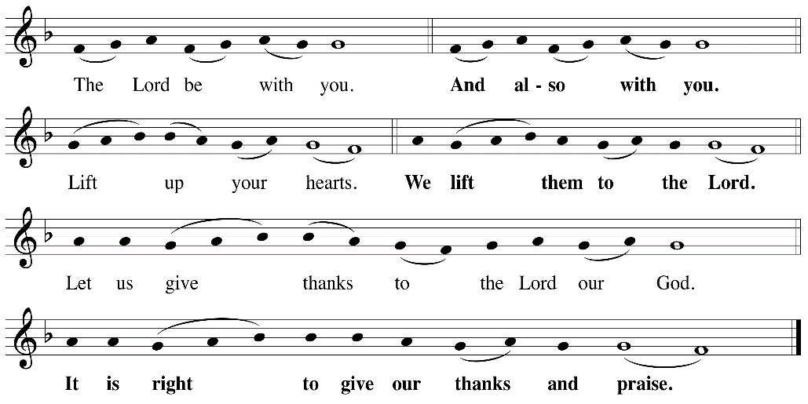

P: It is indeed right, our duty and our joy, that we should at all times and in all places
give thanks and praise ... we praise your name and join their unending hymn:

Holy Holy
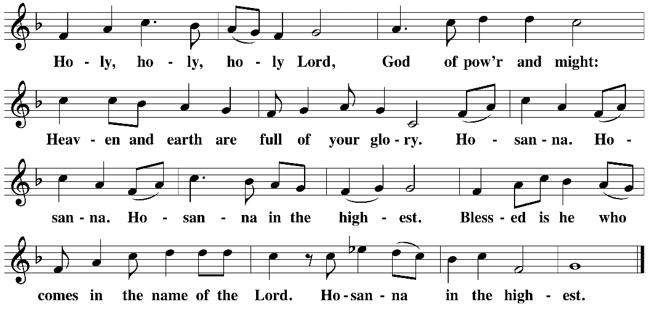

Eucharistic Prayer
The Lord’s Prayer
Our Father in heaven, hallowed be your name, your kingdom come, your will be
done, on earth as in heaven. Give us today our daily bread. Forgive us our sins as
we forgive those who sin against us. Save us from the time of trial and deliver us
from evil. For the kingdom, the power, and the glory are yours, now and forever.
Amen.
Invitation to the Table
You may now take the individual cups provided for communion. Please receive communion with these words: “The body of Christ given for you; the blood of Christ shed for you.”

Communion Hymn – Lamb of God
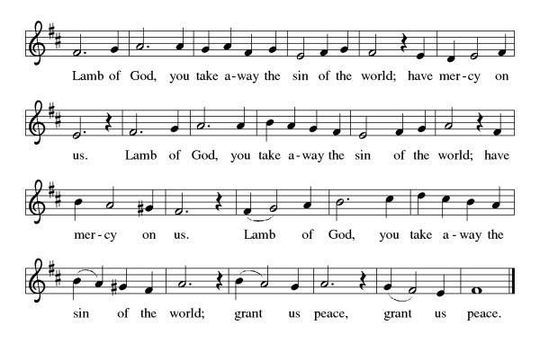
Table Blessing
May the grace of our Lord Jesus Christ and the gifts of his body and blood strengthen, keep and unite us, now and forever. Amen.

Post-Communion Prayer
Wellspring of joy, through this meal you have put gladness in our hearts. Satisfy the hunger still around us, and send us as joyful witnesses, that your love may bring joy to the hearts of all people, through Jesus Christ our Lord. Amen.
Community Time
Blessing
May our glorious God grant you a spirit of wisdom to know and to love the risen Lord Jesus.
The God of life, Father, ☩ Son, and Holy Spirit, bless you now and forever. Amen.

Sending Song – Alleluia, Jesus is Risen! Verse 2-5 ELW 377

Refrain
Jesus is risen and we shall arise.
Give God the glory! Alleluia!
2. Walking the way, Christ in the center
Telling the story to open our eyes;
Breaking our bread, giving us glory:
Jesus our blessing, our constant surprise. Refrain

3. Jesus the vine, we are the branches;
Life in the Spirit the fruit of the tree;
Heaven to earth, Christ to the people,
Gift of the future now flowing to me. Refrain

4. Weeping, be gone; sorrow, be silent:
Death put asunder, and Easter is bright.
Cherubim sing: O grave, be open!
Clothe us in wonder, adorn us in light. Refrain

5. City of God, Easter forever,
Golden Jerusalem, Jesus the Lamb,
River of life, saints and archangels,
Sing with creation to God the I AM! Refrain

Alleluia! Christ is risen.
Christ is risen indeed. Alleluia!
Go in peace. Share the good news. Alleluia!
Thanks be to God. Alleluia!
Share the Peace of the Lord in the comments below!

