St. Mark’s Worship Sunday April 4, 2021
Welcome to our Online Worship
Easter!

Welcome to our worship! Stationed at the tables at the entrance to the patio our greeters have hand sanitizer and masks if you need them, bulletins and self-contained communion cups (please wait for the Pastor to direct you to open them) and they have a plate and envelopes where you can drop off your offering. We also are collecting your name and contact information if you haven't made a reservation. Please follow the direction of the ushers who will seat family groups six feet apart and refrain from hugs and handshakes. The restrooms will be open, but we request that one family group at a time uses the facilities. Unfortunately, we will not be serving coffee or refreshments before or after the services at this time. Outdoors, with masks on, we are allowed to sing and recite during the worship service!

If you are worshipping at home, you may want to prepare some bread, wine, or juice to receive Holy Communion. You may commune yourself or those around you with these words: “The body of Christ given for you; the blood of Christ shed for you.”
Prelude
Easter Greeting

Christ is risen!
Christ is risen indeed! Alleluia!
Why do you seek the living among the dead? Remember what he said to you,
“The Son of Man must be crucified, and the third day rise again.”
Alleluia!
This is the day the Lord has made.
Let us rejoice and be glad in it.
Gathering Hymn – Jesus Christ is Risen Today Verses 1-4 ELW 365

- Jesus Christ is ris'n today, Alleluia!
Our triumphant holy day, Alleluia!
Who did once upon the cross, Alleluia!
Suffer to redeem our loss. Alleluia!

- Hymns of praise then let us sing, Alleluia!
Unto Christ, our heav'nly king, Alleluia!
Who endured the cross and grave, Alleluia!
Sinners to redeem and save. Alleluia!
- But the pains which he endured, Alleluia!
Our salvation have procured; Alleluia!
Now above the sky he's king, Alleluia!
Where the angels ever sing. Alleluia!

- Sing we to our God above, Alleluia!
Praise eternal as his love; Alleluia!
Praise him, all you heav'nly host, Alleluia!
Father, Son, and Holy Ghost. Alleluia!

Welcome
Sacrament of Holy Baptism - Matilda Grace Lodin
(The Sacrament begins with prayer and profession of faith from parents and sponsors)
The sacrament continues with the whole congregation:
Do you believe in God the Father?
I believe in God, the Father almighty,
creator of heaven and earth.

Do you believe in Jesus Christ, the Son of God?
I believe in Jesus Christ, God's only Son, our Lord,
who was conceived by the Holy Spirit,
born of the virgin Mary,
suffered under Pontius Pilate,
was crucified, died, and was buried;
he descended to the dead.
On the third day he rose again;
he ascended into heaven,
he is seated at the right hand of the Father,
and he will come to judge the living and the dead.

Do you believe in God the Holy Spirit?
I believe in the Holy Spirit,
the holy catholic church,
the communion of saints,
the forgiveness of sins,
the resurrection of the body,
and the life everlasting.
Thanksgiving at the Font
Pastor: The Lord be with you.
And also with you.
Let us give thanks to the Lord our God.
It is right to give our thanks and praise.
Pastor: We give you thanks… … in the unity of the Holy Spirit, now and forever.
Amen.
Baptism
Anointing with Oil
Welcome
A lighted candle is given
Pastor: Jesus said, I am the light of the world. Whoever follows me will have the light of life.
Let us welcome the newly baptized.
We welcome you into the body of Christ and into the mission we share:
join us in giving thanks and praise to God
and bearing God's creative and redeeming word to all the world.
Baptismal Hymn - Borning Cry Verses 1-4 Hymn 732

- I was there to hear your borning cry,
I'll be there when you are old.
I rejoiced the day you were baptized
To see your life unfold.
I was there when you were but a child,
With a faith to suit you well;
In a blaze of light you wandered off
To find where demons dwell.

- When you heard the wonder of the Word
I was there to cheer you on;
You were raised to praise the living Lord,
To whom you now belong.
If you find someone to share your time
And you join your hearts as one,
I'll be there to make your verses rhyme
From dusk till rising sun.

- In the middle ages of your life,
Not too old, no longer young,
I'll be there to guide you through the night,
Complete what I've begun.
When the evening gently closes in
And you shut your weary eyes,
I'll be there as I have always been,
With just one more surprise.

- I was there to hear your borning cry,
I'll be there when you are old.
I rejoiced the day you were baptized
To see your life unfold.

Prayer of the Day
God of mercy, we no longer look for Jesus among the dead, for he is alive and has become the Lord of life. Increase in our minds and hearts the risen life we share with Christ and help us to grow as your people toward the fullness of eternal life with you, through Jesus Christ, our Savior and Lord, who lives and reigns with you and the Holy Spirit, one God, now and forever. Amen.
Lesson 1 - Isaiah 25:6-9
⁶On this mountain the LORD of hosts will make for all peoples a feast of rich food, a feast of well-aged wines, of rich food filled with marrow, of well-aged wines strained clear. ⁷And he will destroy on this mountain the shroud that is cast over all peoples, the sheet that is spread over all nations; ⁸he will swallow up death forever. Then the Lord GOD will wipe away the tears from all faces, and the disgrace of his people he will take away from all the earth, for the LORD has spoken. ⁹It will be said on that day, Lo, this is our God; we have waited for him, so that he might save us. This is the LORD for whom we have waited; let us be glad and rejoice in his salvation.
Lesson 2 - 1 Corinthians 15:1-11
¹Now I would remind you, brothers and sisters, of the good news that I proclaimed to you, which you in turn received, in which also you stand, ²through which also you are being saved, if you hold firmly to the message that I proclaimed to you—unless you have come to believe in vain. ³For I handed on to you as of first importance what I in turn had received: that Christ died for our sins in accordance with the scriptures, ⁴and that he was buried, and that he was raised on the third day in accordance with the scriptures, ⁵and that he appeared to Cephas, then to the twelve. ⁶Then he appeared to more than five hundred brothers and sisters at one time, most of whom are still alive, though some have died. ⁷Then he appeared to James, then to all the apostles. ⁸Last of all, as to one untimely born, he appeared also to me. ⁹For I am the least of the apostles, unfit to be called an apostle, because I persecuted the church of God. ¹⁰But by the grace of God I am what I am, and his grace toward me has not been in vain. On the contrary, I worked harder than any of them—though it was not I, but the grace of God that is with me. ¹¹Whether then it was I or they, so we proclaim and so you have come to believe.
Gospel Acclamation
Allelulia! Lord to whom shall we go? You have the words of eternal life! Allelulia!
The Holy Gospel according to St. John.
Glory to you, O Lord.
Gospel - John 20:1-18
¹Early on the first day of the week, while it was still dark, Mary Magdalene came to the tomb and saw that the stone had been removed from the tomb. ²So she ran and went to Simon Peter and the other disciple, the one whom Jesus loved, and said to them, “They have taken the Lord out of the tomb, and we do not know where they have laid him.” ³Then Peter and the other disciple set out and went toward the tomb. ⁴The two were running together, but the other disciple outran Peter and reached the tomb first. ⁵He bent down to look in and saw the linen wrappings lying there, but he did not go in. ⁶Then Simon Peter came, following him, and went into the tomb. He saw the linen wrappings lying there, ⁷and the cloth that had been on Jesus’ head, not lying with the linen wrappings but rolled up in a place by itself. ⁸Then the other disciple, who reached the tomb first, also went in, and he saw and believed; ⁹for as yet they did not understand the scripture, that he must rise from the dead. ¹⁰Then the disciples returned to their homes.
¹¹But Mary stood weeping outside the tomb. As she wept, she bent over to look into the tomb; ¹²and she saw two angels in white, sitting where the body of Jesus had been lying, one at the head and the other at the feet. ¹³They said to her, “Woman, why are you weeping?” She said to them, “They have taken away my Lord, and I do not know where they have laid him.” ¹⁴When she had said this, she turned around and saw Jesus standing there, but she did not know that it was Jesus. ¹⁵Jesus said to her, “Woman, why are you weeping? Whom are you looking for?” Supposing him to be the gardener, she said to him, “Sir, if you have carried him away, tell me where you have laid him, and I will take him away.” ¹⁶Jesus said to her, “Mary!” She turned and said to him in Hebrew, “Rabbouni!” (which means Teacher). ¹⁷Jesus said to her, “Do not hold on to me, because I have not yet ascended to the Father. But go to my brothers and say to them, ‘I am ascending to my Father and your Father, to my God and your God.’” ¹⁸Mary Magdalene went and announced to the disciples, “I have seen the Lord”; and she told them that he had said these things to her.
The Gospel of our Lord.
Praise to you, O Christ
Sermon Pastor Karla Halvorson
Hymn of the Day –I Know That My Redeemer Lives! Verse 1,2,7,8 ELW 619

- I know that my Redeemer lives!
What comfort this sweet sentence gives!
He lives, he lives, who once was dead;
He lives, my ever-living head!

- He lives triumphant from the grave;
He lives eternally to save;
He lives exalted, throned above;
He lives to rule his church in love.
7. He lives and grants me daily breath;
He lives, and I shall conquer death;
He lives my mansion to prepare;
He lives to bring me safely there.

8. He lives, all glory to his name!
He lives, my Savior, still the same;
What joy this blest assurance gives:
I know that my Redeemer lives!

Prayers of Intercession
Leader: Hear us, O God.
Congregation: Your mercy is great.
The Peace
The peace of Christ be with you always.
And also, with you.
(you may share the peace of Christ with anyone who is with you, share the peace in the comments, text an offering of peace to someone, or simply send a prayer of blessing and peace to someone.)
Offering
St. Mark’s Church, 580 Hilltop Dr. Chula Vista, CA 91910
Venmo: @stmarks-churchchulavista

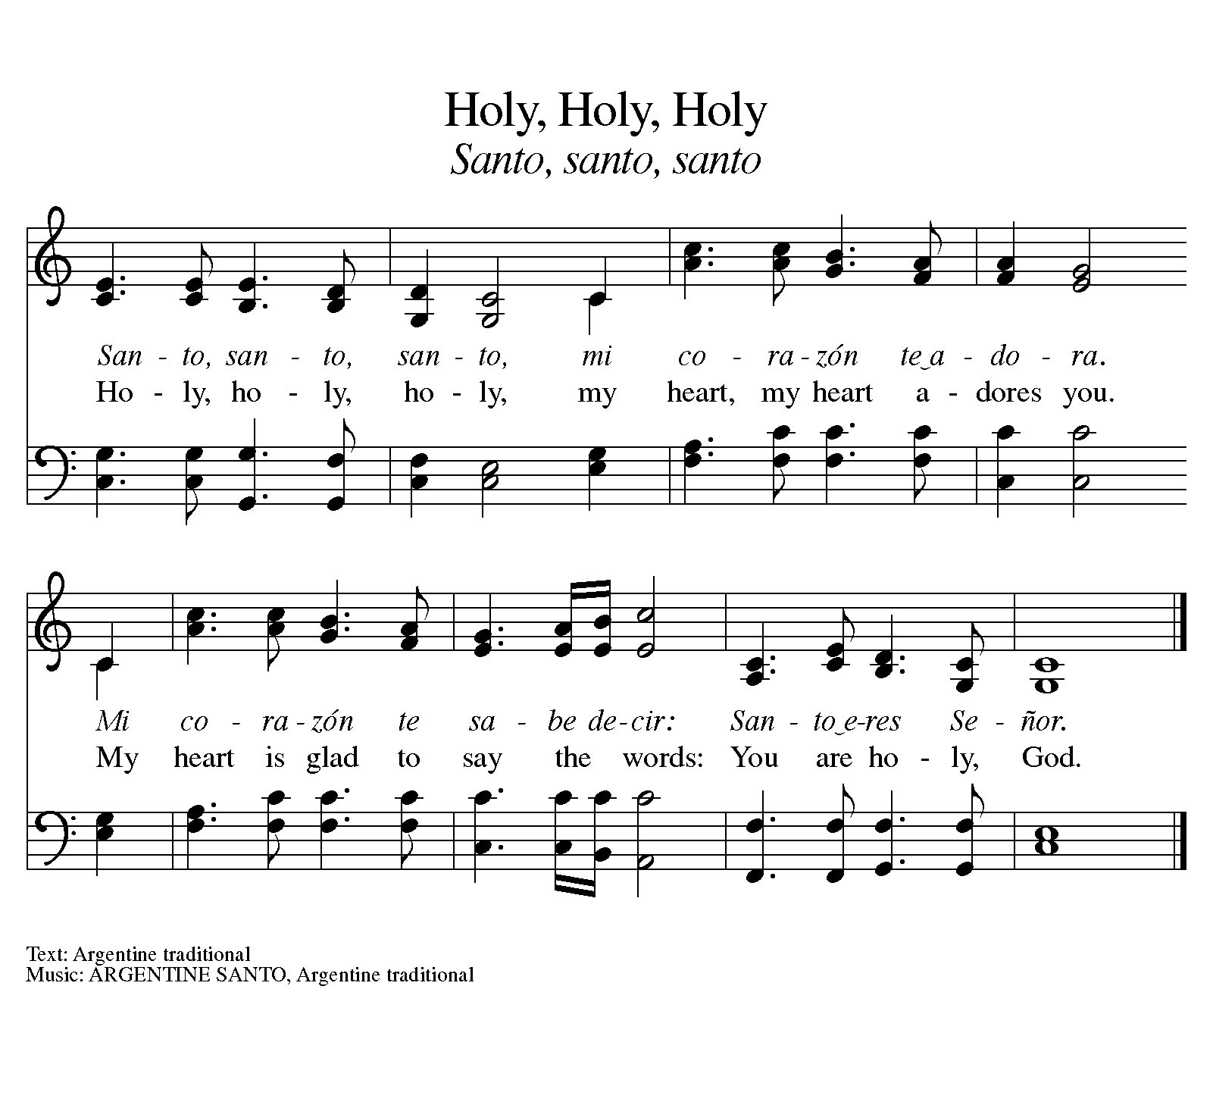
Offering Song – Holy, Holy, Holy

Offering Prayer
God of love, you call us beloved children and welcome us to your table. Receive our lives and the gifts we offer. Abide with us and send us in service to a suffering world, for the sake of your beloved Child, Jesus Christ. Amen.
The Great Thanksgiving
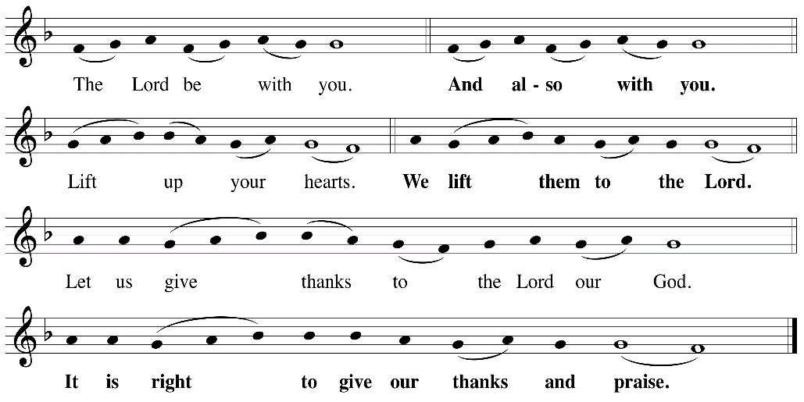

P: It is indeed right, our duty and our joy, that we should at all times and in all places
give thanks and praise ... we praise your name and join their unending hymn:
Holy Holy
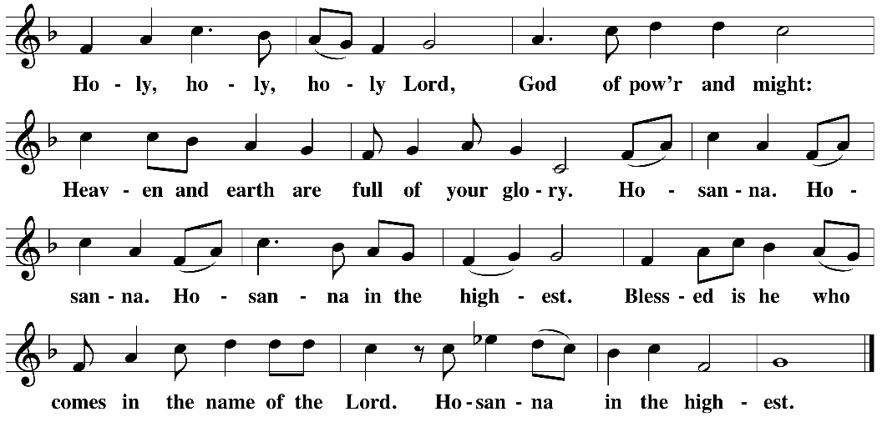

Eucharistic Prayer
The Lord’s Prayer
Lord, remember us in your kingdom and help us to pray…
Our Father in heaven, hallowed be your name, your kingdom come, your will be done, on earth as in heaven. Give us today our daily bread. Forgive us our sins as we forgive those who sin against us. Save us from the time of trial and deliver us from evil. For the kingdom, the power, and the glory are yours, now and forever. Amen.
Invitation to the Table
You may now take the individual cups provided for communion. Please receive communion with these words: “The body of Christ given for you; the blood of Christ shed for you.”
Communion Hymn – Lord, Listen to Your Children/ Señor Escucha Tu Gente

Lord, listen to your children praying,
Lord, send your spirit in this place,
Lord, listen to your children praying,
Send us power, send us love, send us grace.
Señor Escucha a tu gente orando,
Señor envía tu espíritu aquí,
Señor escucha a tu gente orando,
Danos fe, danos paz, danos tu amor.

Table Blessing
May the grace of our Lord Jesus Christ and the gifts of his body and blood strengthen, keep and unite us, now and forever. Amen.

Post-Communion Prayer
Wellspring of joy, through this meal you have put gladness in our hearts. Satisfy the hunger still around us, and send us as joyful witnesses, that your love may bring joy to the hearts of all people, through Jesus Christ our Lord. Amen.
Community Time
Benediction
Almighty God ✛ bless you, renew the risen life of Christ within you, and bring forth in You the fruits of the Holy Spirit. Amen.
Sending Song – Thine is the Glory Verses 1-3 ELW 376

- Thine is the glory,
Risen, conqu'ring Son;
Endless is the vict'ry
Thou o'er death hast won!
Angels in bright raiment
Rolled the stone away,
Kept the folded grave-clothes
Where thy body lay.

Refrain
Thine is the glory,
Risen, conqu'ring Son;
Endless is the vict'ry
Thou o'er death hast won!

- Lo, Jesus meets thee,
Risen from the tomb!
Lovingly he greets thee,
Scatters fear and gloom;
Let his church with gladness
Hymns of triumph sing,
For the Lord now liveth;
Death hath lost its sting! Refrain

- No more we doubt thee,
Glorious Prince of life;
Life is naught without thee;
Aid us in our strife;
Make us more than conqu'rors,
Through thy deathless love;
Bring us safe through Jordan
To thy home above. Refrain

Alleluia! Christ is risen.
Christ is risen indeed. Alleluia!
Go in peace. Share the good news. Alleluia!
Thanks be to God. Alleluia!
Postlude
Share the Peace of the Lord in the comments below!
Assisting with Worship

Musicians:
Jason Chase
Manuel Alvarez
Laura Marquez
Nathan Wu

Tech:
Sheri Barker
Deb Lechner
Andrew Vargas

