St. Mark’s Worship Sunday March 28, 2021
Welcome to our Online Worship
Palm Sunday
Prelude
Welcome and Call to Worship
Mission Statement
“Celebrating God’s Love and Forgiveness, We serve others”
Palm Sunday Greeting
Blessed is he who comes in the name of the Lord.
Hosanna to the Son of David.
The Lord be with you.
And also with you.

Processional Gospel - Mark 11:1-11
Jesus enters Jerusalem
¹When they were approaching Jerusalem, at Bethphage and Bethany, near the Mount of Olives, [Jesus] sent two of his disciples ²and said to them, “Go into the village ahead of you, and immediately as you enter it, you will find tied there a colt that has never been ridden; untie it and bring it. ³If anyone says to you, ‘Why are you doing this?’ just say this, ‘The Lord needs it and will send it back here immediately.’” ⁴They went away and found a colt tied near a door, outside in the street. As they were untying it, ⁵some of the bystanders said to them, “What are you doing, untying the colt?” ⁶They told them what Jesus had said; and they allowed them to take it. ⁷Then they brought the colt to Jesus and threw their cloaks on it; and he sat on it. ⁸Many people spread their cloaks on the road, and others spread leafy branches that they had cut in the fields. ⁹Then those who went ahead and those who followed were shouting,
“Hosanna!
Blessed is the one who comes in the name of the Lord!
¹⁰Blessed is the coming kingdom of our ancestor David!
Hosanna in the highest heaven!”
¹¹Then he entered Jerusalem and went into the temple; and when he had looked around at everything, as it was already late, he went out to Bethany with the twelve.
The Gospel of our Lord
Praise to you, O Christ

Hymn of the Day – All Glory, Laud, and Honor Verse 1,4,5 ELW 344
Refrain
All glory, laud, and honor
to you, redeemer, king,
to whom the lips of children
made sweet hosannas ring.

You are the king of Israel
And David's royal Son,
Now in the Lord's name coming,
Our King and Blessed One. Refrain

To you, before your passion,
They sang their hymns of praise.
To you, now high exalted,
Our melody we raise. Refrain

Their praises you accepted;
Accept the prayers we bring,
Great author of all goodness,
O good and gracious King. Refrain
Prayer of the Day
Everlasting God, in your endless love for the human race you sent our Lord Jesus Christ to take on our nature and to suffer death on the cross. In your mercy enable us to share in his obedience to your will and in the glorious victory of his resurrection, who lives and reigns with you and the Holy Spirit, one God, now and forever. Amen.
Hymn of the Day – One with God Before Creation Verse 1
One with God, before Creation, bringing stars and suns to birth.
Christ, you cast aside your glory, as a servant, walked the earth.

Let your mind, O Christ, be in us, forming us in all our ways.
Let your light and love surround us, guiding, guarding, all our days.
Passion narration from the Gospel of Mark (Mark 15:1-39, 40-47)
Reader’s Theater Actors
Narrator: Sheri Barker
Jesus: Damian Perez
Pilate: Bob Lechner
Crowd: Bob Petrin, Raylani Perez, Rachael Perez, Marcia Salvestrini , and Jason Chase.
Sermon Pastor Karla Halvorson (based on Philippians 2:5-11)
Hymn of the Day – One with God Verse 1, 2, 3, 5
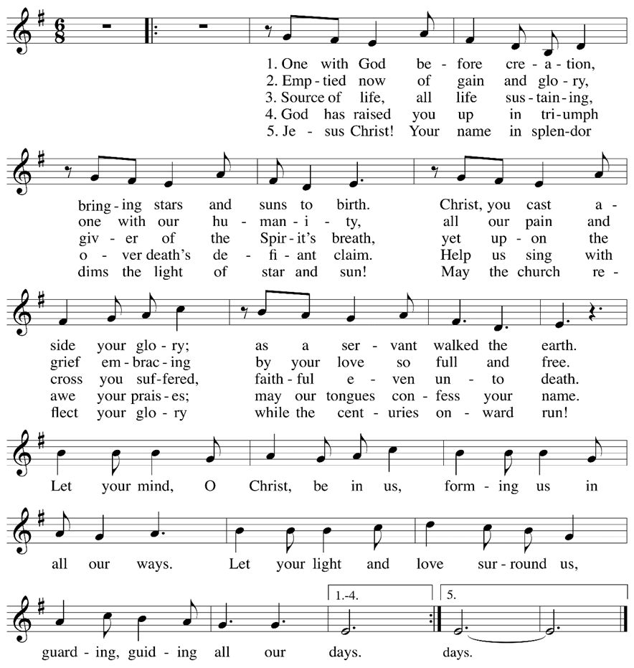

Prayers of Intercession
Leader: Hear us, O God.
Congregation: Your mercy is great.
The Peace
The peace of Christ be with you always.
And also, with you.
(you may share the peace of Christ with anyone who is with you, share the peace in the comments, text an offering of peace to someone, or simply send a prayer of blessing and peace to someone.)

Offering
St. Mark’s Church, 580 Hilltop Dr. Chula Vista, CA 91910
Venmo: @stmarks-churchchulavista
Offering Song – Create in Me a Clean Heart
Create in me a clean heart, O God,
And renew a right spirit within me.
Cast me not away from your presence,
And take not your Holy Spirit from me.
Restore unto me the joy of your salvation,
And uphold me with your free Spirit.
OFFERING PRAYER
Faithful God, you walk beside us in desert places, and you meet us in our hunger with bread from heaven. Accompany us always, that we may pass over from death to life with Jesus Christ, our Savior and Lord. Amen.
Great Thanksgiving
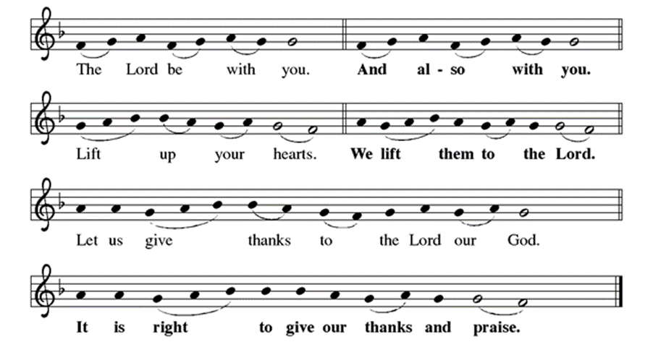
P: It is indeed right, our duty and our joy, that we should, at all times, and in all places
give thanks and praise ... we praise your name and join their unending hymn:

Holy, Holy
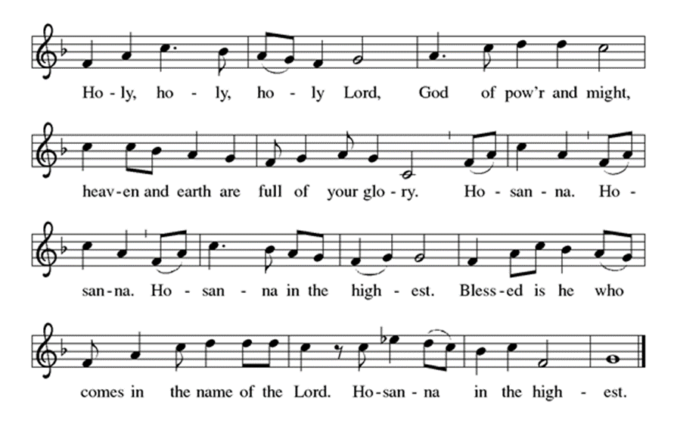
Eucharistic Prayer
The Lord’s Prayer
Our Father in heaven, hallowed be your name, your kingdom come, your will be
done, on earth as in heaven. Give us today our daily bread. Forgive us our sins as
we forgive those who sin against us. Save us from the time of trial and deliver us
from evil. For the kingdom, the power, and the glory are yours, now and forever.
Amen.
Distribution of Communion
(you may share Holy Communion with those around you with these words: The body of Christ given for you; the blood of Christ shed for you. Or you may choose to wait and receive Holy Communion at the drive through communion this afternoon)

COMMUNION SONG - “Lamb of God”
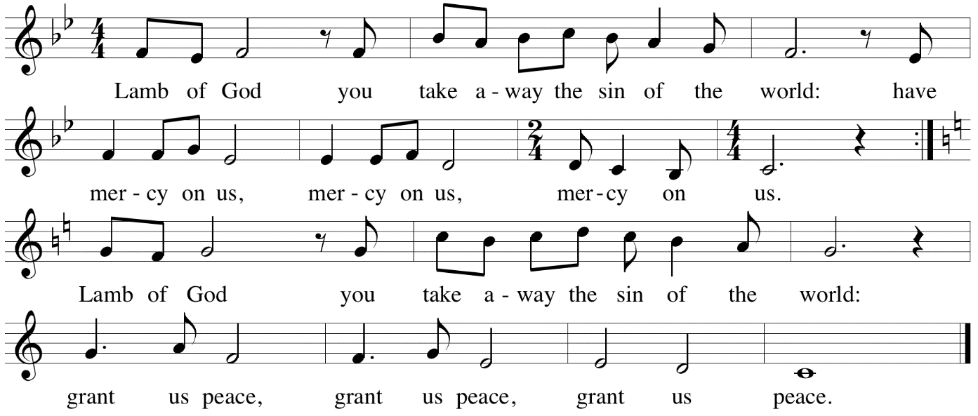
Table Blessing
May the grace of our Lord Jesus Christ and the gifts of his body and blood
strengthen, keep and unite us, now and forever. Amen.
Post-Communion Prayer
Wellspring of joy,
through this meal you have put gladness in our hearts.
Satisfy the hunger still around us,
and send us as joyful witnesses,
that your love may bring joy to the hearts of all people,
through Jesus Christ our Lord.
Amen.
Community Time
Blessing
You are what God made you to be: created in Christ Jesus for good works, chosen as holy and beloved, freed to serve your neighbor. God bless you ☩ that you may be a blessing,
in the name of the holy and life-giving Trinity. Amen.
Sending Song – Precious Lord, Take My Hand Verse 1-3 ELW 773

Precious Lord, take my hand
Lead me on, let me stand
I am tired, I am weak, I am worn
Through the storm, through the night
Lead me on to the light
Take my hand precious Lord, lead me home
When my way grows drear precious Lord linger near
When my life is almost gone
Hear my cry, hear my call
Hold my hand lest I fall
Take my hand precious Lord, lead me home
When the darkness appears and the night draws near
And the day is past and gone
At the river I stand
Guide my feet, hold my hand
Take my hand precious Lord, lead me home
Go in peace. Share the good news.
Thanks be to God.
Share the Peace of the Lord in the comments below!

