St. Mark’s Worship Sunday January 31, 2021
Welcome to our Online Worship
Prelude
Welcome and Call To Worship
Dear friends, we will be celebrating Holy Communion today. We hope you can join us for the drive through celebration today between 3 and 4 pm, but if driving is not possible, we invite you to have some bread or crackers, wine or juice available to receive the body and blood of our Lord Jesus Christ at home.
If you live with others, you can commune each other. If you live alone, you may take the bread and wine when the pastor says these words: The body of Christ given for you; the blood of Christ shed for you.
We invite you to invite others to come to the drive through communion. This is not limited to members of St. Mark’s. It is our belief that any baptized person may receive this means of grace.
Whether we worship together or in our homes, we are united in Jesus Christ, who knows no bounds.
Opening Song – Dearest Jesus, at Your Word Verse 1-4 ELW 520

Dearest Jesus, at your word
We have come again to hear you;
Let our thoughts and hearts be stirred
And in glowing faith be near you
As the promises here given
Draw us wholly up to heaven.

All our knowledge, sense, and sight
Lie in deepest darkness shrouded
Till your Spirit breaks the night,
Filling us with light unclouded.
All good thoughts and all good living
Come but by your gracious giving.

Radiance of God's glory bright,
Light of light from God proceeding,
Jesus, send your blessed light;
Help our hearing, speaking, heeding,
That our prayers and songs may please you,
As with grateful hearts we praise you.

Father, Son, and Holy Ghost,
Praise to you and adoration!
Grant us what we need the most:
All your gospel's consolation
While we here on earth await you,
Till in heav'n with praise we greet you.

Mission Statement
“Celebrating God’s Love and Forgiveness, We serve others”
Confession and Forgiveness
Blessed be the holy Trinity, ☩ one God, whose voice is upon the waters,
whose mercy is poured out upon all people, whose goodness cascades over all creation. Amen.
Let us confess our sin, trusting in the abundant grace of God.
Silence is kept for reflection.
Holy God,
you search us and know us.
You are acquainted with all our ways.
We confess that our hearts are burdened by sin—
our own sins and the broken systems that bind us.
We turn inward, failing to follow
your outward way of love.
We distrust those who are not like us.
We exploit the earth and its resources
and fail to consider generations to come.
Forgive us, gracious God,

for all we have done and left undone.
Even before the words are on our tongues,

you know them;
receive them in your divine mercy.
Amen.

How vast is God’s grace!
Through the power and promise of ☩ Christ Jesus,
our sins are washed away
and we are claimed as God’s own beloved.
Indeed, we are forgiven.
In the wake of God’s forgiveness,
we are called to be the beloved community
living out Christ’s justice
and the Spirit’s reconciling peace.
Amen.
Greeting
From the one who is and who was and who is to come, the Almighty; grace, light, and peace be with you all.
And also with you.

Prayer of the Day
Compassionate God, you gather the whole universe into your radiant presence and continually reveal your Son as our Savior. Bring wholeness to all that is broken and speak truth to us in our confusion, that all creation will see and know your Son, Jesus Christ, our Savior and Lord. Amen.

Hymn of the Day – As We Gather at Your Table Verse 1 ELW 522

As we gather at your table,

As we listen to your word,

help us know, O God, your presence;

Let our hearts and minds be stirred.

Nourish us with sacred story

Till we claim it as our own;

Teach us through this holy banquet

How to make Love's vict'ry known.

Psalm 111
¹Hallelujah! I will give thanks to the Lord with my whole heart,
in the assembly of the upright, in the congregation.
²Great are your works, O Lord,
pondered by all who delight in them.
³Majesty and splendor mark your deeds,
and your righteousness endures forever.
⁴You cause your wonders to be remembered;
you are gracious and full of compassion.
⁵You give food to those who fear you,
remembering forever your covenant.
⁶You have shown your people the power of your works
in giving them the lands of the nations.
⁷The works of your hands are faithfulness and justice;
all of your precepts are sure.
⁸They stand fast forever and ever,
because they are done in truth and equity.
⁹You sent redemption to your people and commanded your covenant forever;
holy and awesome is your name.
¹⁰The fear of the Lord is the beginning of wisdom;
all who practice this have a good understanding. God’s praise endures forever.
“Alleluia”
Alleluia. Lord to whom shall we go?
You have the words of eternal life.
Alleluia.
The Holy Gospel according to Mark.
Glory to you, O Lord.

Gospel – Mark 1: 21-28
Forces that would bring death and disease have taken hold of a man, yet they recognize Jesus and know what his power means for them. Jesus commands these forces to leave and people are amazed at his authority.
²¹[Jesus and his disciples] went to Capernaum; and when the sabbath came, he entered the synagogue and taught.²²They were astounded at his teaching, for he taught them as one having authority, and not as the scribes. ²³Just then there was in their synagogue a man with an unclean spirit, ²⁴and he cried out, “What have you to do with us, Jesus of Nazareth? Have you come to destroy us? I know who you are, the Holy One of God.” ²⁵But Jesus rebuked him, saying, “Be silent, and come out of him!” ²⁶And the unclean spirit, convulsing him and crying with a loud voice, came out of him. ²⁷They were all amazed, and they kept on asking one another, “What is this? A new teaching—with authority! He commands even the unclean spirits, and they obey him.” ²⁸At once his fame began to spread throughout the surrounding region of Galilee.
The Gospel of the Lord.
Praise to you, O Christ
Sermon Pastor Karla Halvorson
Hymn of the Day Cont’d – As We Gather at Your Table Verse 2-3 ELW 522

Turn our worship into witness
In the sacrament of life;
Send us forth to love and serve you,
Bringing peace where there is strife.
Give us, Christ, your great compassion
To forgive as you forgave;
May we still behold your image
In the world you died to save.
Gracious Spirit, help us summon
Other guests to share that feast
Where triumphant Love will welcome
Those who had been last and least.
There no more will envy blind us
Nor will pride our peace destroy,
As we join with saints and angels
To repeat the sounding joy.
Apostle’s Creed
I believe in God, the Father almighty,
creator of heaven and earth.
I believe in Jesus Christ, God’s only Son, our Lord,
who was conceived by the Holy Spirit,
born of the virgin Mary,
suffered under Pontius Pilate,
was crucified, died, and was buried;
he descended to the dead.*
On the third day he rose again;
he ascended into heaven,
he is seated at the right hand of the Father,
and he will come to judge the living and the dead.
I believe in the Holy Spirit,
the holy catholic church,
the communion of saints,
the forgiveness of sins,
the resurrection of the body,
and the life everlasting. Amen.
Prayers of Intercession
Leader: Let us pray.
Congregation: Have mercy, O God.
Blessing of prayer quilts
The Peace
The peace of Christ be with you always.
And also with you.
(you may share the peace of Christ with anyone who is with you, share the peace in the comments, text an offering of peace to someone, or simply send a prayer of blessing and peace to someone.)
Offering
St. Mark’s Church, 580 Hilltop Dr. Chula Vista CA 91910
Venmo: @stmarks-churchchulavista
Offering Song – Praise and Thanksgiving Verse 1 ELW 689
Praise and thanksgiving, God, we would offer
For all things living, you have made good:
Harvest of sown fields, fruits of the orchard,
Hay from the mown fields, blossom and wood.
OFFERING PRAYER
O God, receive these gifts as you receive us: like a mother receives her child, with arms open wide. Nourish us anew in your tender care, and empower us in faithful service to tend to others with this same love, through Jesus Christ, our saving grace. Amen.

Great Thankgiving
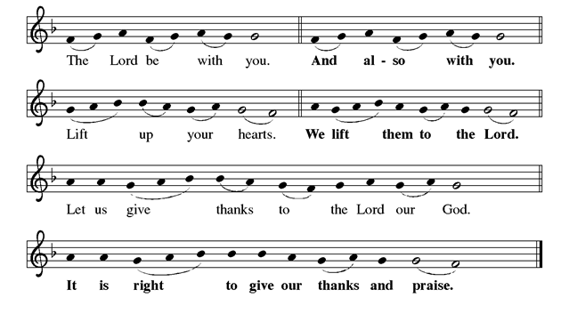
P: It is indeed right, our duty and our joy...we praise your name and join the unending
hymn:
Holy, Holy
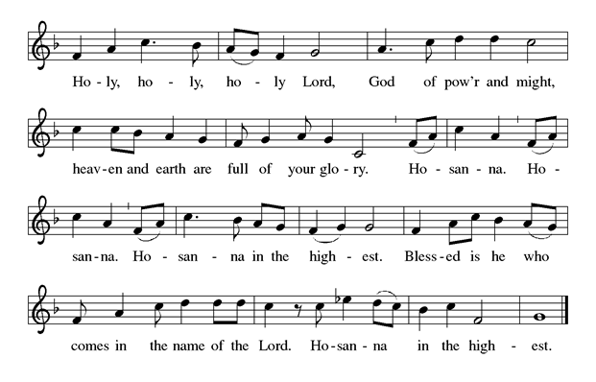
Thanksgiving at the Table

The Lord’s Prayer
Our Father in heaven, hallowed be your name, your kingdom come, your will be
done, on earth as in heaven. Give us today our daily bread. Forgive us our sins as
we forgive those who sin against us. Save us from the time of trial and deliver us
from evil. For the kingdom, the power, and the glory are yours, now and forever.
Amen.
Distribution of Communion
(you may share Holy Communion with those around you with these words: The body of Christ given for you; the blood of Christ shed for you. Or you may choose to wait and receive Holy Communion at the drive through communion this afternoon)

COMMUNION SONG - “Lamb of God”
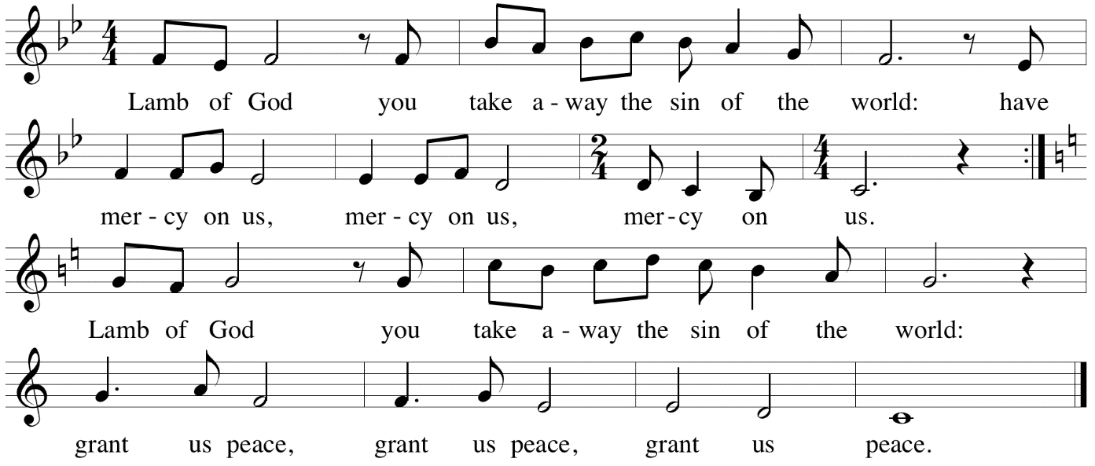

Prayer after Communion
Christ Jesus,
at this table we have feasted on your very life
and are strengthened for our journey.
Send us forth from this banquet
nourished in body and in spirit
to proclaim your good news
and serve others in your name.
Amen.
Community Time

Blessing
God the creator strengthen you; Jesus the beloved fill you; and the Holy Spirit the comforter ☩ keep you in peace. Amen.
Sending Song – Now Thank We All Our God Verse 1-3 ELW 840

Now thank we all our God
With hearts and hands and voices,
Who wondrous things has done,
In whom this world rejoices;
Who, from our mothers' arms,
Has blest us on our way
With countless gifts of love,
And still is ours today.

Oh, may this bounteous God
Through all our life be near us,
With ever joyful hearts
And blessed peace to cheer us,
And keep us all in grace,
And guide us when perplexed,
And free us from all harm
In this world and the next.

All praise and thanks to God
The Father now be given,
The Son, and Spirit blest,
Who reign in highest heaven,
The one eternal God,
Whom earth and heav'n adore;
For thus it was, is now,
And shall be evermore.
Text: Martin Rinkhart, 1586-1649; tr. Catherine Winkworth, 1827-1878

Go in peace. Be the light of Christ.
Thanks be to God.
Share the Peace of the Lord in the comments below, see you this afternoon!

