St. Mark’s Worship Sunday December 13, 2020
Welcome to our Online Worship

Prelude
Welcome and Announcements
Dear friends, we will be celebrating Holy Communion today. We hope you can join us for the drive through celebration today between 3 and 4 pm, but if driving is not possible, we invite you to have some bread or crackers, wine or juice available to receive the body and blood of our Lord Jesus Christ at home.
If you live with others, you can commune each other. If you live alone, you may take the bread and wine when the pastor says these words: The body of Christ given for you; the blood of Christ shed for you.
We invite you to invite others to come to the drive through communion. This is not limited to members of St. Mark’s. It is our belief that any baptized person may receive this means of grace.
Whether we worship together or in our homes, we are united in Jesus Christ, who knows no bounds.
Advent Litany
Lord Jesus, you are the light of the world.
Come, Lord Jesus.
You are light in our darkness.
Come, Lord Jesus.
Son of God, save us from our sins.
Come, Lord Jesus.
Son of Mary, deepen our love.
Come, Lord Jesus.
Bring hope into the lives of all people.
Come, Lord Jesus.
Give your peace to all nations.
Come, Lord Jesus.
Be the joy of all who love you.
Come, Lord Jesus
Bring unity among all who believe in you.
Come, Lord Jesus.
Bless us as we gather here in your name.
Come, Lord Jesus.
Lord Jesus, stay with us always.
Come, Lord Jesus.
Let us pray:
Let us prepare our hearts as we await the coming of our Lord. Let us watch for the one who heard our cries and shouldered the suffering of our world. Let us anticipate the coming of Christ’s eternal world with wholeness, reconciliation and plenty for all. Let us wait in expectation for the day when God’s glory is revealed in all its fullness.
May Christ give us his peace and joy, and let us share them with others.
All peace and glory are his forever.
Amen.
Greeting
From the one who is and who was and who is to come, the Almighty; grace, light, and peace be with all of you.
And also with you.
Lighting of The Advent Wreath
Song – Light the Advent Candle
Light the Advent candle, one:
Now the waiting has begun;
we have started on our way,
time to think of Christmas day.

Refrain: Candle, candle, burning bright,
shining in the cold winter night;
candle, candle, burning bright,
fill our hearts with Christmas light.

Light the Advent candle, two:
Think of humble shepherds, who
filled with wonder at the sight
of the child on Christmas night.

Light the Advent candle, three:
Think of heavenly harmony;
angels singing "Peace on earth"
at the blessed Savior's birth.

The St. Mark’s Children’s Christmas Story
Narrator - Carolyn Lechner - A long time ago, in the land of Galilee, lived a woman named Mary. And God sent an angel to speak to her.

Scene 1 – Raylani and Daymian Perez, Isabella McCall, Estella Uribe
Song – O Little Town of Bethlehem Pastor Karla and Jason Chase
O little town of Bethlehem,
how still we see thee lie!
Above thy deep and dreamless sleep
the silent stars go by;
yet in thy dark streets shineth
the everlasting light.
The hopes and fears of all the years
are met in thee tonight.

Scene 2 - Raylani and Daymian Perez, Isabella McCall, Estella Uribe, Ezekiel Adam Murillo
Song – Away in a Manger
Away in a manger, no crib for his bed,
the little Lord Jesus laid down his sweet head;
the stars in the bright sky looked down where he lay,
the little Lord Jesus asleep on the hay.

Scene 3 - Kris, Elsa & Anna Jerpseth, Sara Halvorson, Missy, Riley, Ketzaly & Kamila Romero

Song – O Come All Ye Faithful
O come, all ye faithful,
joyful and triumphant!
O come ye, O come ye to Bethlehem;
come and behold him,
born the king of angels:

Refrain
O come, let us adore him,
O come, let us adore him,
O come, let us adore him,
Christ the Lord!

Scene 4 - Richard Roy, Meredith McCall, Andrew Vargas and Bob Lechner
Song – We Three Kings
We three kings of Orient are;
bearing gifts we traverse afar,
field and fountain, moor and mountain,
following yonder star.

Refrain
Oh, star of wonder, star of night,
star with royal beauty bright;
westward leading, still proceeding,
guide us to thy perfect light!

Scene 5 - Raylani and Daymian Perez, Ezekiel Adam Murillo
Narrator - We hope you all enjoyed our Christmas Program. Thank you to our musicians and singers. Thank you to our children and their families for taking the time to record this show
And we thank all of you for being a part of this Christmas!
All the children, pastors and musicians - Feliz navidad! Merry Christmas!!

Song - Joy to the World
Joy to the world, the Lord is come!
Let earth receive her king;
let ev'ry heart prepare him room
and heav'n and nature sing,
and heav'n and nature sing,
and heav'n, and heav'n and nature sing.

Prayers of the People
Hear us, O God.
Your mercy is great.

Prayer Quilts

Offering
St. Mark’s Church, 580 Hilltop Dr. Chula Vista CA 91910
Venmo: @stmarks-churchchulavista

Song - We Give Thee But Thine Own
We give thee but thine own,
Whate’er the gift may be;
All that we have is thine alone,
A trust, O Lord, from thee.

Offering Prayer
Generous God,
you have created all that is,
and you provide for us in every season.
Bless all that we offer,
that through these gifts the world will receive your blessing.
In the name of Jesus, Emmanuel, we pray.
Amen.

Invitation to Communion
Even as we watch and wait, Christ is here. Come, eat and drink.

Great Thanksgiving
You may now take the bread and wine or juice when you hear these words; “the body of Christ given for you. The blood of Christ shed for you” or we will see you this afternoon at 3 pm for our safe drive through Holy Communion and La Posada

The Lord be with you. And also with you.
Lift up your hearts. We lift them to the Lord.
Let us give thanks to the Lord our God.
It is right to give our thanks and praise.
It is indeed right, our duty and our joy...we praise your name and join the unending hymn:

Holy, Holy 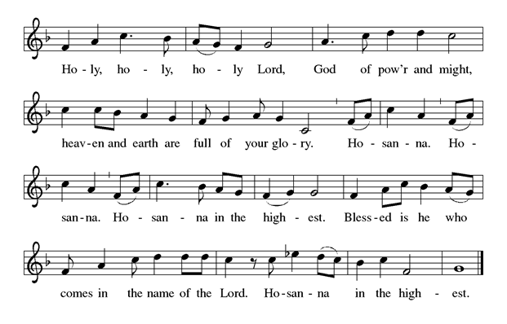
The Lord’s Prayer
Our Father in heaven, hallowed be your name, your kingdom come, your will be
done, on earth as in heaven. Give us today our daily bread. Forgive us our sins as
we forgive those who sin against us. Save us from the time of trial and deliver us
from evil. For the kingdom, the power, and the glory are yours, now and forever.
Amen.

Distribution of Communion

Prayer after Communion
Gracious and abundant God,
you have done great things for us, and we rejoice.
In this bread and cup you give us life forever.
In your boundless mercy, strengthen us
and open our hearts to the world’s needs,
for the sake of Jesus Christ, our Lord.
Amen.

Song - Hark the Herald Angels Sing
Hark! The herald angels sing, “Glory to the newborn king;
peace on earth, and mercy mild, God and sinners reconciled”
Joyful all you nations rise; join the triumph of the skies;
with the angelic hosts proclaim, “Christ is born in Bethlehem!”
Hark! The herald angels sing, “Glory to the newborn king!”

Blessing
The Creator of the stars bless your Advent waiting,
the long-expected Savior fill you with love,
the unexpected Spirit guide your journey,
now and forever.
Amen.

Dismissal
Go in peace. Prepare the way of the Lord.
Thanks be to God.
Share the Peace of the Lord - see you this afternoon!

