St. Mark’s Worship Sunday November 15, 2020
Welcome to our Online Worship
Welcome and Announcements
Dear friends, we will be celebrating Holy Communion today. We hope you can join us for the drive through celebration today between 2:30 and 4 pm, but if driving is not possible, we invite you to have some bread or crackers, wine or juice available to receive the body and blood of our Lord Jesus Christ at home.

If you live with others, you can commune each other. If you live alone, you may take the bread and wine when the pastor says these words: The body of Christ given for you; the blood of Christ shed for you.

We invite you to invite others to come to the drive through communion. This is not limited to members of St. Mark’s. It is our belief that any baptized person may receive this means of grace.

Whether we worship together or in our homes, we are united in Jesus Christ, who knows no bounds.
Give Thanks
Give thanks, with a grateful heart
Give thanks to the Holy One
Give thanks because He's given Jesus Christ, His Son
Give thanks with a grateful heart
Give thanks to the Holy One
Give thanks because He's given Jesus Christ, His Son

And now let the weak say, "I am strong"
Let the poor say, "I am rich
Because of what the Lord has done for us"
And now let the weak say, "I am strong"
Let the poor say, "I am rich
Because of what the Lord has done for us"
Give Thanks!
Mission Statement
“Celebrating God’s Love and Forgiveness, We serve others”
My Faith Looks Up to Thee Verse 1,2 ELW 759
My faith looks up to thee,
thou Lamb of Calvary,
Savior divine!
Now hear me while I pray,
take all my guilt away,
oh, let me from this day
be wholly thine!

May thy rich grace impart
strength to my fainting heart,
my zeal inspire;
as thou hast died for me,
oh, may my love to thee
pure, warm, and changeless be,
a living fire!
Call to Worship
P: Let’s begin worship in the name of the Father, and the Son and of the Holy Spirit
C: Amen
Confession and Forgiveness
P: Blessed be the holy Trinity, ☩ one God,
in whose image we are made,
who claims us and calls us beloved.
Amen.
Silence is kept for reflection.
C: Holy One,
We confess that we are not awake for you.
We are not faithful in using your gifts.
We forget the least of our siblings.
We do not see your beautiful image in one another.
We are infected by sin
That divides your beloved community.
Open our hearts to your coming,
Open our eyes to see you in our neighbor,
Open our hands to serve your creation. Amen.
P: Beloved, we are God’s children,
and Jesus, our Beloved, opens the door to us.
Through ☩ Jesus you are forgiven,
by Jesus you are welcome,
in Jesus you are called to rejoice!
Let us live in the promises prepared for us
from the foundation of the world.
All: Amen.
Prayer of the Day
P: Righteous God, our merciful master, you own the earth and all its peoples, and you
give us all that we have. Inspire us to serve you with justice and wisdom, and
prepare us for the joy of the day of your coming, through Jesus Christ, our Savior
and Lord.
C: Amen.
My Faith Looks Up to Thee Verse 3,4 ELW 759
While life's dark maze I tread
and griefs around me spread,
be thou my guide;
bid darkness turn to day,
wipe sorrow's tears away,
nor let me ever stray
from thee aside.

When ends life's transient dream,
when death's cold, sullen stream
shall o'er me roll;
blest Savior, then, in love
fear and distrust remove;
oh, bear me safe above,
a ransomed soul!
1 Thessalonians 5:1-11 NRSV
¹Now concerning the times and the seasons, brothers and sisters, you do not need to have anything written to you. ²For you yourselves know very well that the day of the Lord will come like a thief in the night. ³When they say, “There is peace and security,” then sudden destruction will come upon them, as labor pains come upon a pregnant woman, and there will be no escape! ⁴But you, beloved, are not in darkness, for that day to surprise you like a thief; ⁵for you are all children of light and children of the day; we are not of the night or of darkness. ⁶So then let us not fall asleep as others do, but let us keep awake and be sober; ⁷for those who sleep sleep at night, and those who are drunk get drunk at night. ⁸But since we belong to the day, let us be sober, and put on the breastplate of faith and love, and for a helmet the hope of salvation. ⁹For God has destined us not for wrath but for obtaining salvation through our Lord Jesus Christ, ¹⁰who died for us, so that whether we are awake or asleep we may live with him. ¹¹Therefore encourage one another and build up each other, as indeed you are doing.

“Alleluia”
Alleluia. Lord to whom shall we go?
You have the words of eternal life.
Alleluia.
Matthew 25: 14-30 NRSV
[Jesus said to the disciples:] ¹⁴“For it is as if a man, going on a journey, summoned his slaves and entrusted his property to them; ¹⁵to one he gave five talents, to another two, to another one, to each according to his ability. Then he went away. ¹⁶The one who had received the five talents went off at once and traded with them, and made five more talents. ¹⁷In the same way, the one who had the two talents made two more talents. ¹⁸But the one who had received the one talent went off and dug a hole in the ground and hid his master’s money. ¹⁹After a long time the master of those slaves came and settled accounts with them. ²⁰Then the one who had received the five talents came forward, bringing five more talents, saying, ‘Master, you handed over to me five talents; see, I have made five more talents.’ ²¹His master said to him, ‘Well done, good and trustworthy slave; you have been trustworthy in a few things, I will put you in charge of many things; enter into the joy of your master.’ ²²And the one with the two talents also came forward, saying, ‘Master, you handed over to me two talents; see, I have made two more talents.’ ²³His master said to him, ‘Well done, good and trustworthy slave; you have been trustworthy in a few things, I will put you in charge of many things; enter into the joy of your master.’ ²⁴Then the one who had received the one talent also came forward, saying, ‘Master, I knew that you were a harsh man, reaping where you did not sow, and gathering where you did not scatter seed; ²⁵so I was afraid, and I went and hid your talent in the ground. Here you have what is yours.’ ²⁶But his master replied, ‘You wicked and lazy slave! You knew, did you, that I reap where I did not sow, and gather where I did not scatter? ²⁷Then you ought to have invested my money with the bankers, and on my return I would have received what was my own with interest. ²⁸So take the talent from him, and give it to the one with the ten talents. ²⁹For to all those who have, more will be given, and they will have an abundance; but from those who have nothing, even what they have will be taken away. ³⁰As for this worthless slave, throw him into the outer darkness, where there will be weeping and gnashing of teeth.’ ”
Sermon Pastor Karla Halvorson
Jesus the Very Thought Verse 1, 2 ELW 754
Jesus, the very thought of you
fills us with sweet delight;
but sweeter far your face to view
and rest within your light.

No voice can sing, no heart can frame,
nor can the mind recall
a sweeter sound than your blest name,
O Savior of us all!
Apostle’s Creed
I believe in God, the father almighty, creator of heaven and earth.
I believe in Jesus Christ, his only Son, Our Lord.
He was conceived by the power of the Holy Spirit and born of the virgin Mary.
He suffered under Pontius Pilate, was crucified, died and was buried.
He descended into hell. On the third day he rose again.
He ascended into heaven, and is seated at the right hand of the Father.
He will come again to judge the living and the dead.
I believe in the Holy Spirit, the holy catholic church, the communion of saints, the
forgiveness of sins, the resurrection of the body and the life everlasting. Amen
Prayers of the People
L: Hear us, O God
C: Your Mercy is Great
Offering
St. Mark’s Church, 580 Hilltop Dr. Chula Vista CA 91910
Venmo: @stmarks-churchchulavista
We Give Thee But Thine Own
We give thee but thine own,
Whate’er the gift may be;
All that we have is thine alone,
A trust, O Lord, from thee.

OFFERING PRAYER
P: Let us pray.
Holy God, gracious and merciful, you bring forth food from the earth and nourish
your whole creation. Turn our hearts toward those who hunger in any way, that all
may know your care; and prepare us now to feast on the bread of life, Jesus Christ,
our Savior and Lord.
C: Amen.
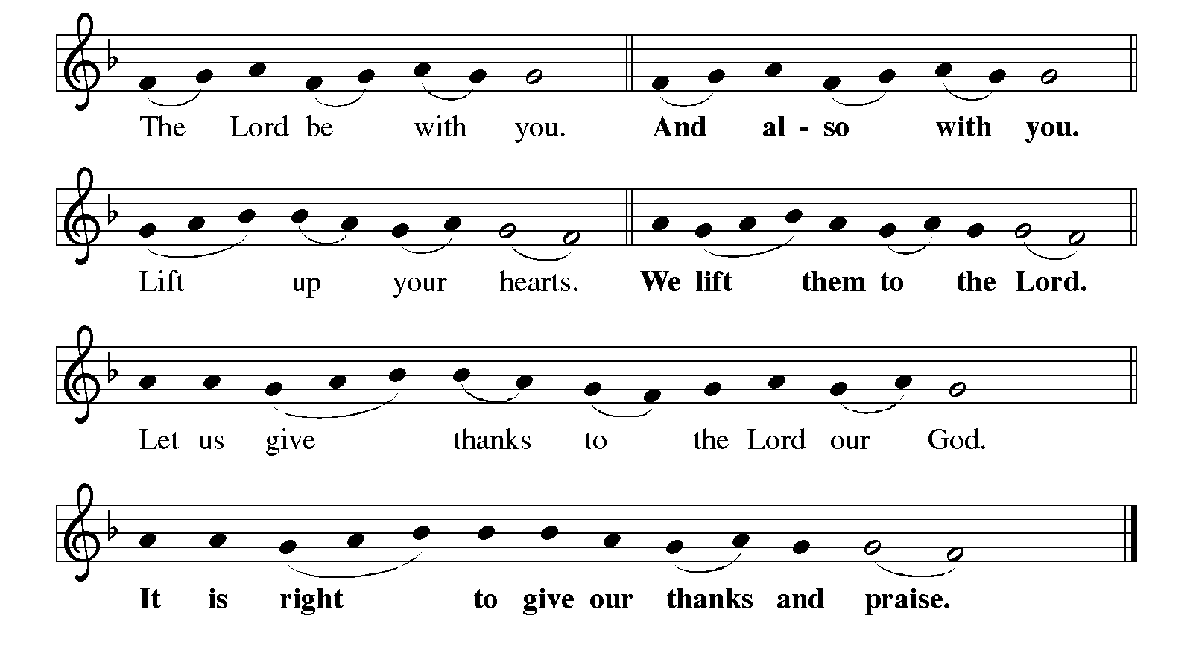
GREAT THANKSGIVING
P: It is indeed right, our duty and our joy… …and join their unending hymn

HOLY, HOLY,
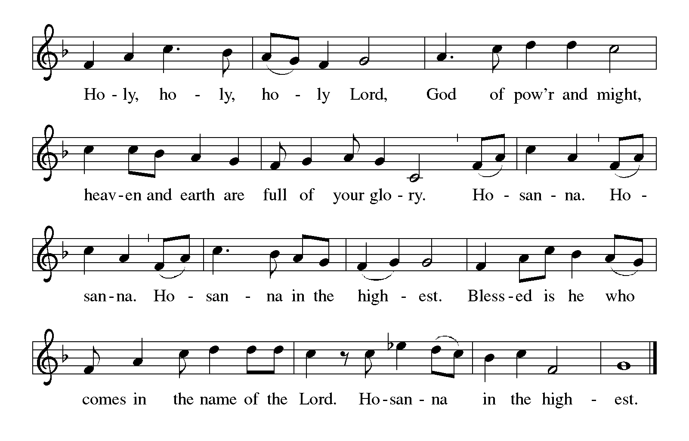

P: You are indeed holy, almighty and merciful God... in your holy church now and
forever.
C: Amen
The Lord’s Prayer
Our Father in heaven, hallowed be your name, your kingdom come, your will be
done, on earth as in heaven. Give us today our daily bread. Forgive us our sins as
we forgive those who sin against us. Save us from the time of trial and deliver us
from evil. For the kingdom, the power, and the glory are yours, now and forever.
Amen.
Invitation to Communion
If you are communing at home, you may now take the bread and wine and commune each other or yourself. The body of Christ is given for you. The blood of Christ is shed for you.
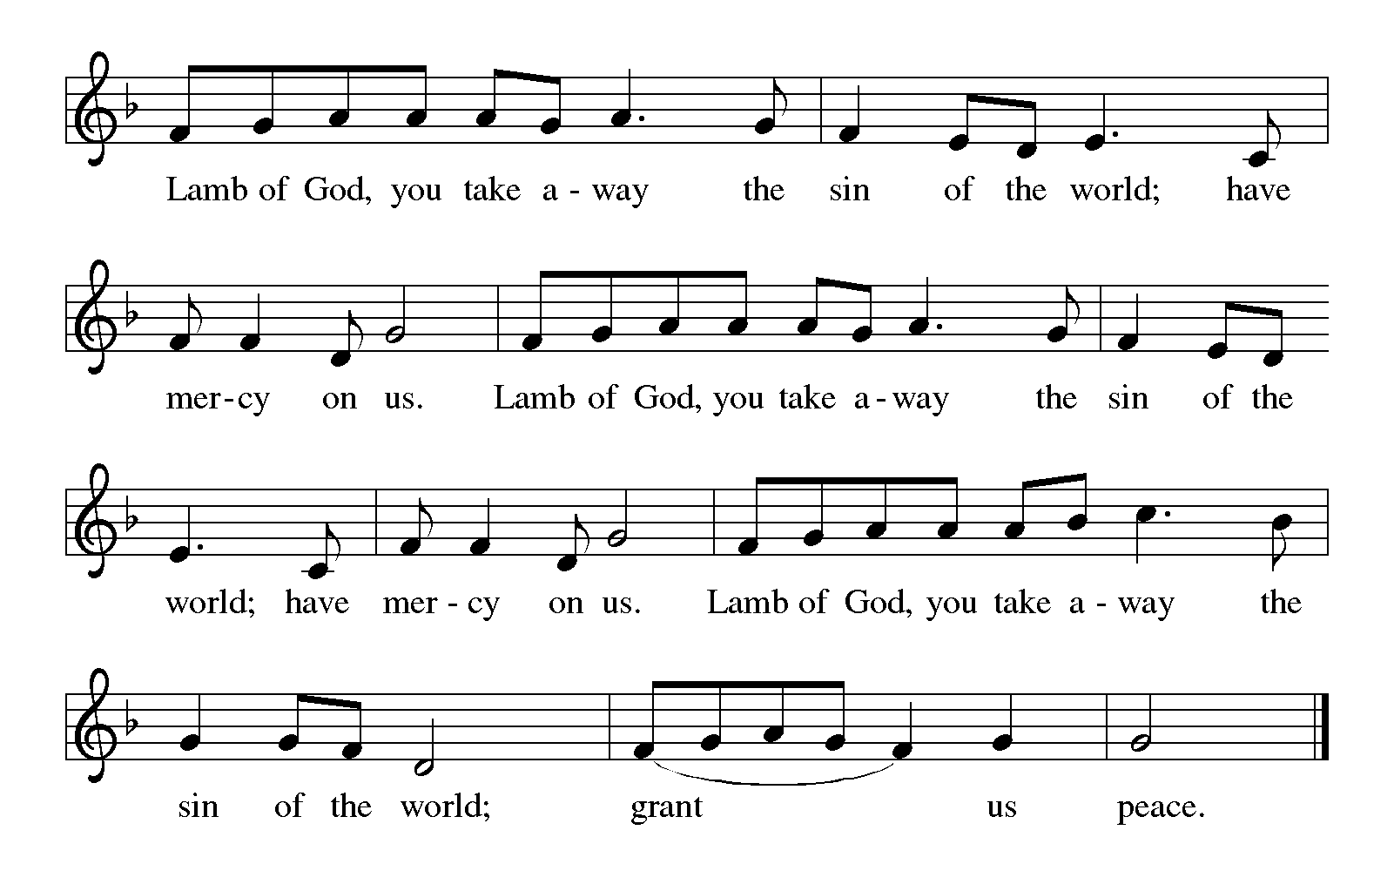
Communion Song
PRAYER AFTER COMMUNION
P: Let us pray.
Gracious God, in this meal you have drawn us to your heart, and nourished us at
your table with food and drink, the body and blood of Christ. Now send us forth to
be your people in the world, and to proclaim your truth this day and evermore,
through Jesus Christ, our Savior and Lord.
C: Amen.
Blessing
P: Almighty God, Father, ☩ Son, and Holy Spirit, bless you now and forever.
C: Amen.
Jesus The Very Thought Verse 3,4 ELW 754
O Hope of ev'ry contrite soul,
O joy of all the meek,
how kind you are to those who fall!
How good to those who seek!

O Jesus, be our joy today;
help us to prize your love;
grant us at last to hear you say:
"Come, share my home above."
P: Go in Peace; Remember the Poor.
C: Thanks be to God!
Share the Peace of the Lord in the comments below!

