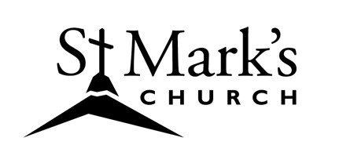

ST. MARK’S LUTHERAN CHURCH
2017 Annual Report
for the January 28, 2018 Meeting of the Congregation

TABLE OF CONTENTS

Agenda for the January 28, 2018 Annual Meeting 1
Minutes of January 29, 2017 Annual Meeting (missing) 1
St. Mark's Church Council Report 2
Synod Listening Post Recommendations Summary 3

Financial Reports
Audit Report 6
Balance Sheet 9
Financial Report and 2018 Budget 10

Ministry Reports
Pastoral Acts 12
Activities on the St. Mark's Campus 13
Altar Committee 14
Coffee Ministry Report 15
Communications & Marketing Report 15 Memorial Endowment Fund Report 16
Music Ministry Report 17 Prayer Quilt Ministry Report 18
Property Committee Report 19 Spanish Language Ministry 19 Women of St. Mark's Report 21
Youth of St. Mark's Report 21

